Inhoudsopgave
DEMO PROJECTS BASIC (APEX 5.1 TUTORIAL) 2
DEMO PROJECTS ADVANCED (APEX 5.0 TUTORIAL) 36
FUNDAMENTALS 1 90
FUNDAMENTALS 2 115
Application 260 115
Application 280 135
OVERIG 140
APEX Algemeen 158
Template 166
Authorization Scheme 166
Application Item 168
Authentication Scheme 169
Shared Components - Lists – Desktop Navigation Bar 171
Rendering 176
Dynamic Action 176
Processing 177
THEMA’S 178
Algemeen 178
Create Page 178
File Browse 179
APEX_MAIL 180
Application Groups 181
Shuttle 182
Switch 184
Validatie 185
DB en SC Items 186
Buttons 189
Get and Set Page Item values 198
Compute Dependencies 198
PL/SQL Dynamic Content 199
Icons 200
Tips & Tricks 200
CSS 210
HTML 214
Javascript 215
Open Modal/Inline dialogue using Javascript in Oracle Apex 5.0 216
AZL PROJECTEN 219
KAR (Straat-1) 219
UPA (Straat-5) 252
Workshop 267
Vragen 12-06-2018 267
Vragen 26-06-2018 271
Vragen 24-07-2018 273
Zelfstudie 273
Vragen 273
Openstaand 291
Problemen 292

DEMO PROJECTS BASIC (APEX 5.1 TUTORIAL)

You will not be able to run modal and non-modal pages directly using Save and Run Page. Instead you will need to navigate to a normal page and run the page from there and then navigate within the running application to the modal or non-modal page. Modal pages must be invoked from a base page. The reason such pages can not be run directly is that when the modal page is closed it must have a target page to return to, being the page it was invoked from.

:APP_USER : The person running the application.

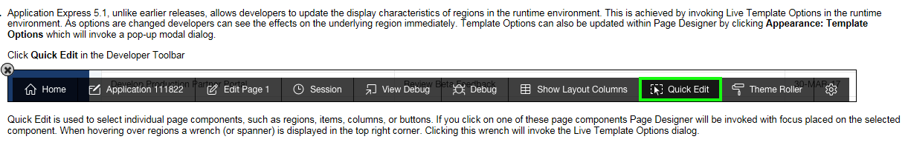

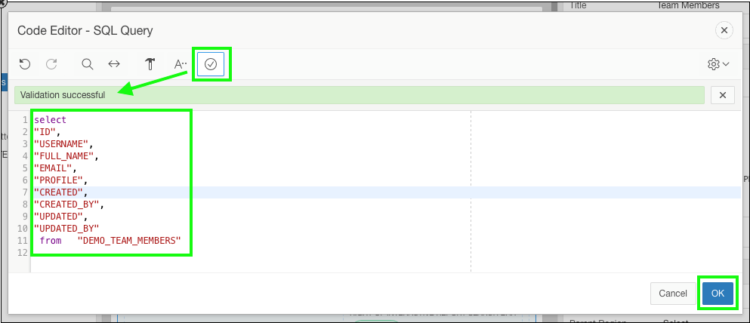

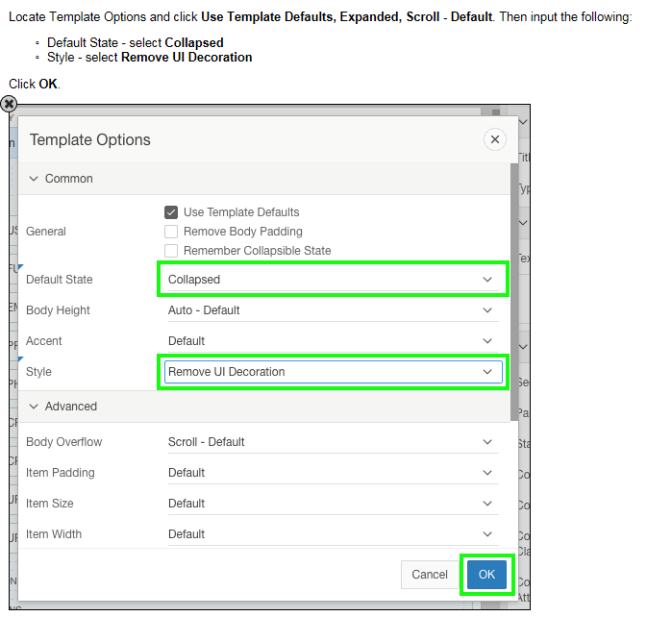

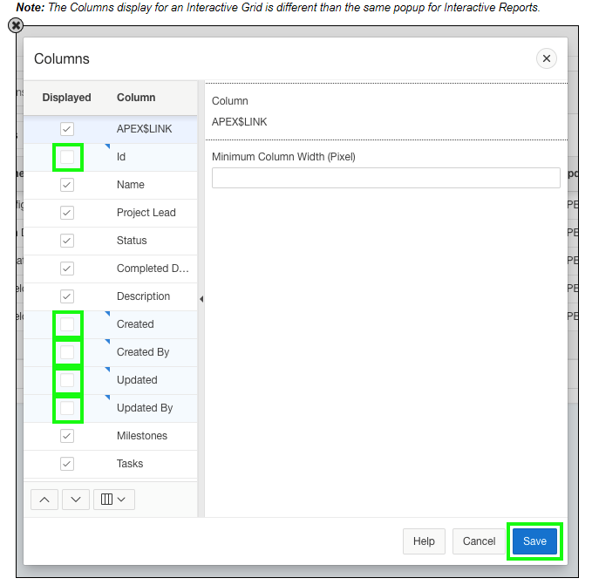

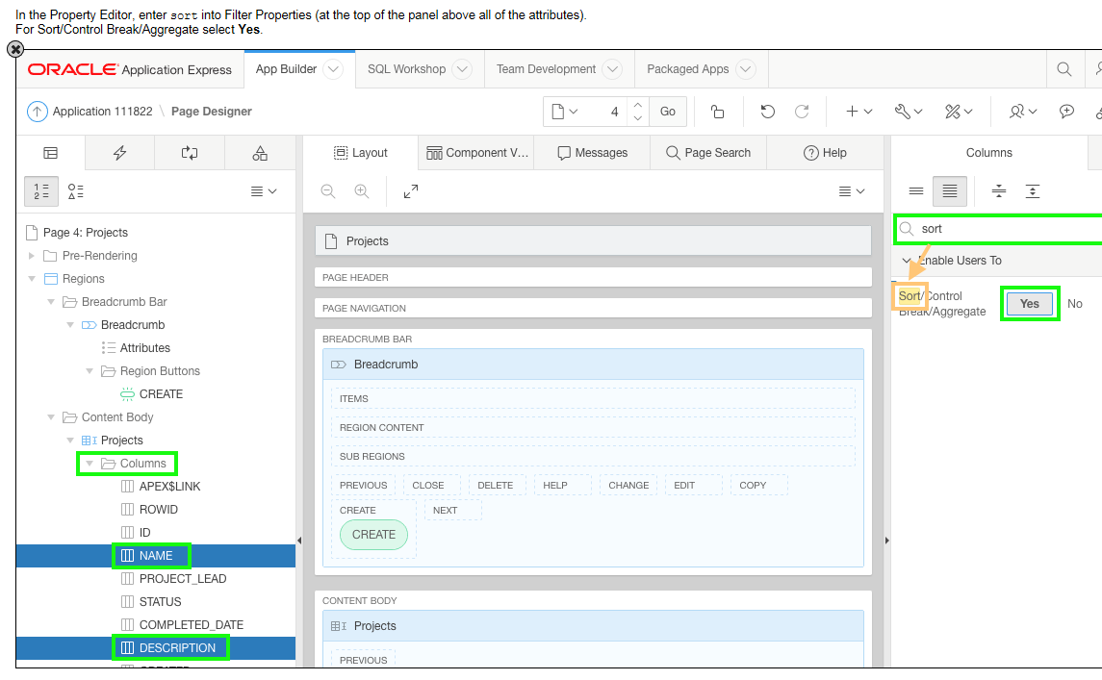
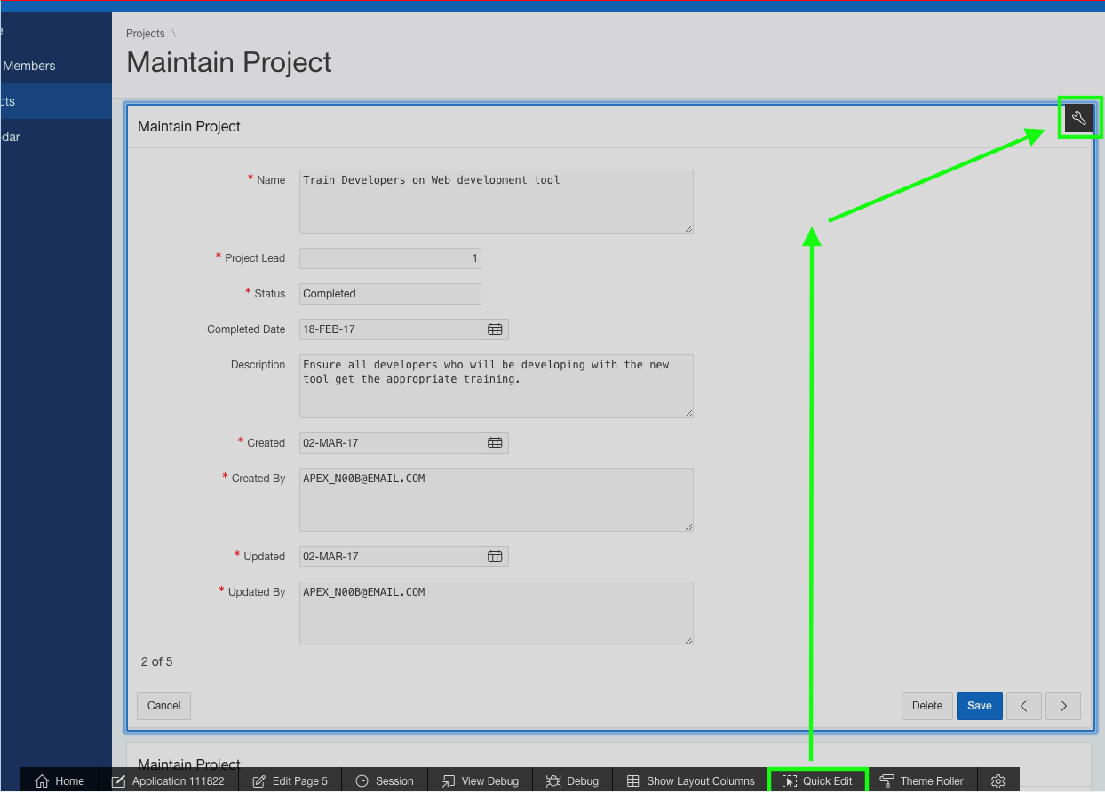

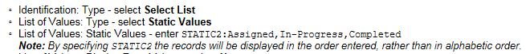

Generally when an item is mandatory you update the Template to Required and the Value Required to Yes. However, in this instance the Value Required attribute should remain No because the item is only mandatory when the status is Completed. A validation is added later in this section to enforce this business rule.

For Dynamic Action types, such as Show, Enable, and Expand Tree, it is important to also include the corresponding opposite action. In that way the affected elements are set one way if the Client-side Condition evaluates to True and the opposite if the Client-side Condition evaluates to False.

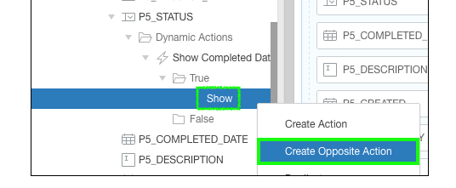

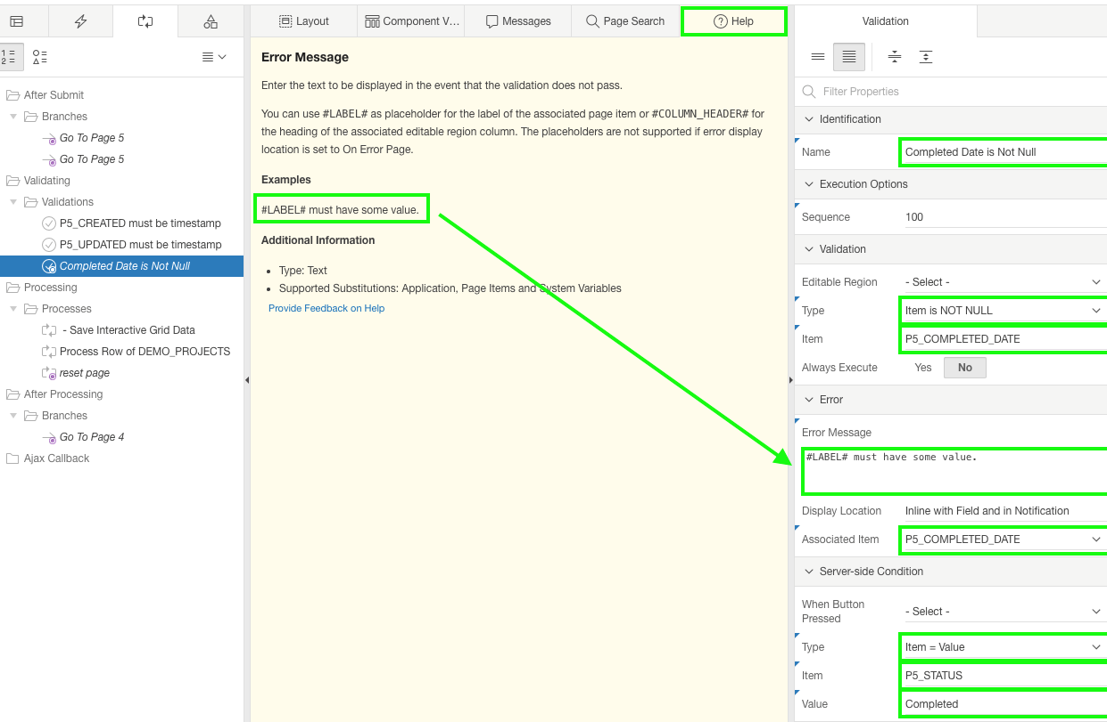

Validation: PL/SQL Expression - enter :P5_COMPLETED_DATE <= SYSDATE
Note: To reference a page item in PL/SQL you use the :ITEM_NAME syntax. SYSDATE returns the current date from the Oracle Database.

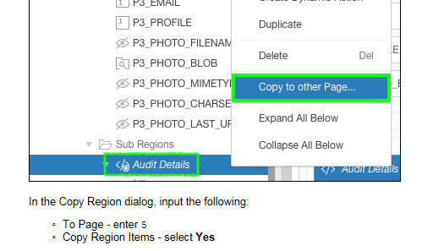

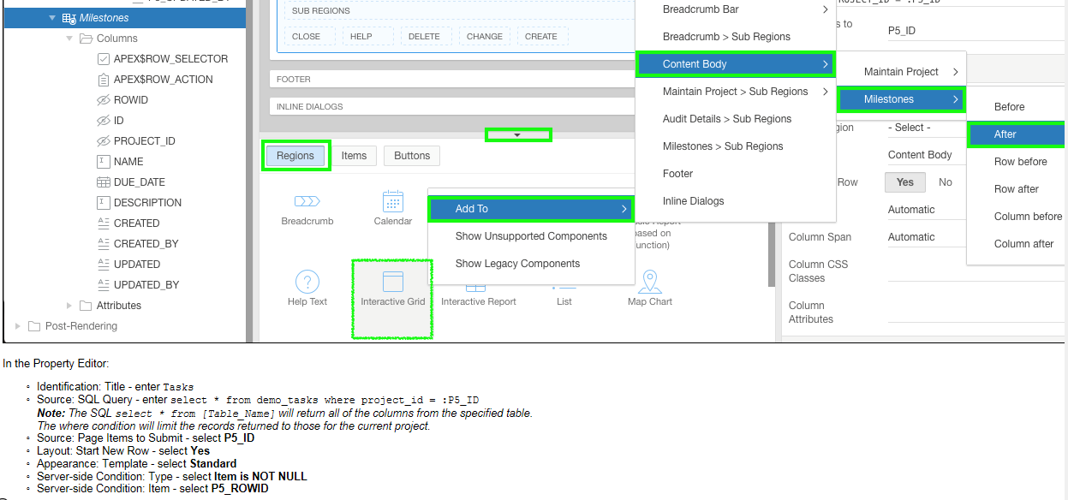

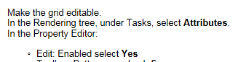

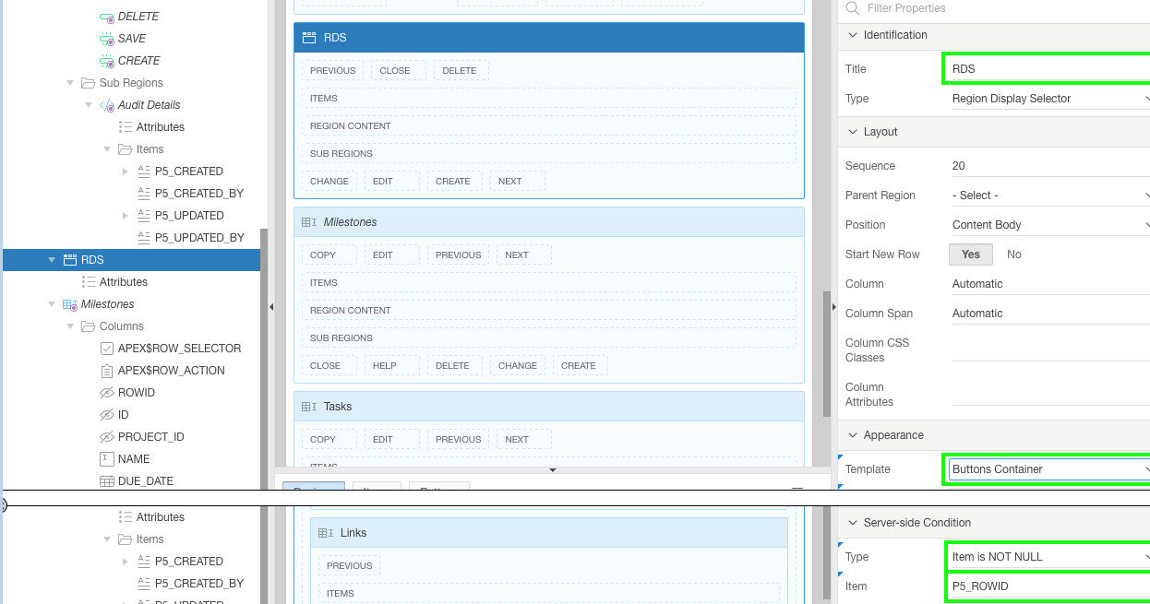

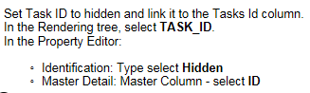

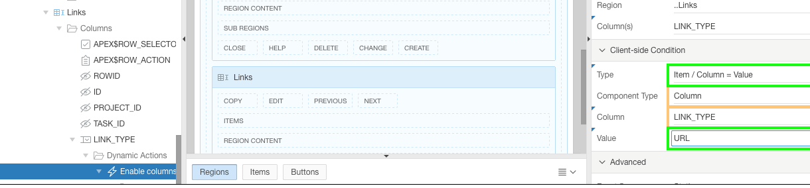

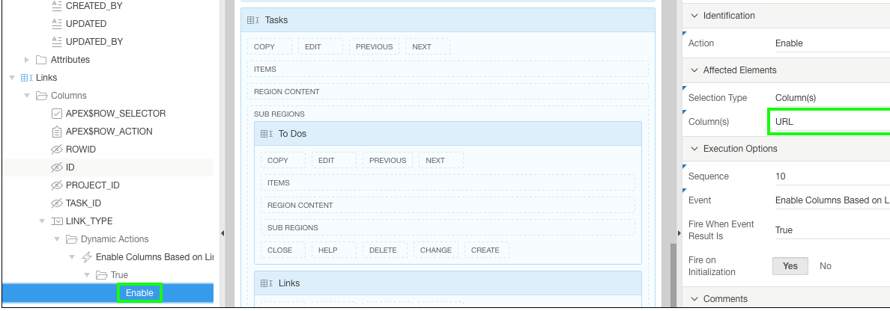

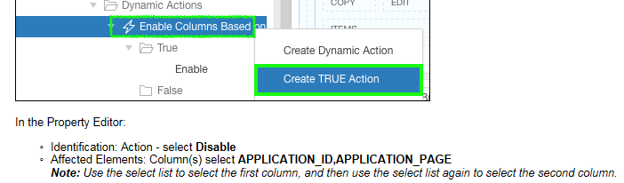

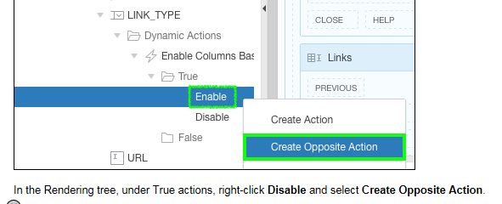

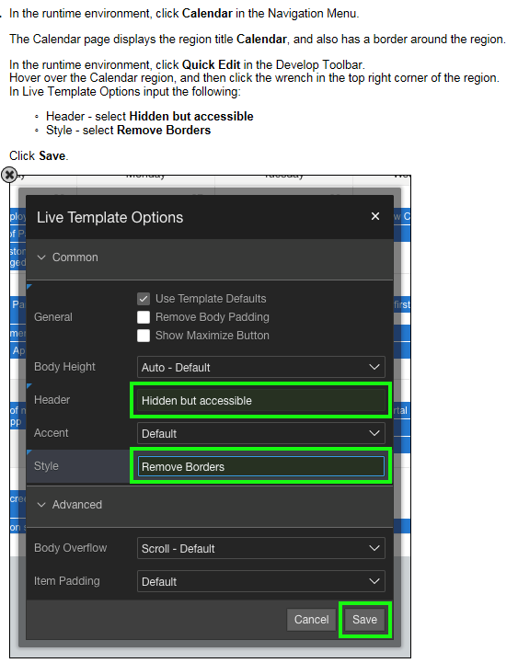

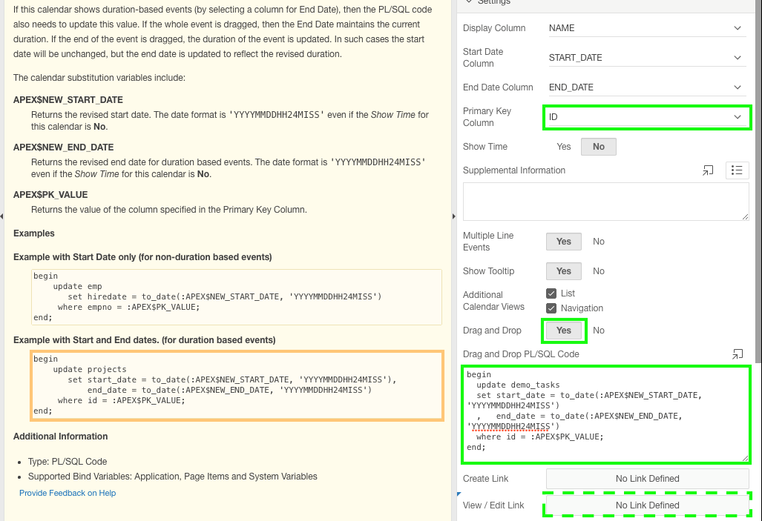

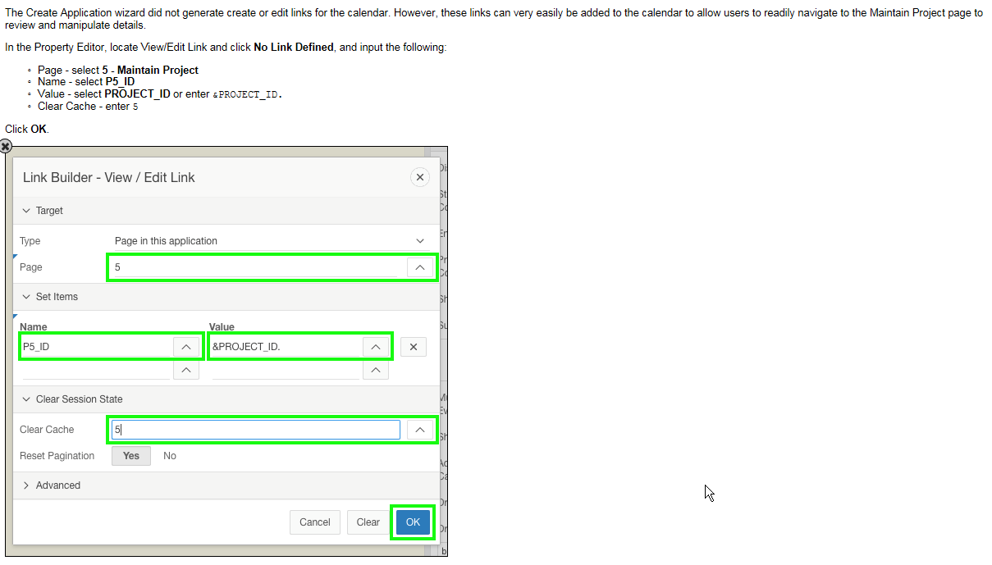

Open de applicatie in de “App Builder” en klik op “Edit Application Properties”:

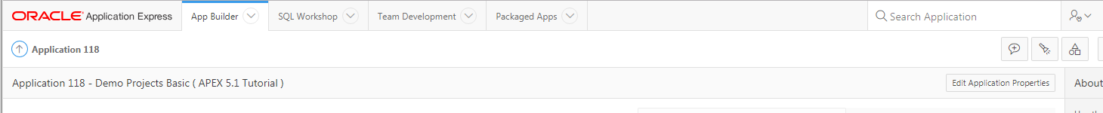
Klik op “User Interface” en vul bij “Logo” de gewenste tekst in:
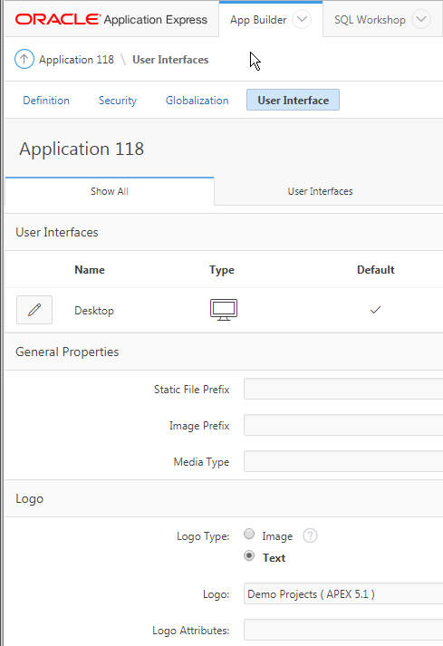

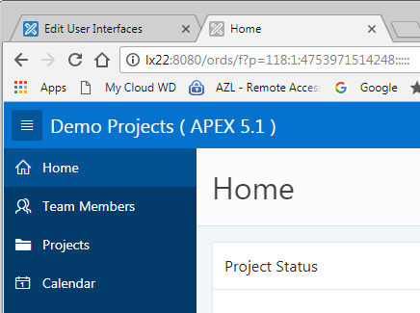
Het navigatie menu aan de linkerzijde:
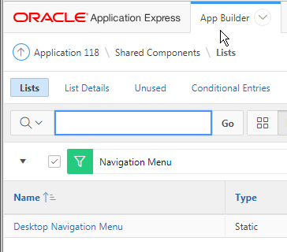
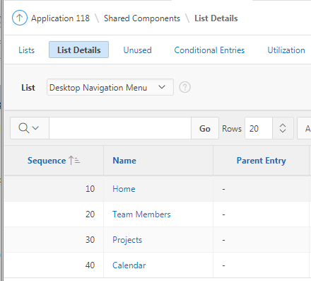
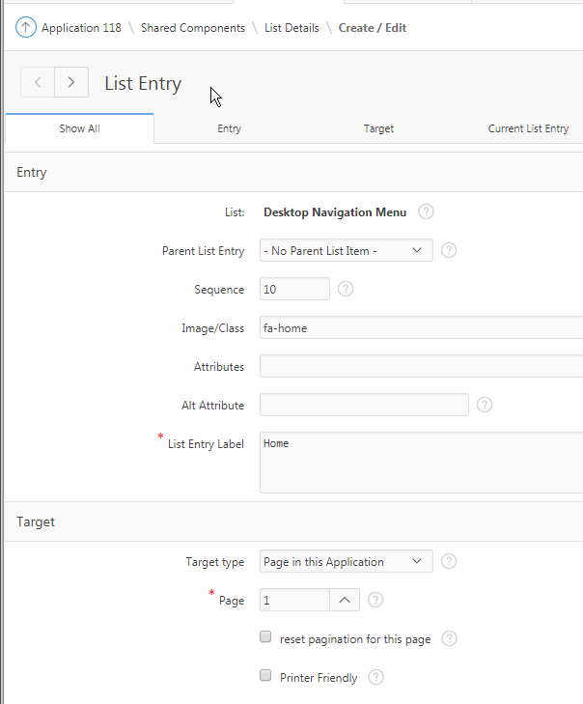
Button “Add Team Member”:
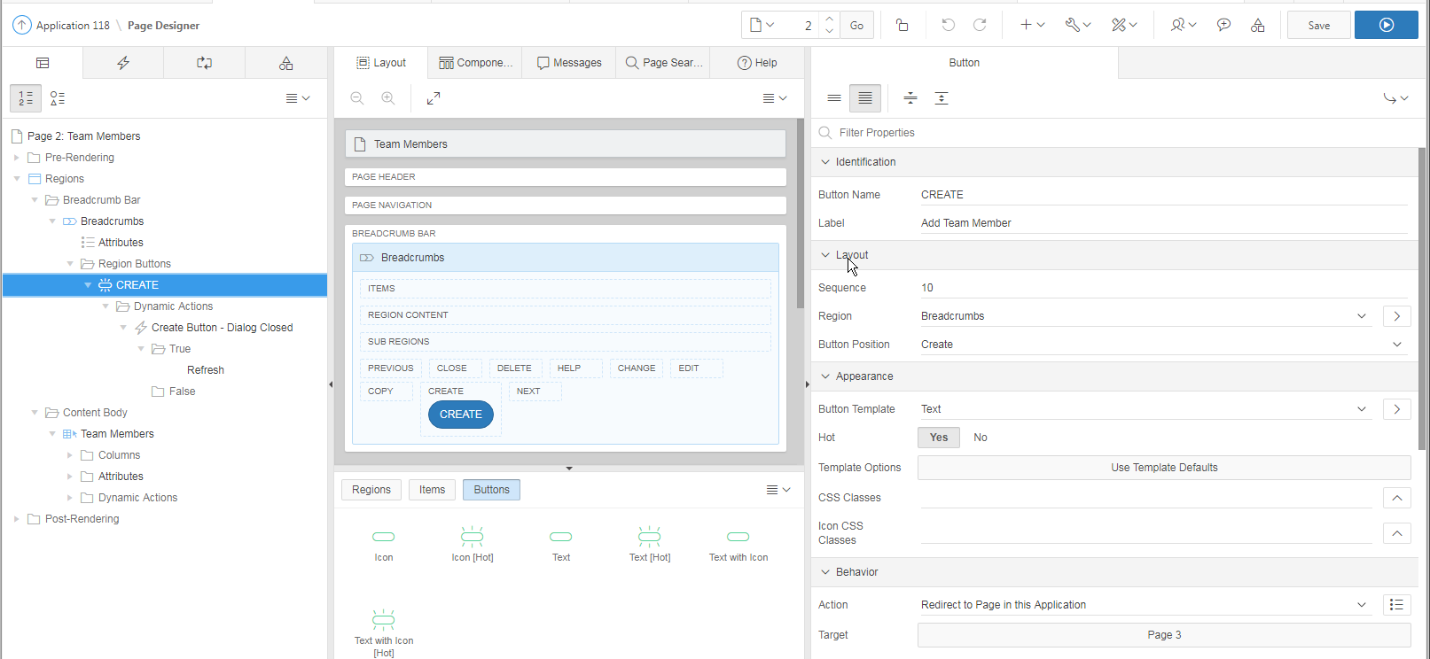
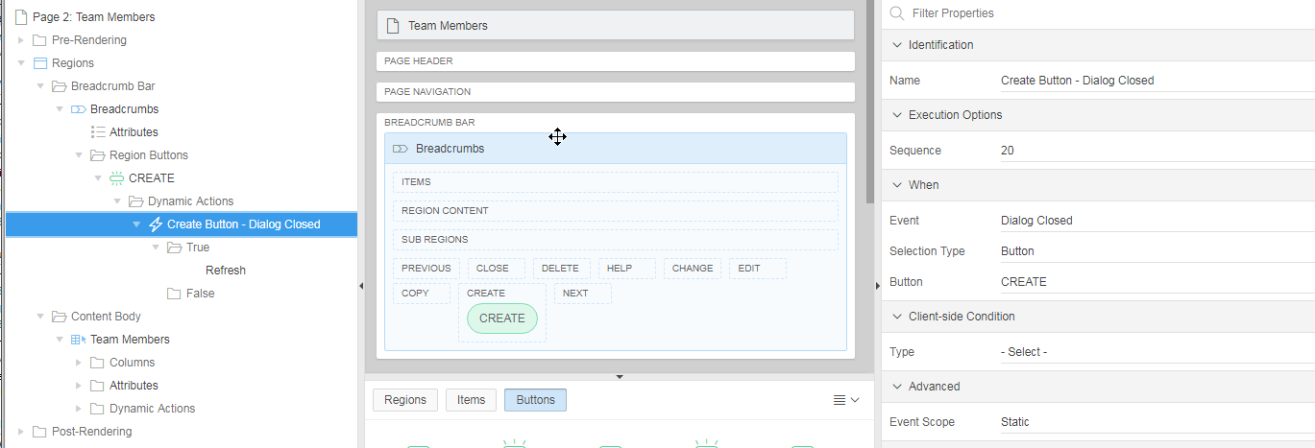
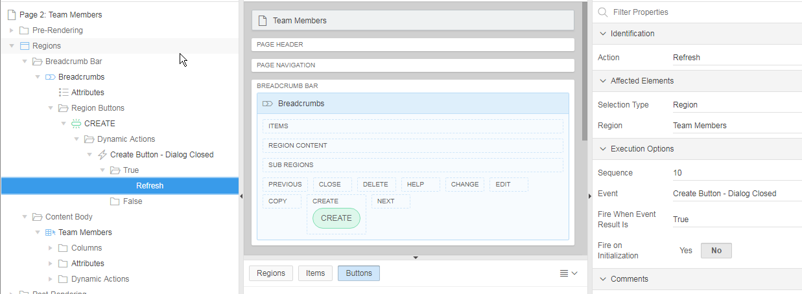
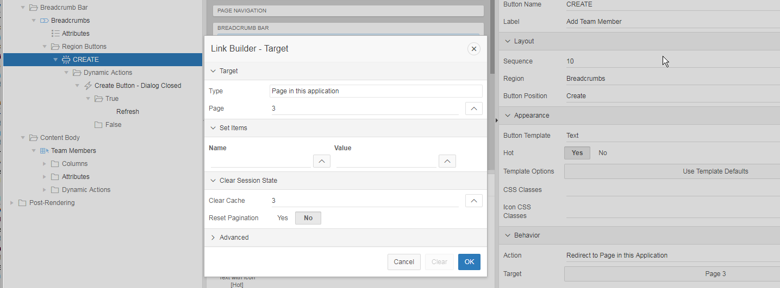
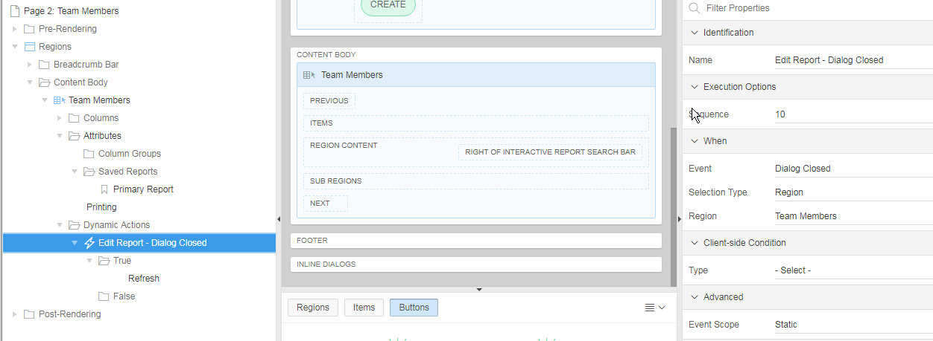
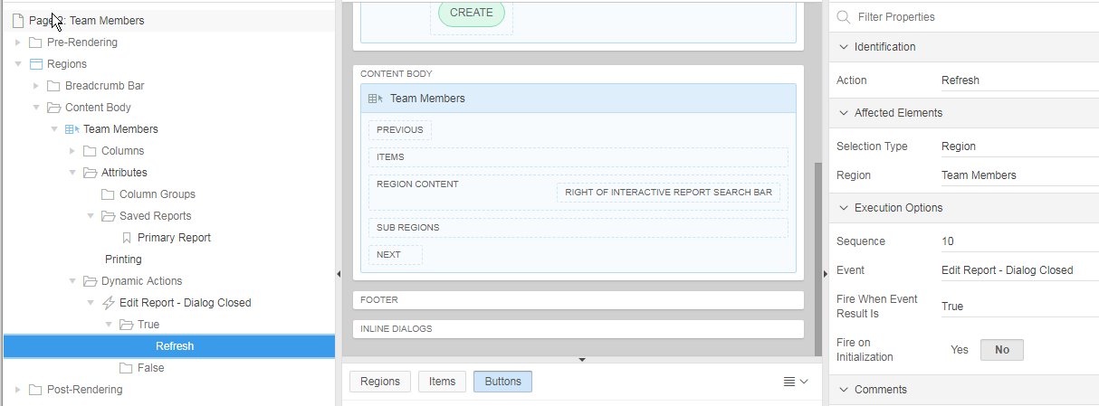
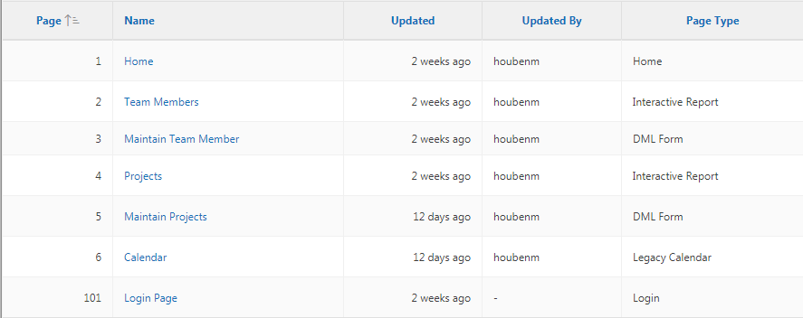
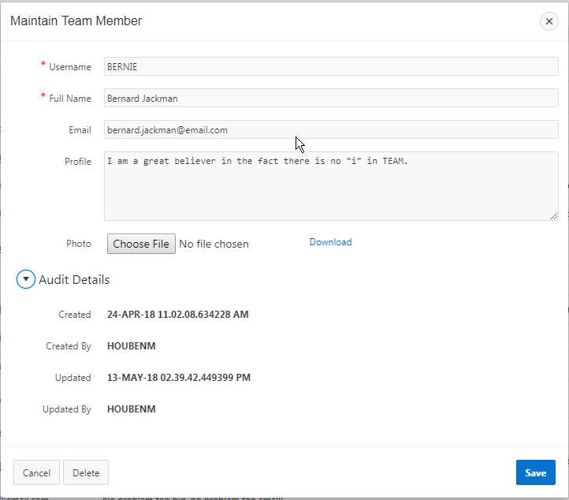
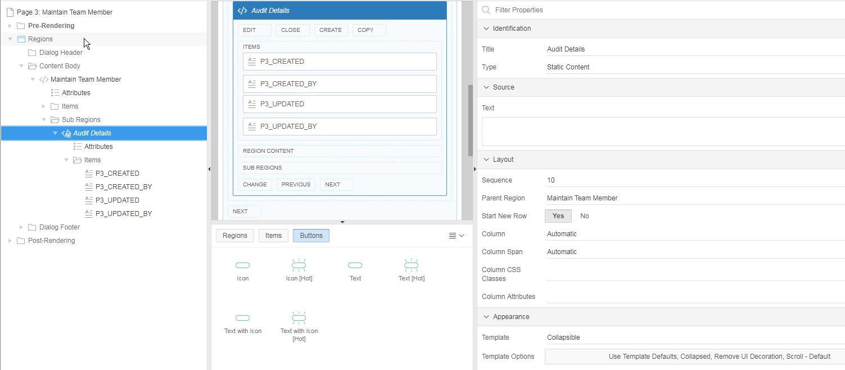
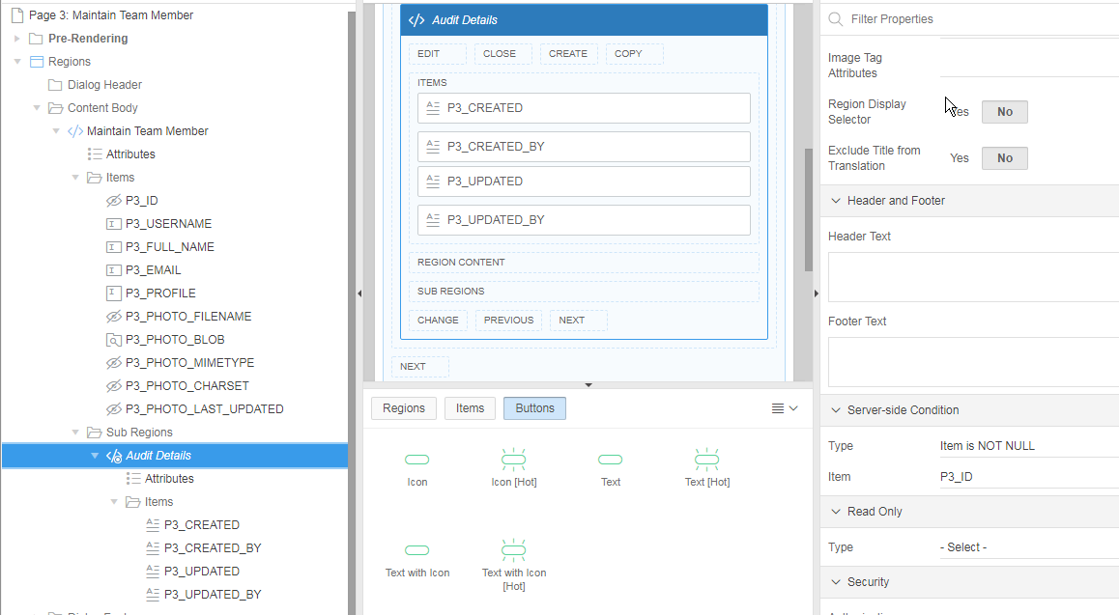
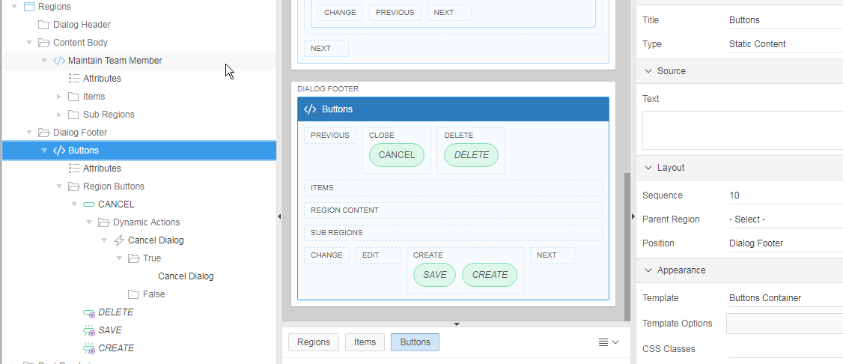
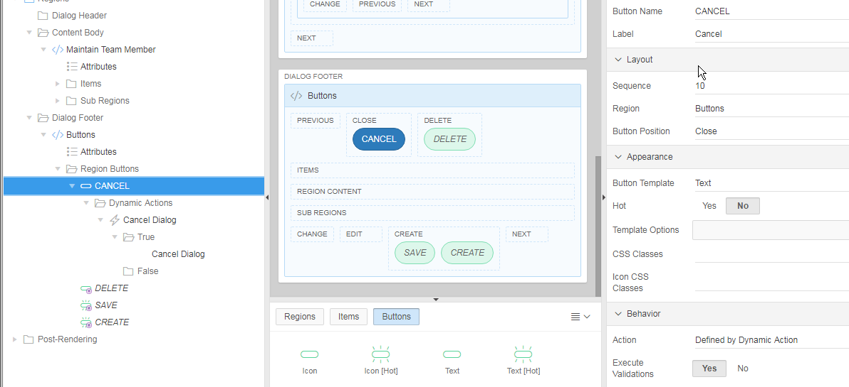
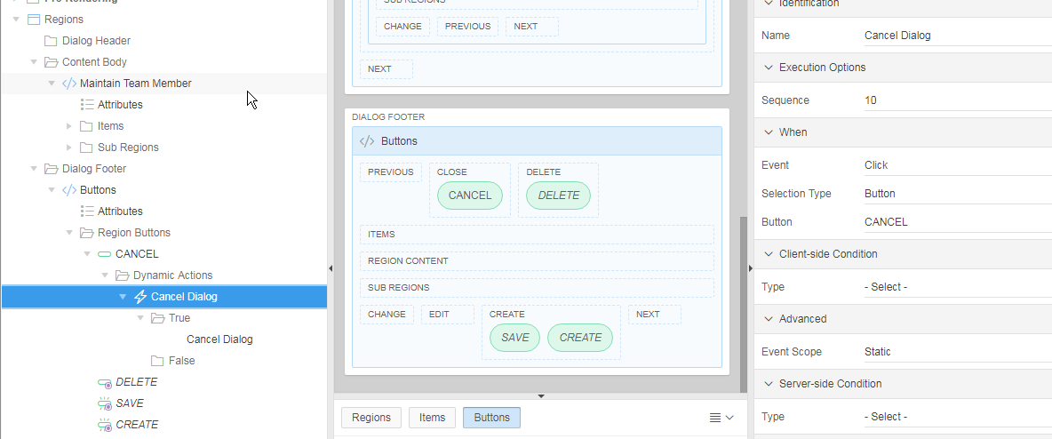
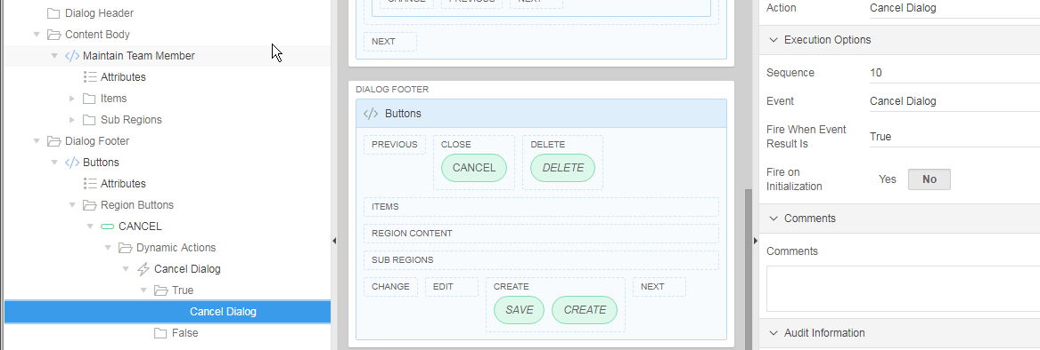
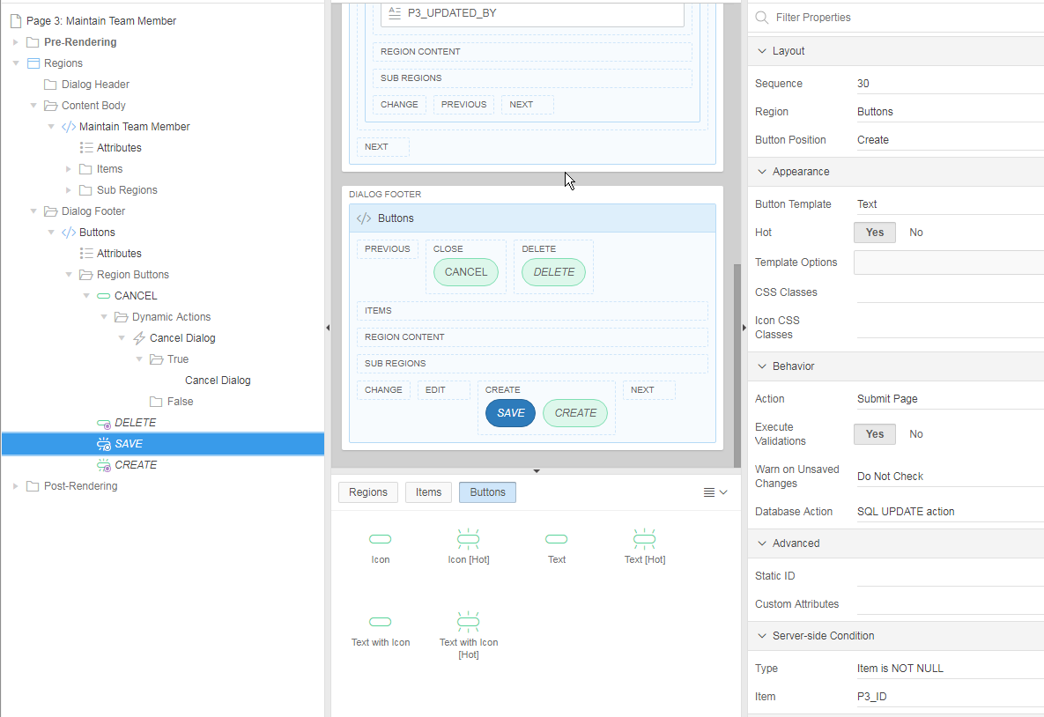
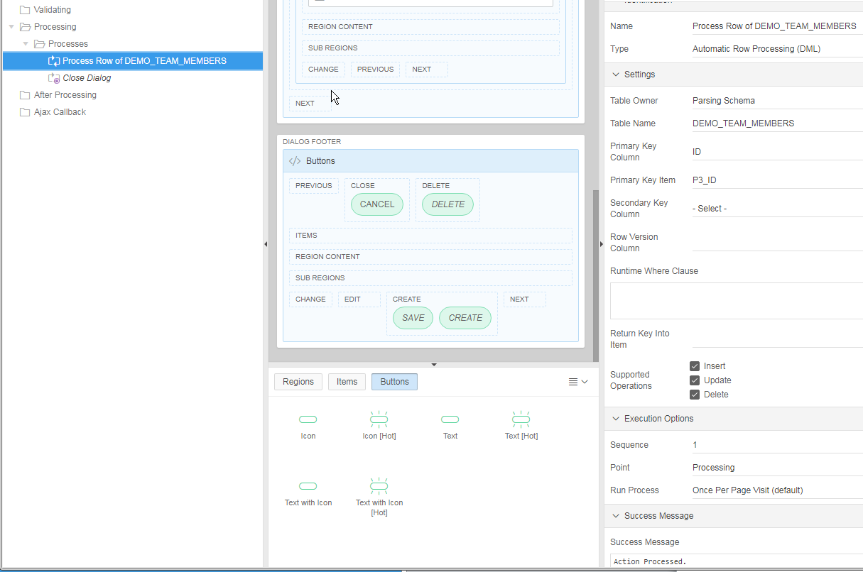
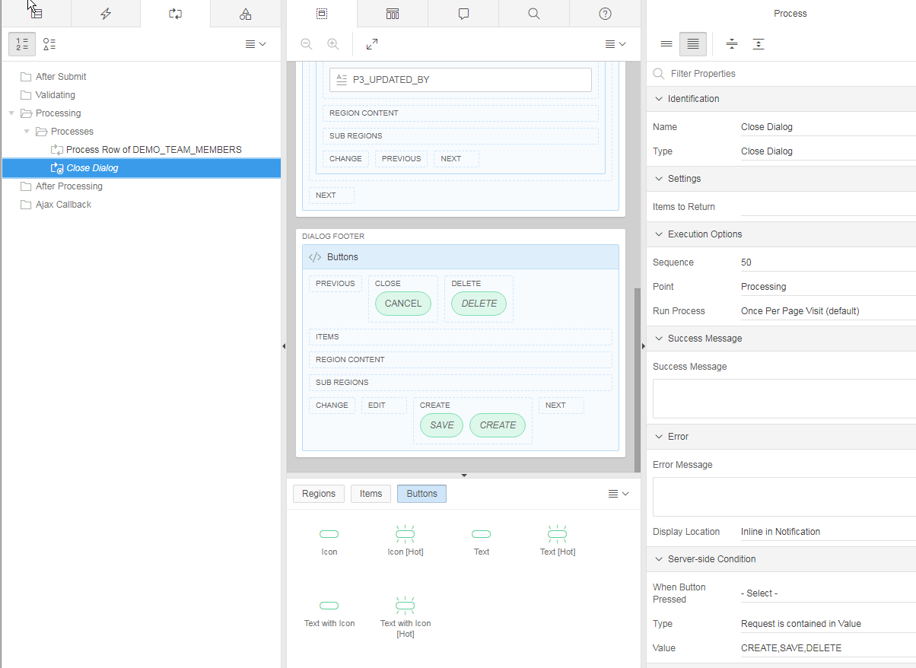
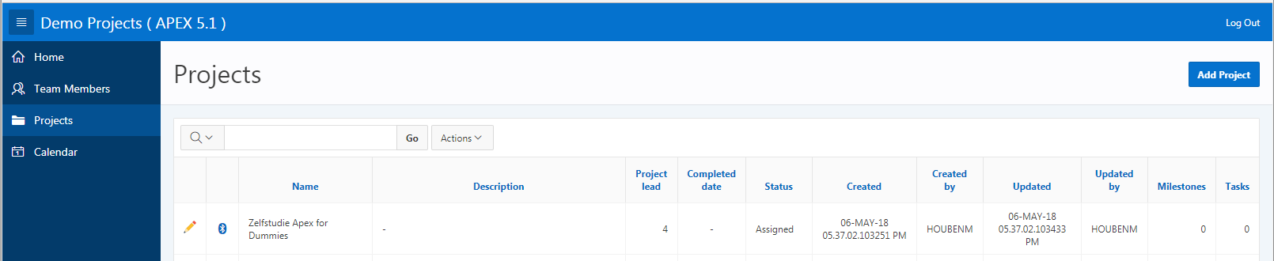
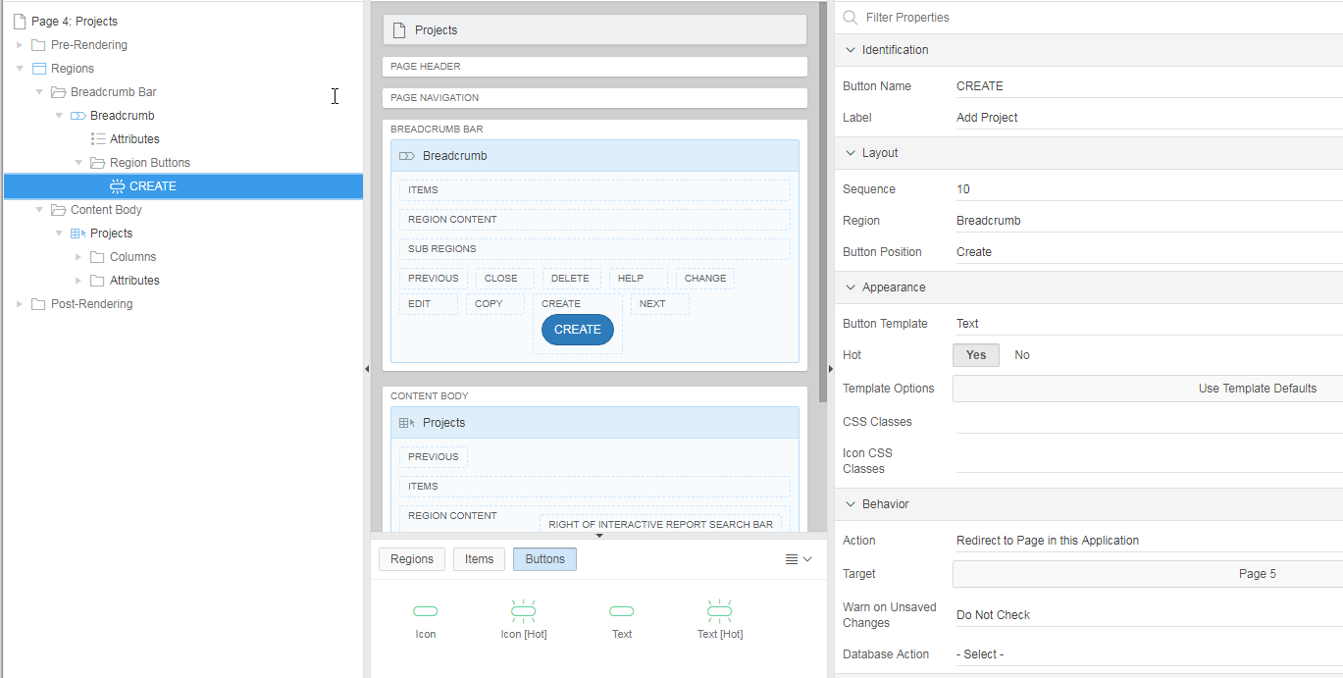
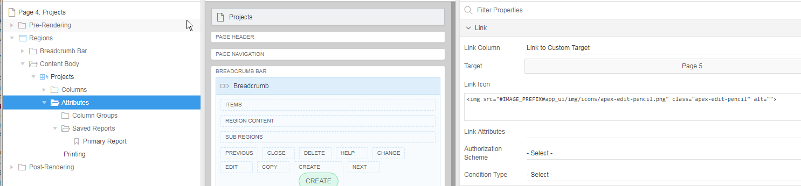
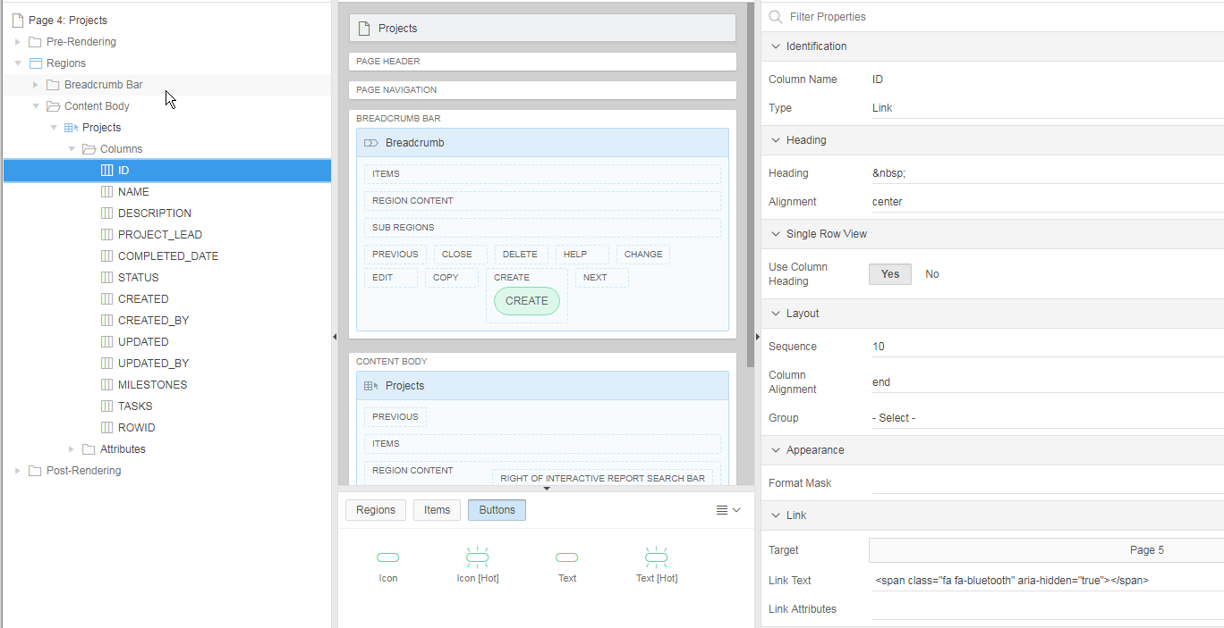
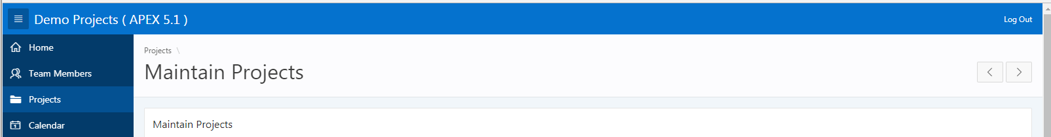
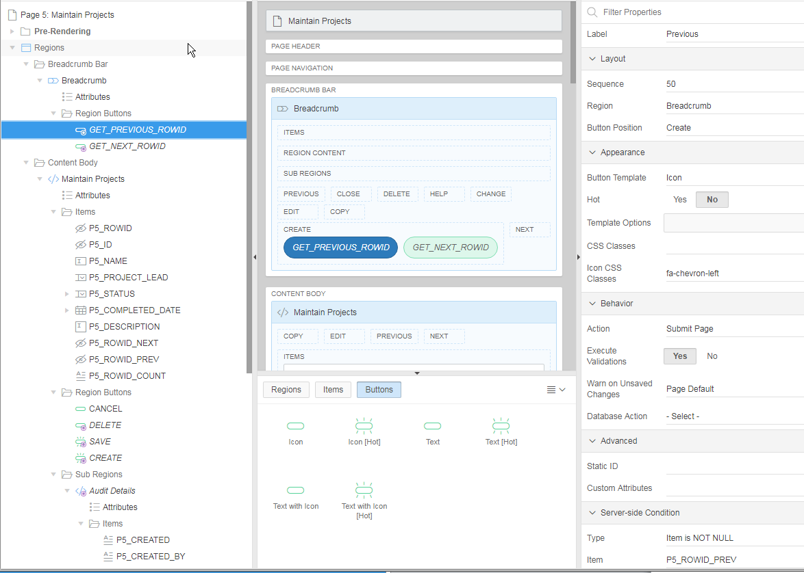
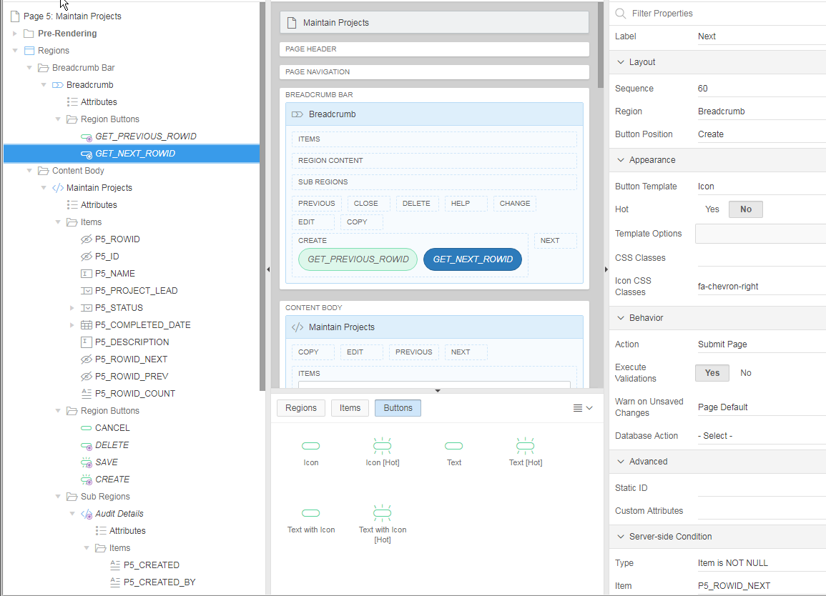
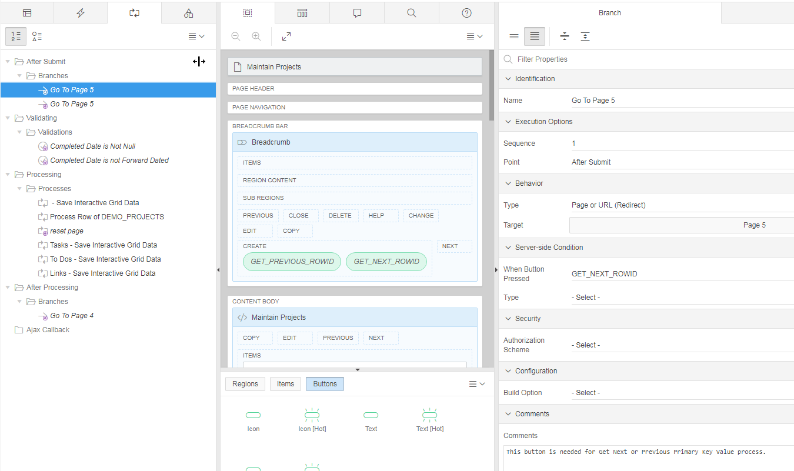
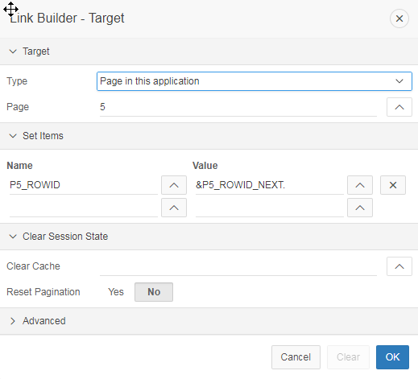
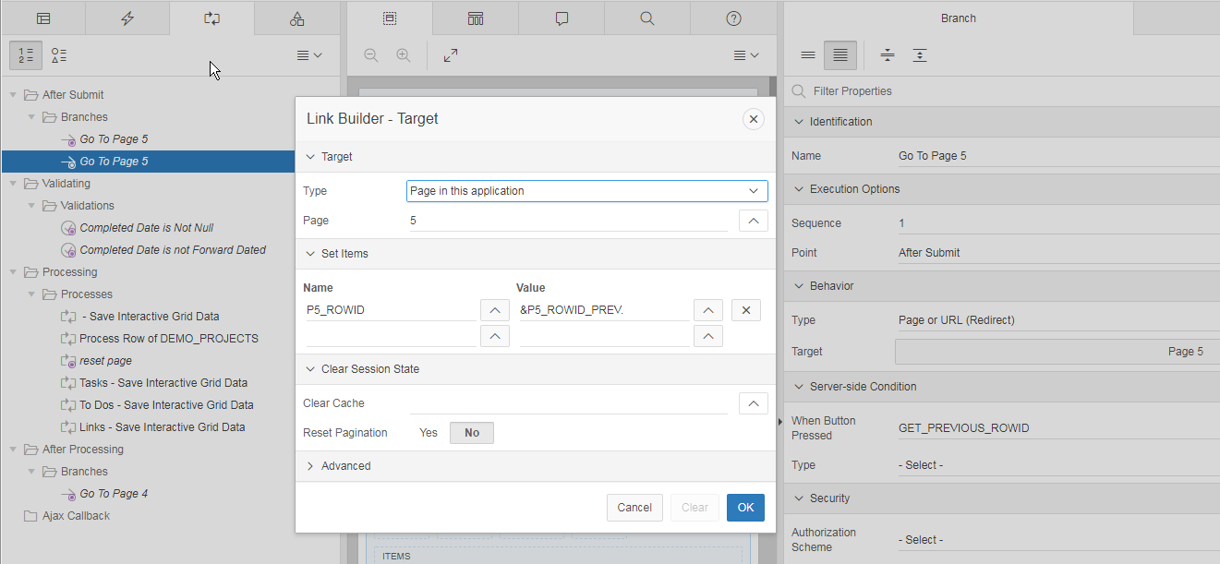
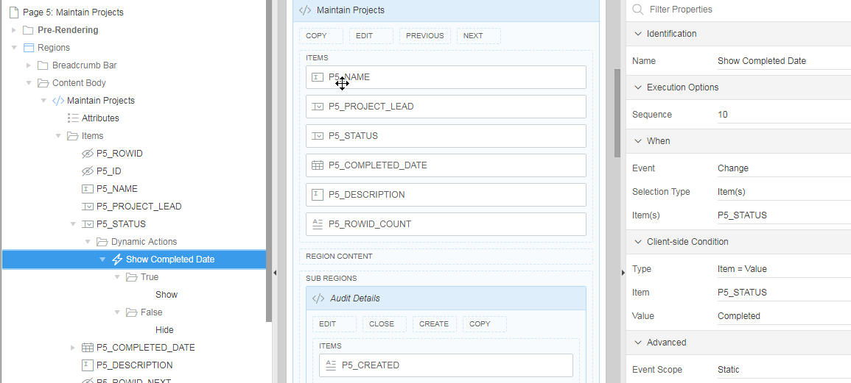
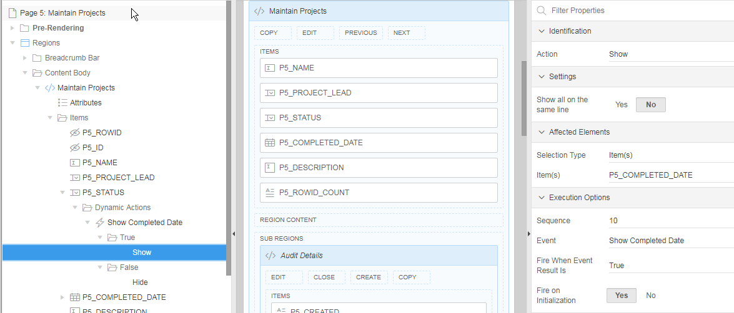
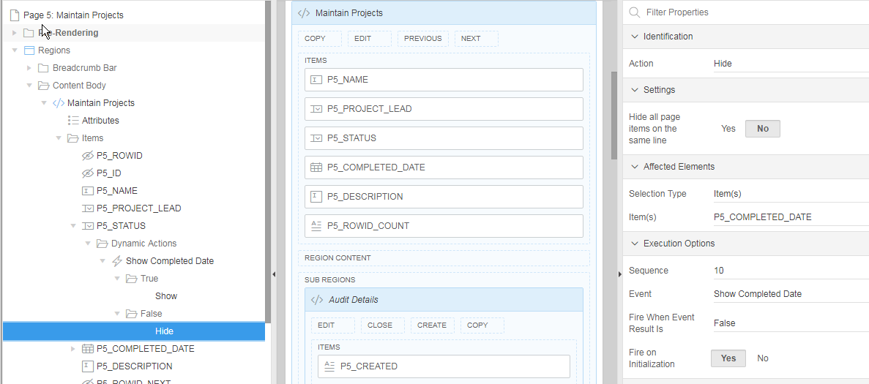
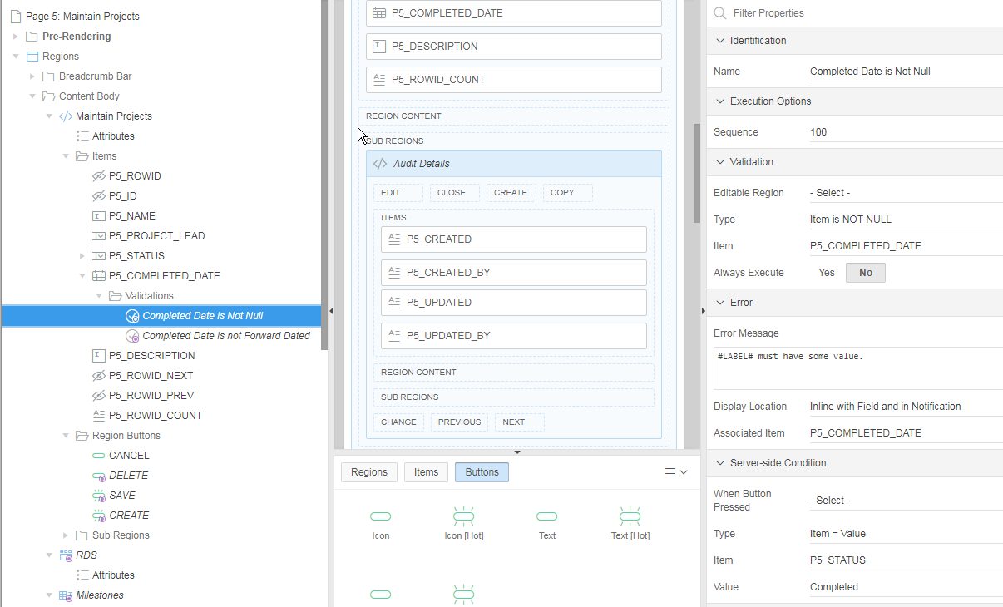
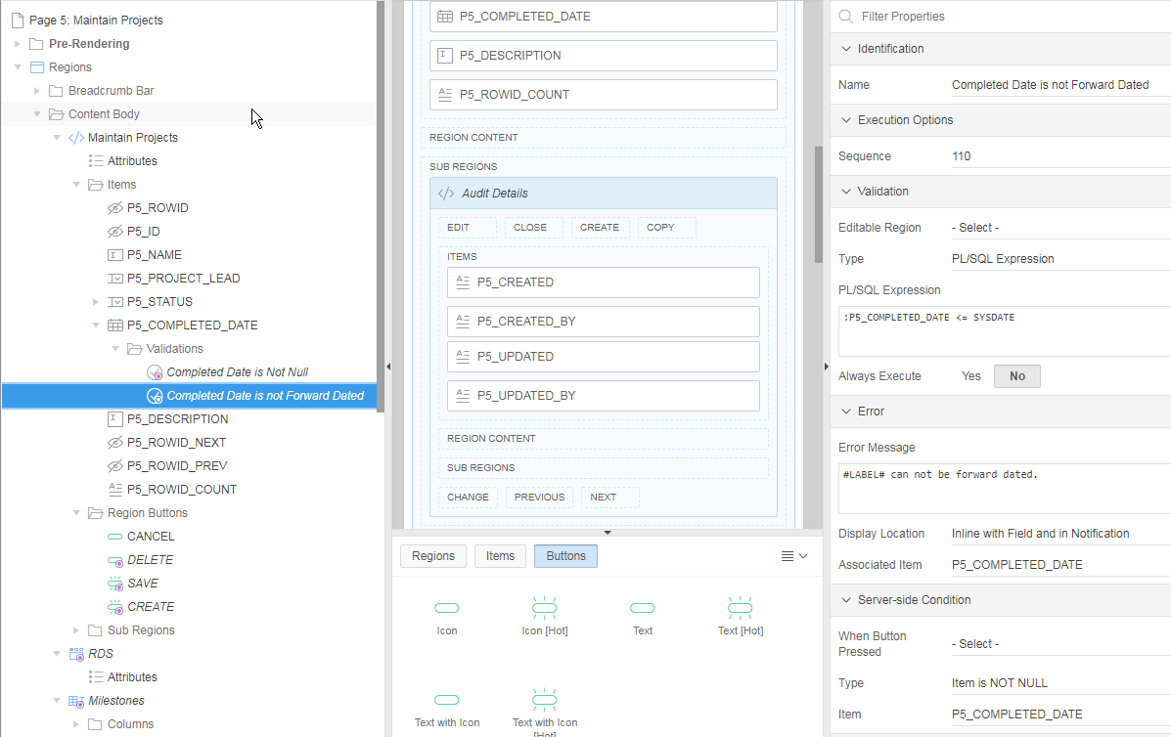
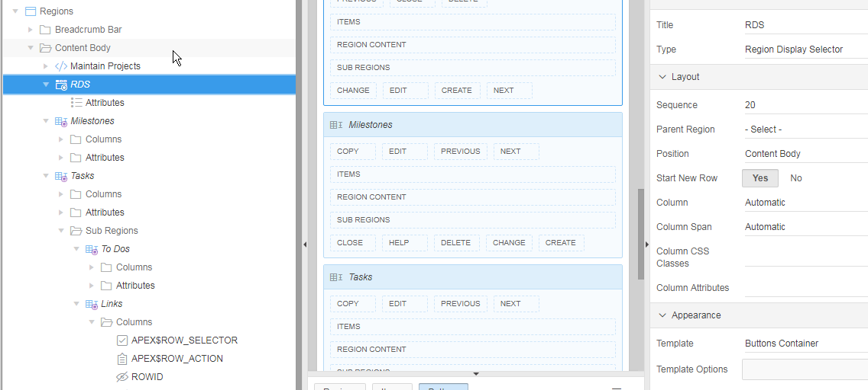
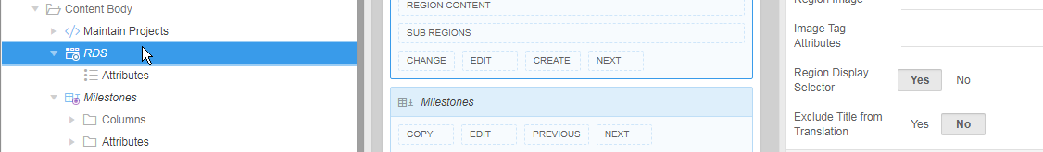
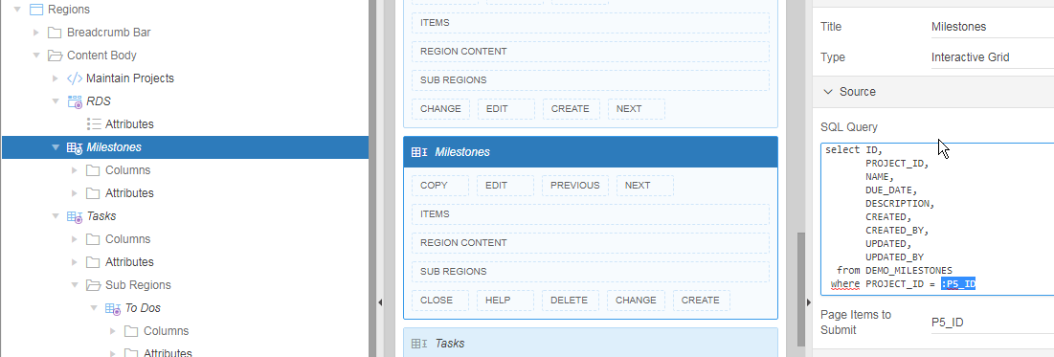
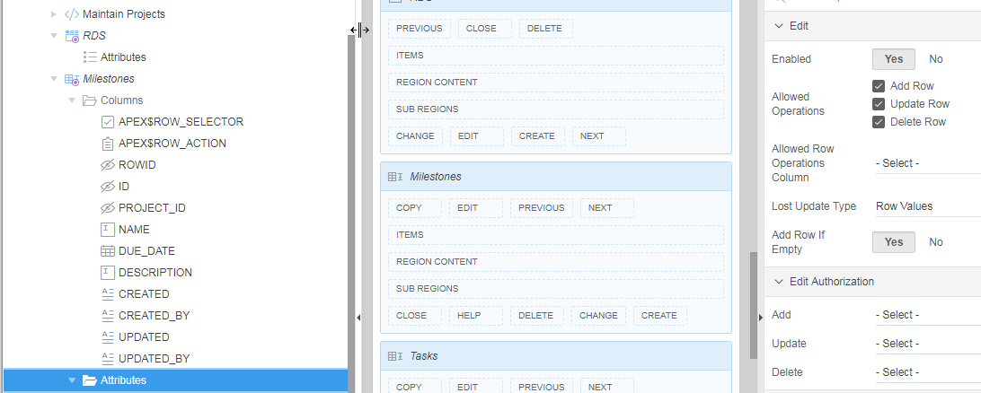
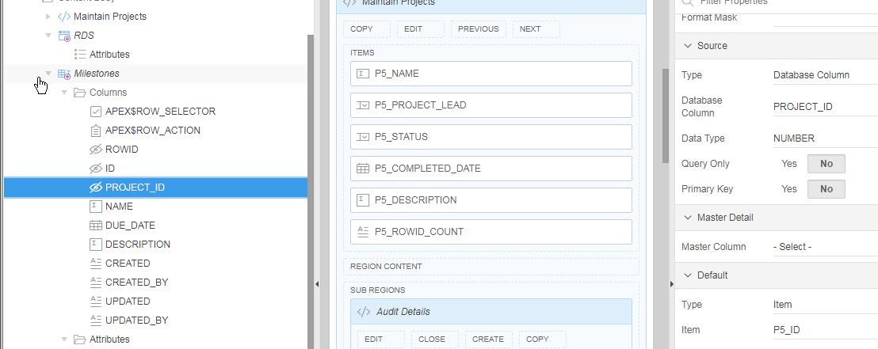
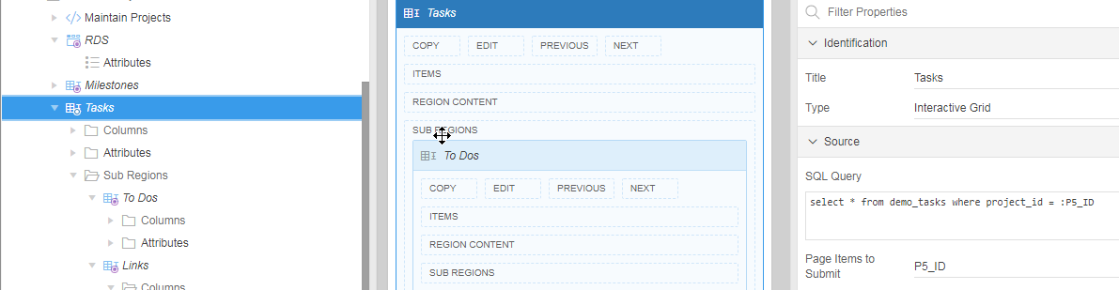
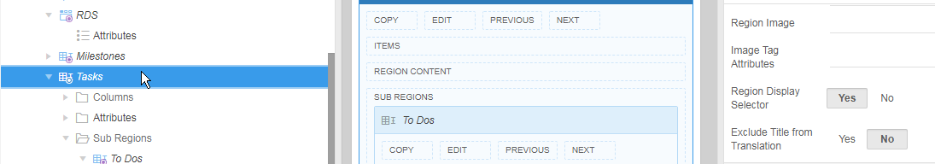
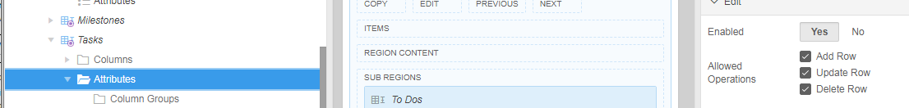
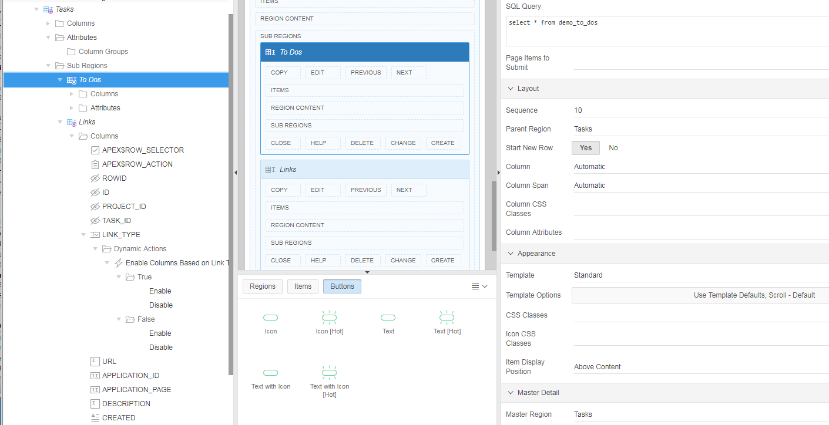
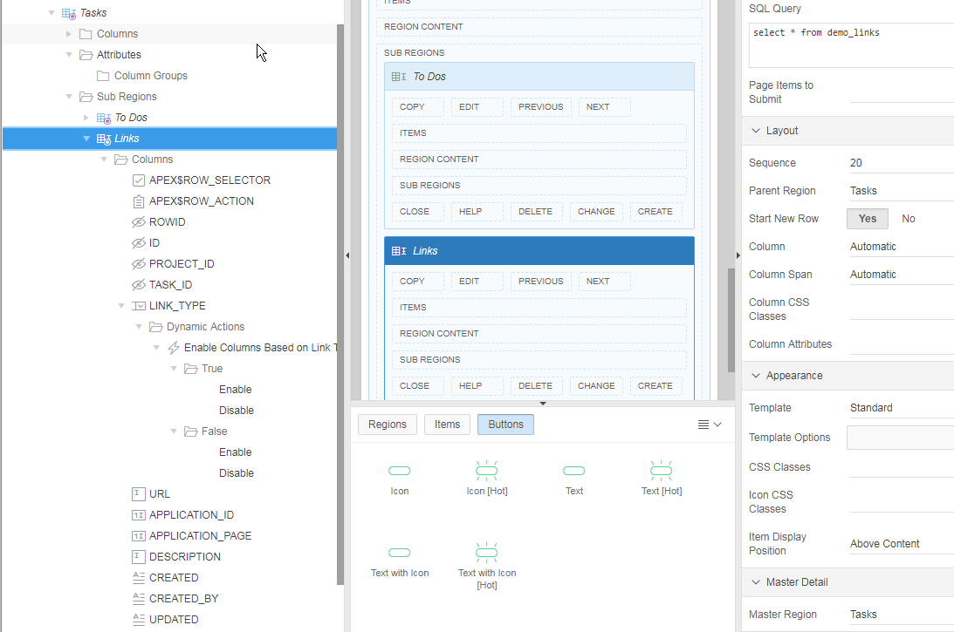
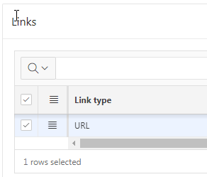
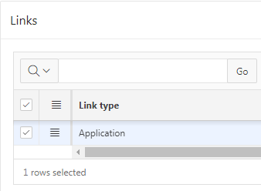
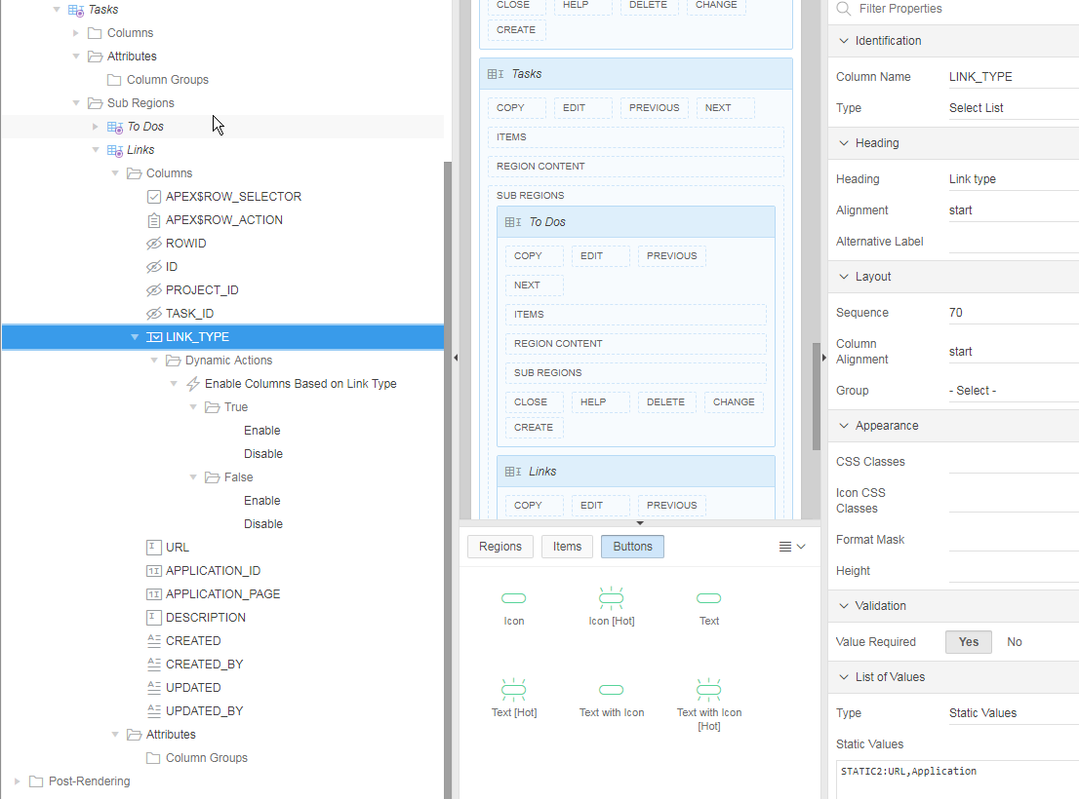
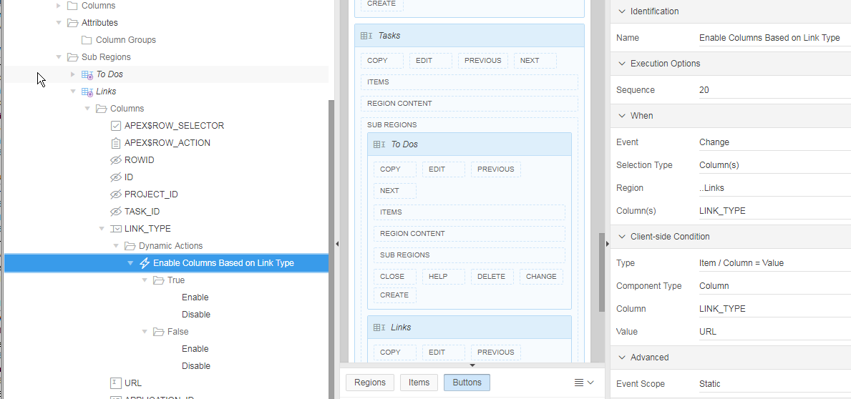
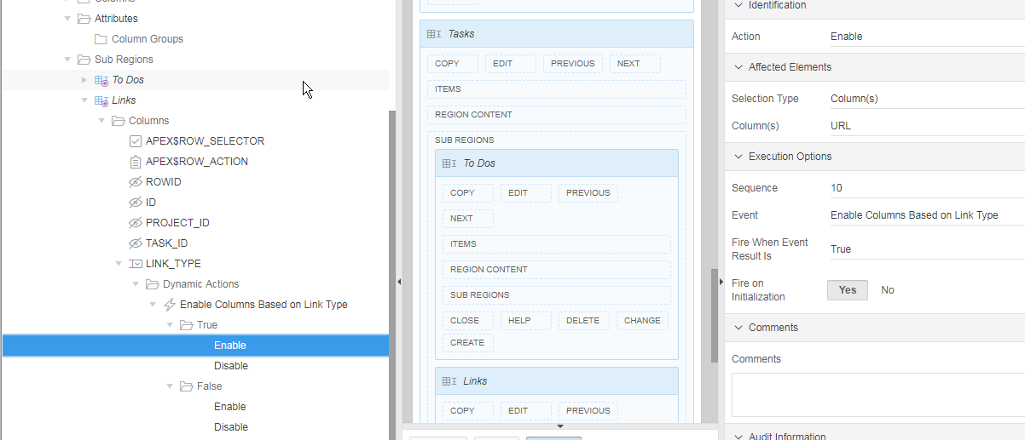
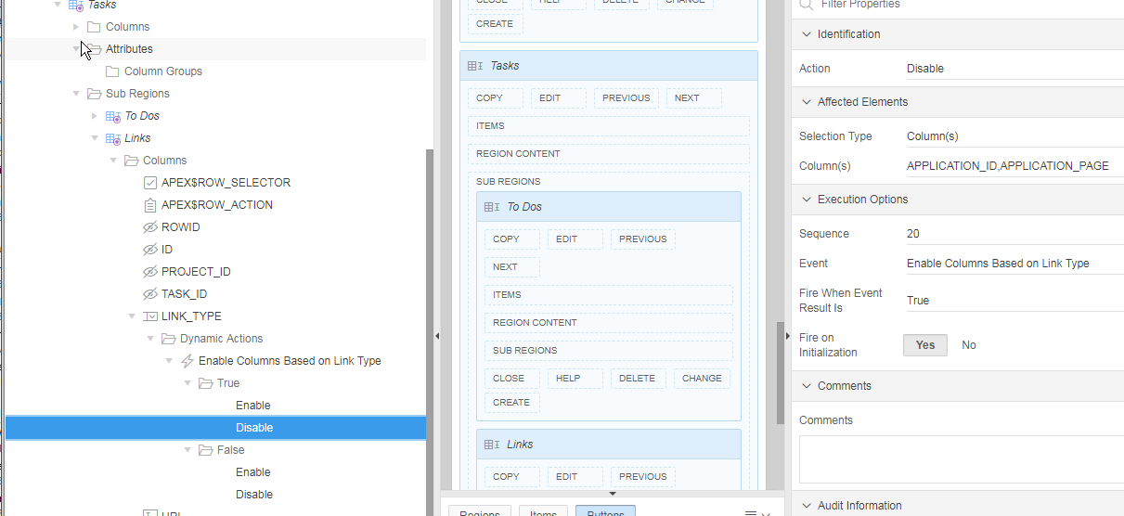
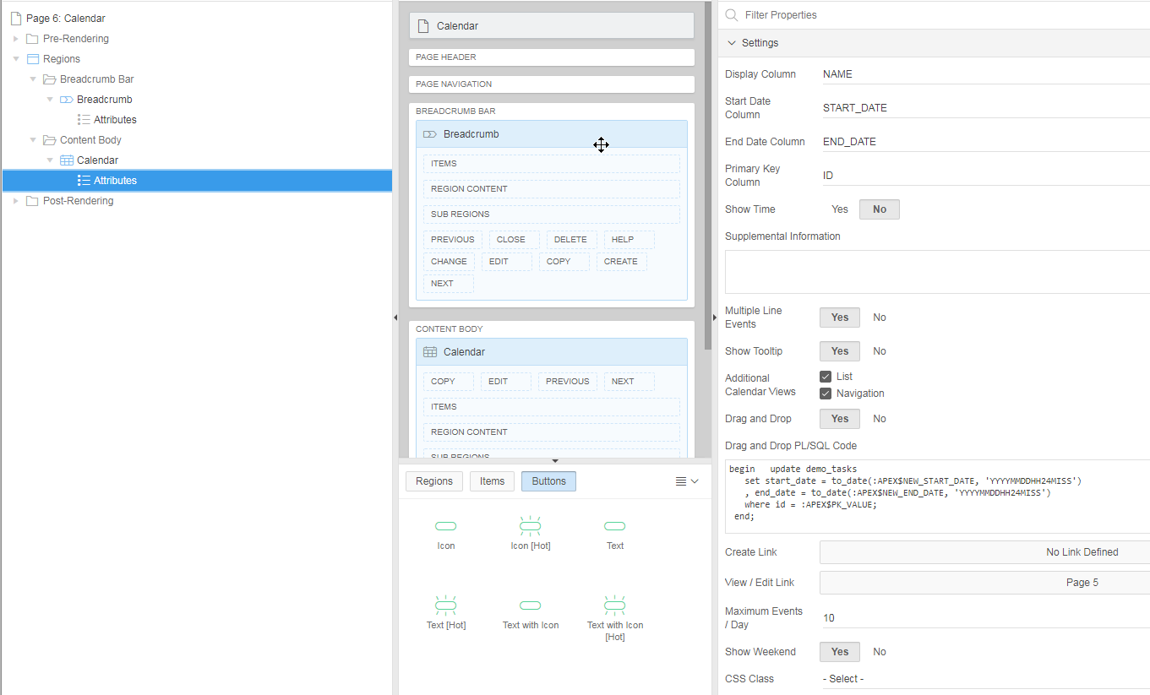

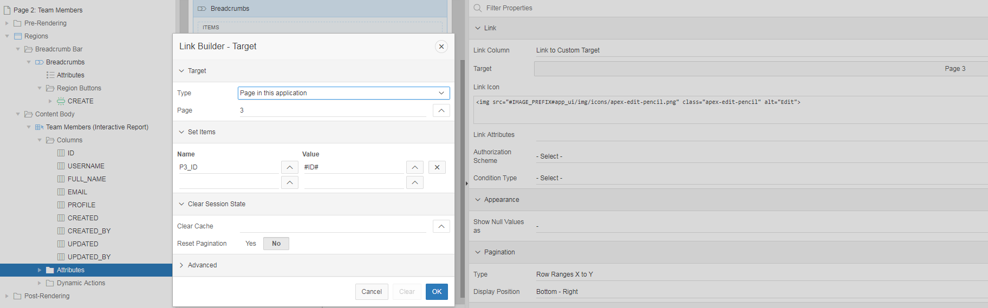

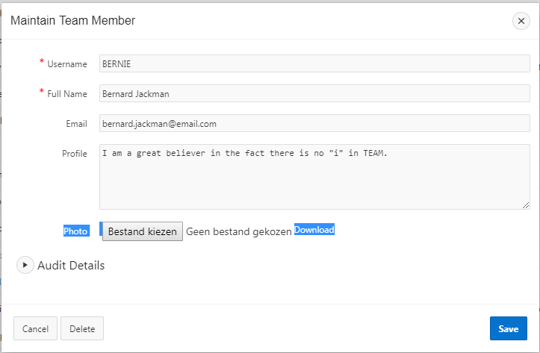

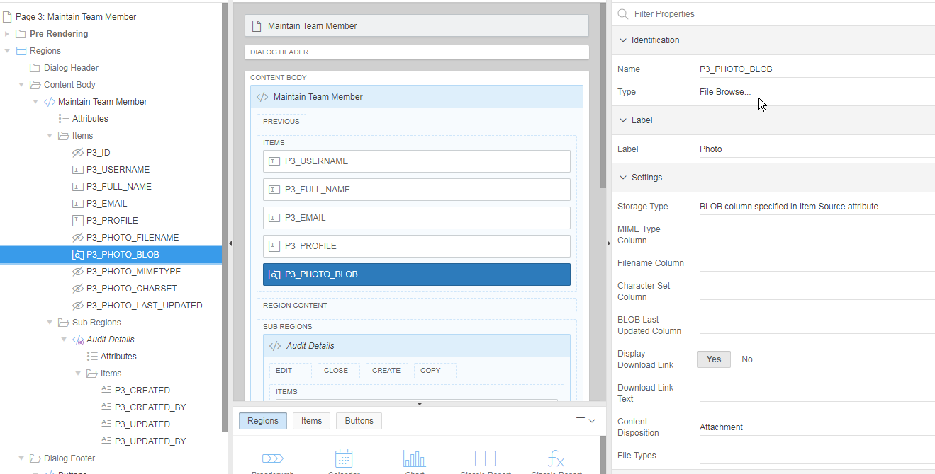

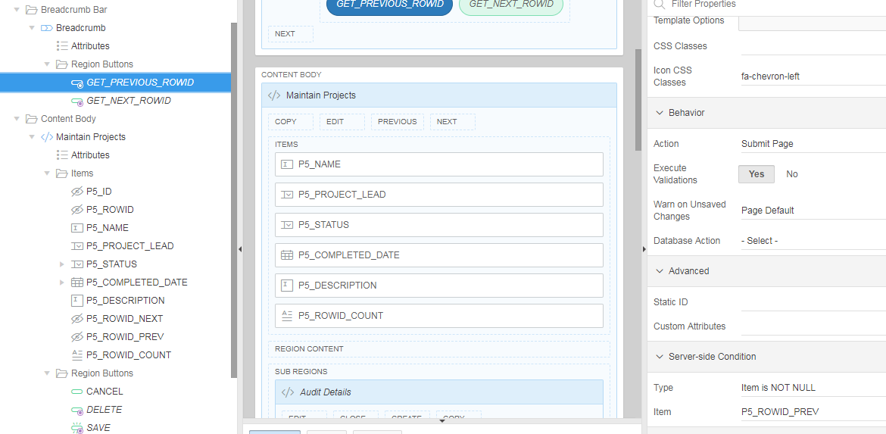

DEMO PROJECTS ADVANCED (APEX 5.0 TUTORIAL)

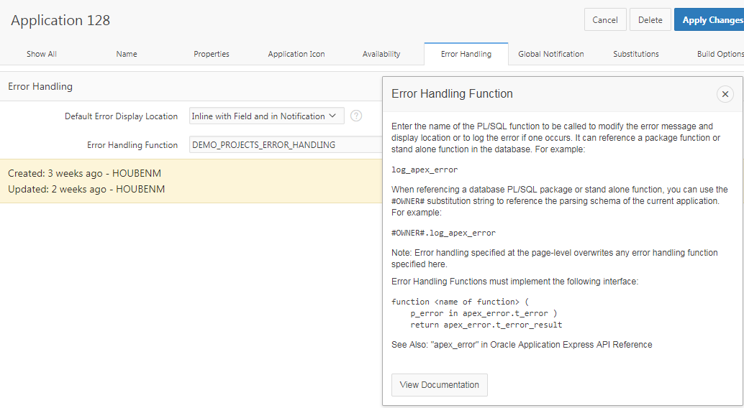

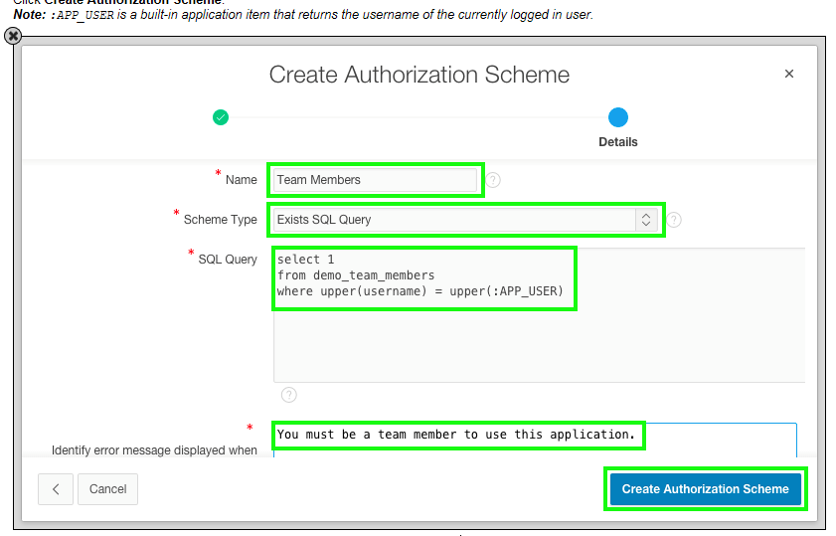

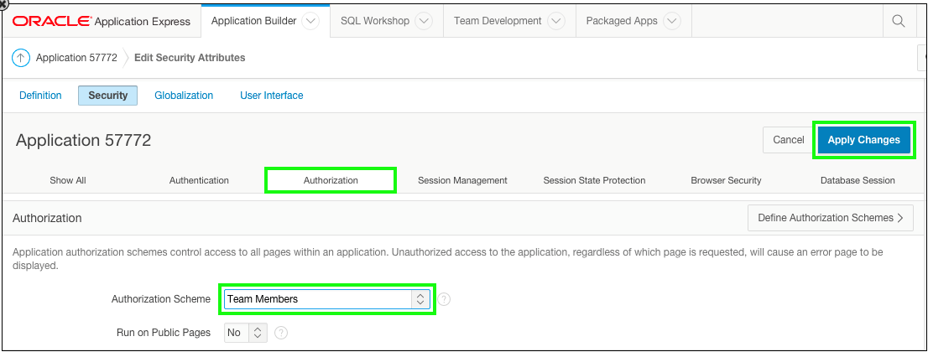

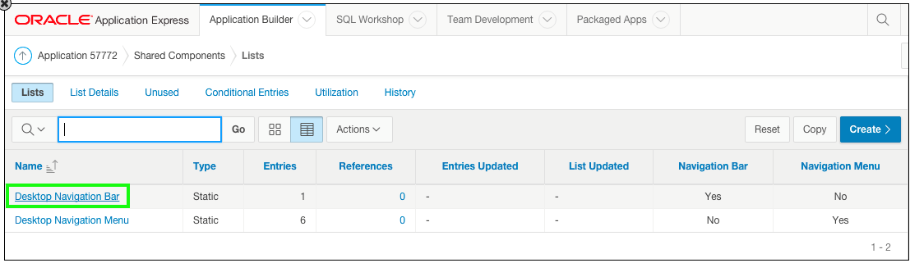

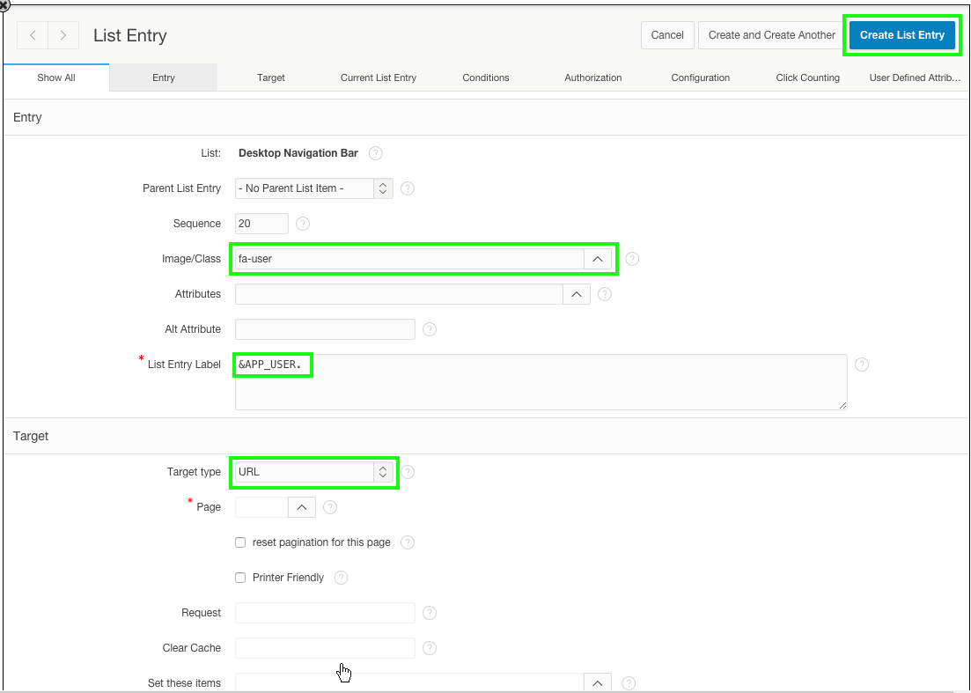
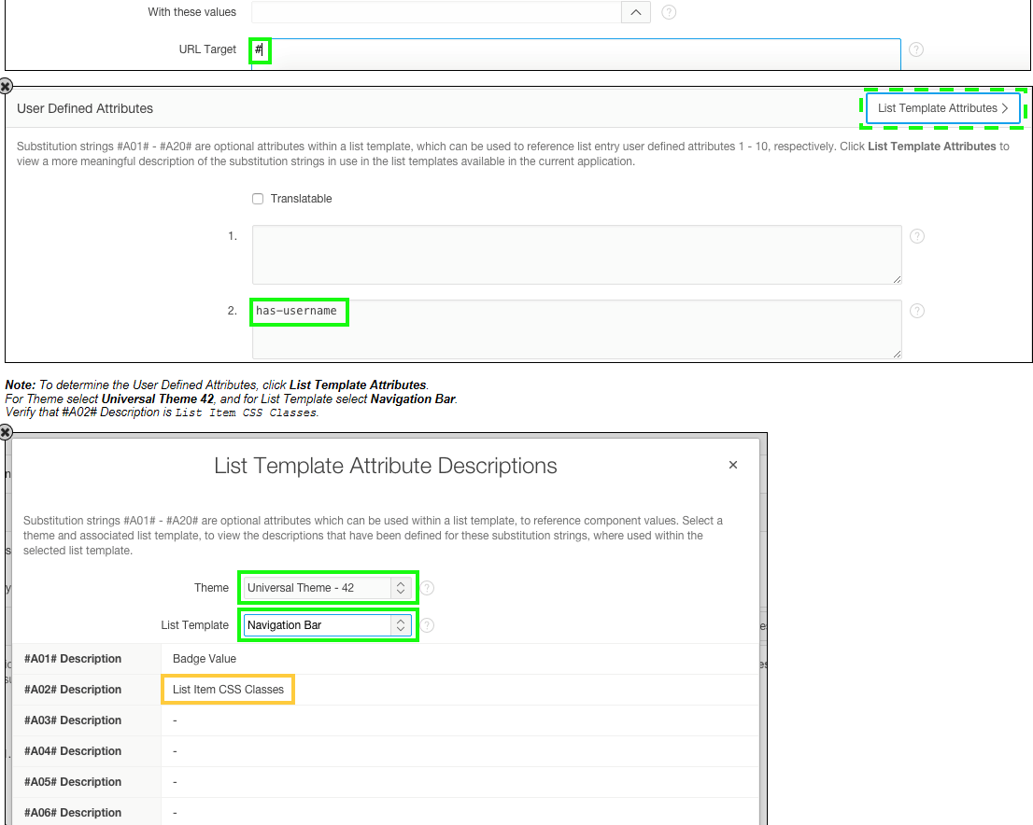
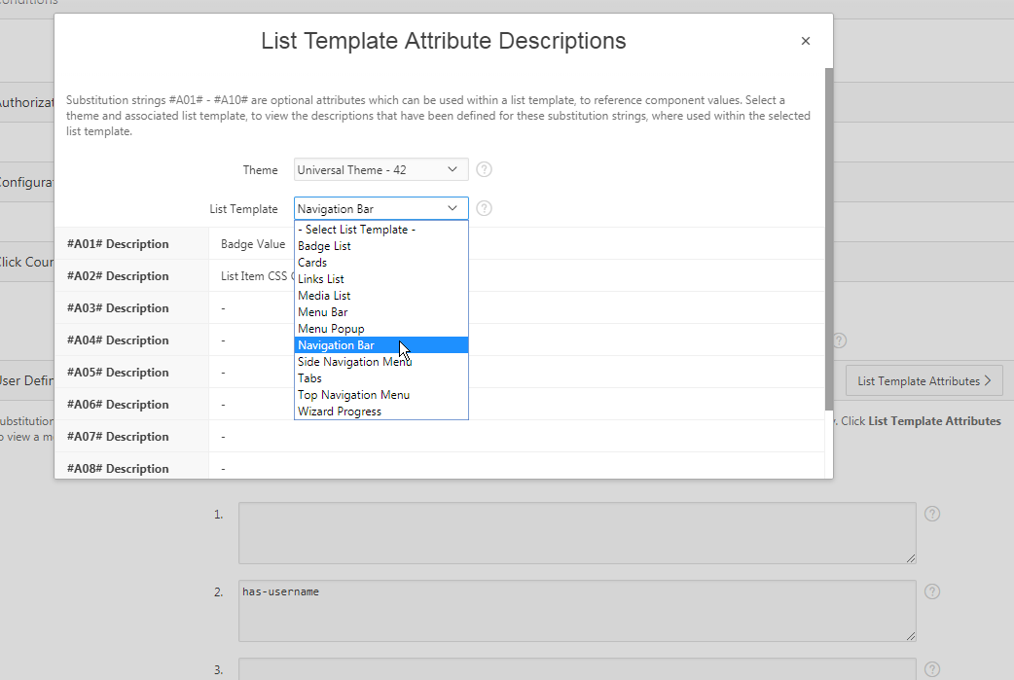

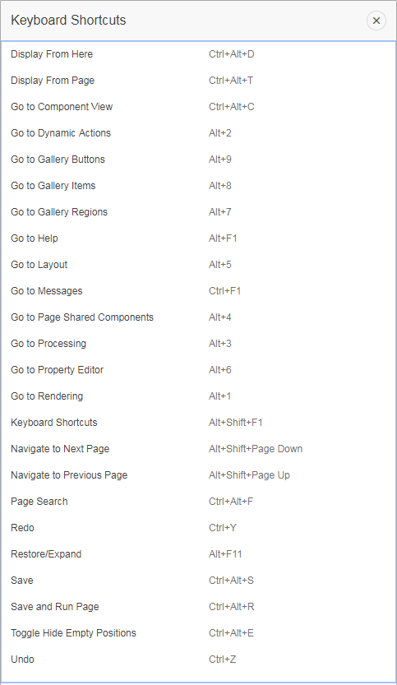

The value of APP_USER (using :APP_USER or v('APP_USER')).

:APP_ID
:APP_SESSION
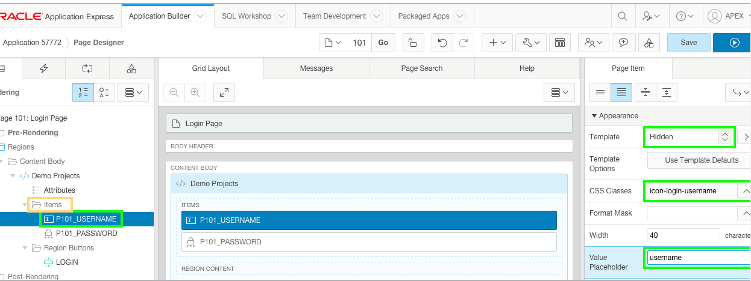

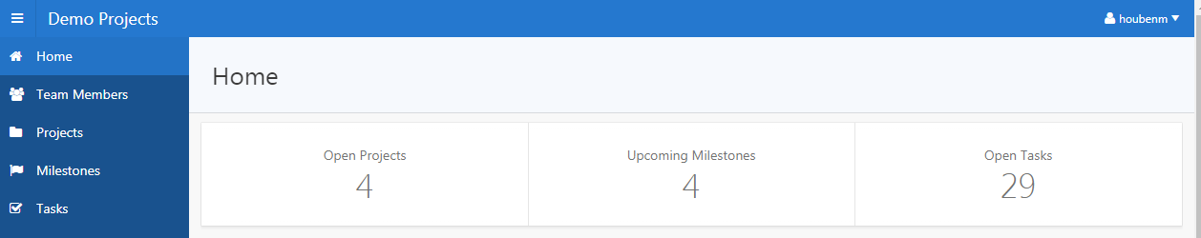

select 'Open Projects' label
, count(*) value
, 'f?p='||:APP_ID||':4:'||:APP_SESSION||':::::' link
from demo_projects
where status != 'Completed'
UNION ALL
select 'Upcoming Milestones' label
, count(*) value
, 'f?p='||:APP_ID||':4:'||:APP_SESSION||':::::' link
from demo_milestones
where due_date > sysdate
UNION ALL
select 'Open Tasks' label
, count(*) value
, 'f?p='||:APP_ID||':4:'||:APP_SESSION||':::::' link
from demo_tasks
where is_complete_yn = 'N'

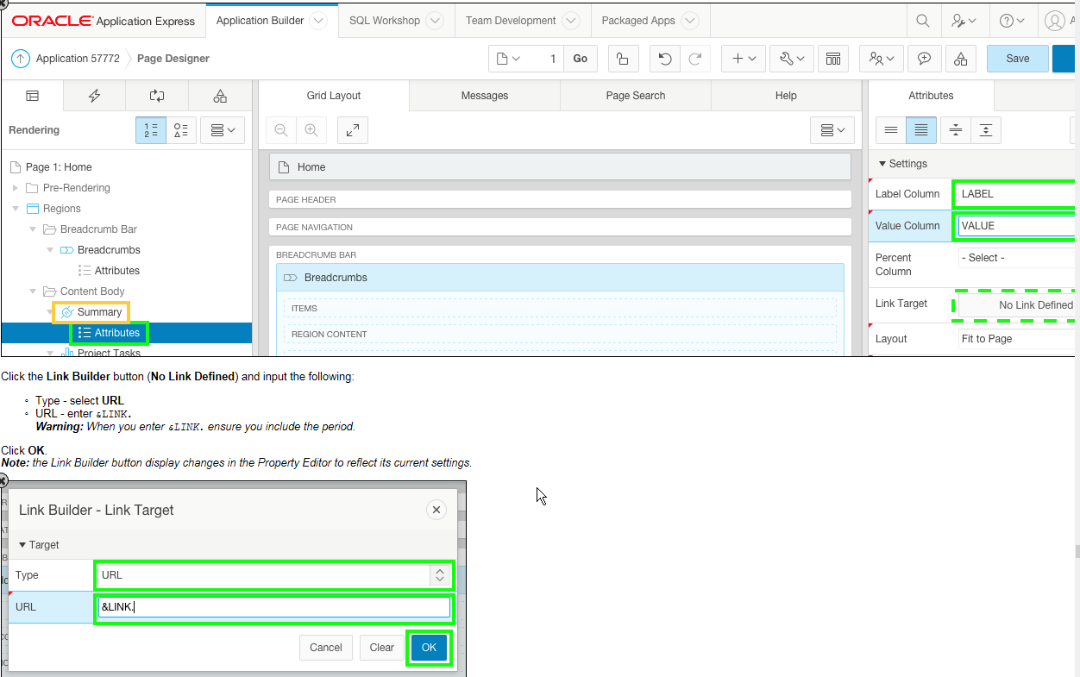

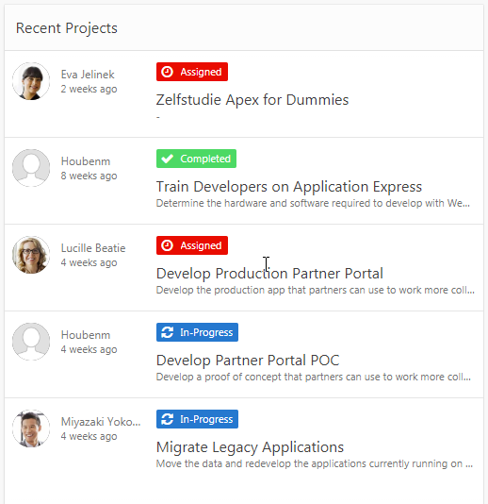

select p.id project_id
, t.id
, null event_modifiers
, null event_attributes
, null user_color
, dbms_lob.getlength('PHOTO_BLOB') user_avatar
, t.full_name user_name
, nvl(p.completed_date, p.updated) event_date
, (case p.status
when 'Assigned' then 'is-removed'
when 'In-Progress' then 'is-updated'
when 'Completed' then 'is-new'
end) event_status
, p.status event_type
, (case p.status
when 'Assigned' then 'fa fa-clock-o'
when 'In-Progress' then 'fa fa-refresh'
when 'Completed' then 'fa fa-check'
end) event_icon
, p.name event_title
, p.description event_desc
from demo_projects p
, demo_team_members t
where p.project_lead = t.id
order by p.updated desc

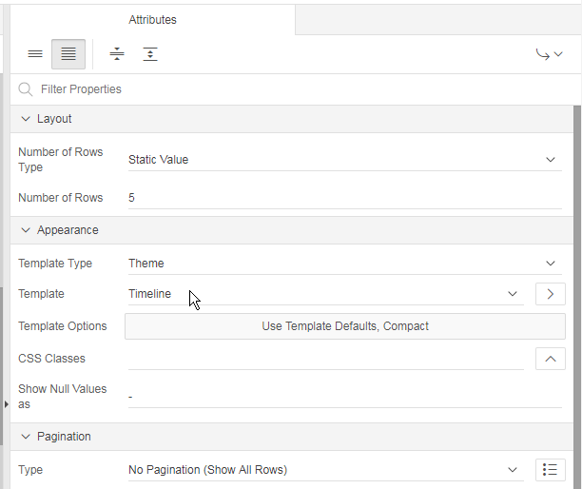

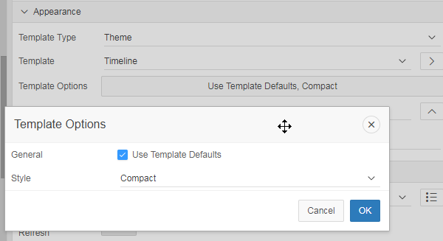

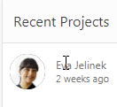

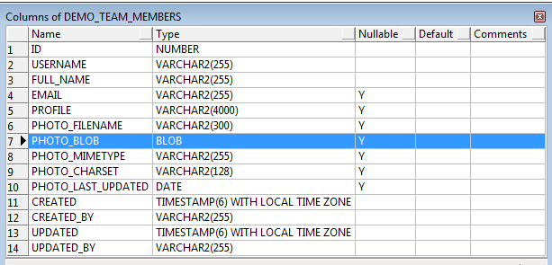

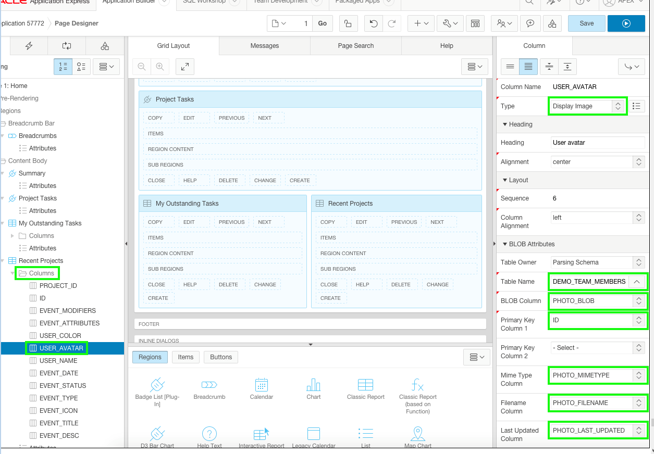

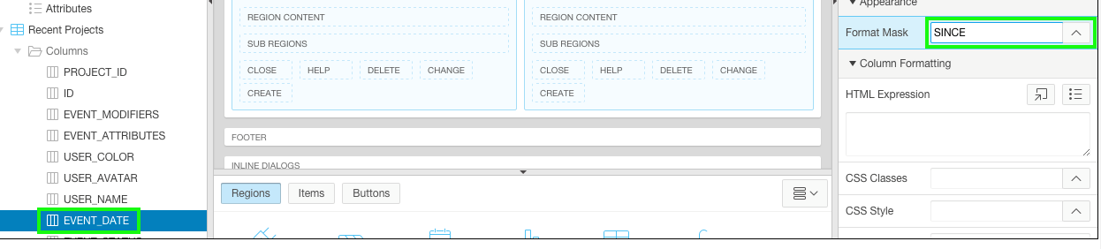

.t-Card-icon img {
width: 48px;
height: 48px;
}

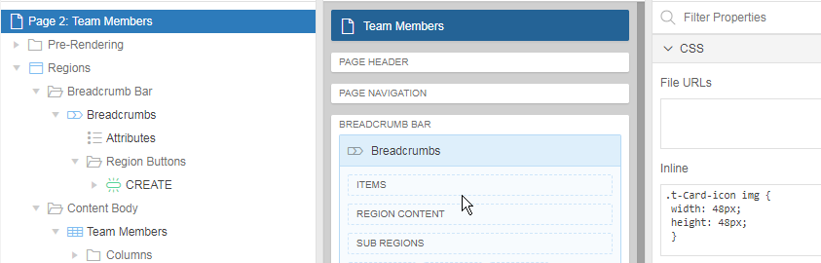

select id
, full_name card_title
, profile card_text
, nvl(email,' ') card_subtext
, dbms_lob.getlength('PHOTO_BLOB') card_initials
, apex_util.prepare_url('f?p='||:APP_ID||':3:'||:APP_SESSION||'::::P3_ID:'||id) card_link
, photo_filename
, photo_mimetype
, photo_charset
, photo_last_updated
from demo_team_members
order by created
Note: This SQL query uses specific column names, such as card_title, which correspond to the columns required for the Card template.

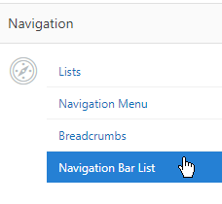
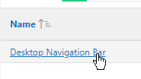
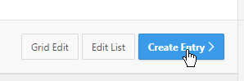

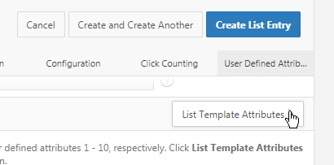

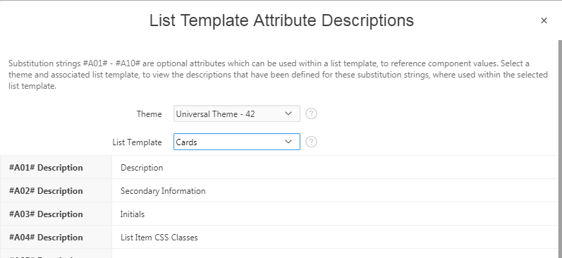

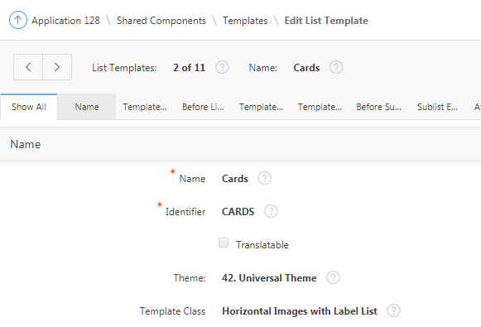

Punt 6 : Updating the Project Pages

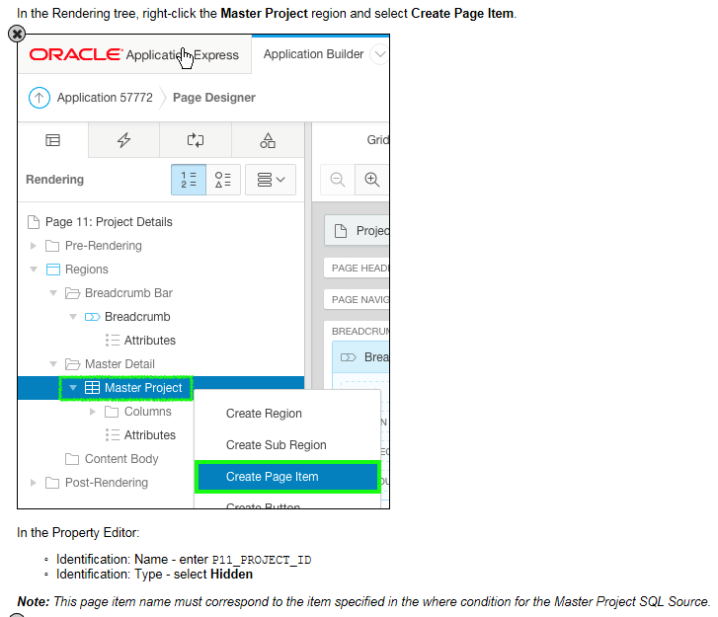

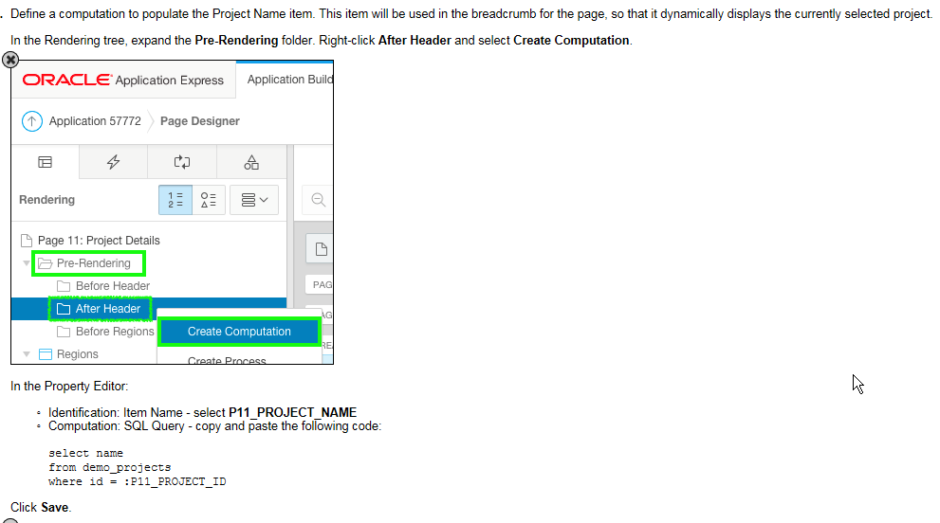

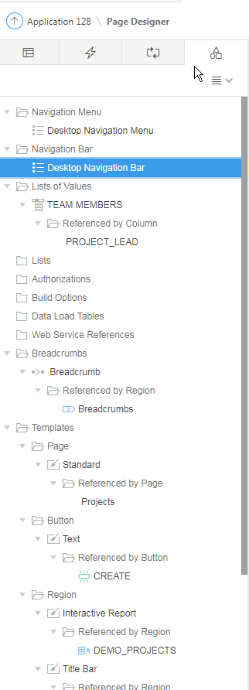

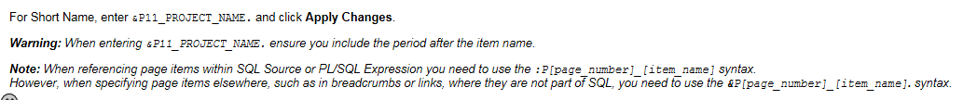

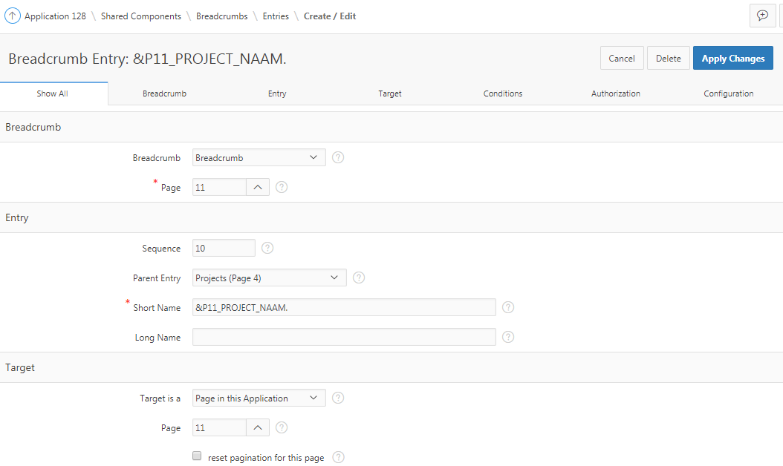

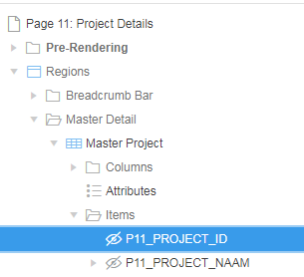

Op pagina 4 wordt P11_PROJECT_ID gevuld met het ID van DEMO_PROJECTS

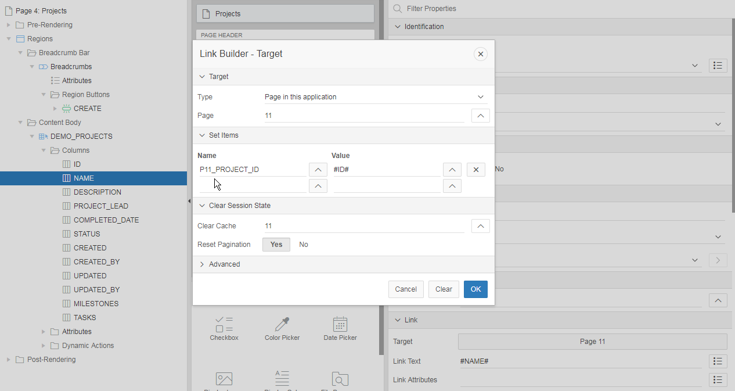

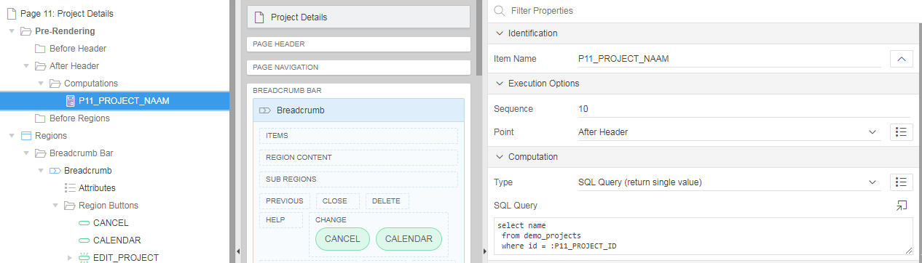

fa-chevron-left
fa-calendar
fa-plus
fa-chevron-right

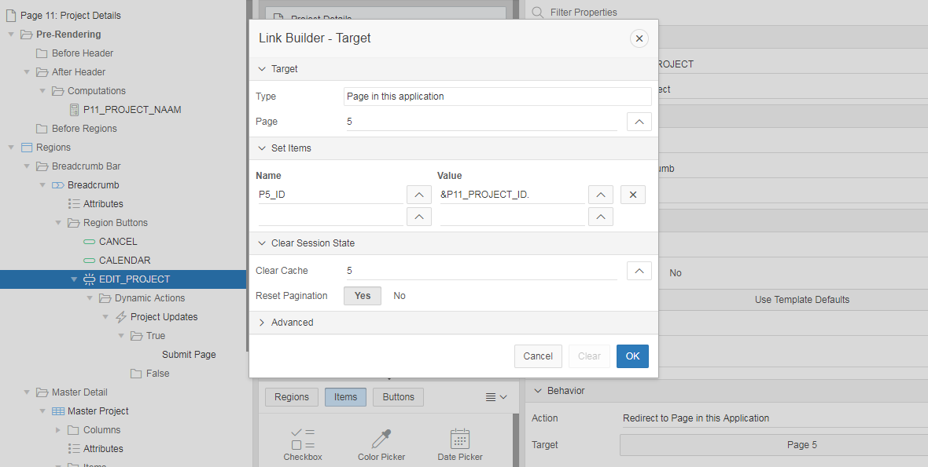

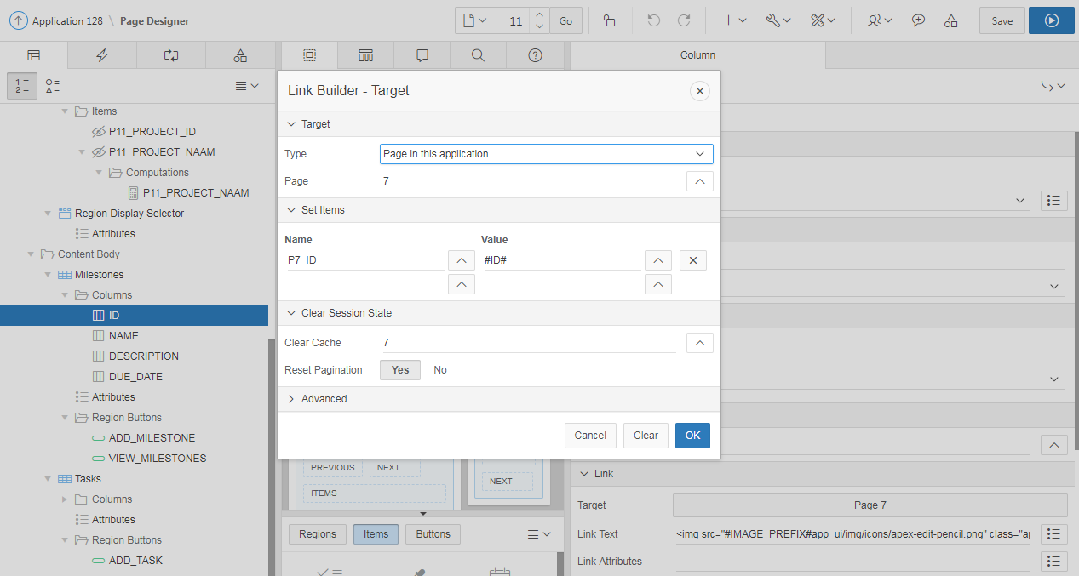
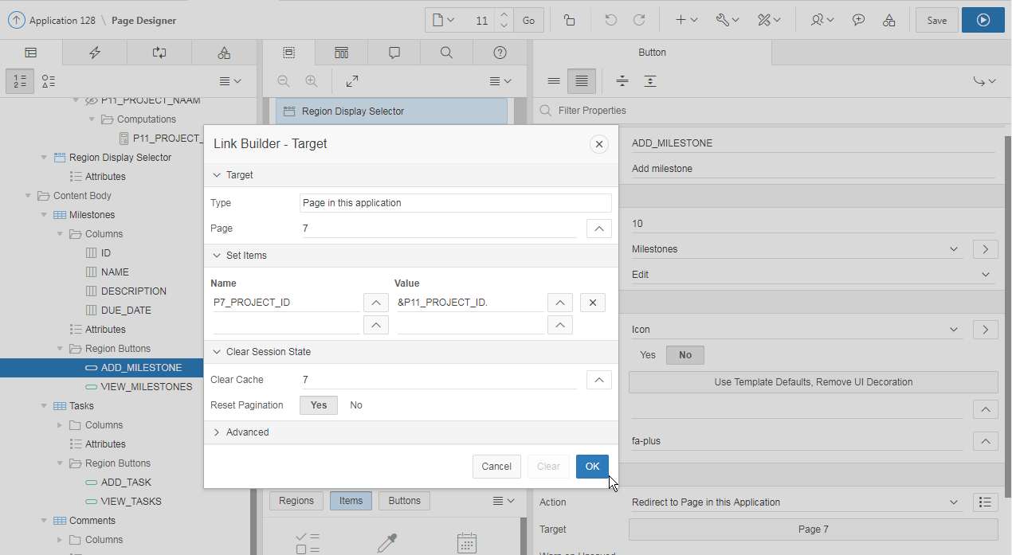

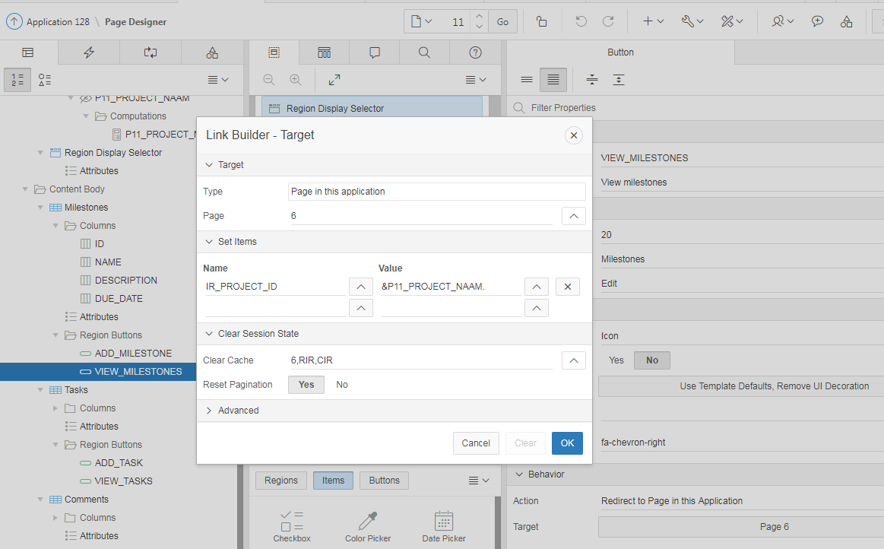

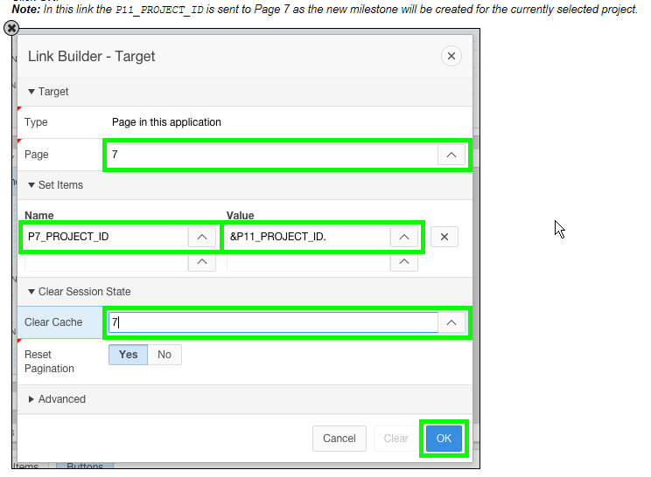

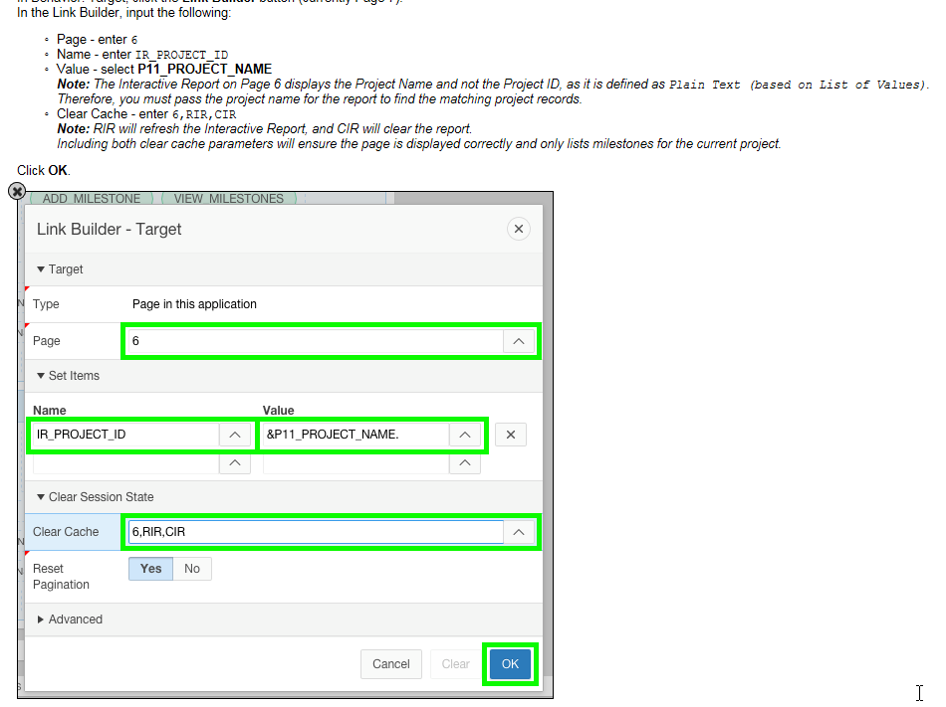

Pagina 11 : Tasks

select t.id
, t.name
, t.description
, decode(nvl(t.is_complete_yn,'N'),
'N','<span class="u-VisuallyHidden">No</span>',
'Y','<span class="fa fa-check"><span class="u-VisuallyHidden">Yes</span></span>'
) completed
, (select m.name from demo_milestones m where m.id = t.milestone_id) milestone
, (select tm.full_name from demo_team_members tm where tm.id = t.assignee) assignee
, t.start_date
, t.end_date
from demo_tasks t
where t.project_id = :P11_PROJECT_ID
order by nvl(t.end_date, sysdate) desc

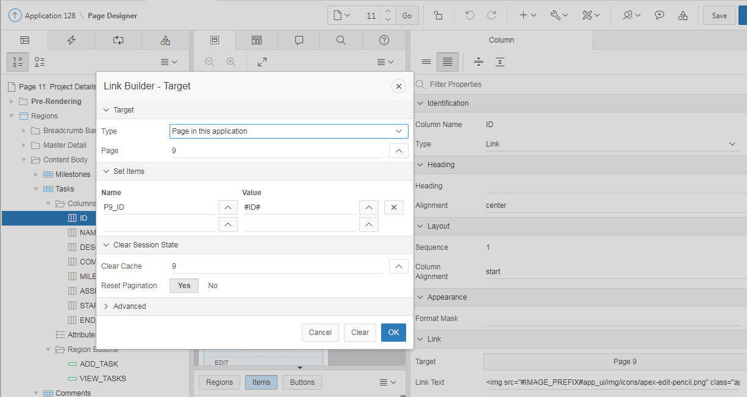

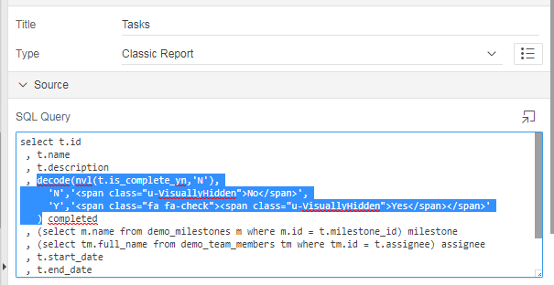

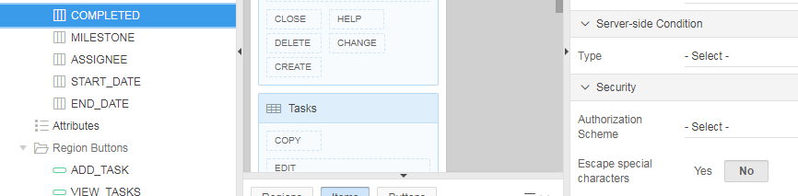

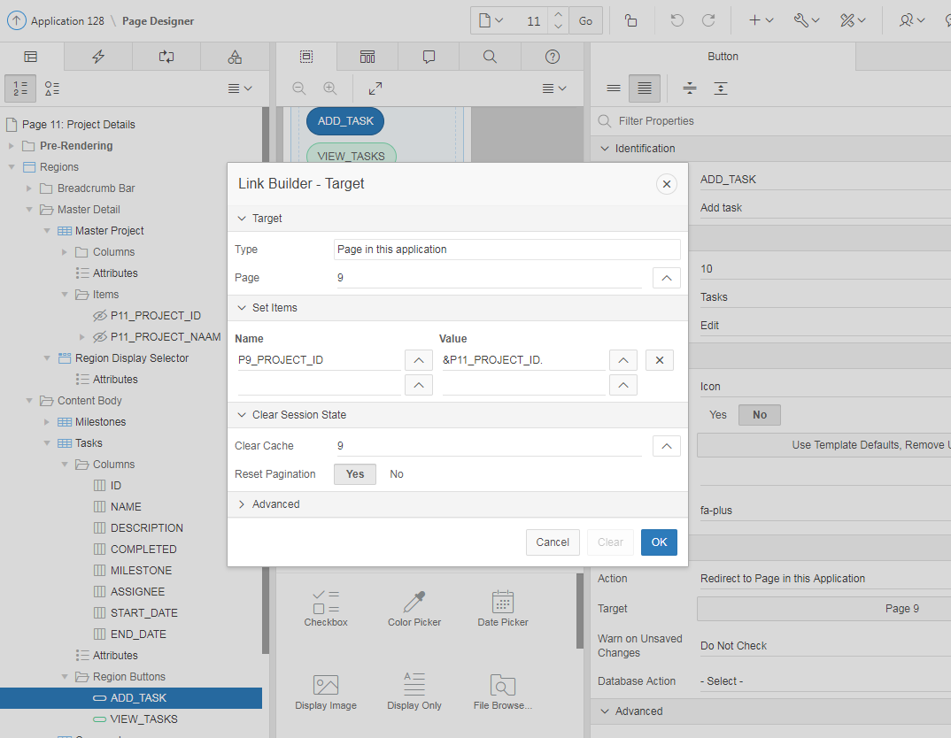

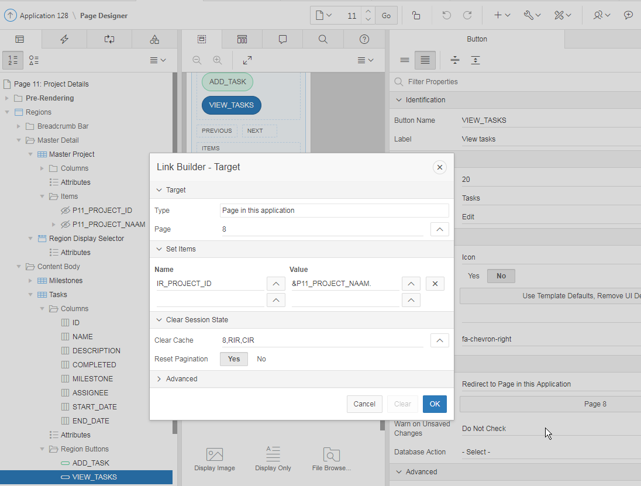

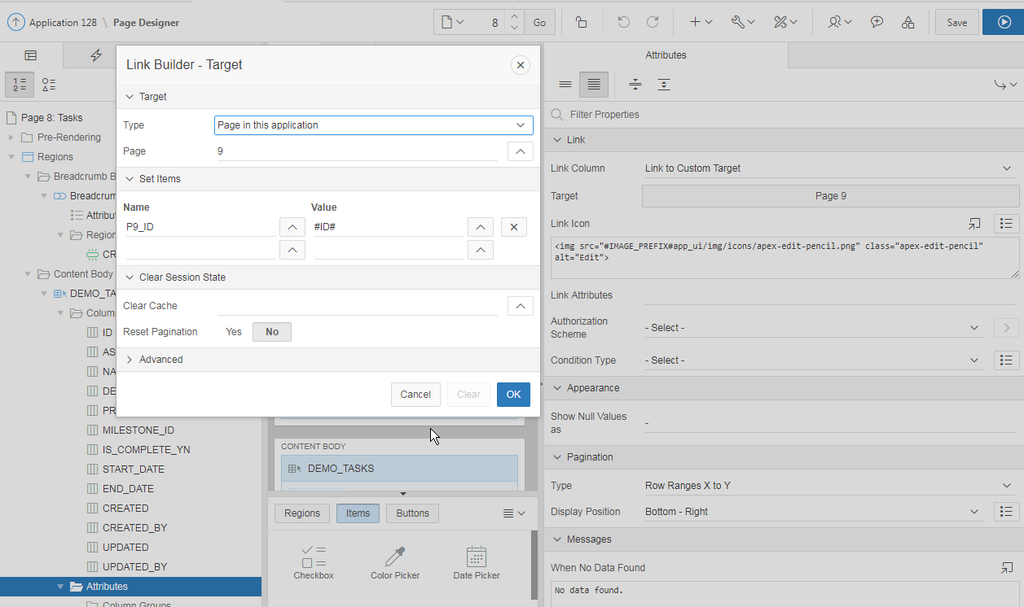

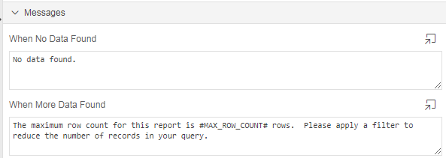

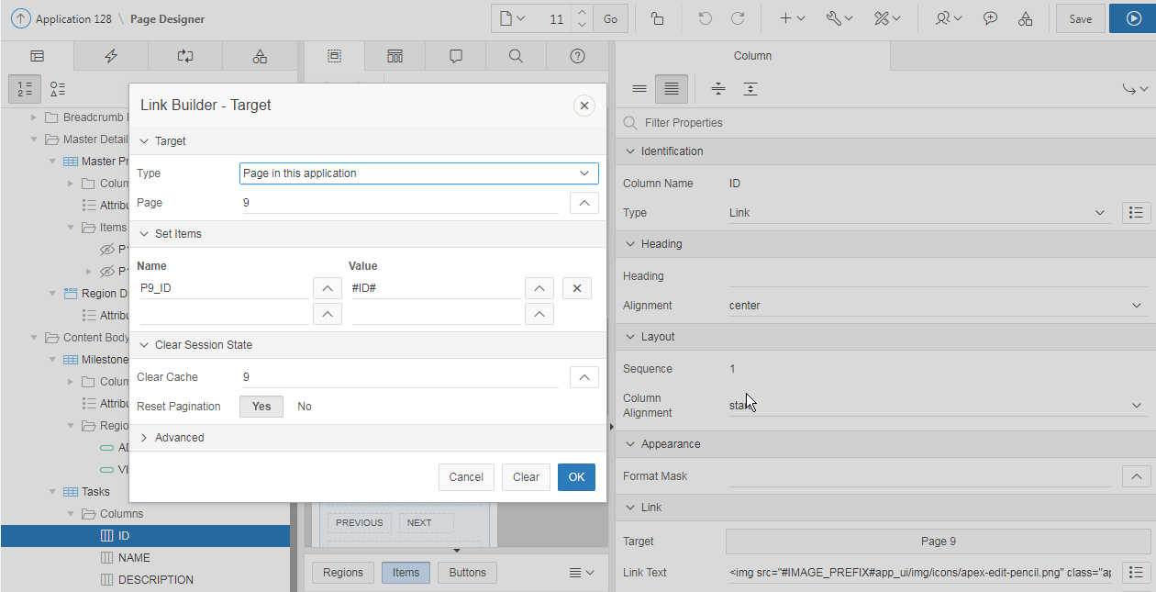

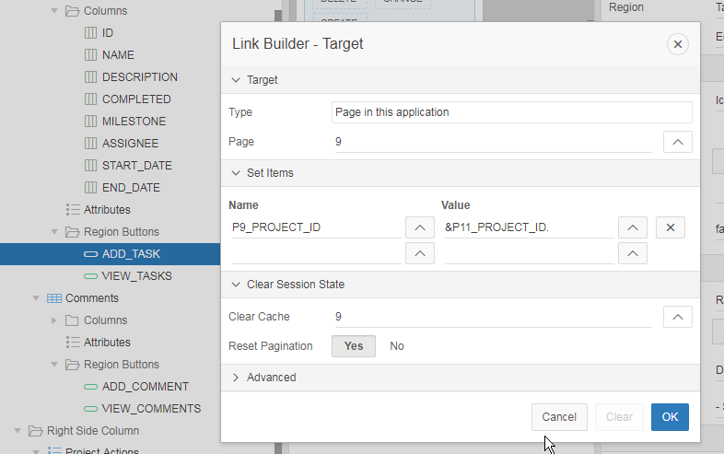

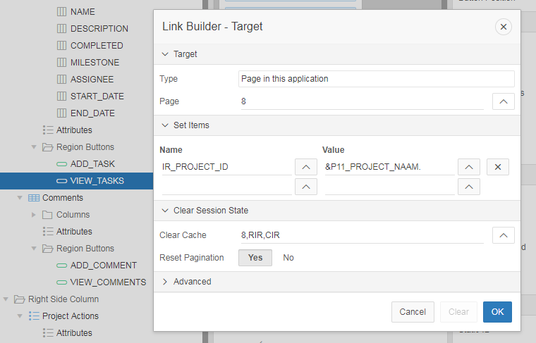

select tm.id id
, c.id comment_id
, ' ' icon_modifier
, c.comment_text
, c.created comment_date
, dbms_lob.getlength(tm.photo_blob) user_icon
, tm.full_name user_name
, null actions
, null attribute_1
, null attribute_2
, null attribute_3
, null attribute_4
from demo_team_members tm
, demo_project_comments c
where c.project_id = :P11_PROJECT_ID
and upper(c.created_by) = upper(tm.username)
order by c.created desc

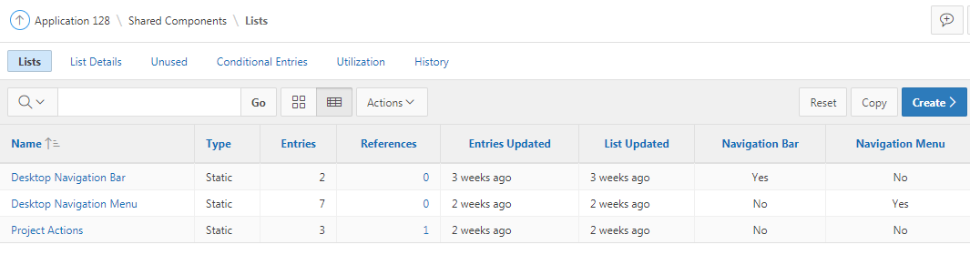

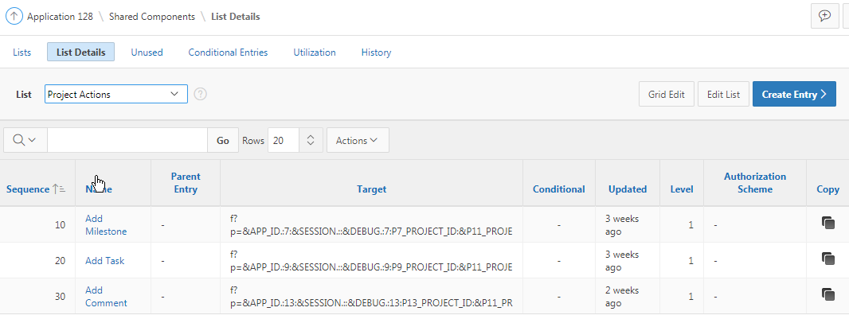

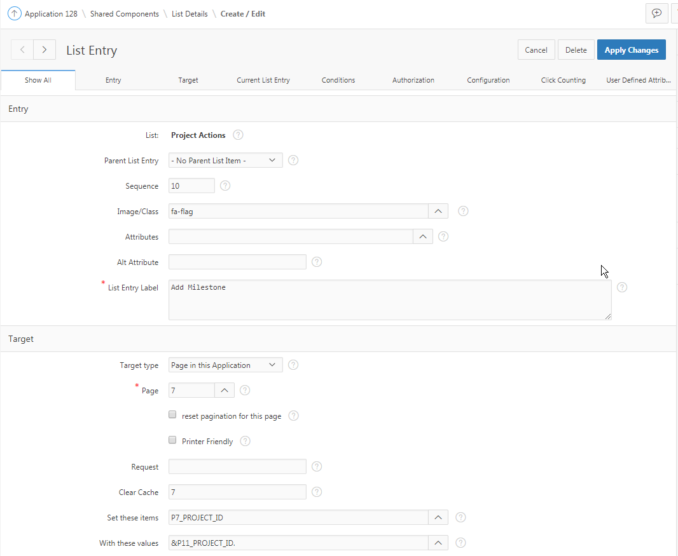

fa-flag
fa-check-square-o
fa-comment

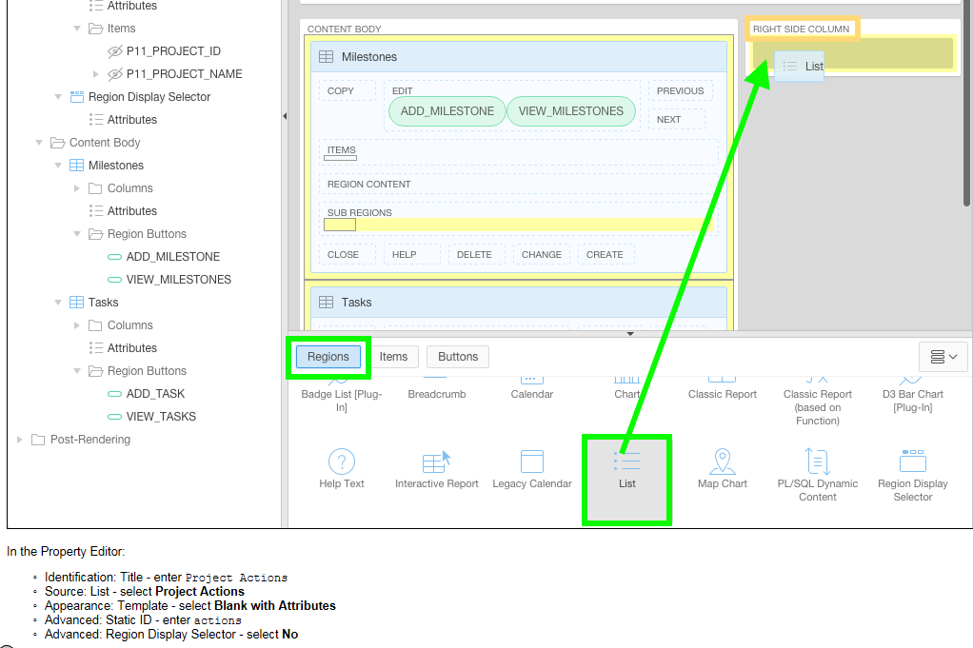

&nbsp;
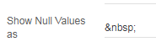

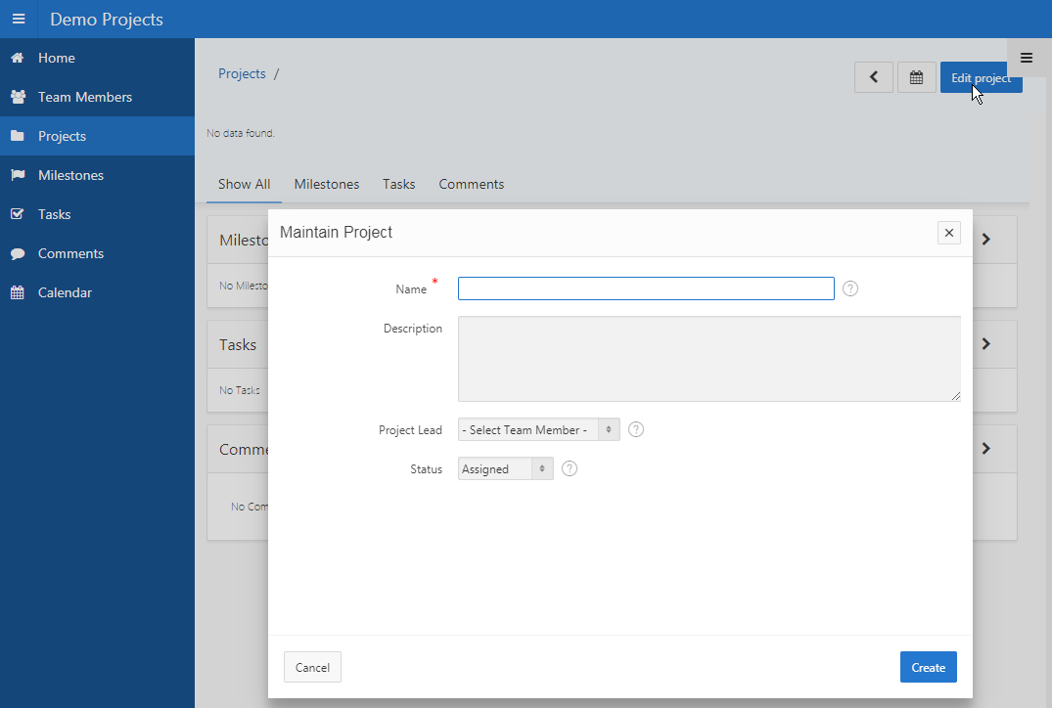

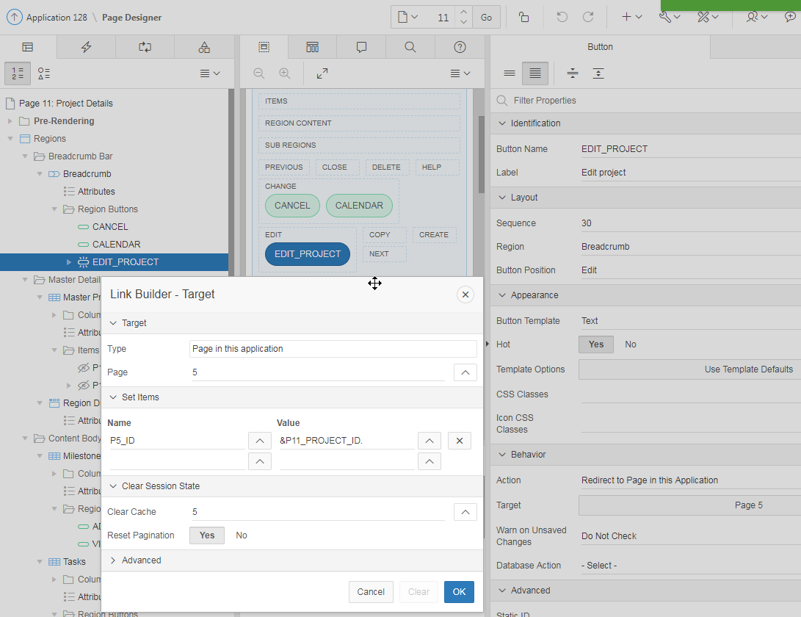

Punt 7 : Adding Dynamic Actions

Adding Dynamic Actions to the page will ensure changes made on modal pages are reflected on the page, as soon as the modal page is closed.

Furthermore, Maintain Task (Page 9) needs to have navigation improved to return to the page it was called from. One alternative is to define a hidden item on the page and populate that item with the calling page. Then use the hidden item in the Cancel button and Branch processing to return to the correct page.
Instead you will convert the page to a modal page.

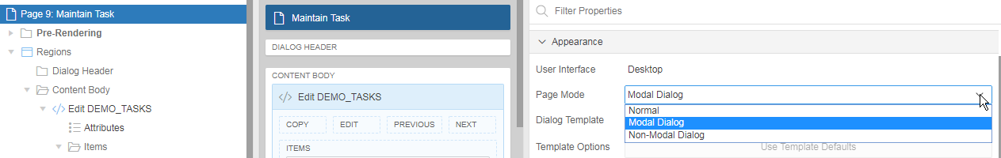

Create a buttons region in the dialog footer, so that the buttons are always dispalyed at the bottom of the modal page.

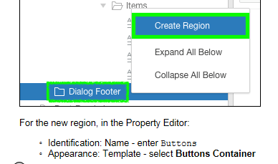

Dynamic Actions within Application Express are used to declaratively define client-side behaviors without needing to write JavaScript or AJAX. Instead the Application Express engine implements the necessary code, based on your declaration.
In the first lab you defined a dynamic action to show or hide an item based on the value of a previous item. In this topic you will create more complex dynamic actions that fire based on the Edit Project button or jQuery selectors to refresh the page or specific regions. These dynamic actions ensure that this page reflects changes made on any of the modal pages, called from this page, as soon as the user returns from the modal page.

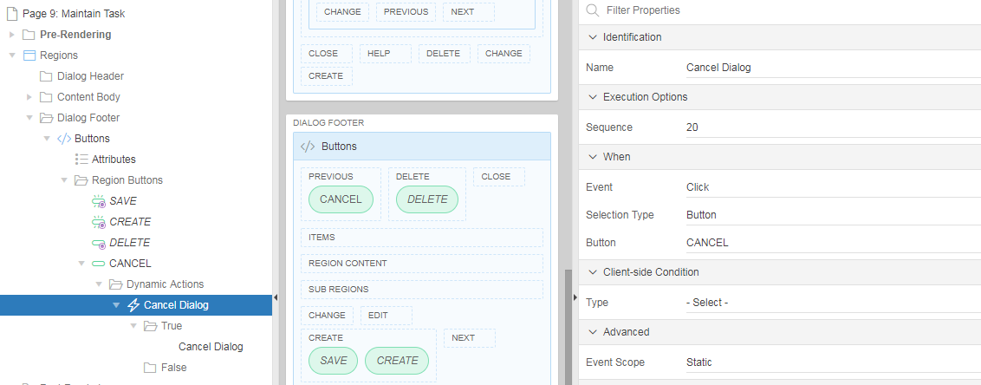

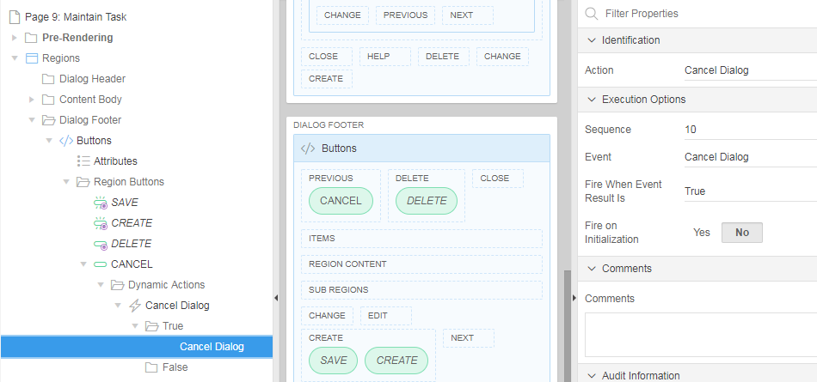

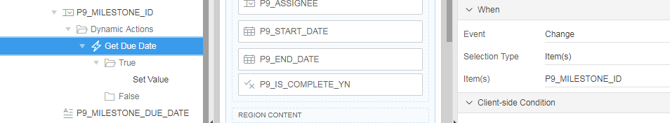

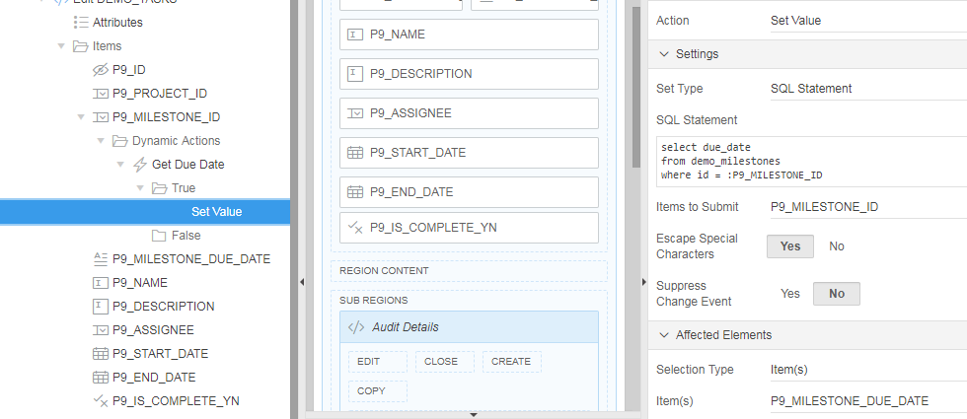

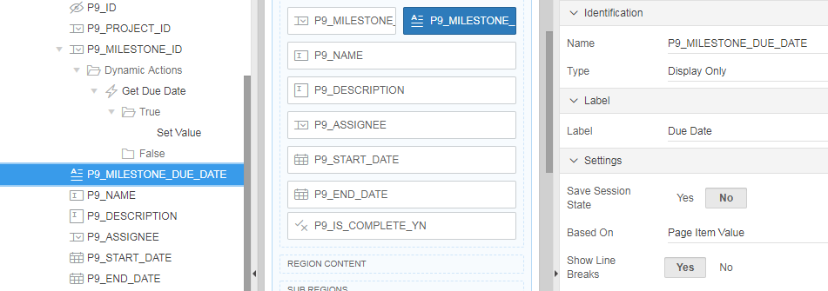

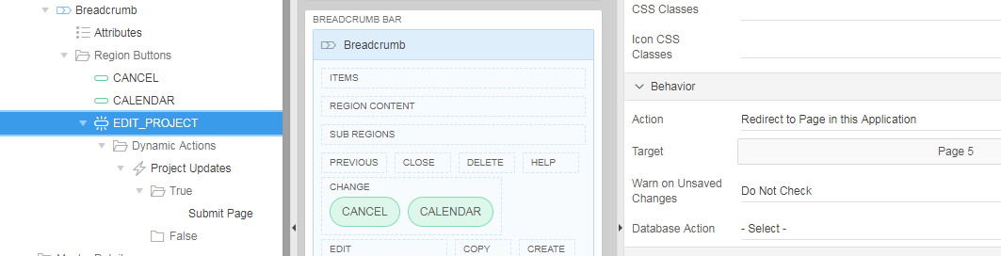

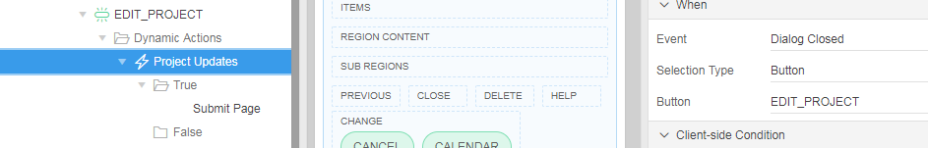

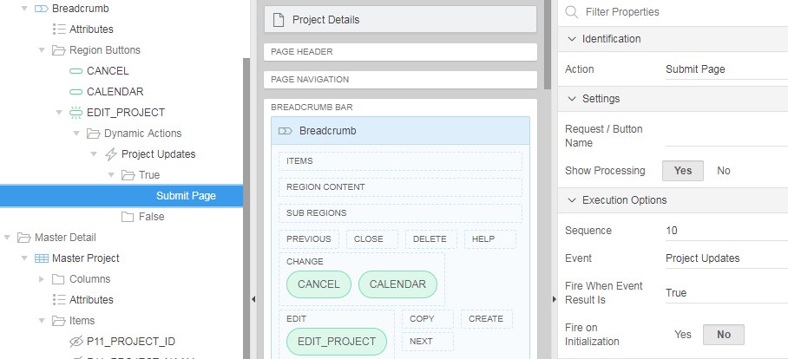

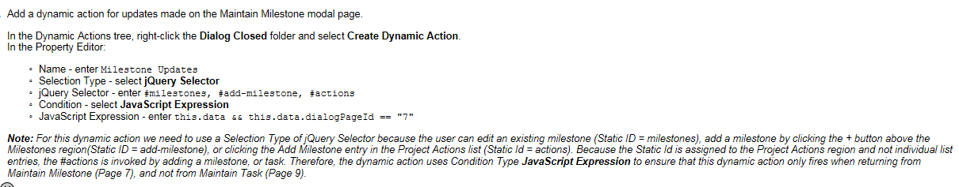

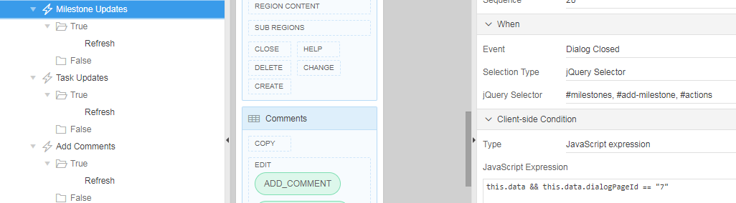

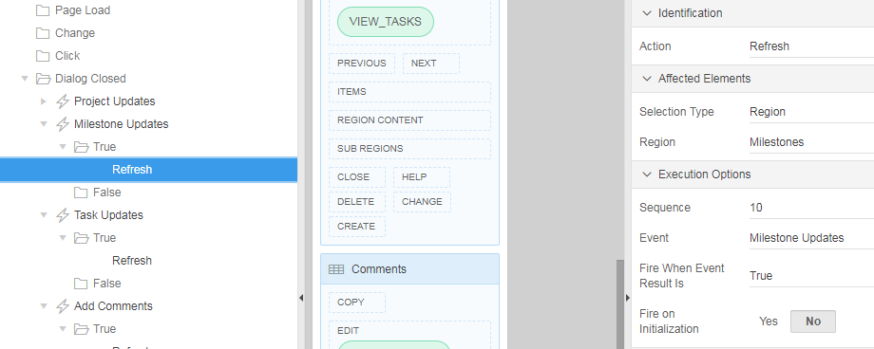

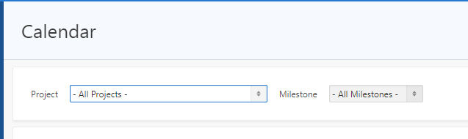

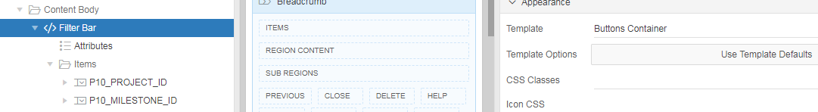

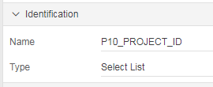

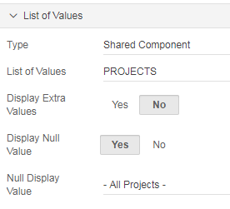

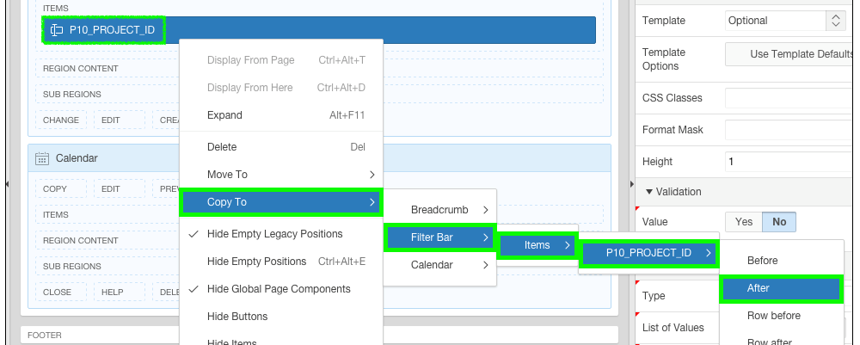

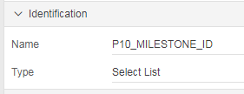

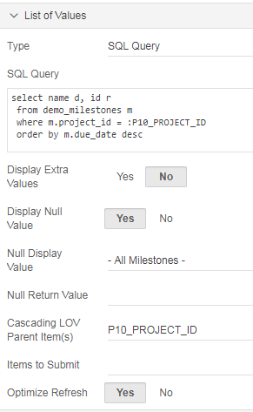

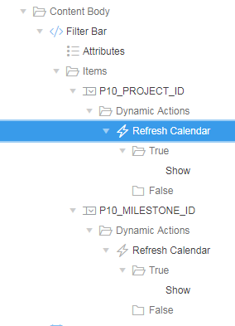

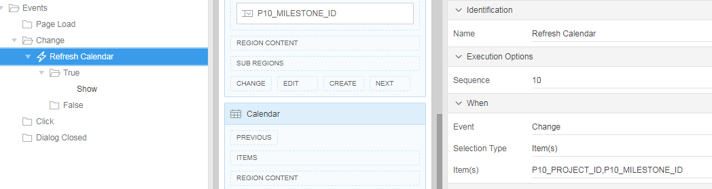

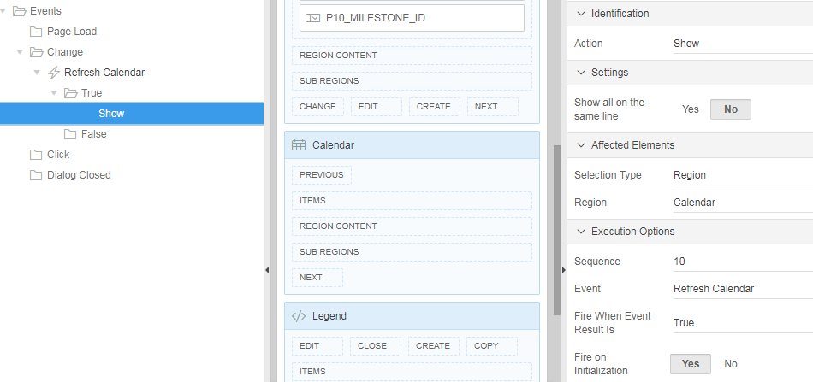

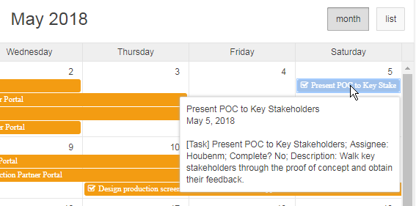

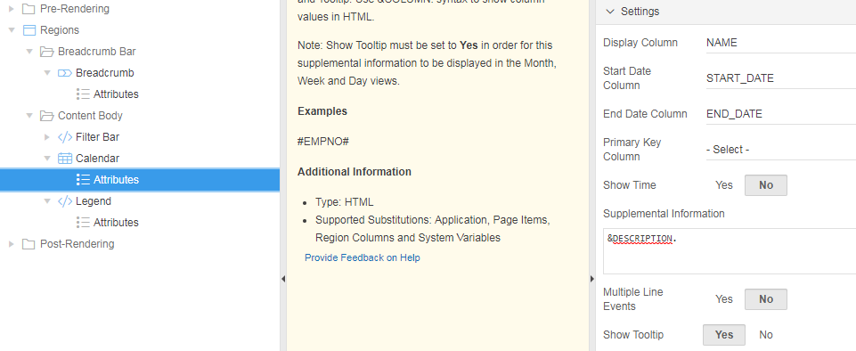

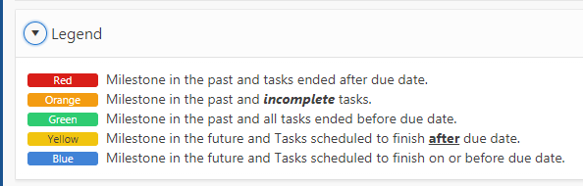

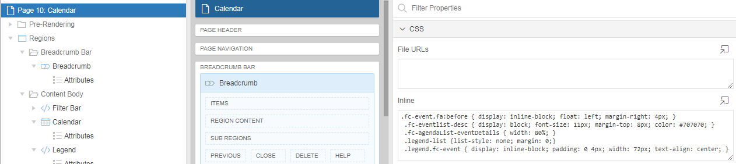

This HTML code uses the CSS classes added to the page CSS Code to achieve the desired presentation.

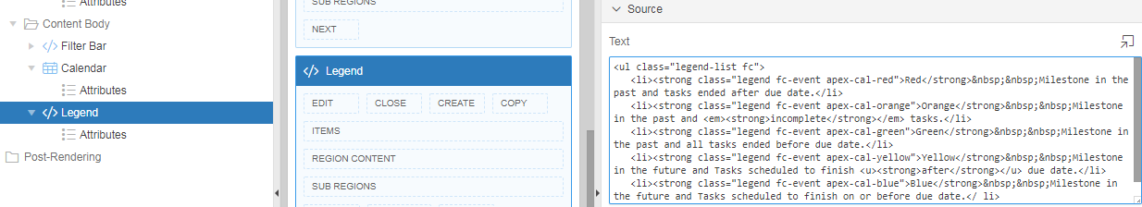

fa-calendar
fa-comment

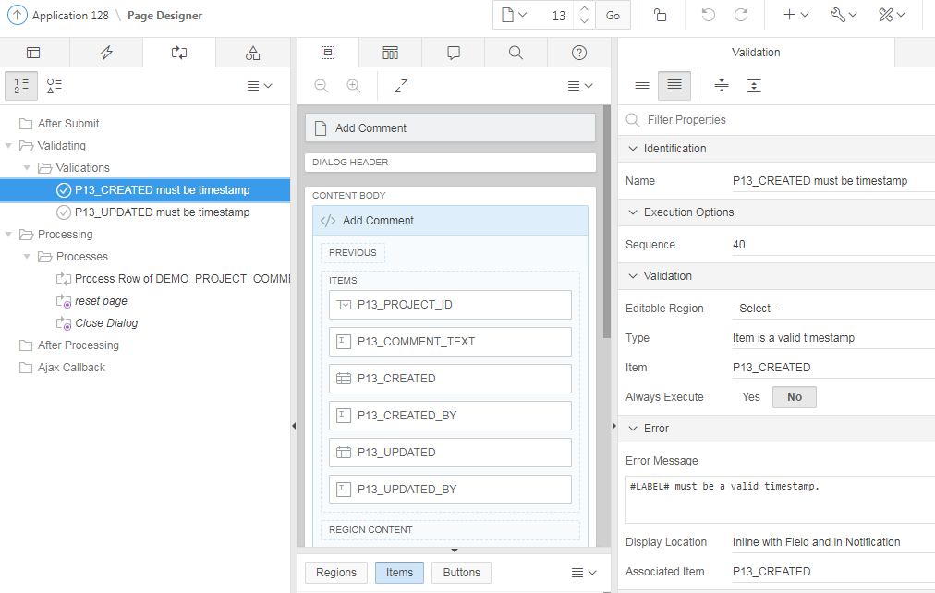

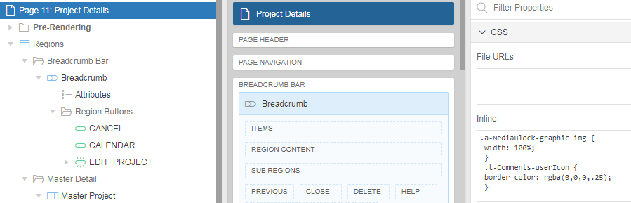

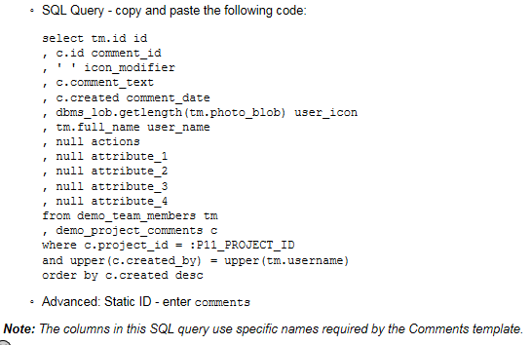
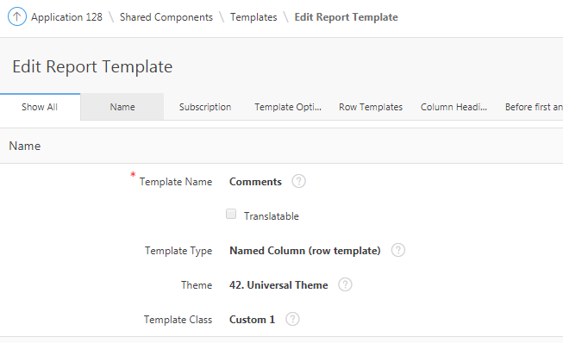

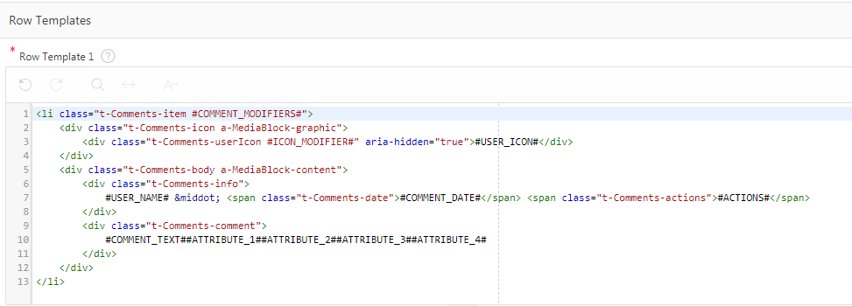

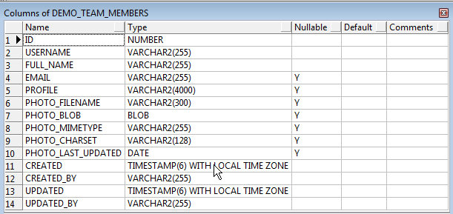

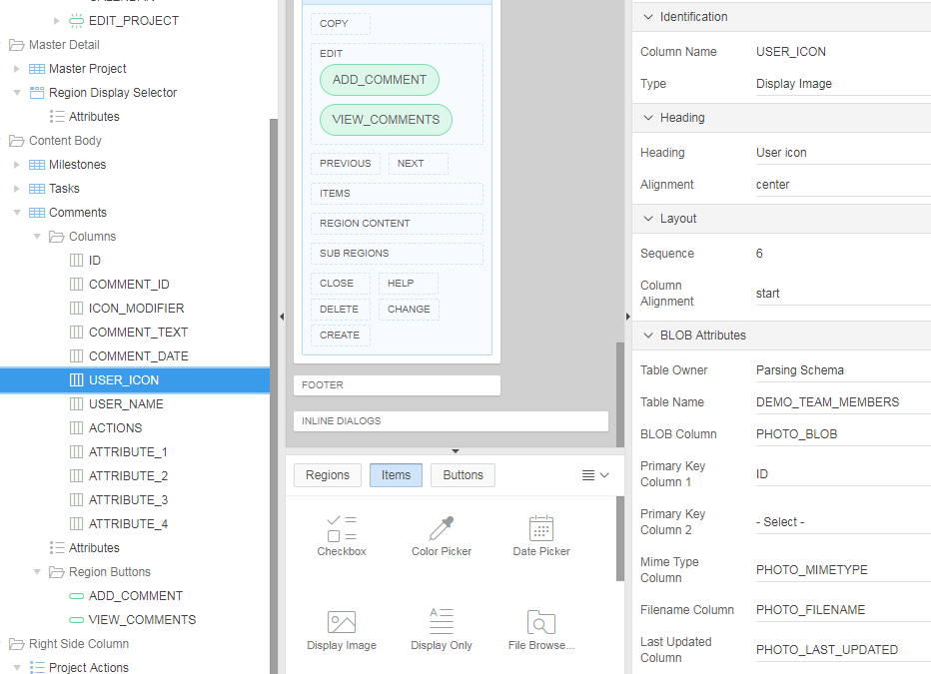

Appearance: Show Null Values as - enter &nbsp;

For the new Dynamic Action, in the Property Editor:
  - Identification: Name - enter Add Comments
  - When: Selection Type - select jQuery Selector
  - When: jQuery Selector - enter #add-comment, #actions Static ID
  - When: Condition - select JavaScript Expression
  - When: JavaScript Expression - enter this.data && this.data.dialogPageId == "13"

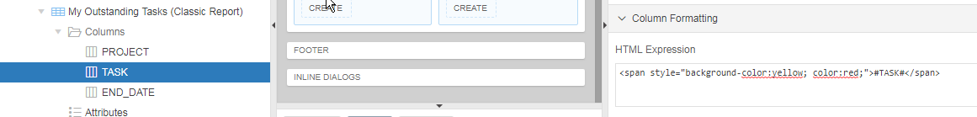
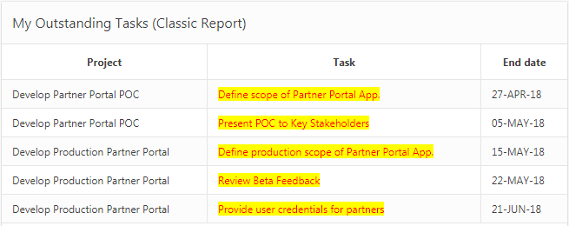

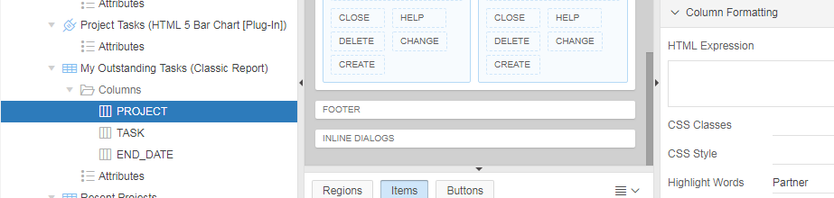
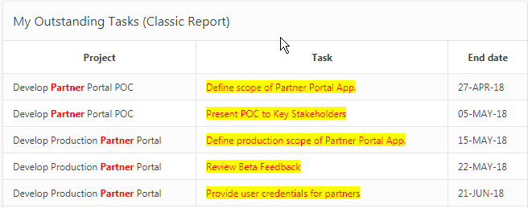

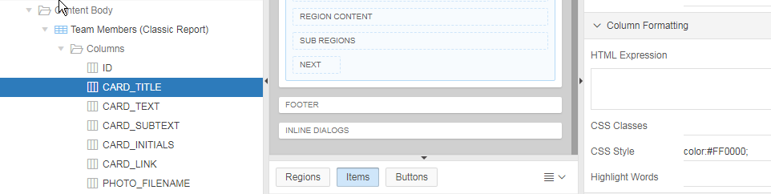
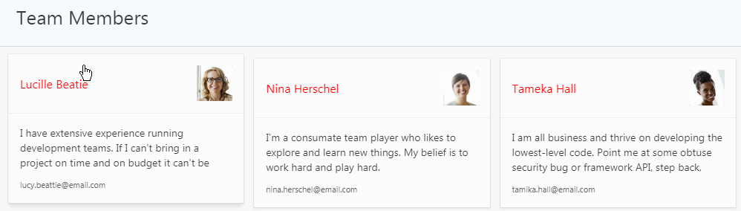

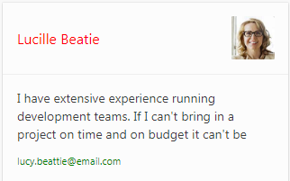
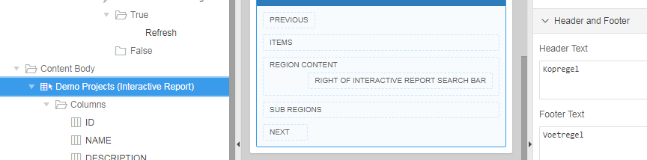
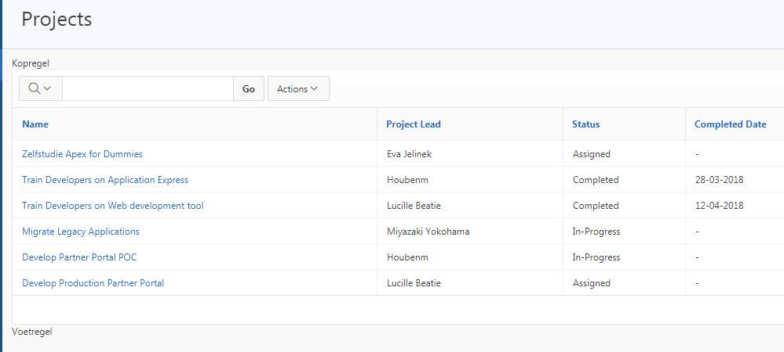
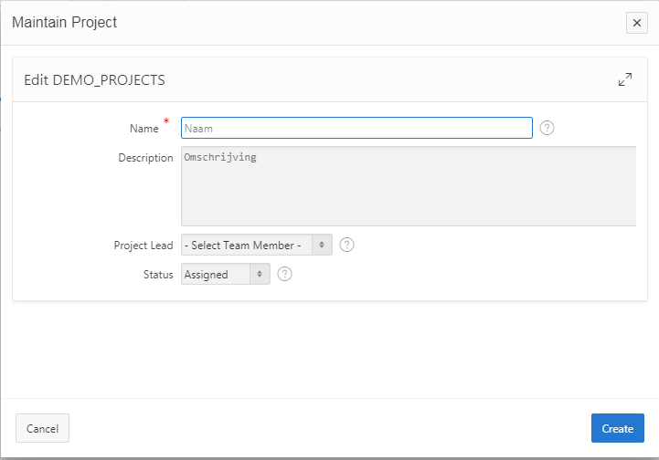
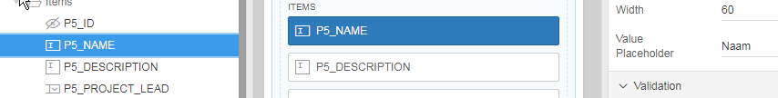

Link Icon:
<img src="#IMAGE_PREFIX#app_ui/img/icons/apex-edit-pencil.png" class="apex-edit-pencil" alt="Edit">

<img src="#IMAGE_PREFIX#app_ui/img/icons/apex-edit-pencil-alt.png" class="apex-edit-pencil-alt" alt="">

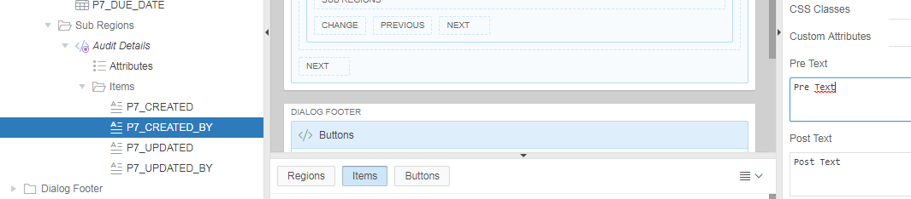
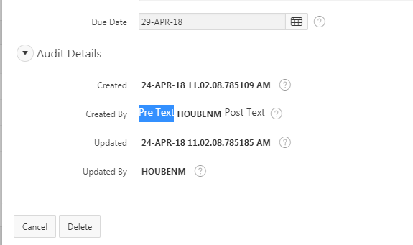

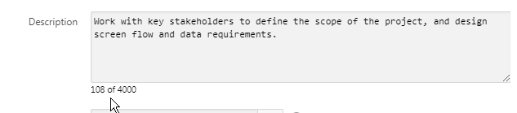

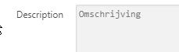

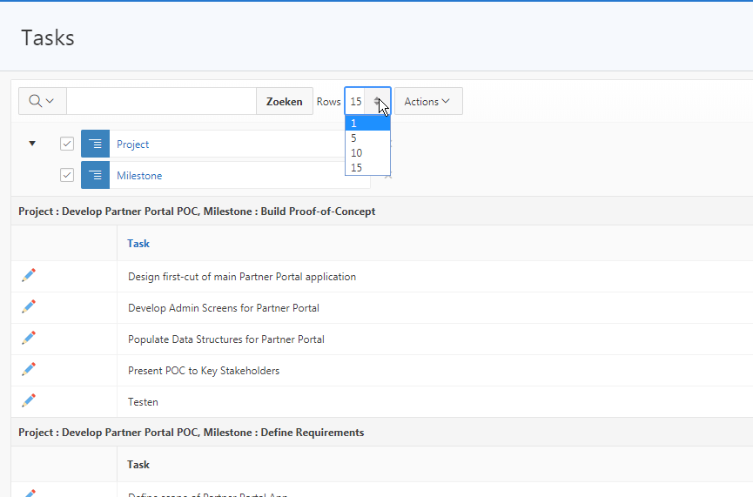

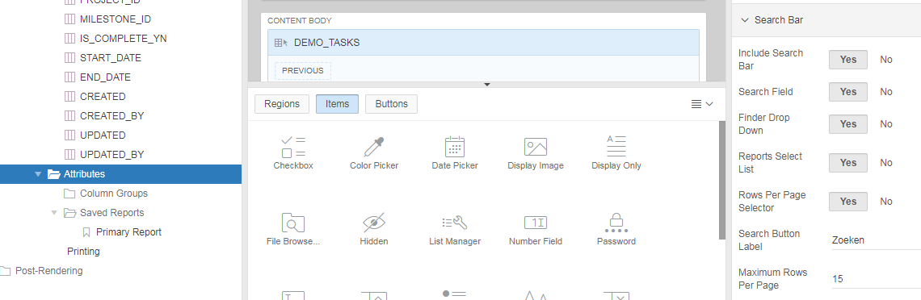

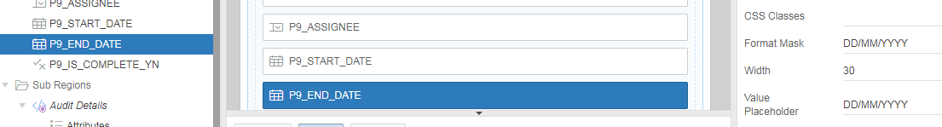

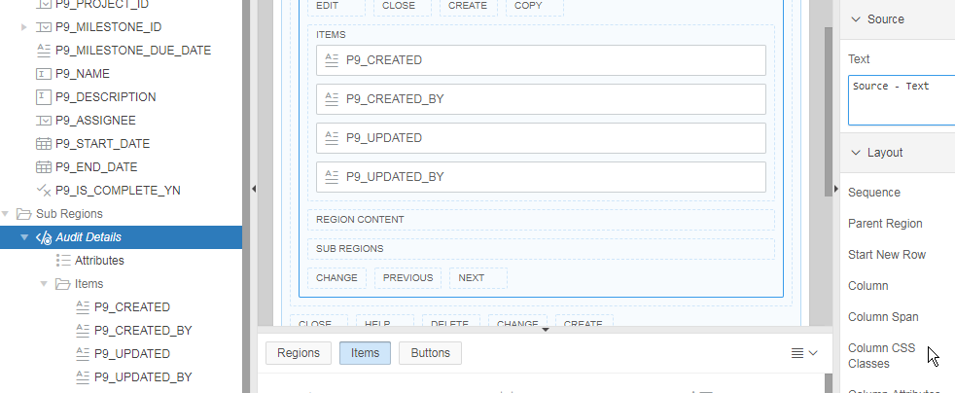

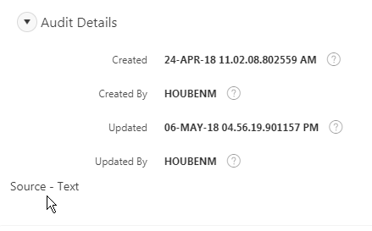

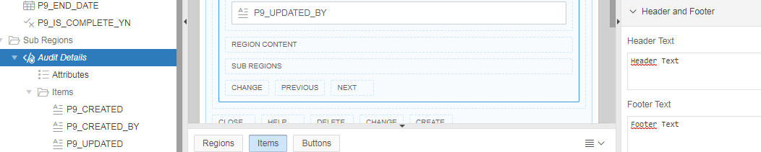

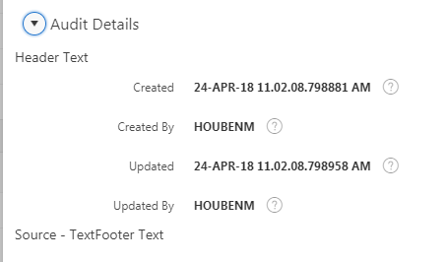

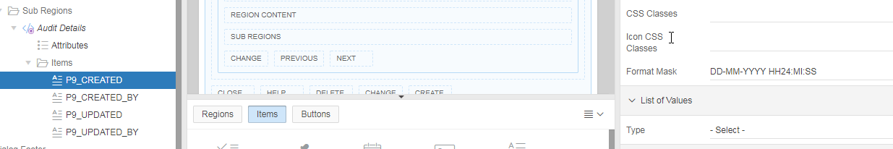

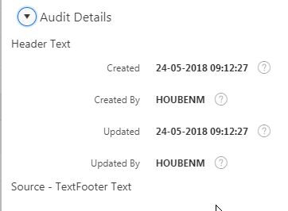

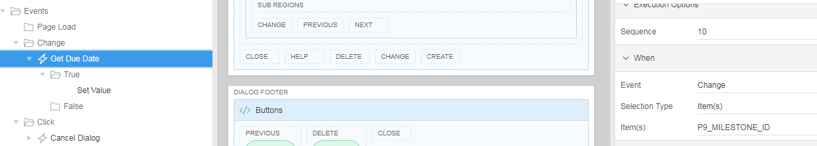

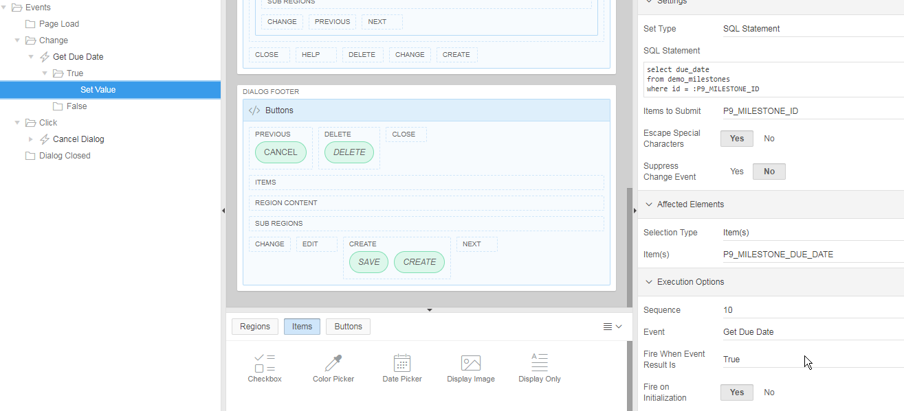

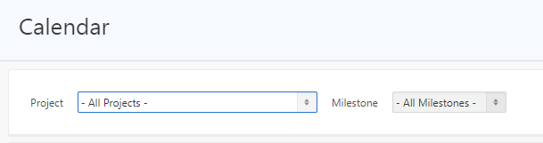

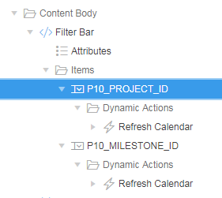

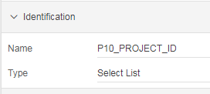

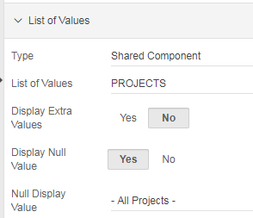

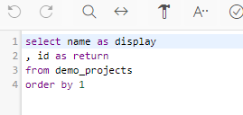

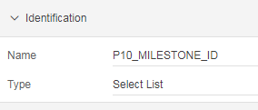
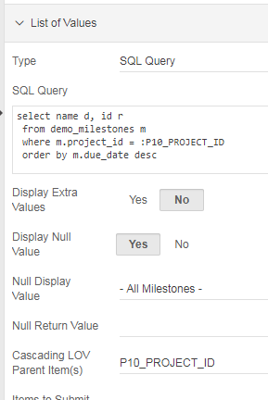

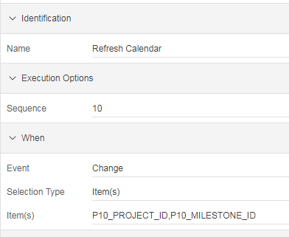

Cascading: Je kunt pas een Milestone selecteren NADAT je een Project geselecteerd hebt:

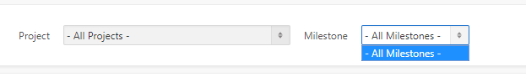

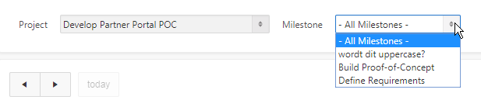

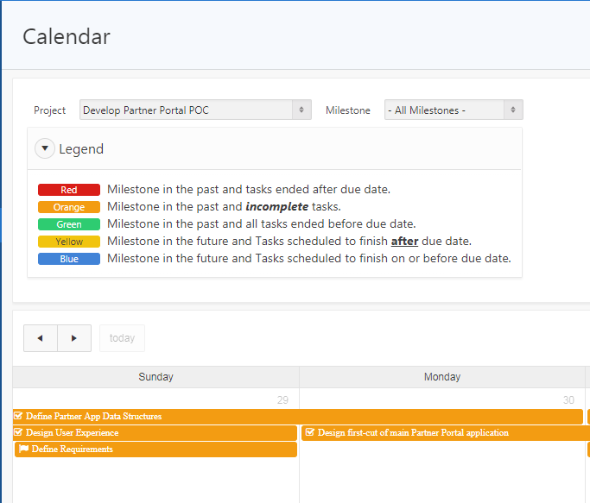

<span style="text-transform: uppercase;">#COMMENT_TEXT#</span>

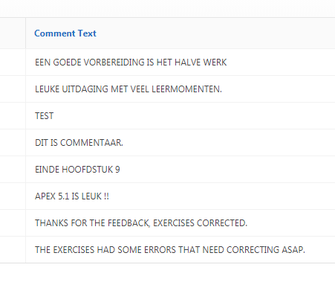

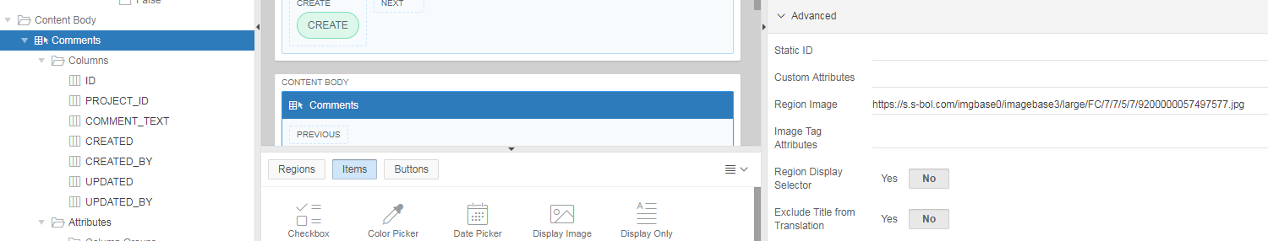

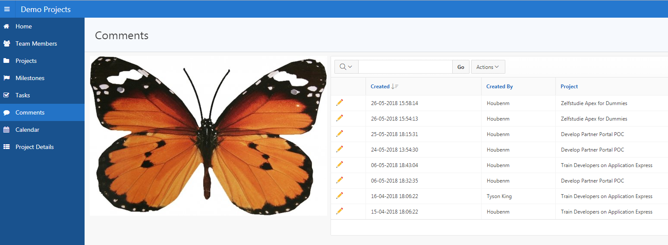

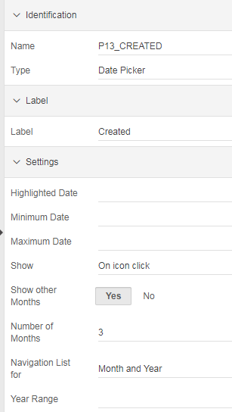

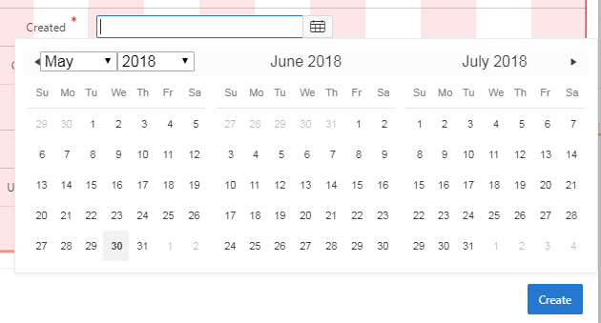

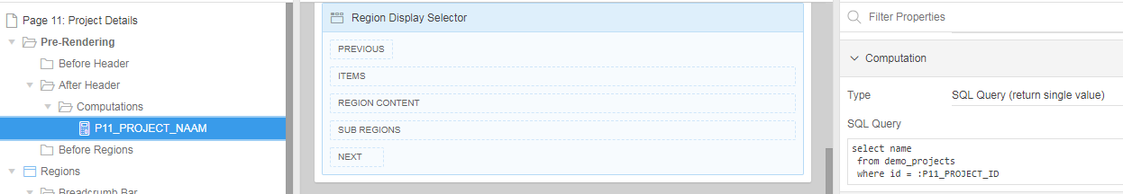

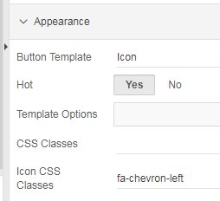

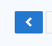

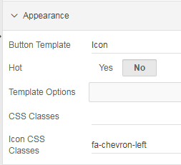

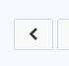

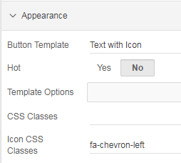

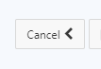

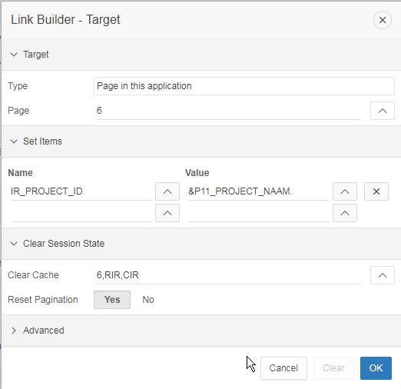

In een SQL query:

decode(nvl(t.is_complete_yn,'N'),
'N','<span class="u-VisuallyHidden">No</span>',
'Y','<span class="fa fa-check"><span class="u-VisuallyHidden">Yes</span></span>'

Show Null Values as: &nbsp;

FUNDAMENTALS 1

Local List

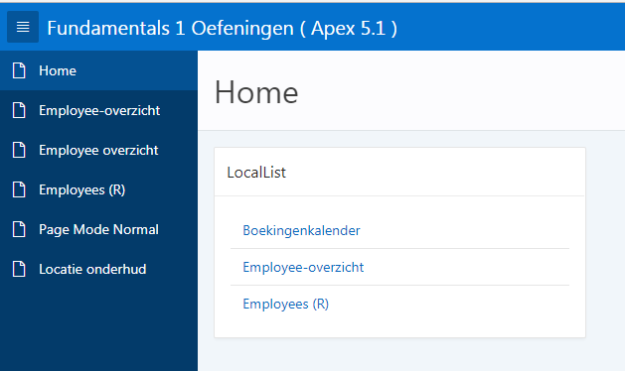

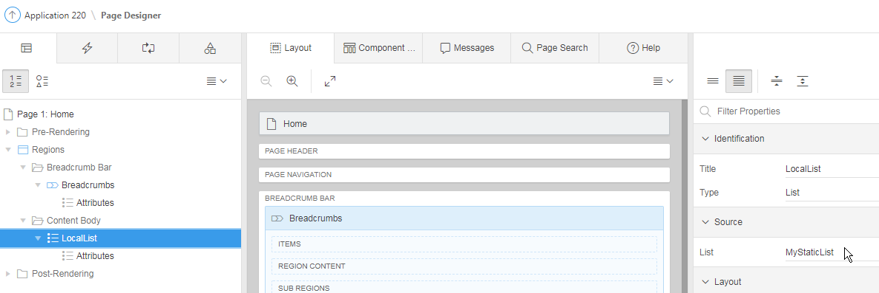

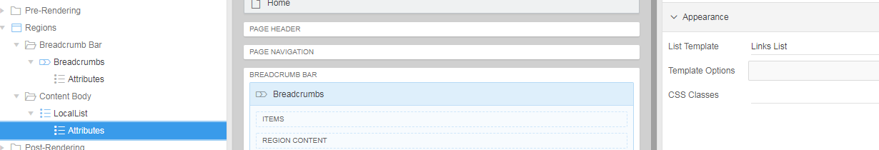

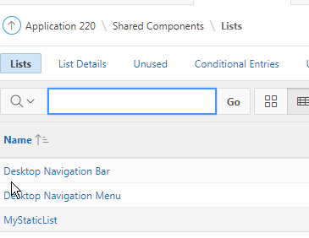

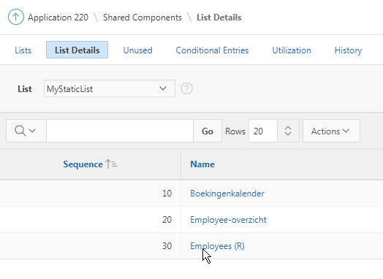
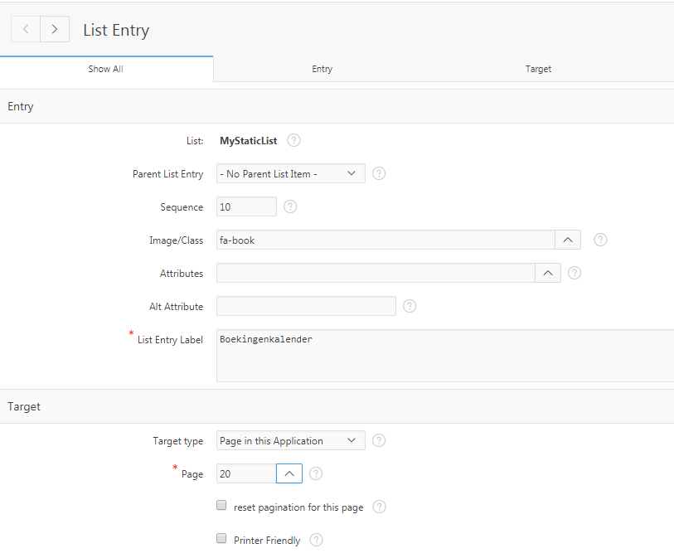

Tree

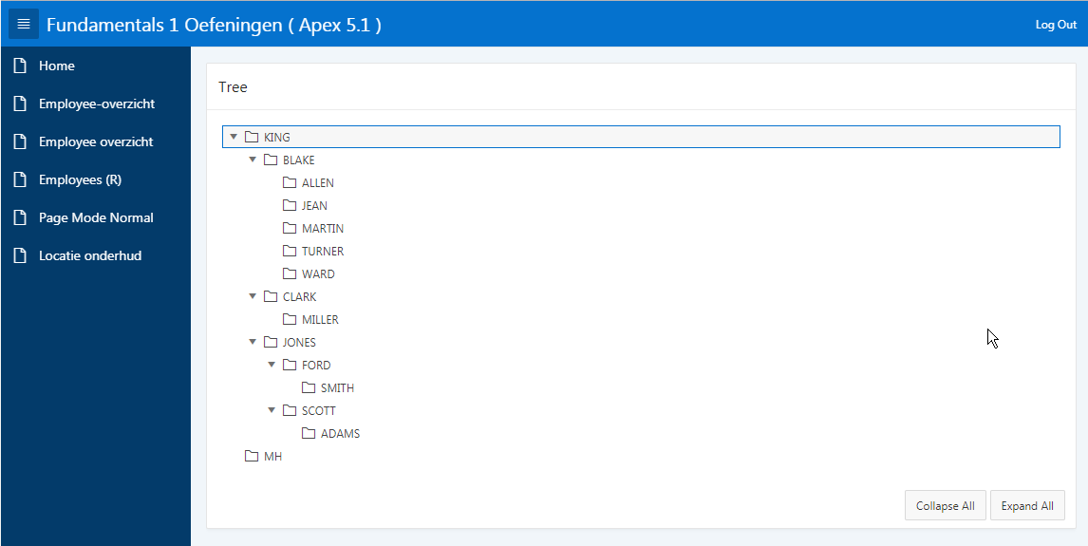

select case when connect_by_isleaf = 1 then 0
when level = 1 then 1
else -1
end as status,
level,
"ENAME" as title,
null as icon,
"EMPNO" as value,
"HIREDATE" as tooltip,
null as link
from "#OWNER#"."EMP"
start with "MGR" is null
connect by prior "EMPNO" = "MGR"
order siblings by "ENAME"

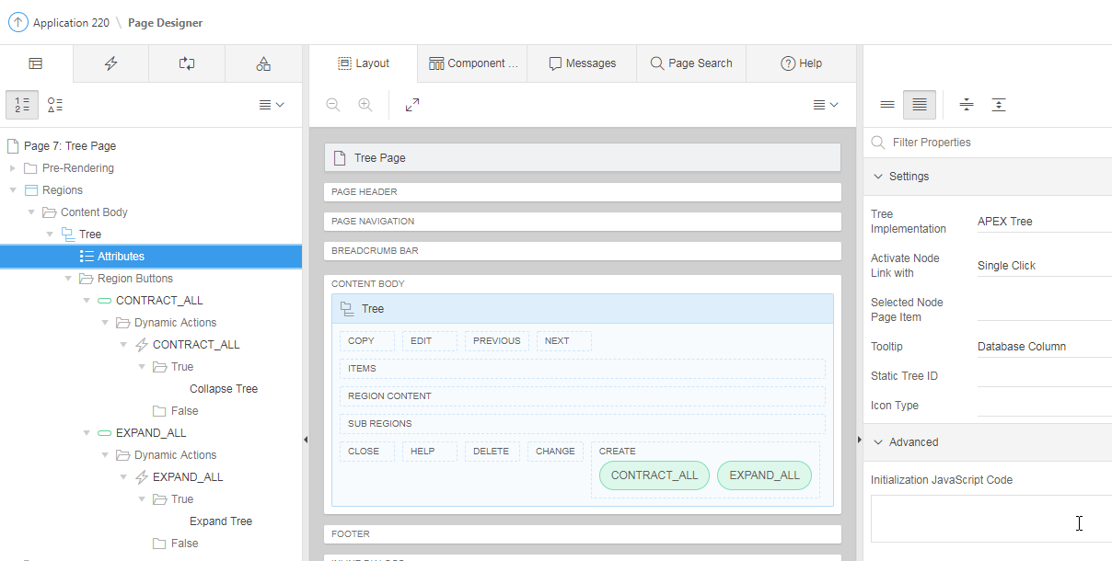

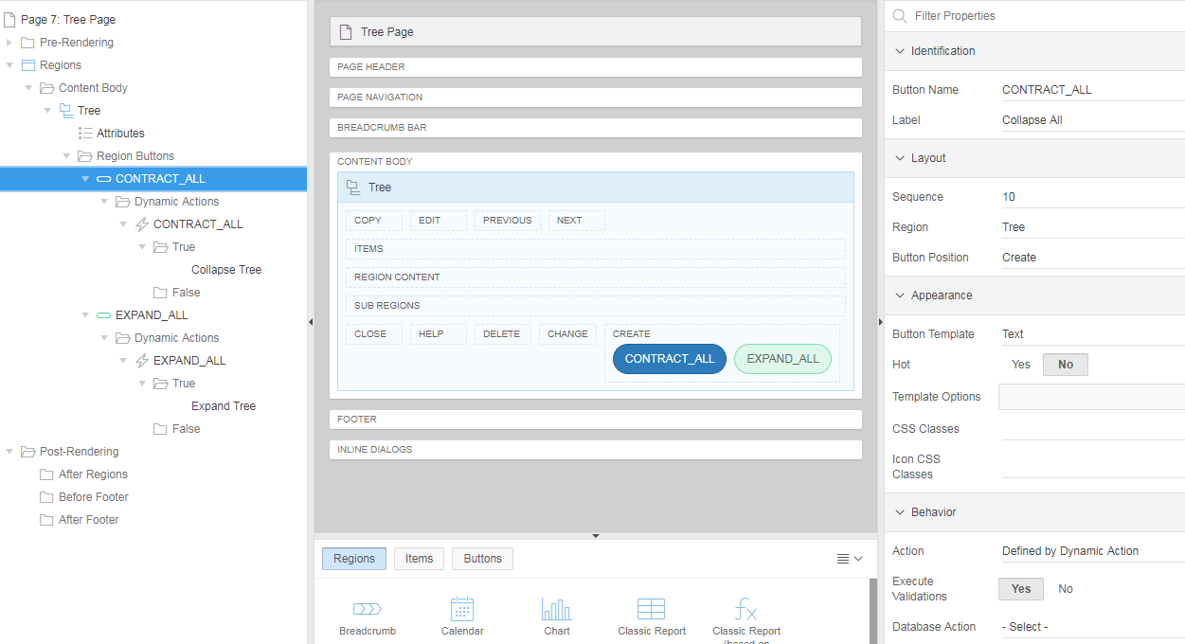

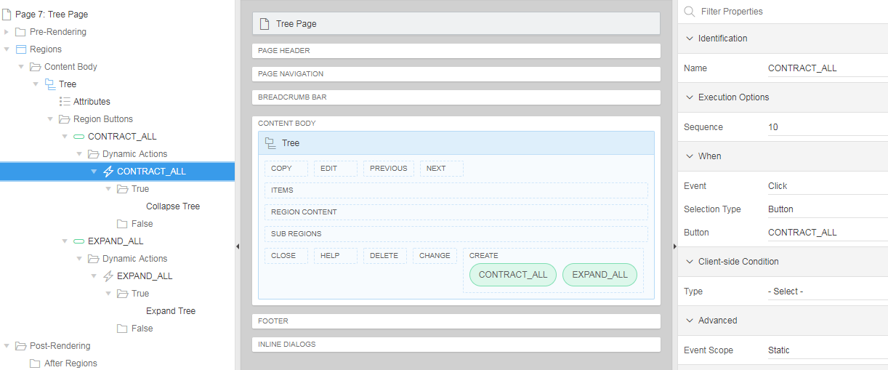

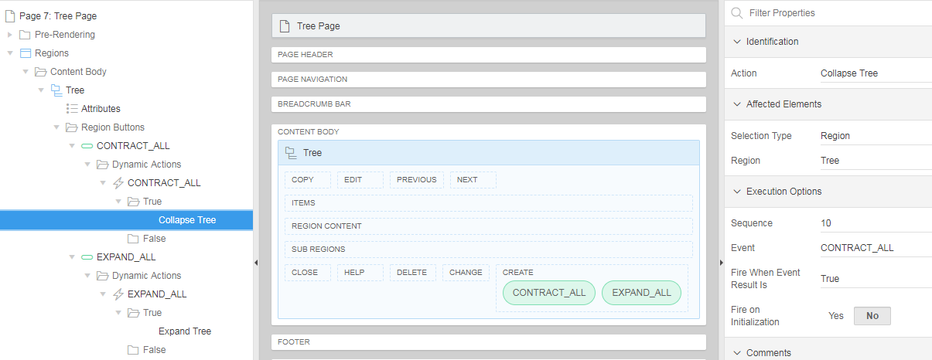

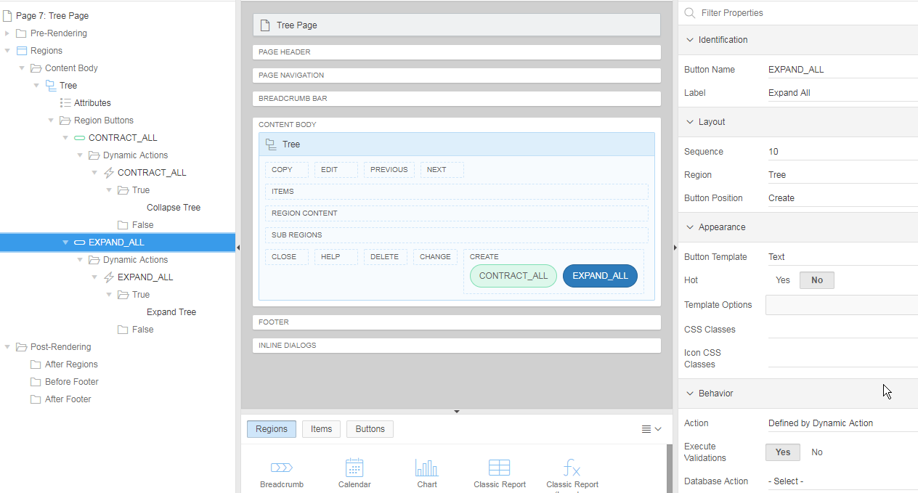

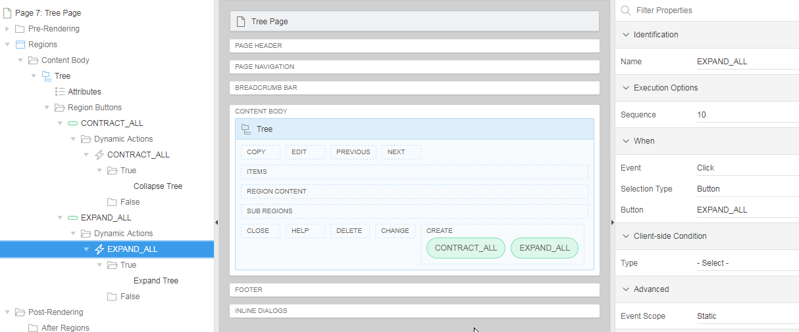

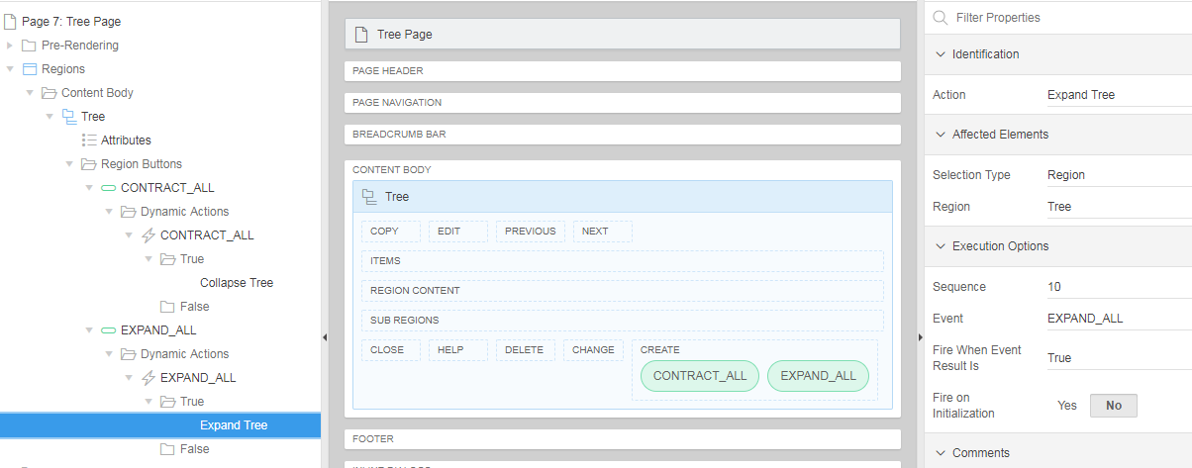

Chart

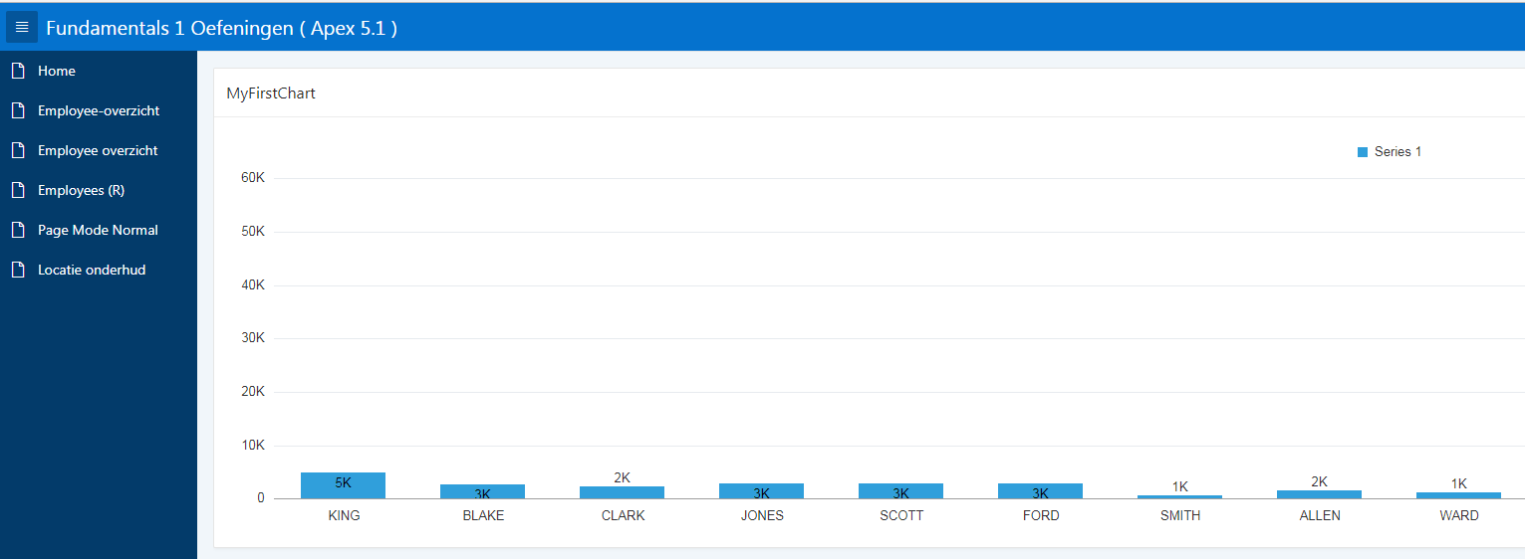

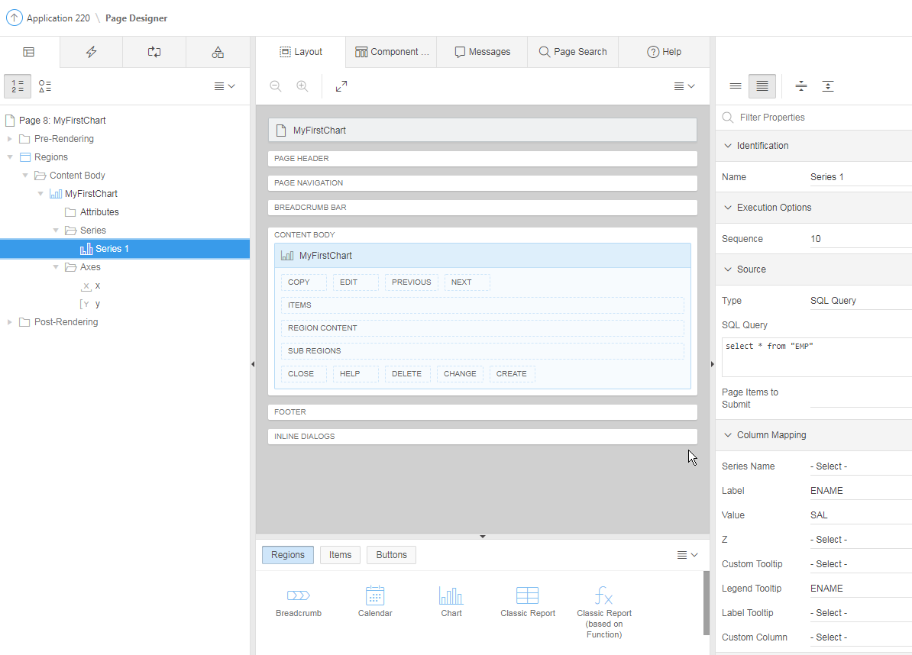

Map Chart

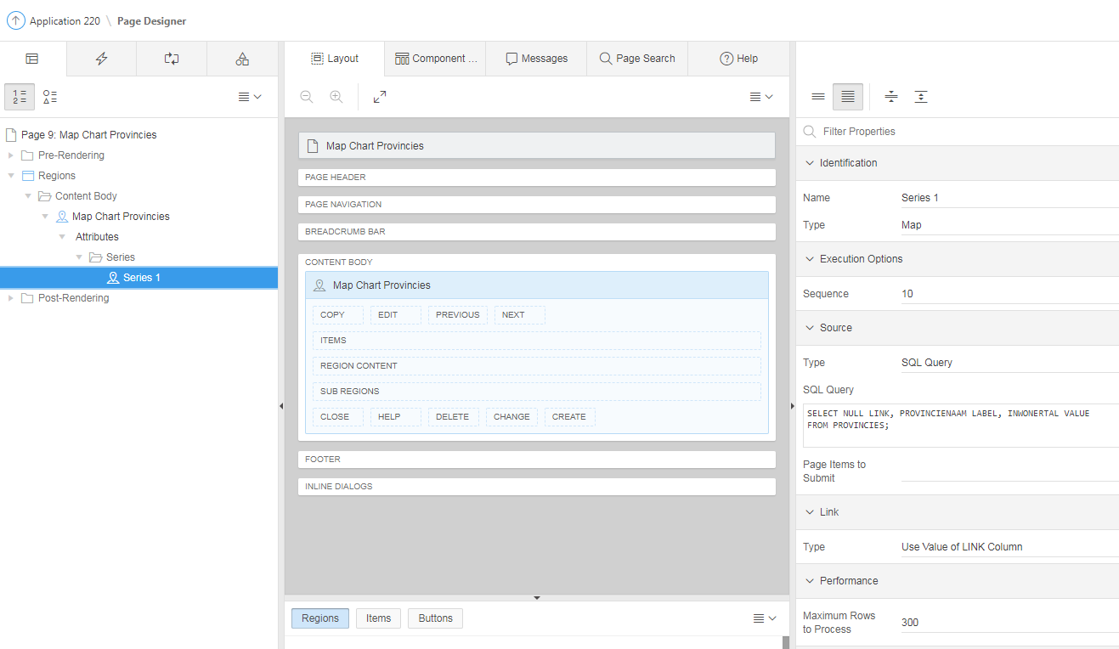

Calendar:

begin
update emp
set hiredate = to_date(:APEX$NEW_START_DATE, 'YYYYMMDDHH24MISS')
where empno = :APEX$PK_VALUE;
end;

Get PK (Proces) (When Button Pressed: CREATE):

begin
if :P21_BKN_ID is null then
select "#OWNER#"."BOEKINGEN_SEQ".nextval
into :P21_BKN_ID
from sys.dual;
end if;
end;

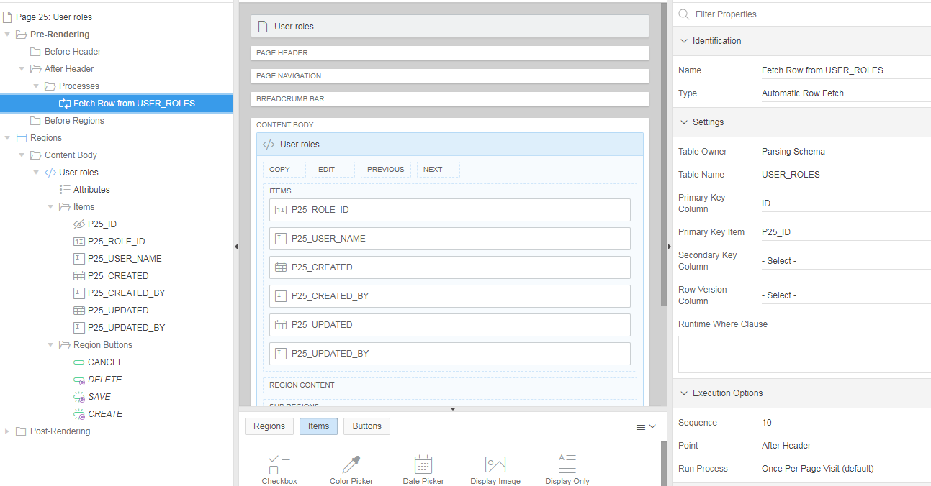

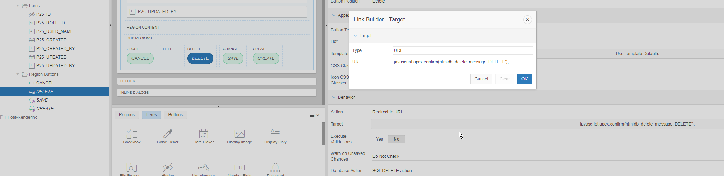

javascript:apex.confirm(htmldb_delete_message,'DELETE');

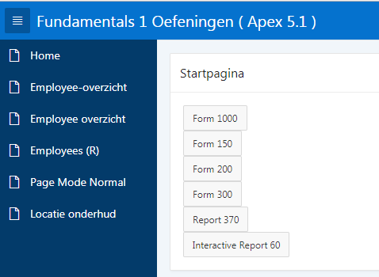

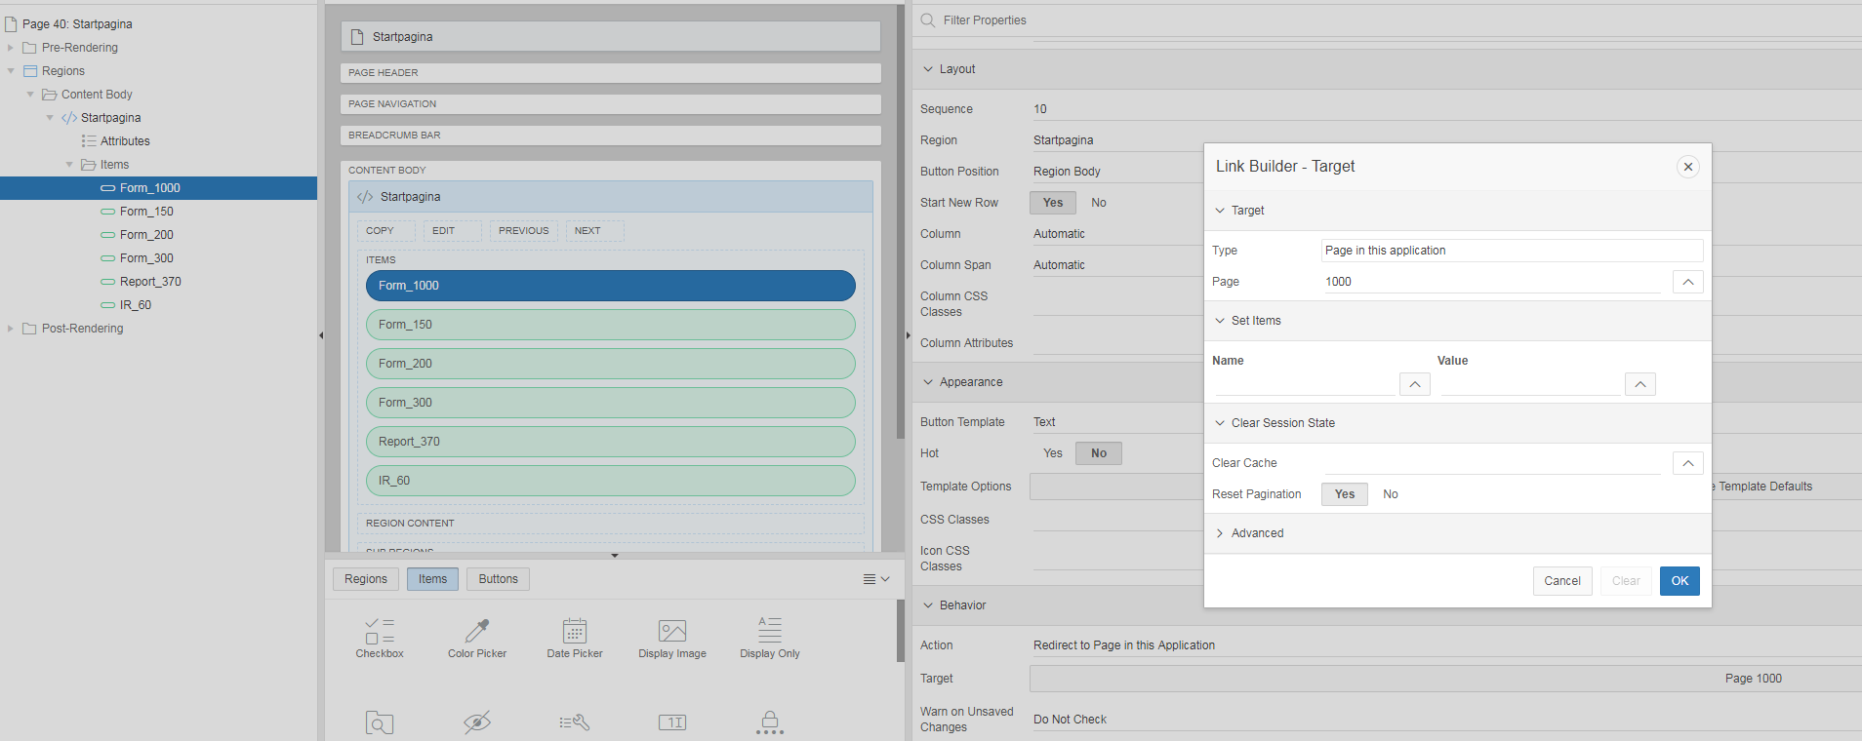

Redirect to URL: verwijzen naar Static ID van andere Region

URL : #Kalenderblok
Static ID : Kalenderblok

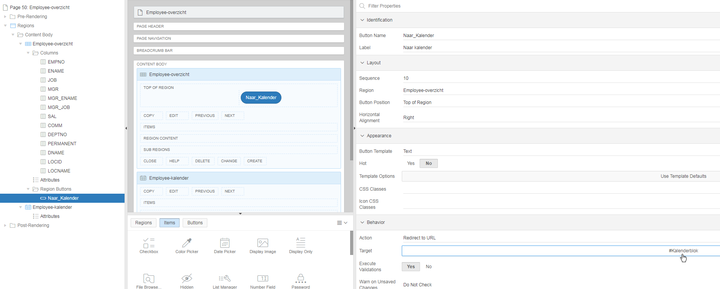

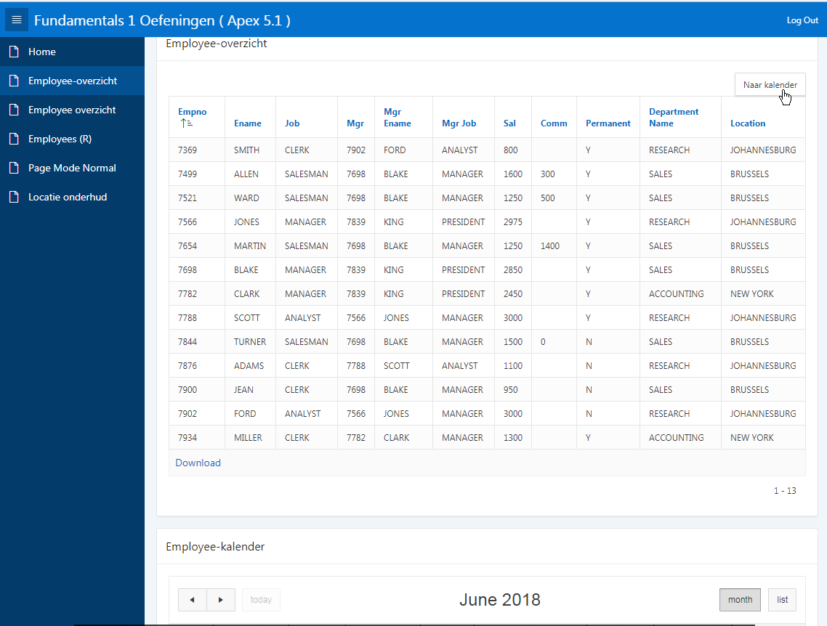

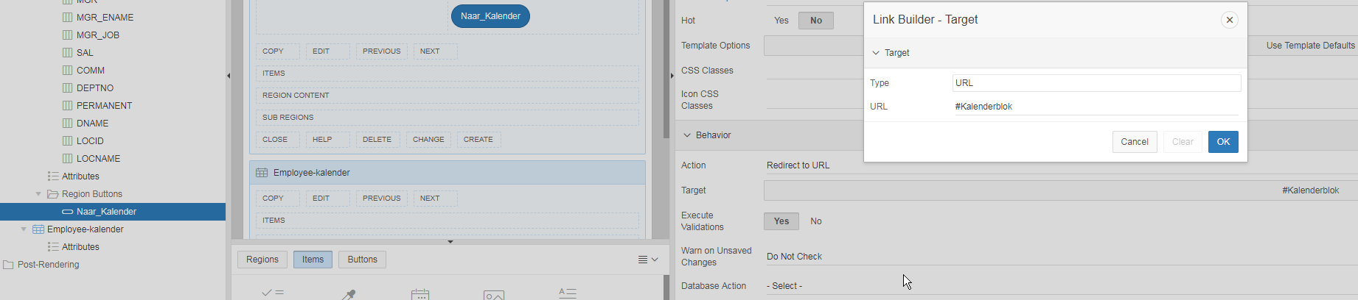

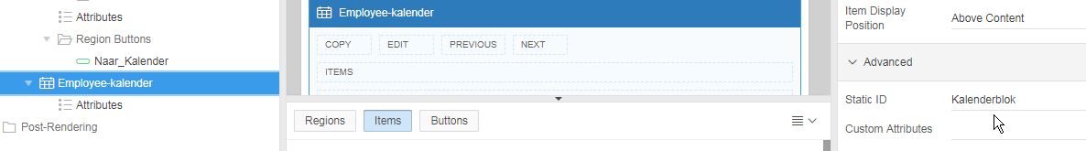

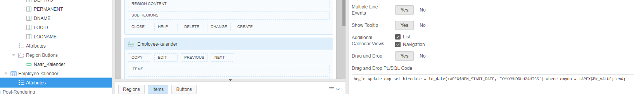

Interactive Report:
Attributes:
Link:
Link Column : Link to Single Row View
Uniquely Identify Rows by: Unique Column
Unique Column : EMPNO
Link Icon : <img src="#IMAGE_PREFIX#app_ui/img/icons/apex-edit-pencil.png" class="apex-edit-pencil" alt="">

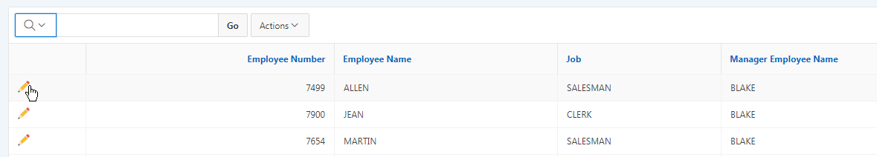

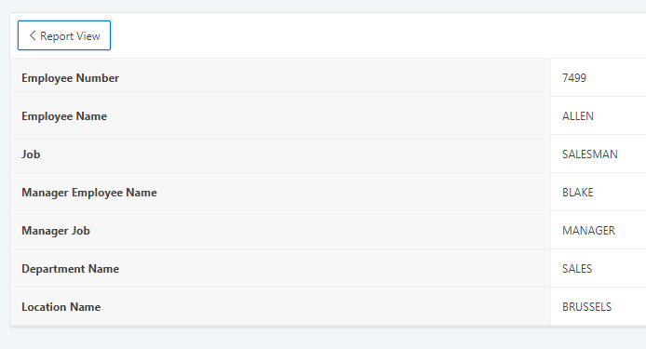

Cascading LOV Parent Item(s)

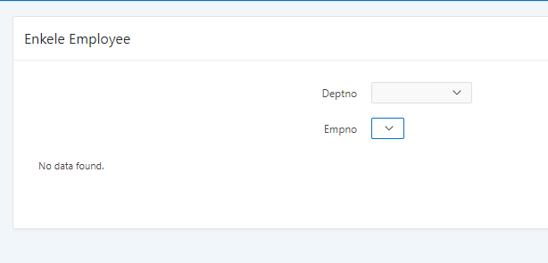

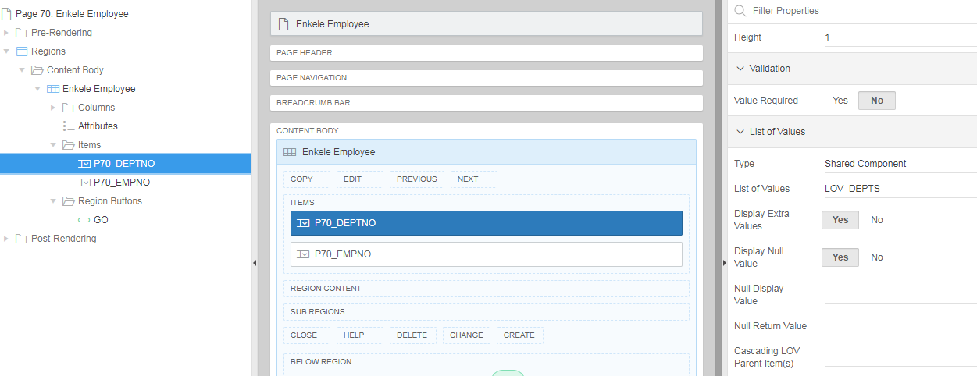
LOV_DEPTS:
select dname as d,
deptno as r
from dept
order by 1

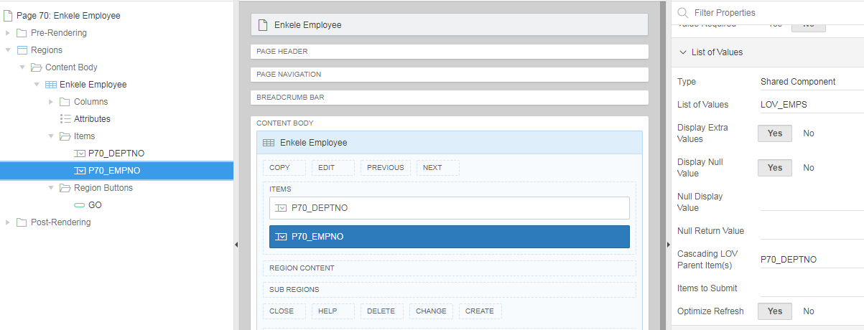

LOV_EMPS:
select ename as d,
empno as r
from emp
where deptno = :p70_deptno

Page 101 : Login Page

Get username cookie:
:P101_USERNAME := apex_authentication.get_login_username_cookie;

Set username cookie:
apex_authentication.send_login_username_cookie (
p_username => lower(:P101_USERNAME) );

apex_authentication.login(
p_username => :P101_USERNAME,
p_password => :P101_PASSWORD );
Master - Detail

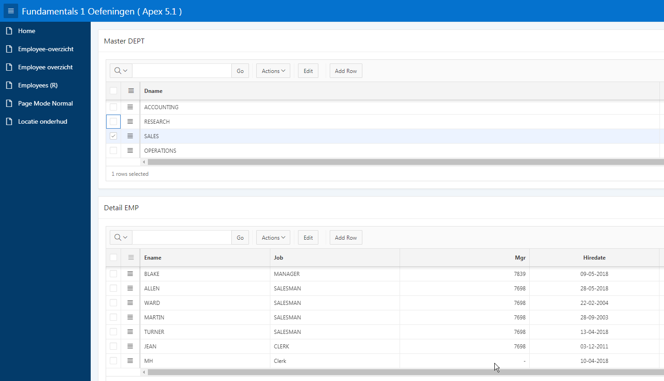

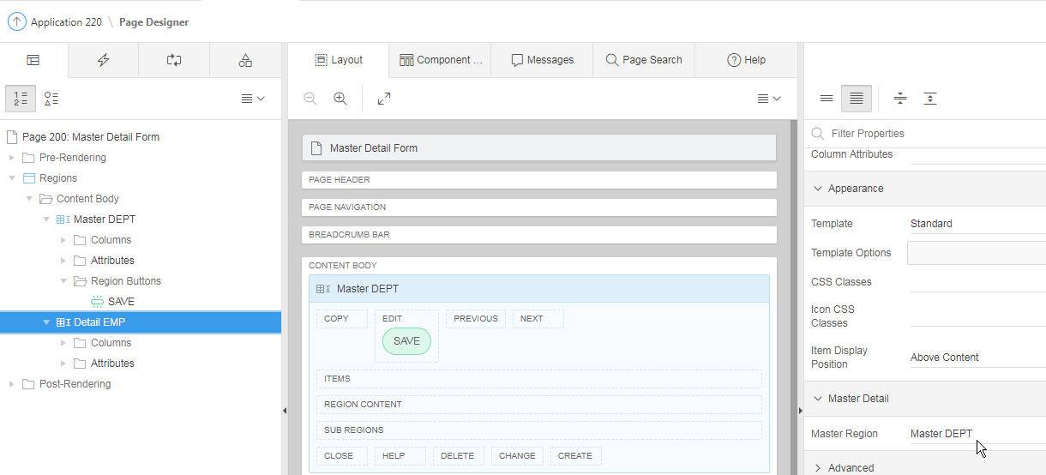

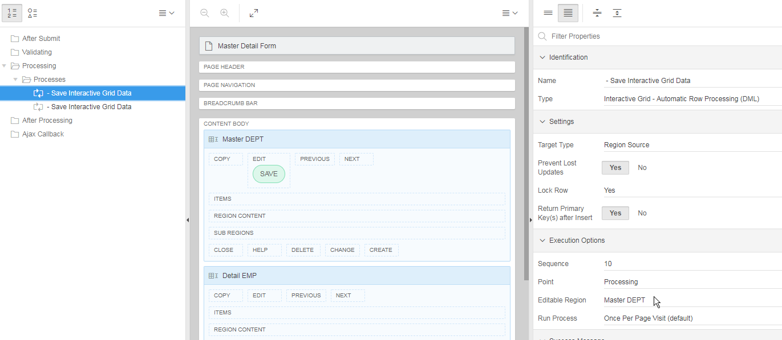
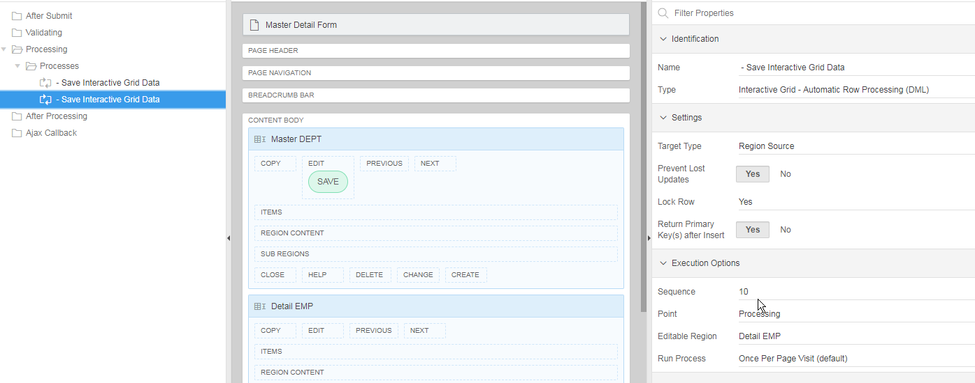

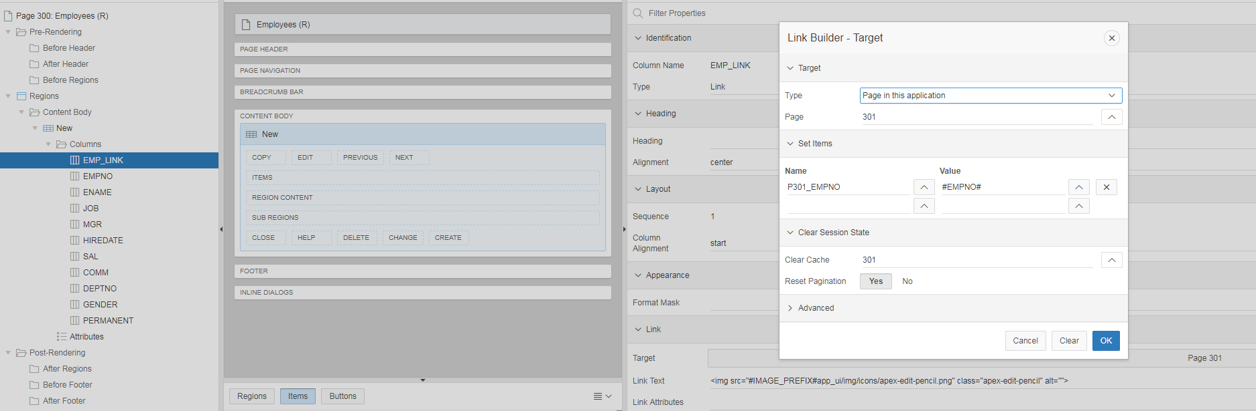

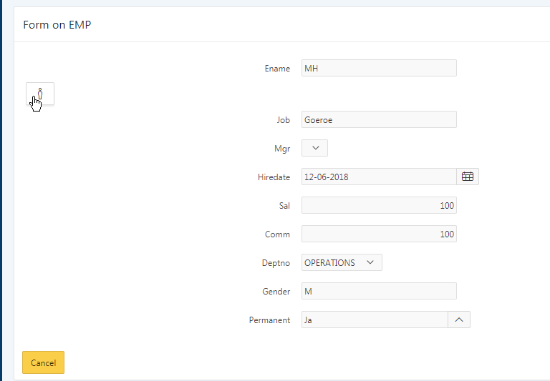

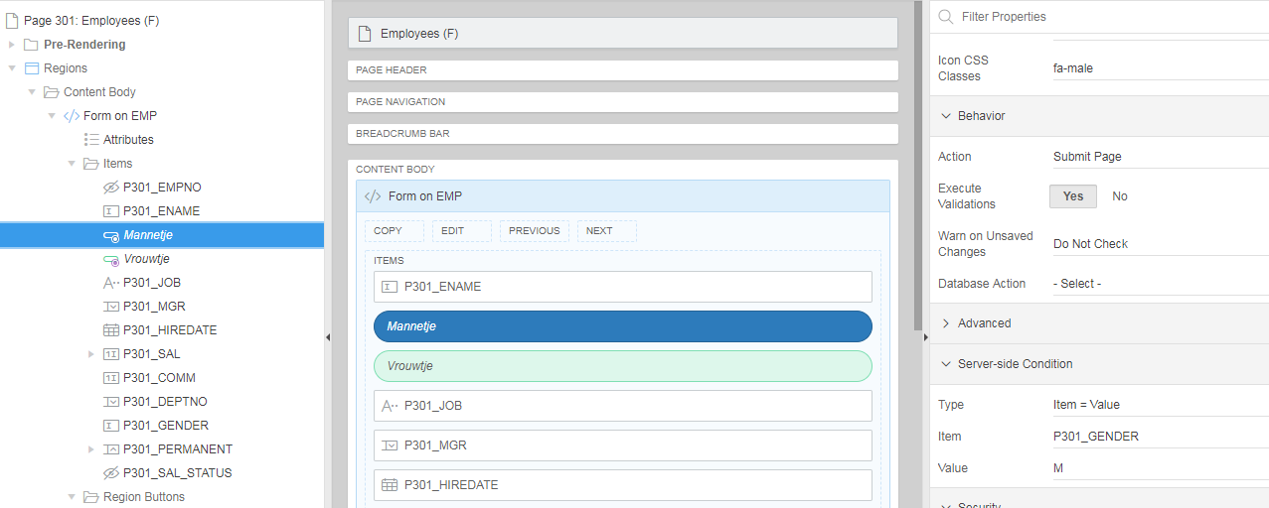



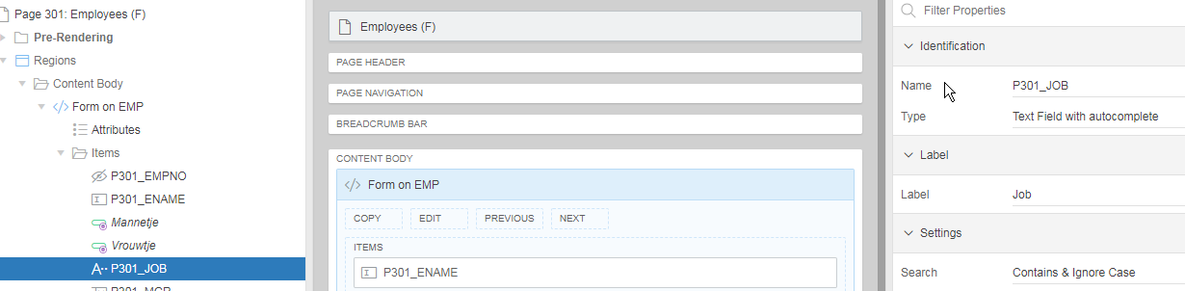

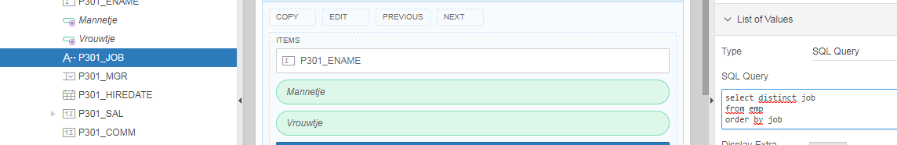

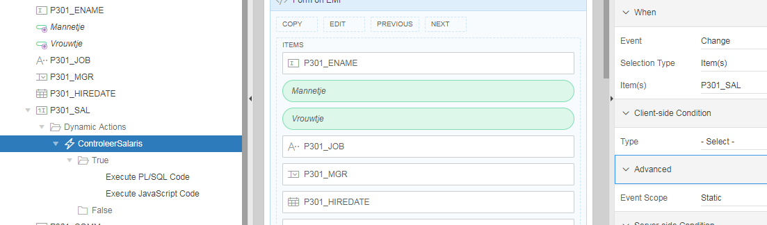

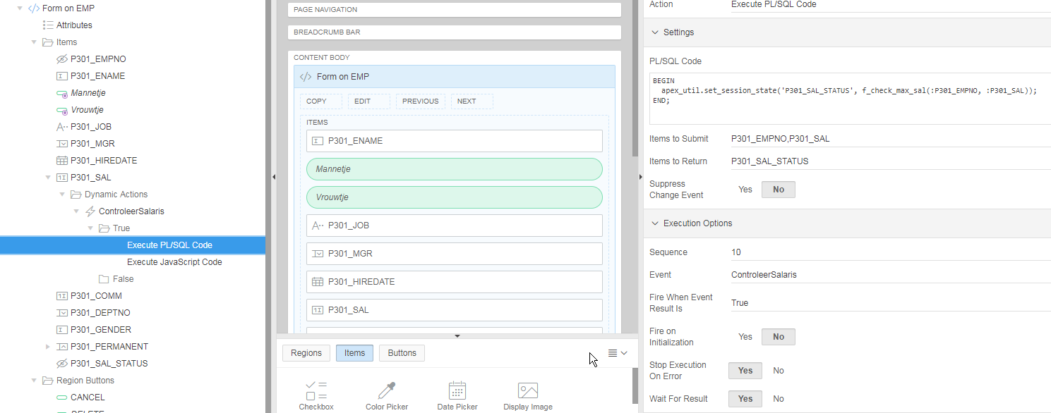

BEGIN
apex_util.set_session_state('P301_SAL_STATUS', f_check_max_sal(:P301_EMPNO, :P301_SAL));
END;

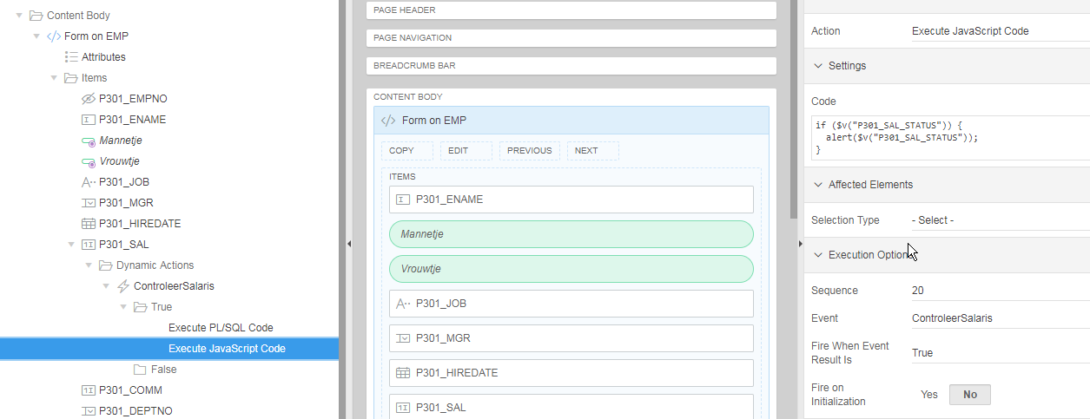

if ($v("P301_SAL_STATUS")) {
alert($v("P301_SAL_STATUS"));
}

File Browse…
APEX_APPLICATION_TEMP_FILES

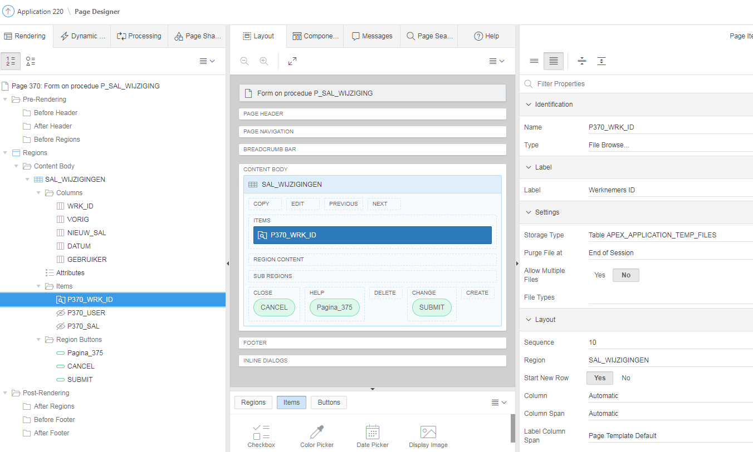

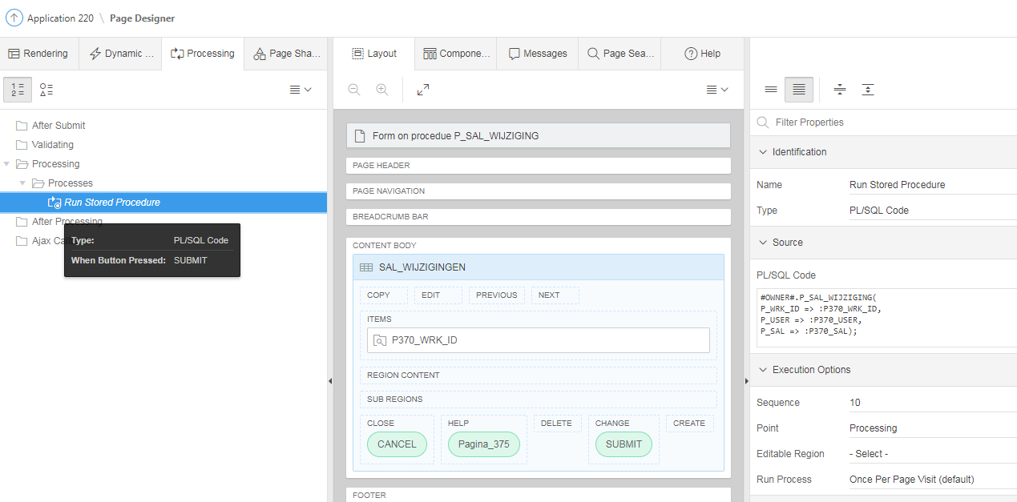

#OWNER#.P_SAL_WIJZIGING( P_WRK_ID => :P370_WRK_ID,
P_USER => :P370_USER,
P_SAL => :P370_SAL );

CREATE OR REPLACE PROCEDURE P_SAL_WIJZIGING(P_WRK_ID NUMBER, P_SAL NUMBER, P_USER VARCHAR2)
AS
CURSOR HAAL_SAL_OP (B_WRK_ID NUMBER)
IS
SELECT SAL
FROM WERKNEMERS
WHERE ID = B_WRK_ID;
V_HUIDIG_SAL NUMBER;
BEGIN
OPEN HAAL_SAL_OP (P_WRK_ID);
FETCH HAAL_SAL_OP
INTO V_HUIDIG_SAL;
CLOSE HAAL_SAL_OP;
IF P_SAL <> V_HUIDIG_SAL THEN
INSERT INTO SAL_WIJZIGINGEN VALUES
(P_WRK_ID, V_HUIDIG_SAL, P_SAL, SYSDATE, P_USER);
COMMIT;
END IF;
END;

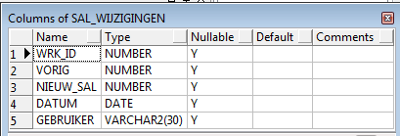

Authorization Scheme
Authentication

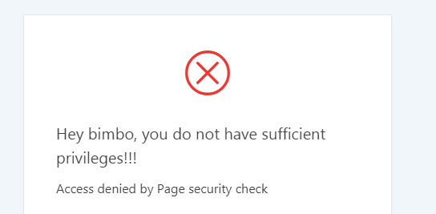

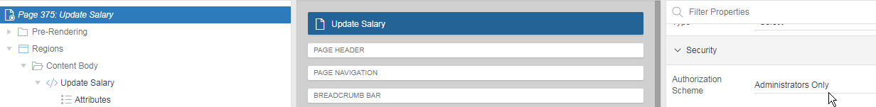

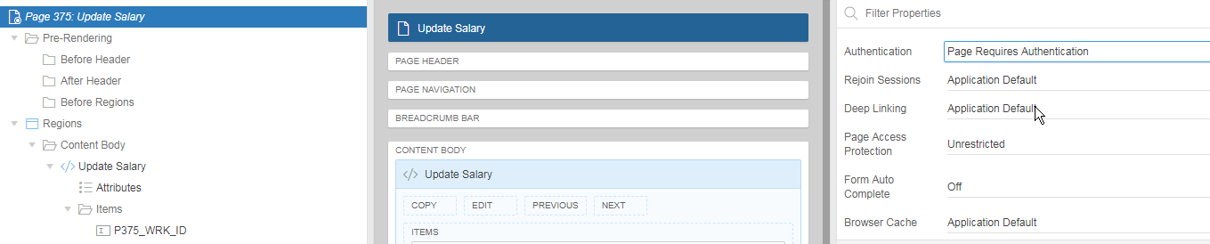
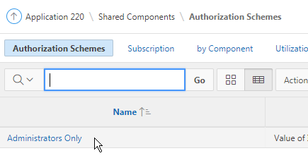

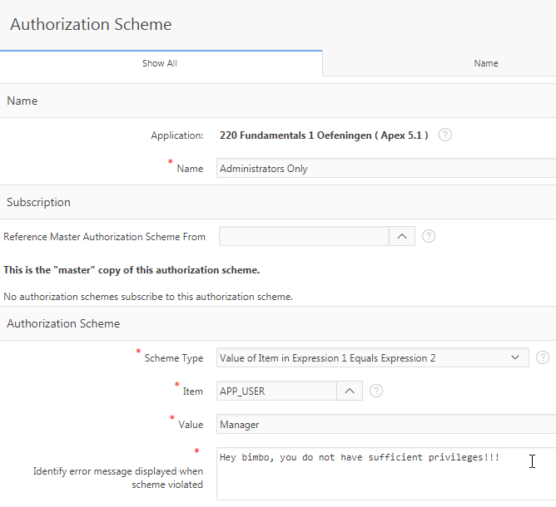

CSS
Inline : .above-average{ color:red; }

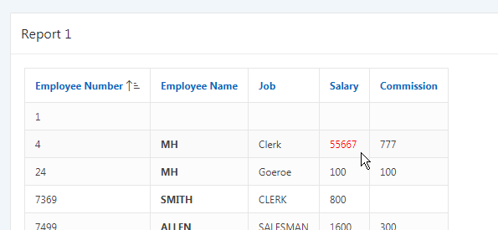

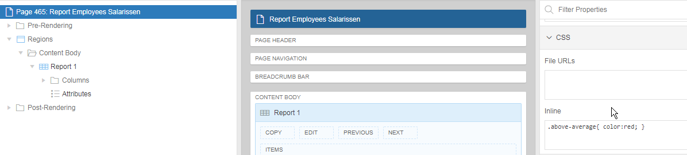
.above-average{ color:red; }

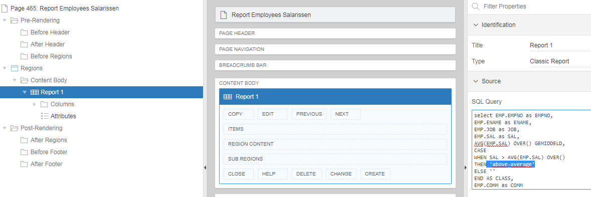

select EMP.EMPNO as EMPNO,
EMP.ENAME as ENAME,
EMP.JOB as JOB,
EMP.SAL as SAL,
AVG(EMP.SAL) OVER() as GEMIDDELD,
CASE
WHEN SAL > AVG(EMP.SAL) OVER()
THEN 'above-average'
ELSE ''
END as CLASS,
EMP.COMM as COMM
from EMP

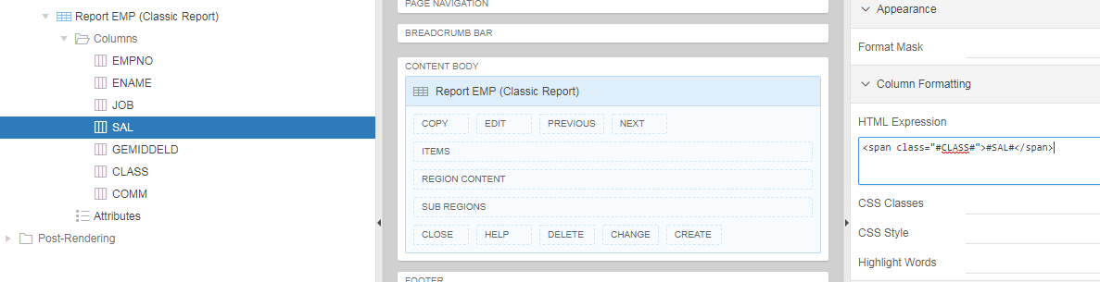
<span class="#CLASS#">#SAL#</span>

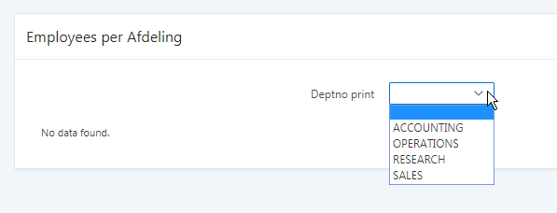

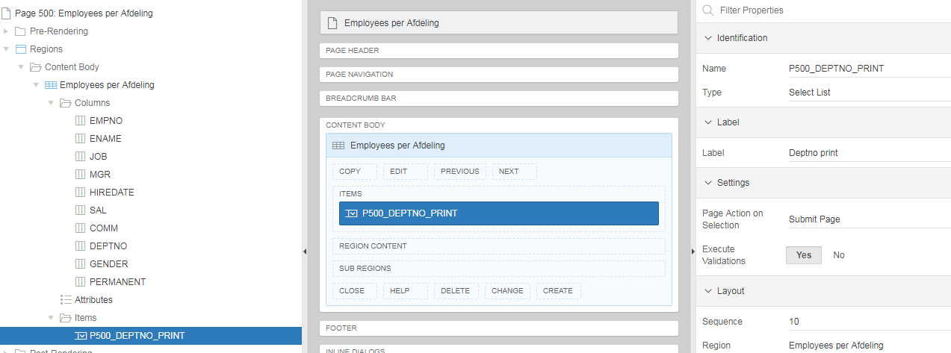

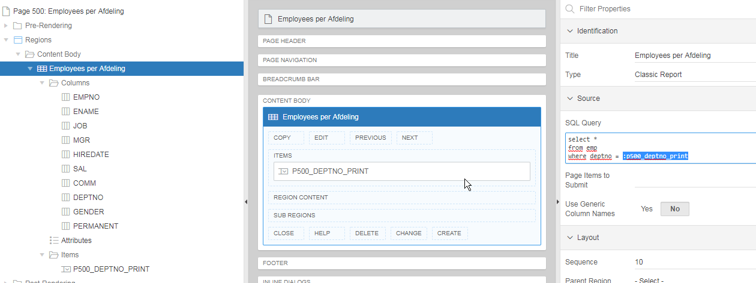

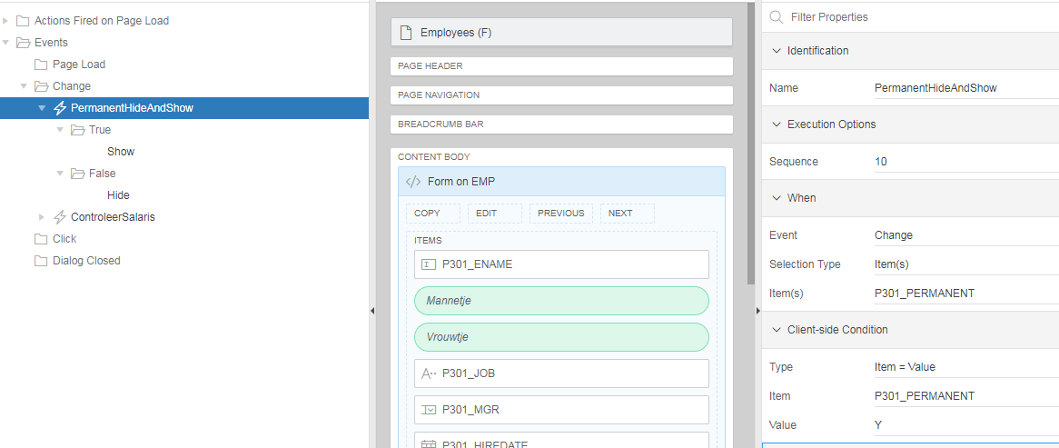

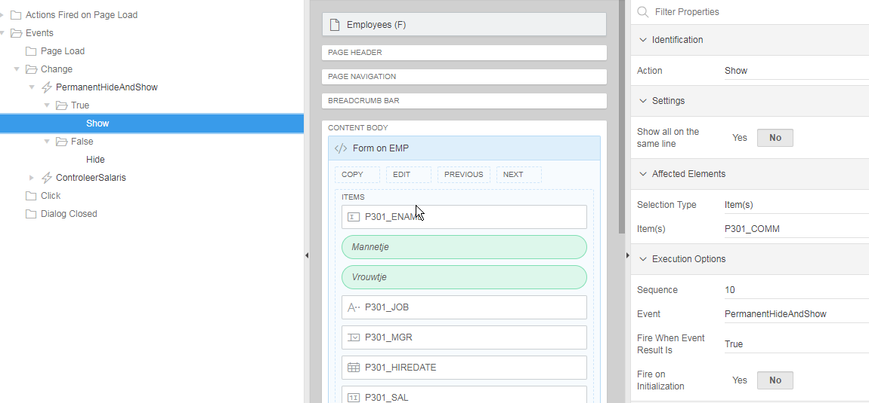

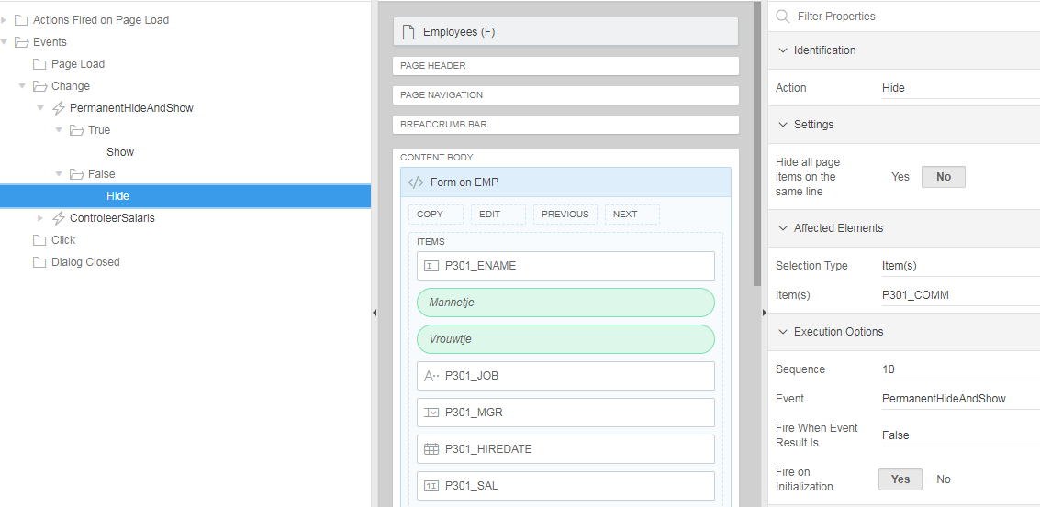

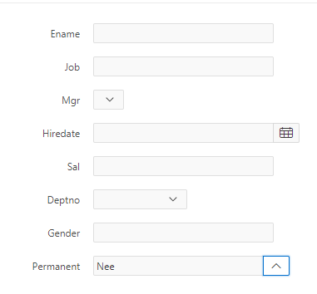

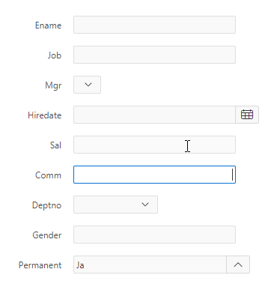

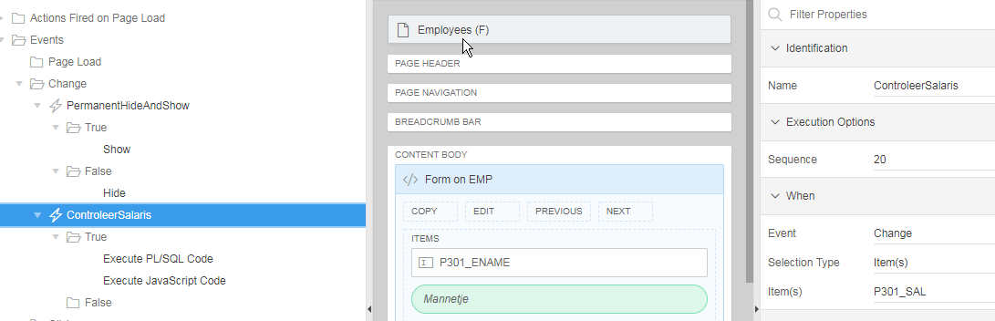

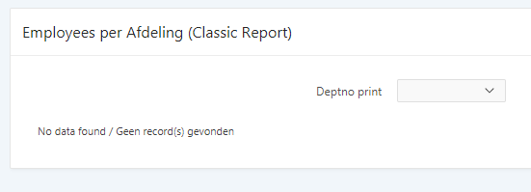

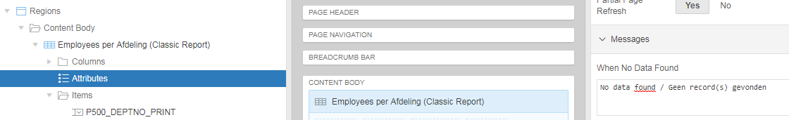

FUNDAMENTALS 2

Application 260

Pre-Rendering : Automatic Row Fetch

Table Name: PAGES
Primary Key Column: ID
Primary Key Item: P5_ID

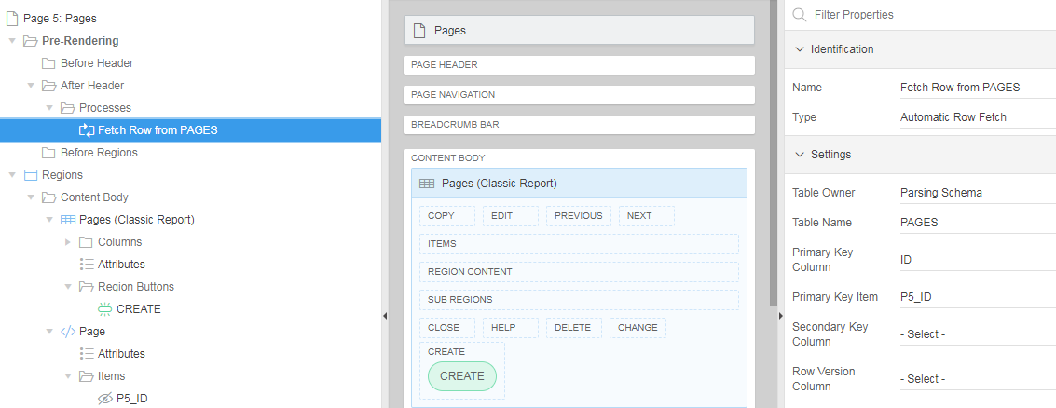

Character Counter:

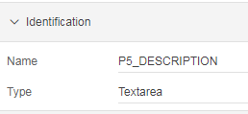

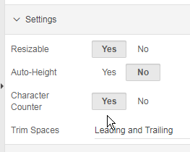

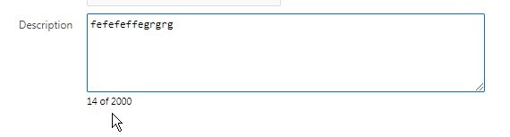
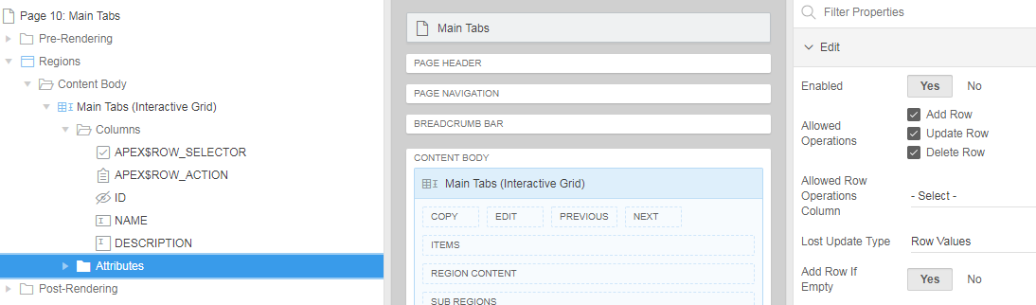

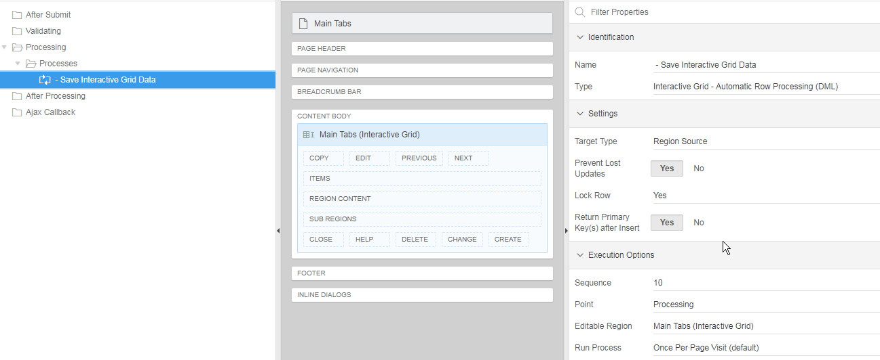

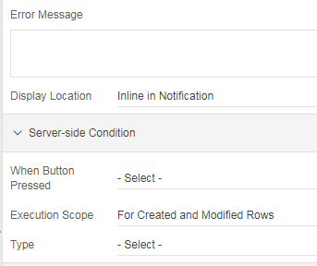

Menu opties rechtermuisklik

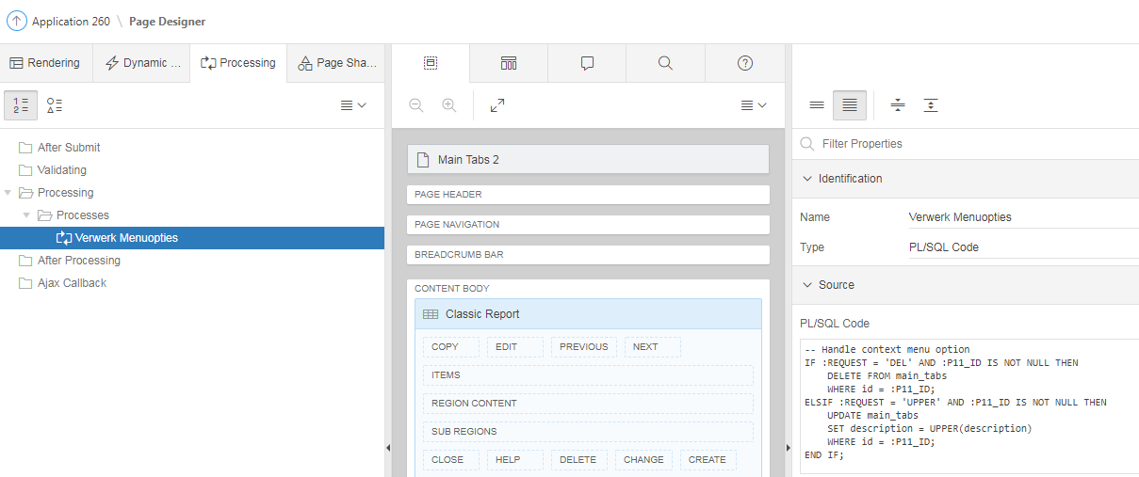

-- Handle context menu option
IF :REQUEST = 'DEL' AND :P11_ID IS NOT NULL THEN
DELETE FROM main_tabs
WHERE id = :P11_ID;
ELSIF :REQUEST = 'UPPER' AND :P11_ID IS NOT NULL THEN
UPDATE main_tabs
SET description = UPPER(description)
WHERE id = :P11_ID;
END IF;

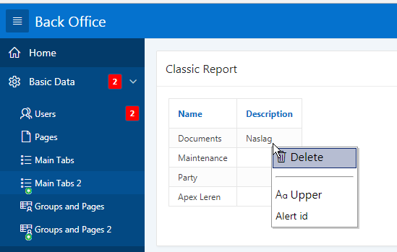

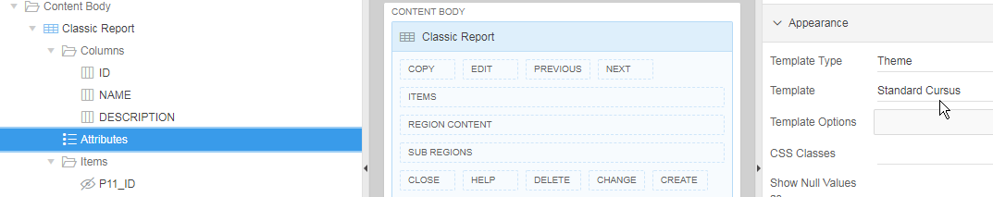

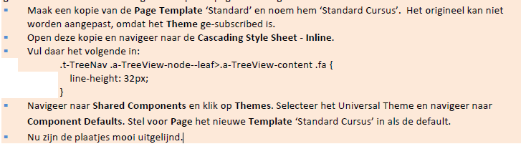

Vul Shuttle

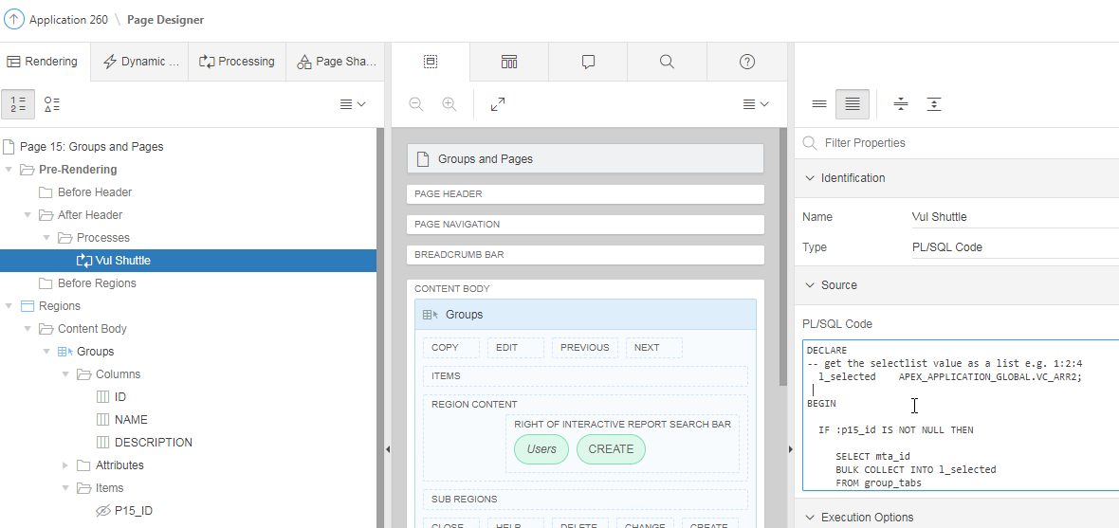

DECLARE
-- get the selectlist value as a list e.g. 1:2:4
l_selected APEX_APPLICATION_GLOBAL.VC_ARR2;

BEGIN

IF :p15_id IS NOT NULL THEN

SELECT mta_id
BULK COLLECT INTO l_selected
FROM group_tabs
WHERE gro_id = :p15_id ;

-- Assign the colon separated list to l_selected
:p15_shuttle := APEX_UTIL.TABLE_TO_STRING(l_selected);

END IF;

END;

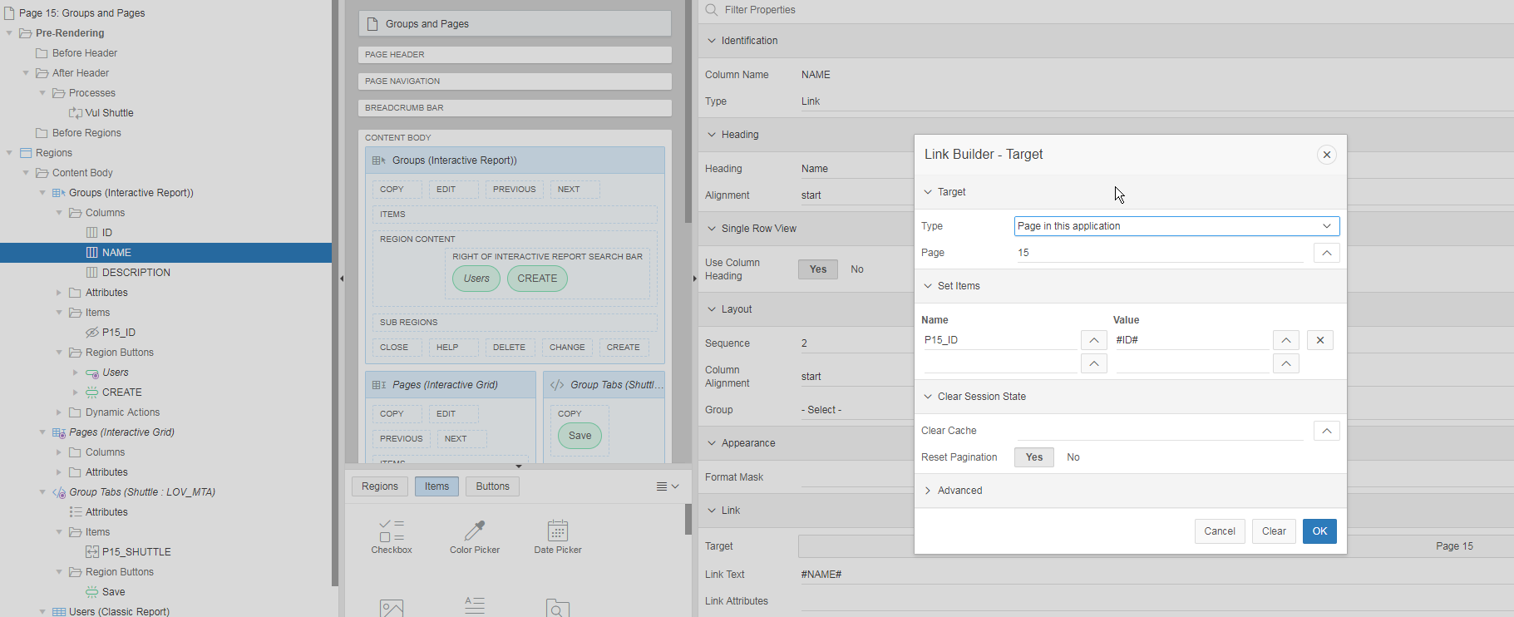

Open scherm via Javascript

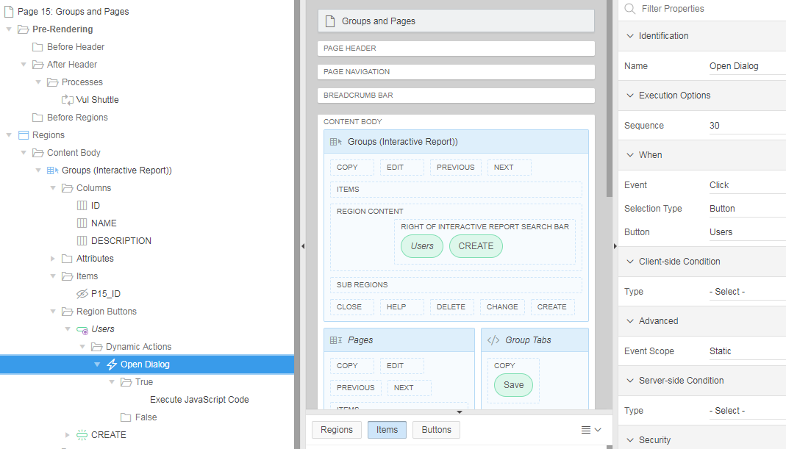

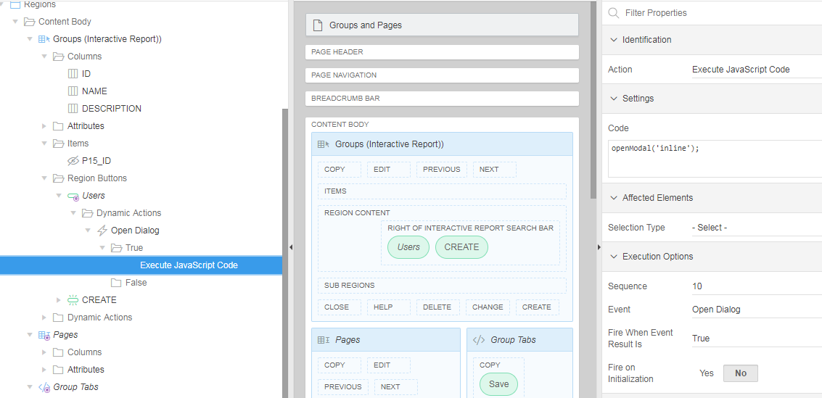

openModal('inline');

inline is het “Static ID” van het Classic Report Users:

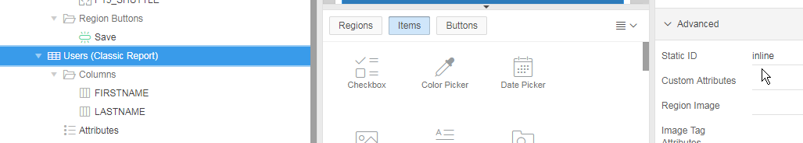

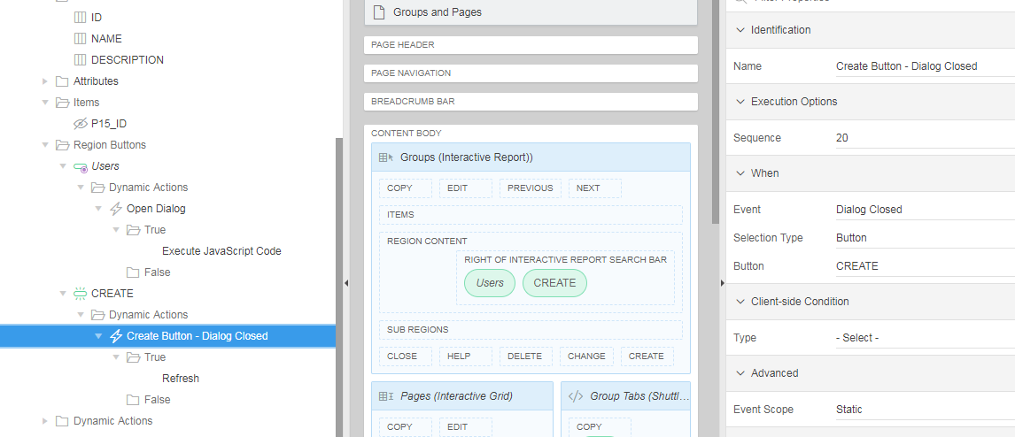

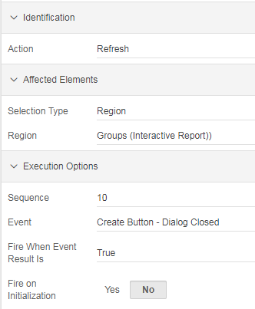

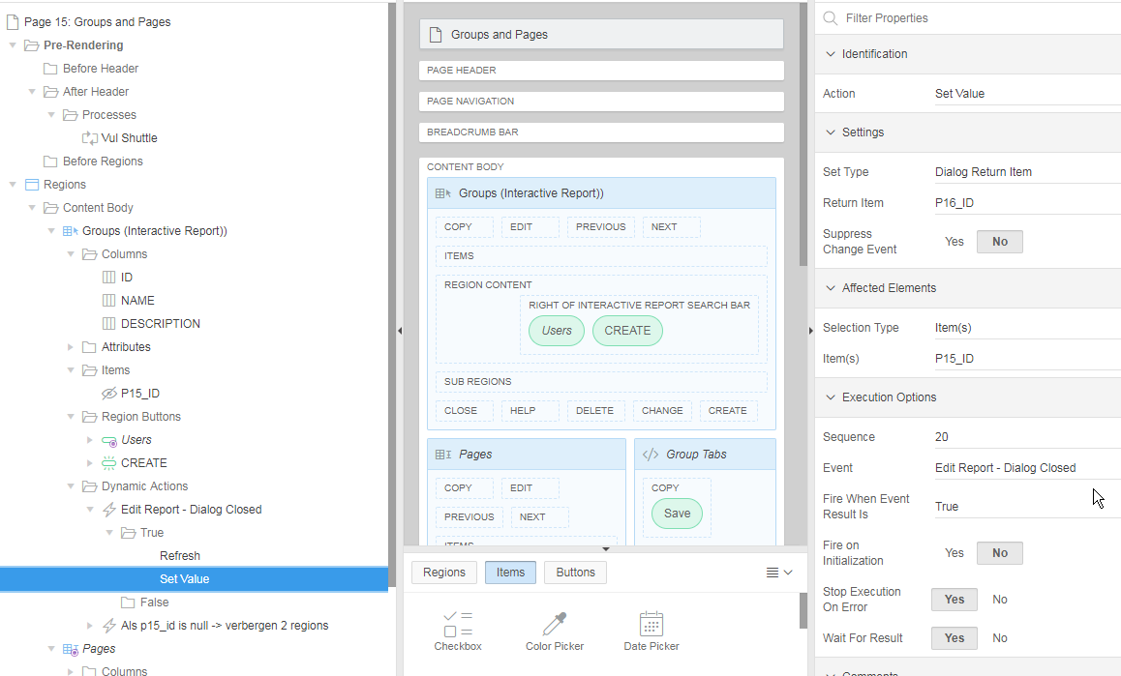

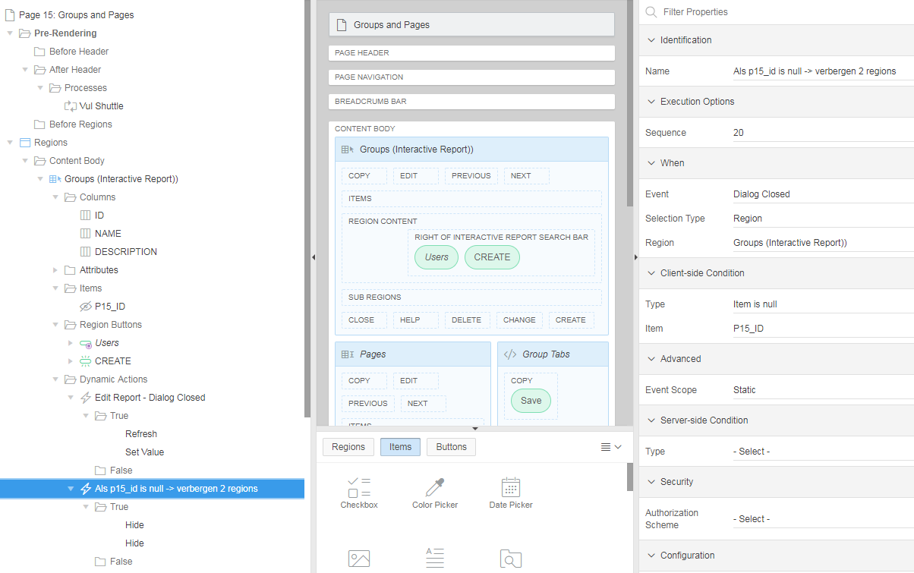

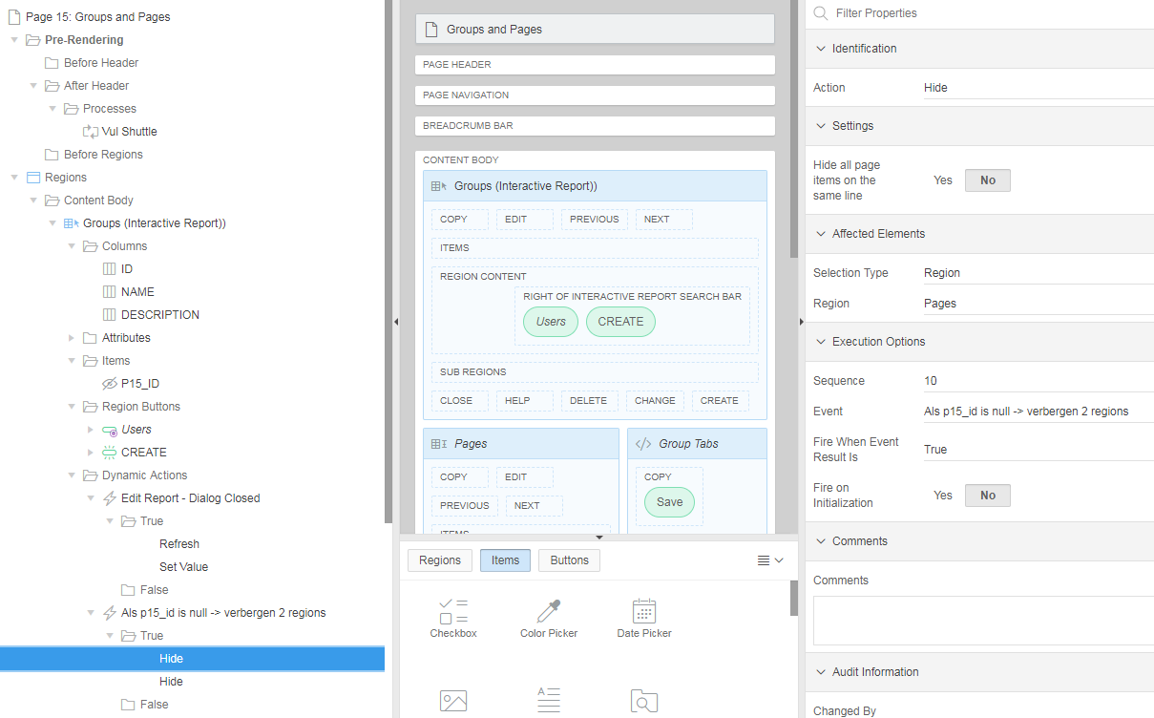

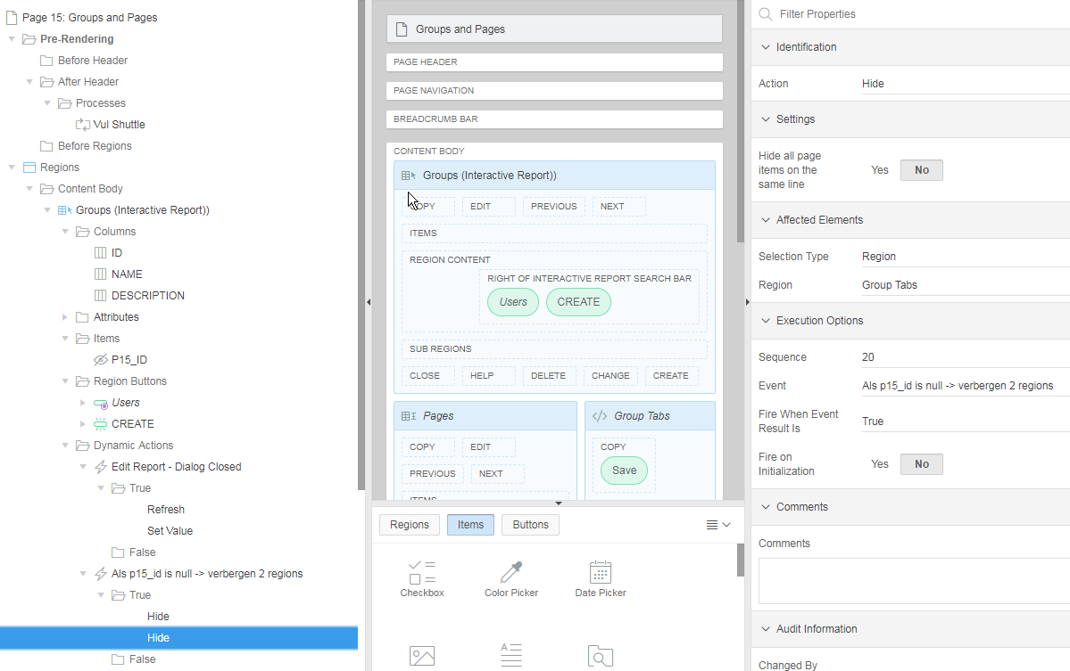

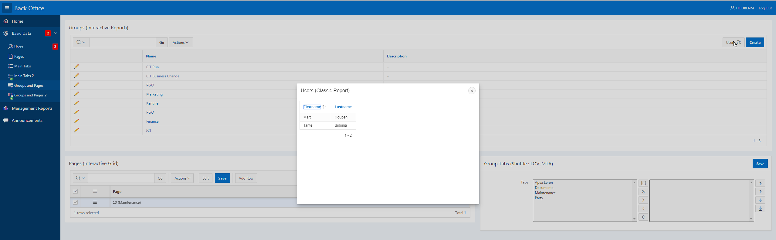

Save Shuttle

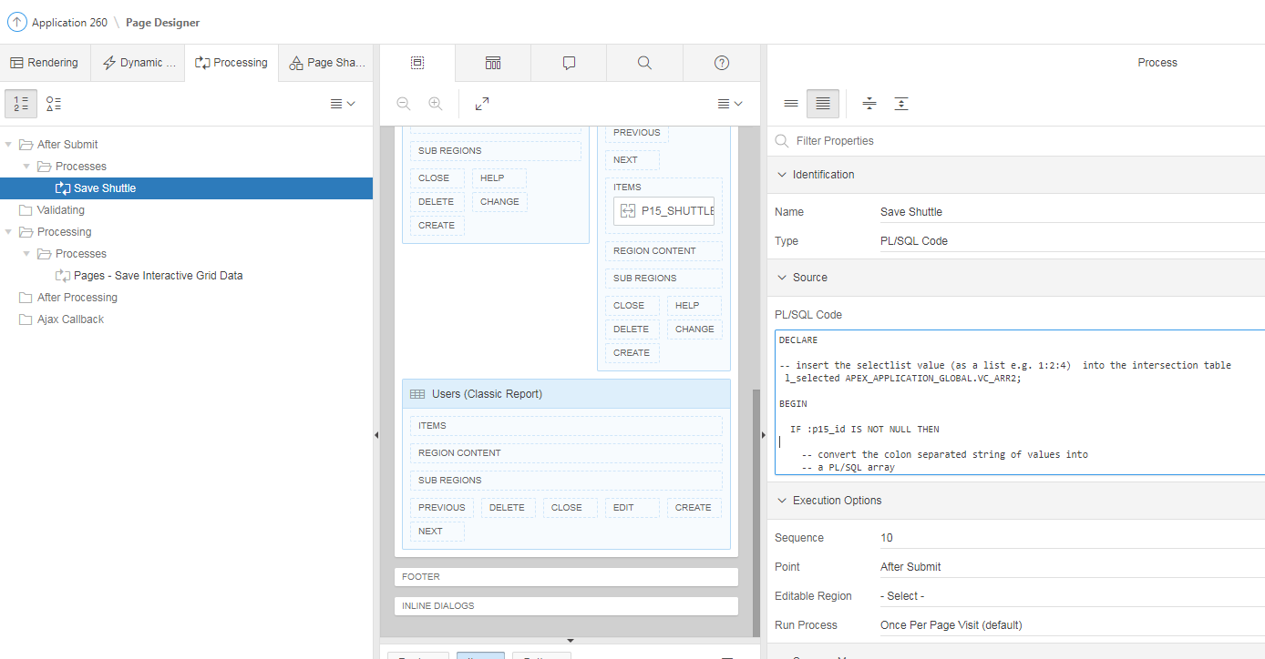

DECLARE

-- insert the selectlist value (as a list e.g. 1:2:4) into the intersection table
l_selected APEX_APPLICATION_GLOBAL.VC_ARR2;

BEGIN

IF :p15_id IS NOT NULL THEN

-- convert the colon separated string of values into
-- a PL/SQL array
l_selected := APEX_UTIL.STRING_TO_TABLE(:p15_shuttle);

-- clean up the intersection table first
DELETE FROM group_tabs
WHERE gro_id = :p15_id;

-- Loop over array to insert lookup_ids and master_id
-- in to intersection table
FOR i IN 1..l_selected.count LOOP
INSERT INTO group_tabs
( id
, gro_id
, mta_id)
VALUES
(seq_all.nextval
, :p15_id
, l_selected(i) );

END LOOP;

END IF;

END;

Pagina 20

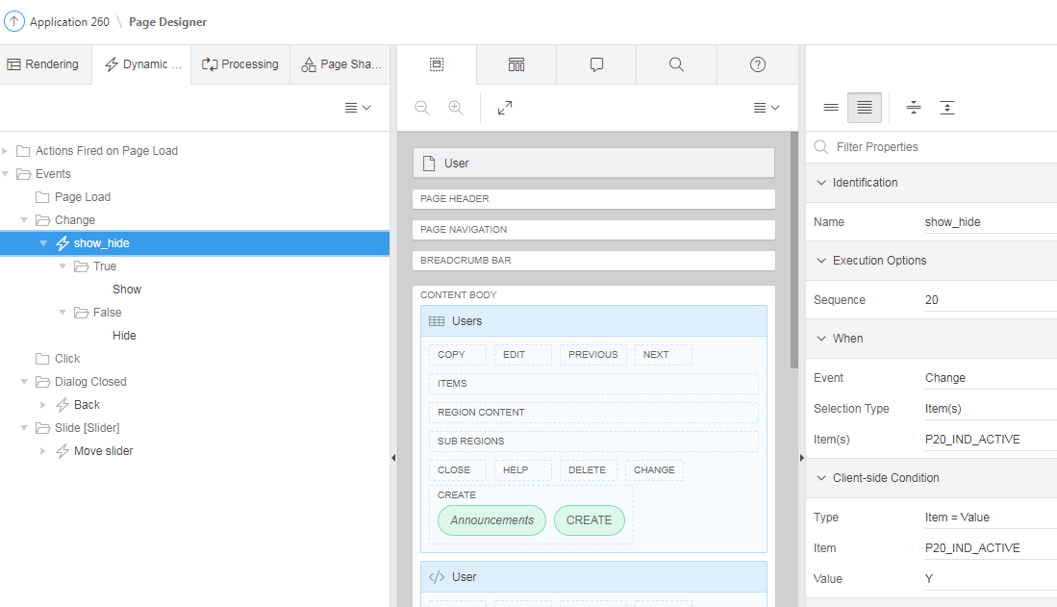

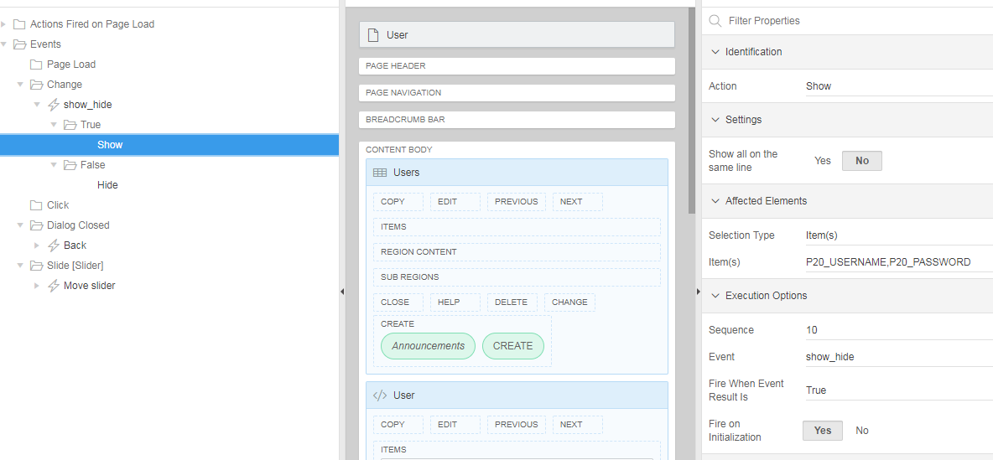

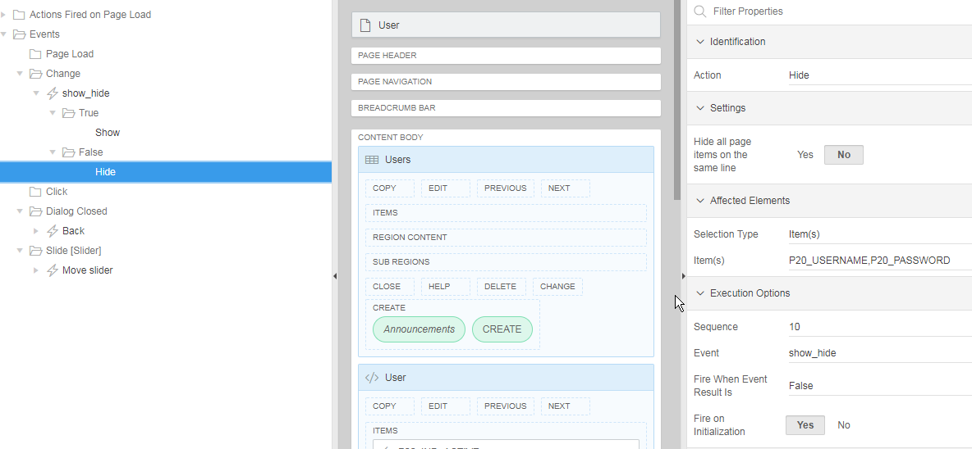

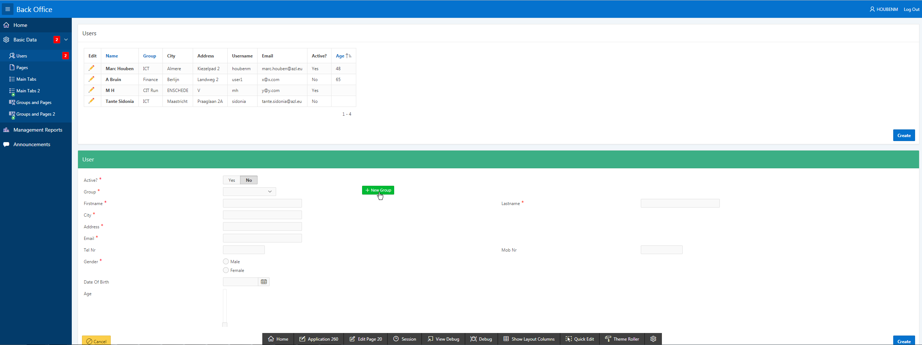

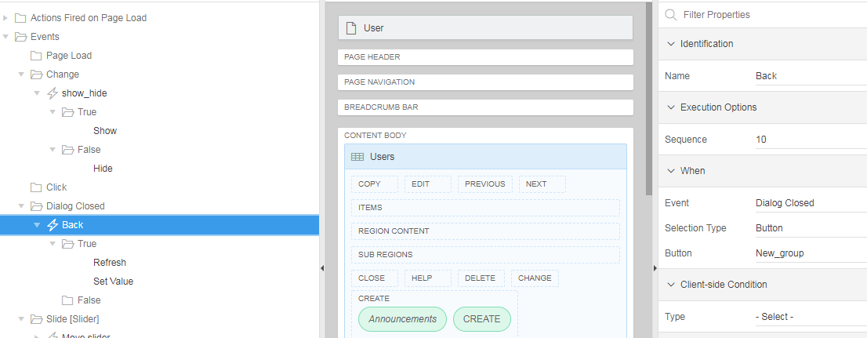

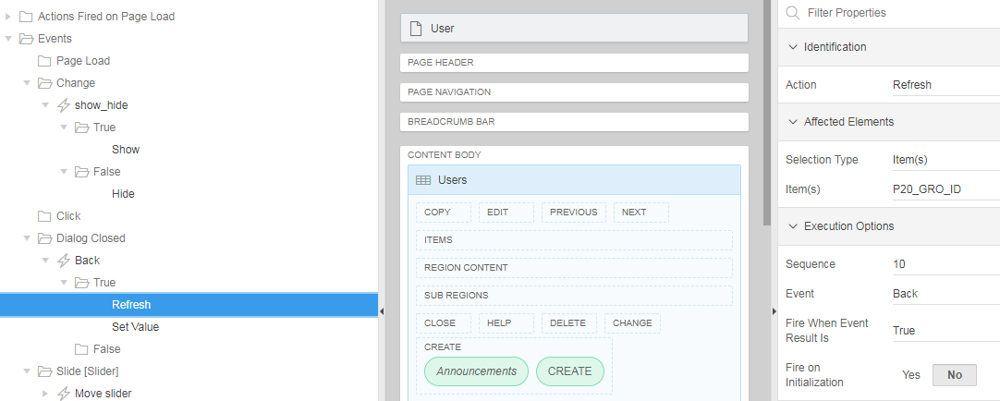

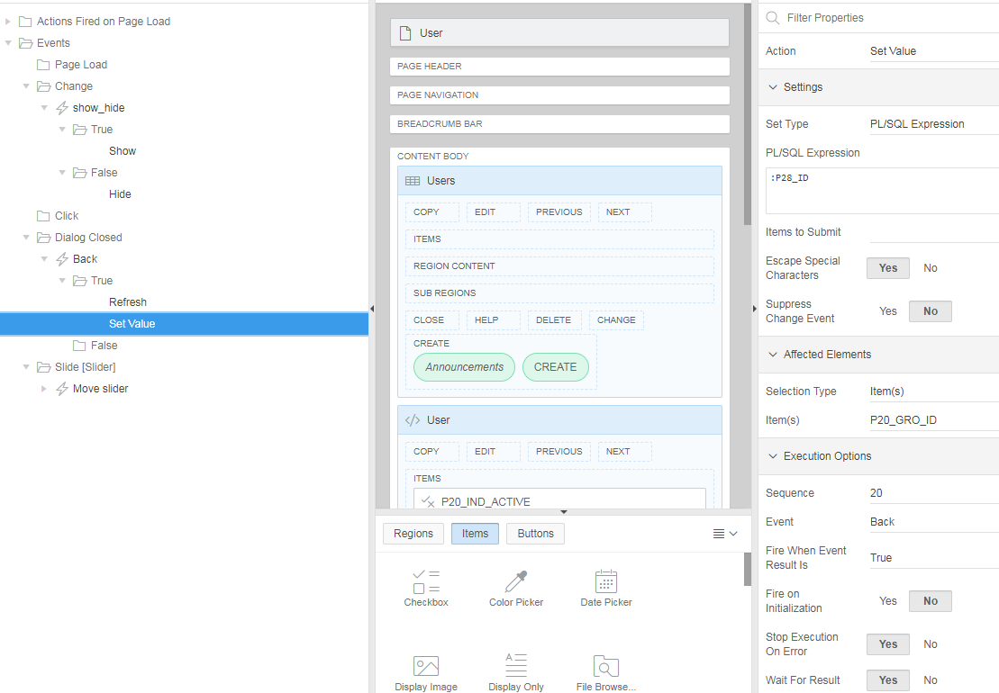

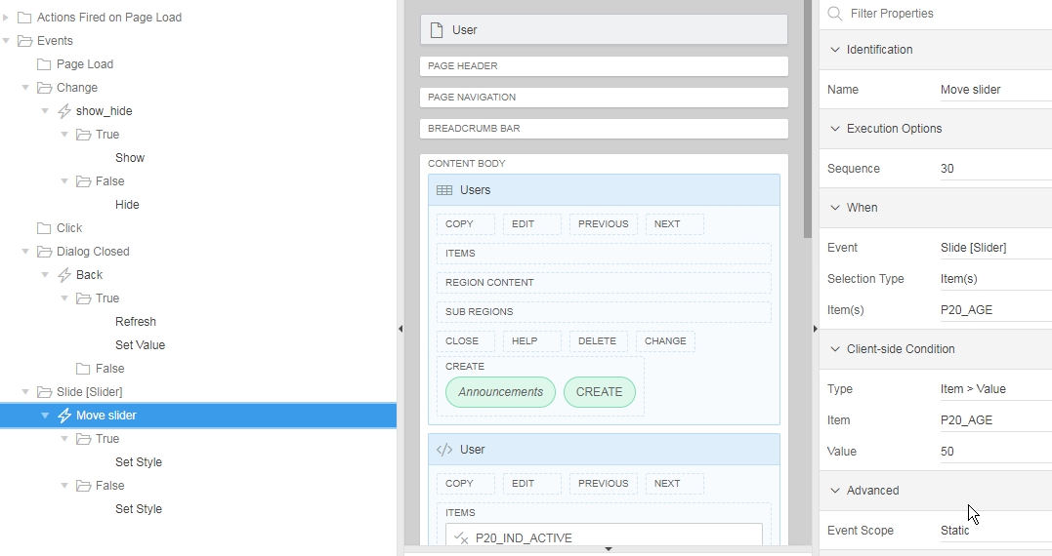

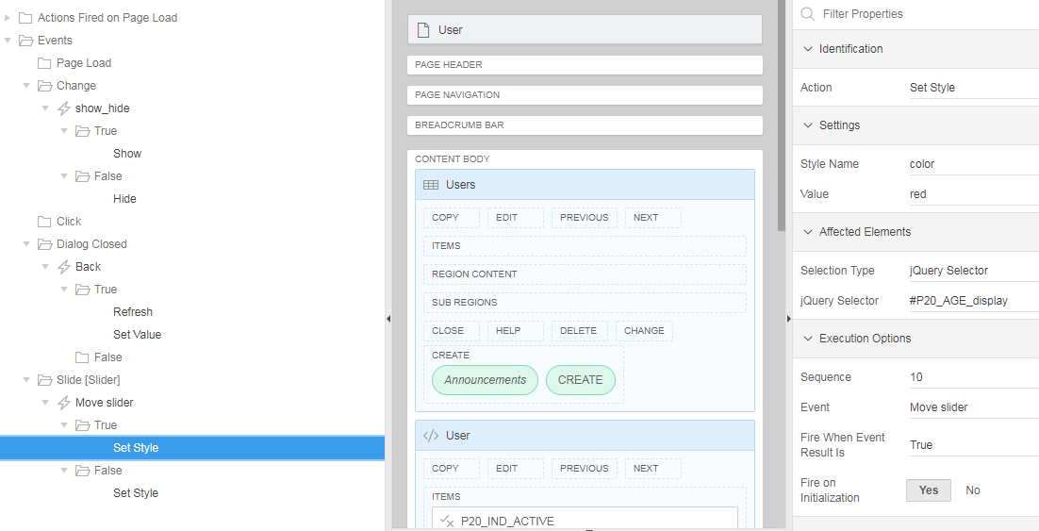

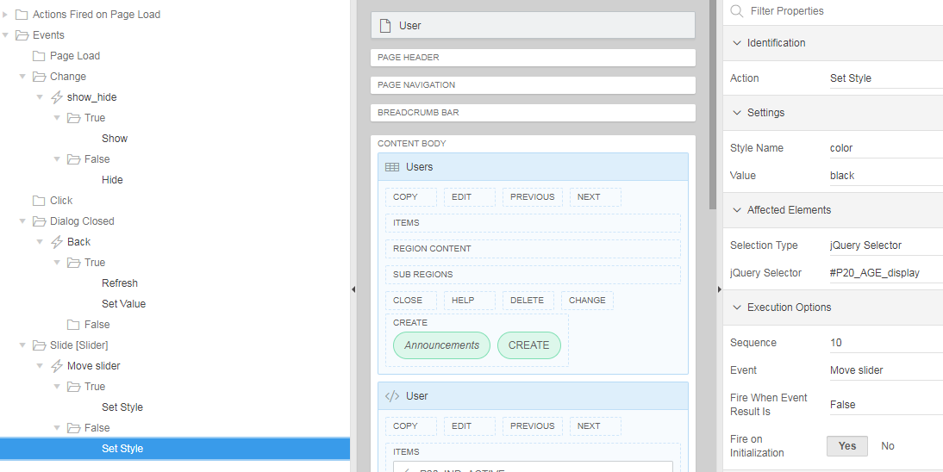

PL/SQL Dynamic Content

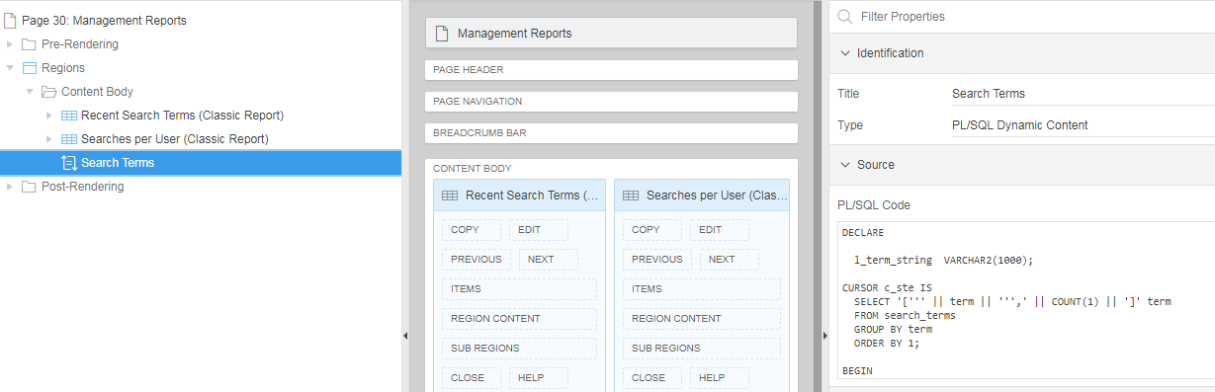

DECLARE

l_term_string VARCHAR2(1000);

CURSOR c_ste IS
SELECT '[''' || term || ''',' || COUNT(1) || ']' term
FROM search_terms
GROUP BY term
ORDER BY 1;

BEGIN

FOR r_ste IN c_ste LOOP
l_term_string := l_term_string || ',' || r_ste.term;
END LOOP;
l_term_string := substr(l_term_string,2);
htp.p('
<script type="text/javascript" src="https://www.gstatic.com/charts/loader.js"></script>
<script type="text/javascript">
google.charts.load(''current'', {''packages'':[''corechart'']});
google.charts.setOnLoadCallback(drawChart);
function drawChart() {
var data = new google.visualization.DataTable();

data.addColumn(''string'', ''Term'');
data.addColumn(''number'', ''nr'');
data.addRows([
');
htp.p(l_term_string);
htp.p(' ]);
var options = {''title'':''Search terms'',
''width'':400,
''height'':300};
var chart = new google.visualization.PieChart(document.getElementById(''chart_div''));
chart.draw(data, options);
}
</script>
<div id="chart_div"></div>
');

END;

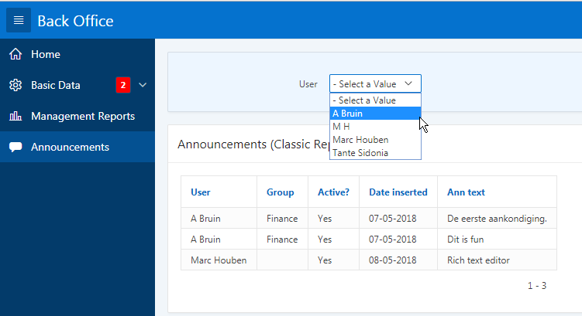

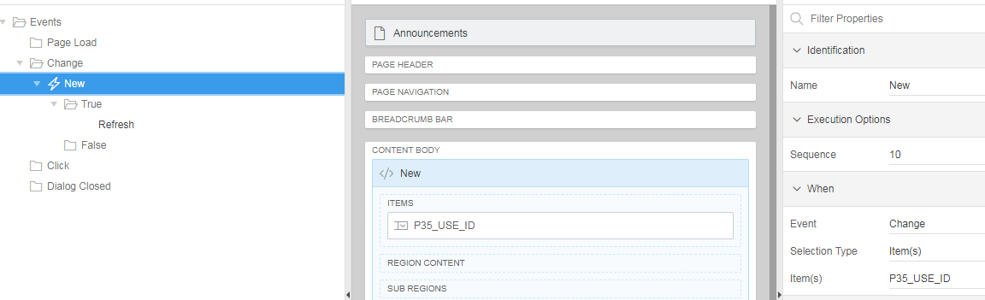

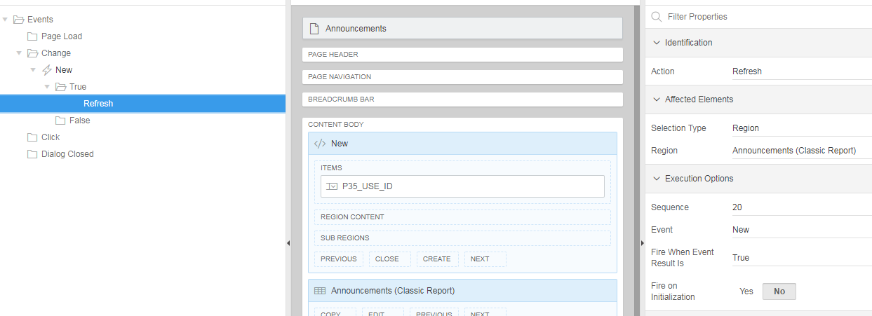

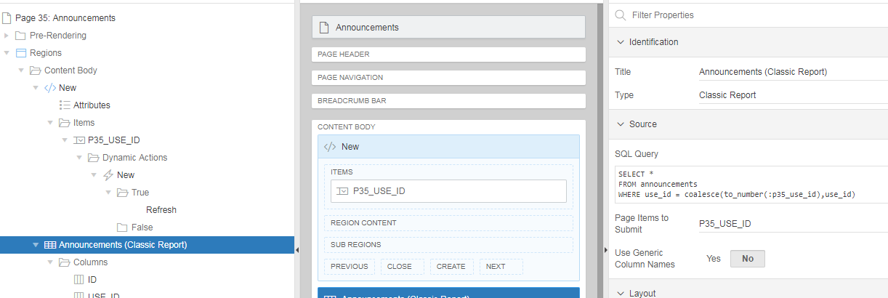
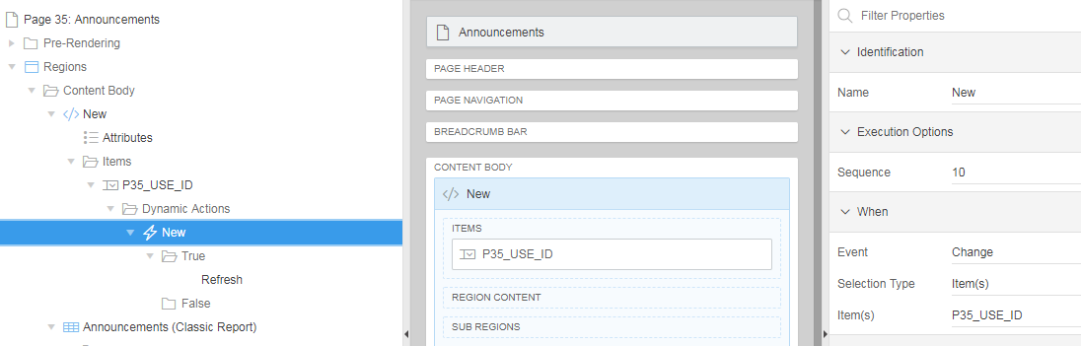

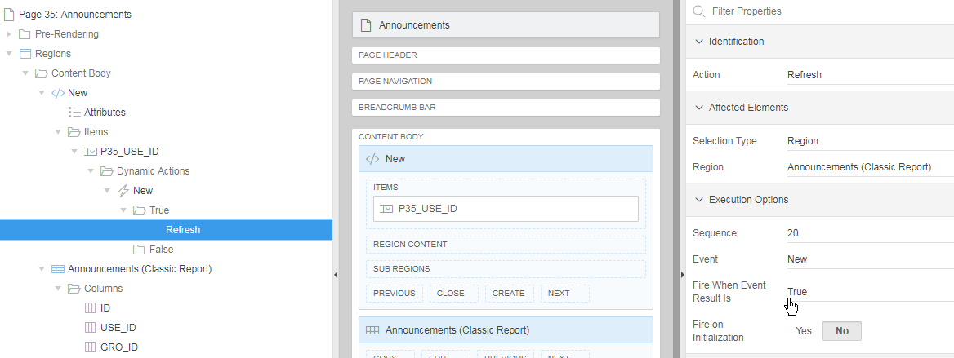

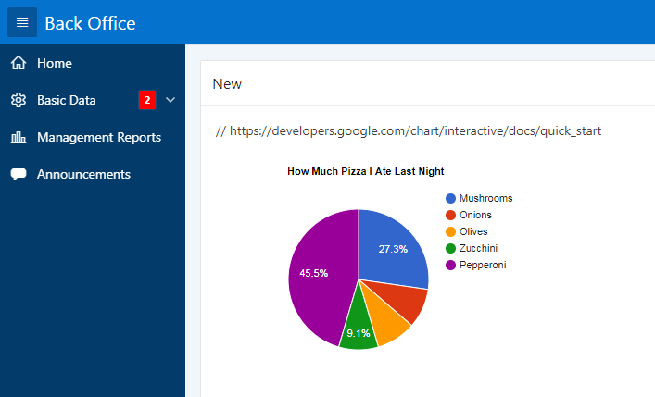

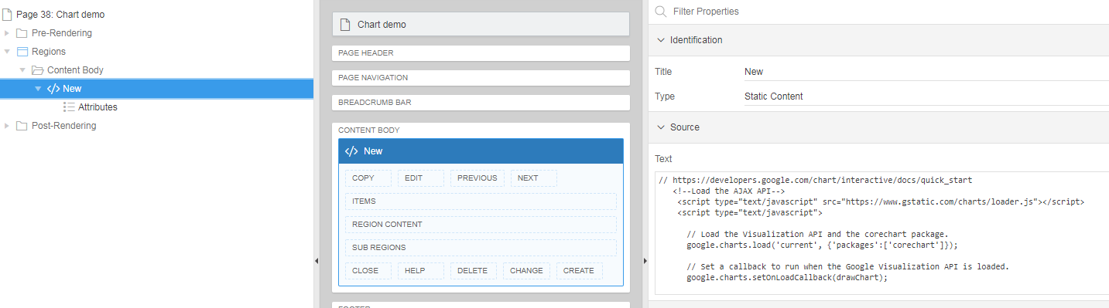

// https://developers.google.com/chart/interactive/docs/quick_start
<!--Load the AJAX API-->
<script type="text/javascript" src="https://www.gstatic.com/charts/loader.js"></script>
<script type="text/javascript">

// Load the Visualization API and the corechart package.
google.charts.load('current', {'packages':['corechart']});

// Set a callback to run when the Google Visualization API is loaded.
google.charts.setOnLoadCallback(drawChart);

// Callback that creates and populates a data table,
// instantiates the pie chart, passes in the data and
// draws it.
function drawChart() {

// Create the data table.
var data = new google.visualization.DataTable();
data.addColumn('string', 'Topping');
data.addColumn('number', 'Slices');
data.addRows([
['Mushrooms', 3],
['Onions', 1],
['Olives', 1],
['Zucchini', 1],
['Pepperoni', 5]
]);

// Set chart options
var options = {'title':'How Much Pizza I Ate Last Night',
'width':400,
'height':300};

// Instantiate and draw our chart, passing in some options.
var chart = new google.visualization.PieChart(document.getElementById('chart_div'));
chart.draw(data, options);
}
</script>

<!--Div that will hold the pie chart-->
<div id="chart_div"></div>

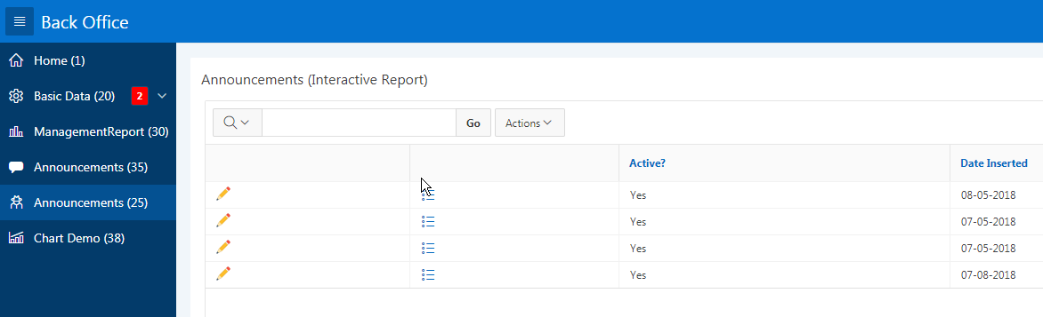

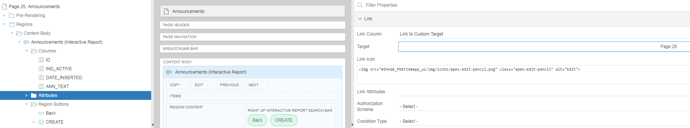

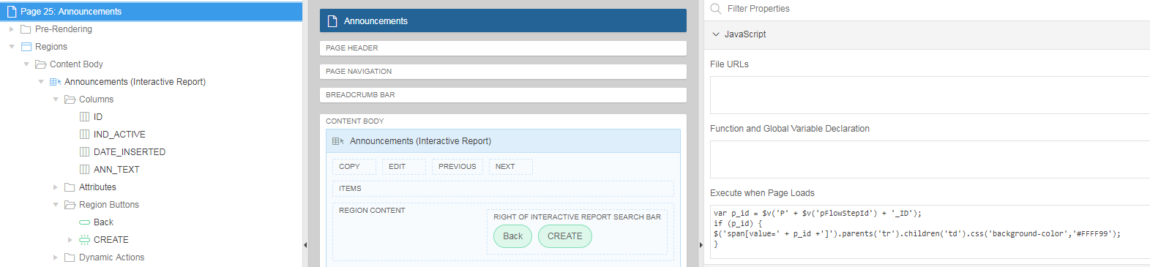

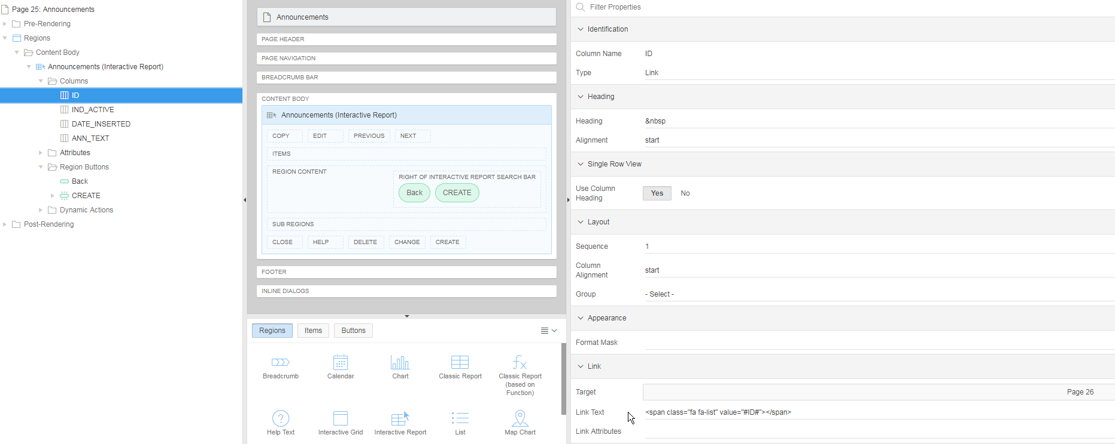

Application 280

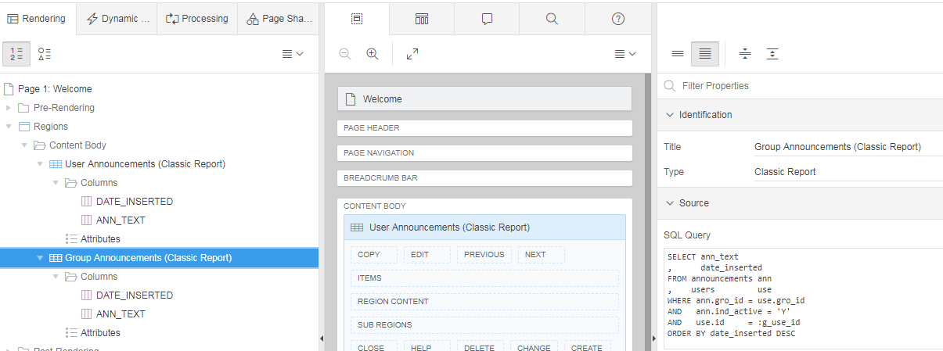

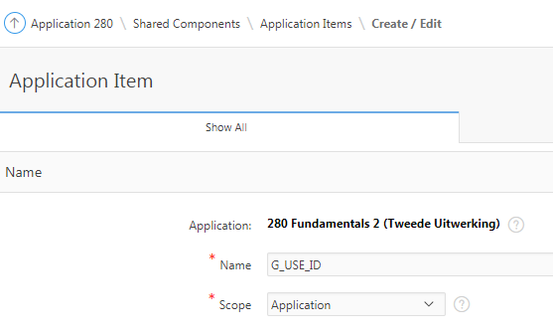
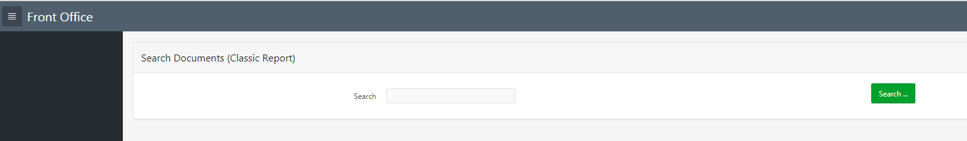

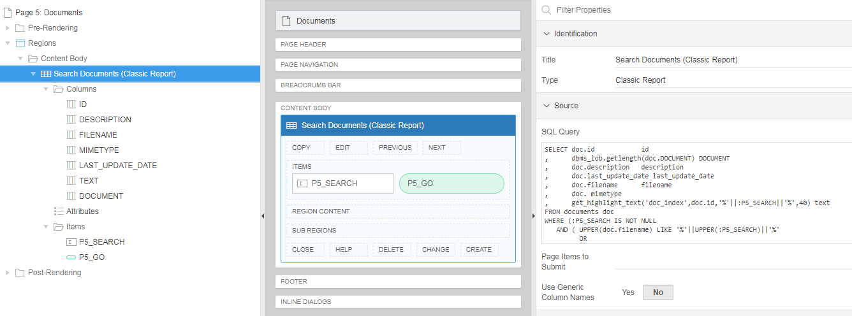

SELECT doc.id id
, dbms_lob.getlength(doc.DOCUMENT) DOCUMENT
, doc.description description
, doc.last_update_date last_update_date
, doc.filename filename
, doc. mimetype
, get_highlight_text('doc_index',doc.id,'%'||:P5_SEARCH||'%',40) text
FROM documents doc
WHERE (:P5_SEARCH IS NOT NULL
AND ( UPPER(doc.filename) LIKE '%'||UPPER(:P5_SEARCH)||'%'
OR
UPPER(doc.description) LIKE '%'||UPPER(:P5_SEARCH)||'%'
OR
CONTAINS(doc.document, '%'||:P5_SEARCH||'%', 1 ) > 0
)
)

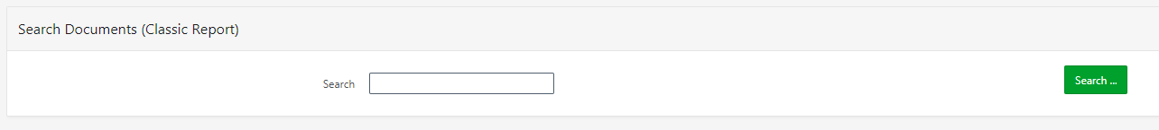

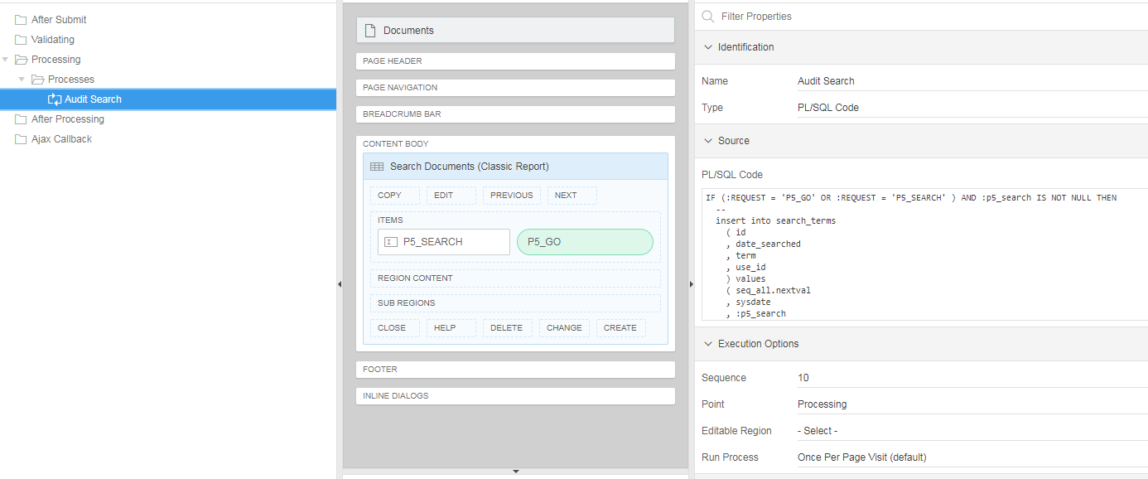

IF (:REQUEST = 'P5_GO' OR :REQUEST = 'P5_SEARCH' ) AND :p5_search IS NOT NULL THEN
--
insert into search_terms
( id
, date_searched
, term
, use_id
) values
( seq_all.nextval
, sysdate
, :p5_search
, :g_use_id
);
--
END IF;

File Browse…

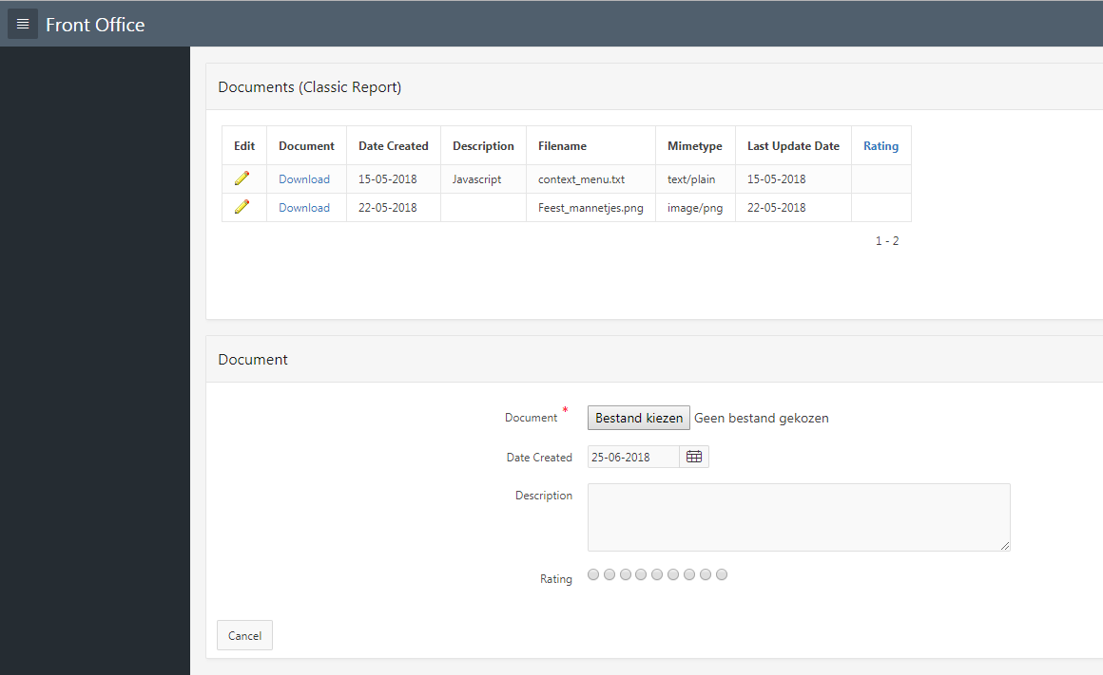

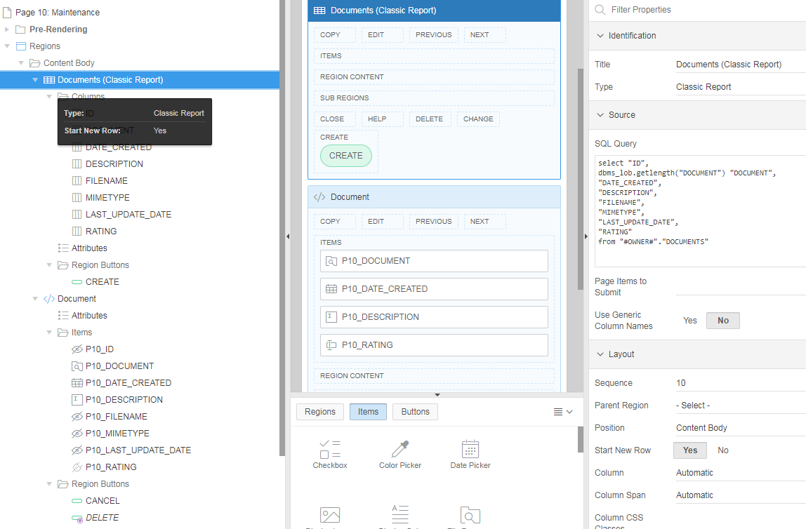

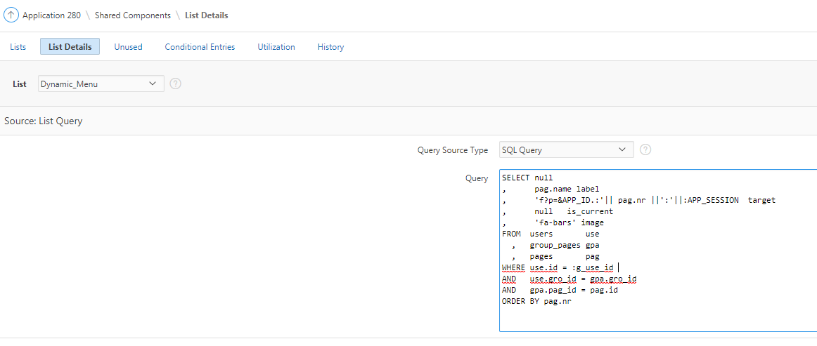

SELECT null
, pag.name label
, 'f?p=&APP_ID.:'|| pag.nr ||':'||:APP_SESSION target
, null is_current
, 'fa-bars' image
FROM users use
, group_pages gpa
, pages pag
WHERE use.id = :g_use_id
AND use.gro_id = gpa.gro_id
AND gpa.pag_id = pag.id
ORDER BY pag.nr

SELECT * FROM USERS;
-- id = 18, gro_id = 5

SELECT * FROM pages;
-- id = 1 = Maintenance

SELECT * FROM group_pages;

SELECT null
, pag.name label
--, 'f?p=&APP_ID.:'|| pag.nr ||':'||:APP_SESSION target
, null is_current
, 'fa-bars' image
FROM users use
, group_pages gpa
, pages pag
WHERE use.id = 18
AND use.gro_id = gpa.gro_id
AND gpa.pag_id = pag.id
ORDER BY pag.nr

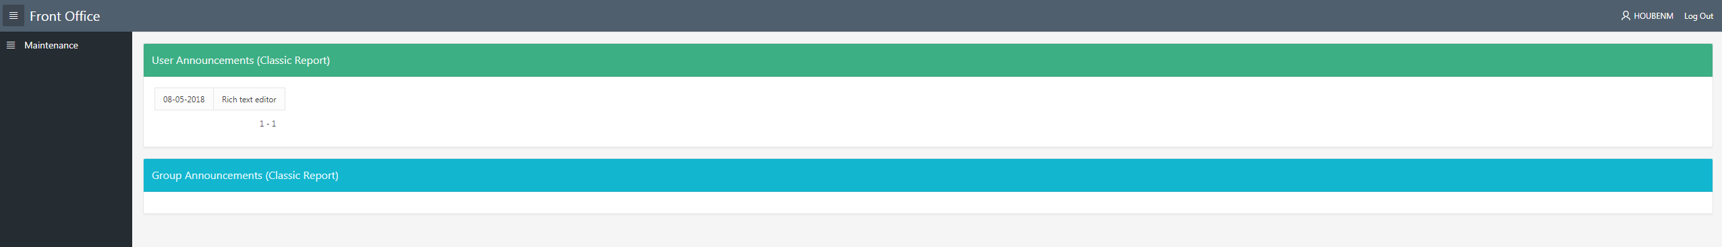

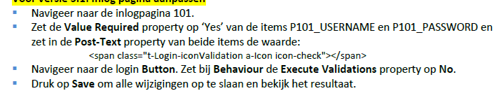

OVERIG

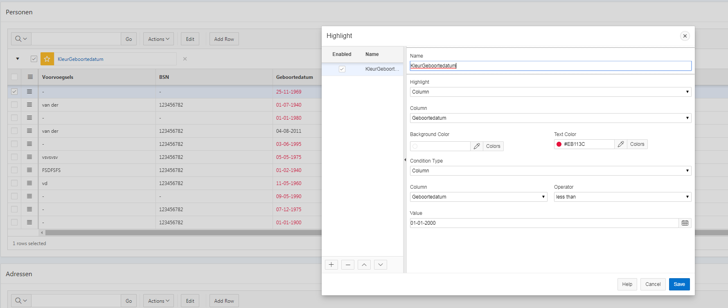

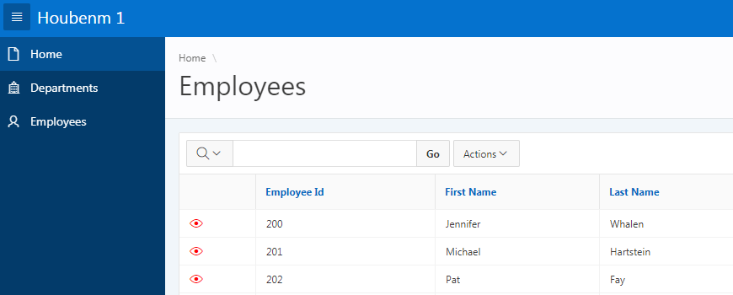
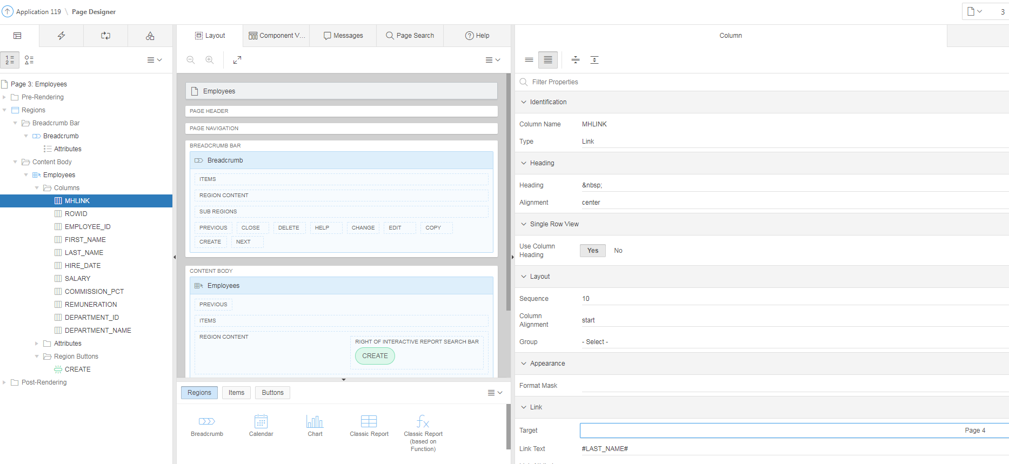
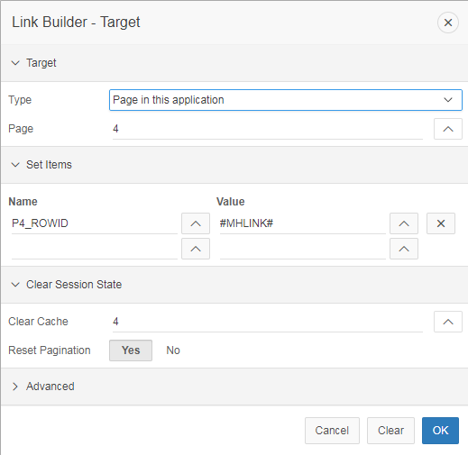

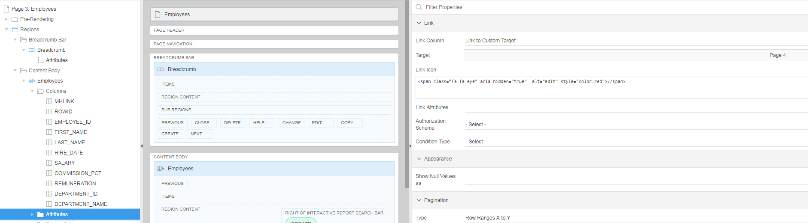
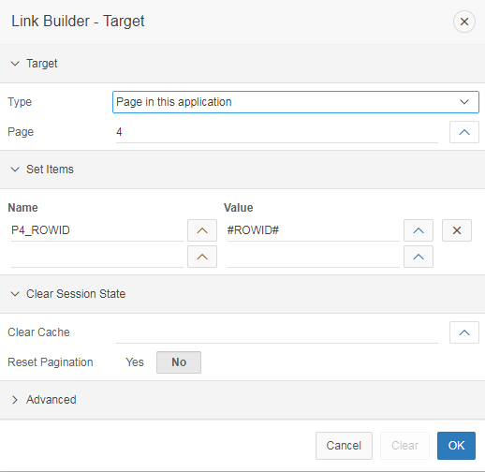
Link Icon: <span class="fa fa-eye" aria-hidden="true" alt="Edit" style="color:red"></span>

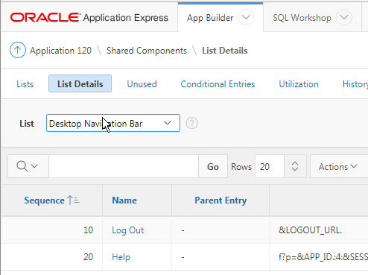
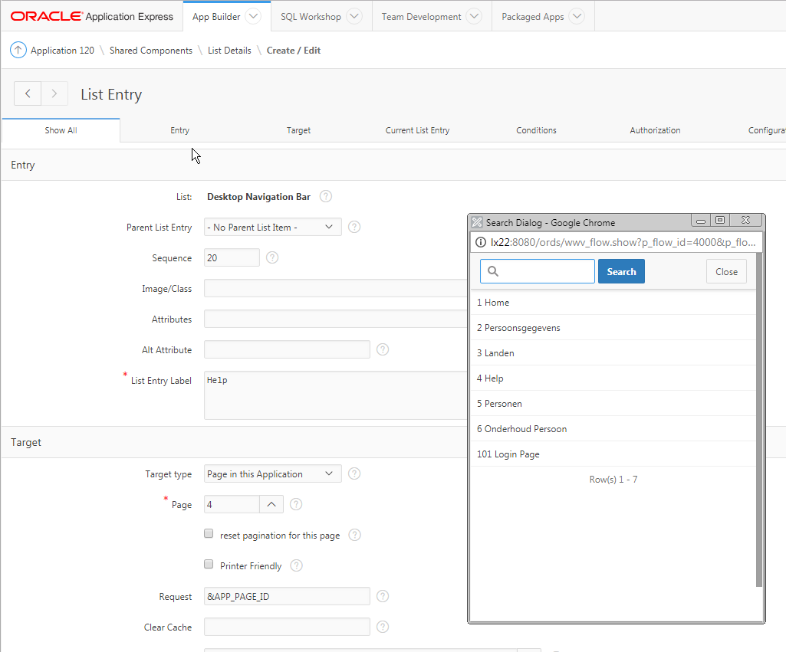
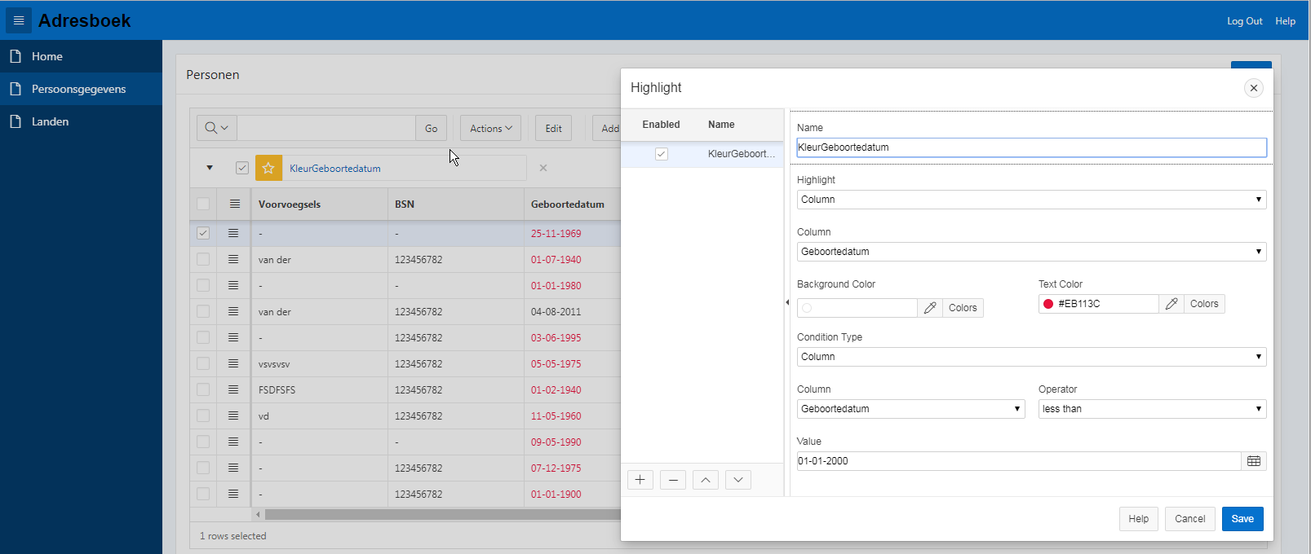
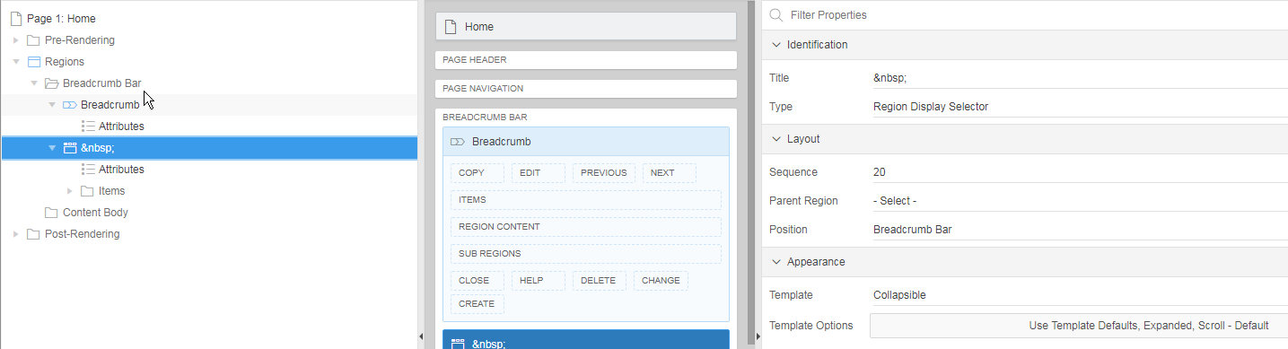
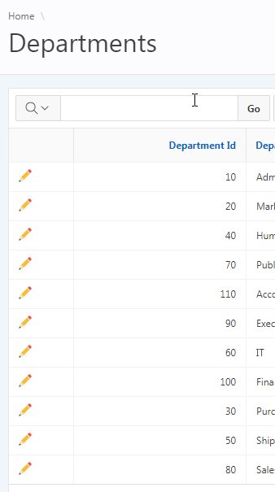
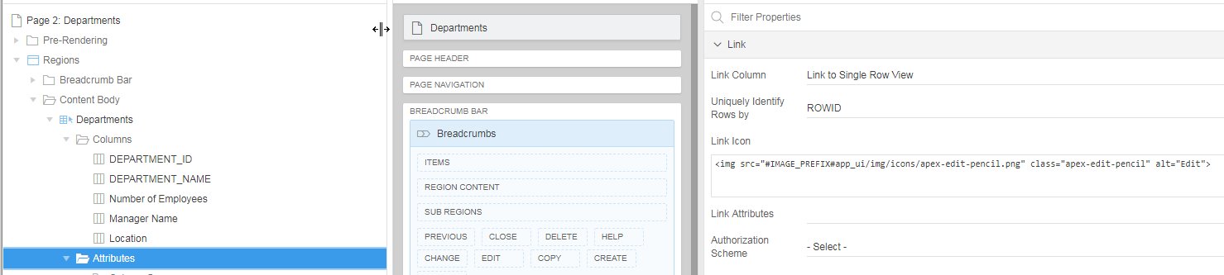
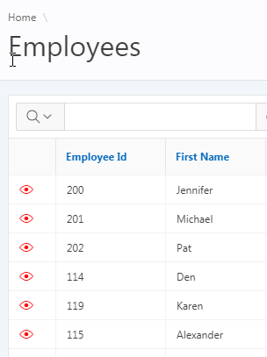
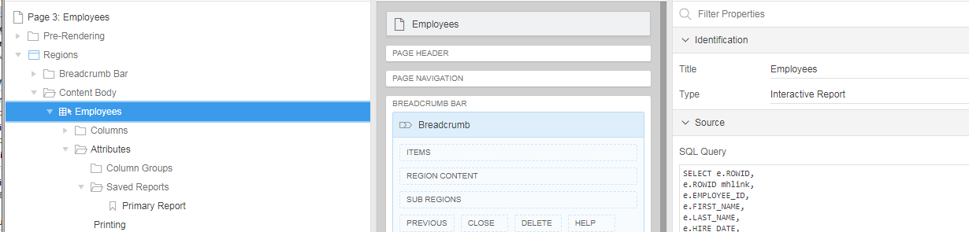
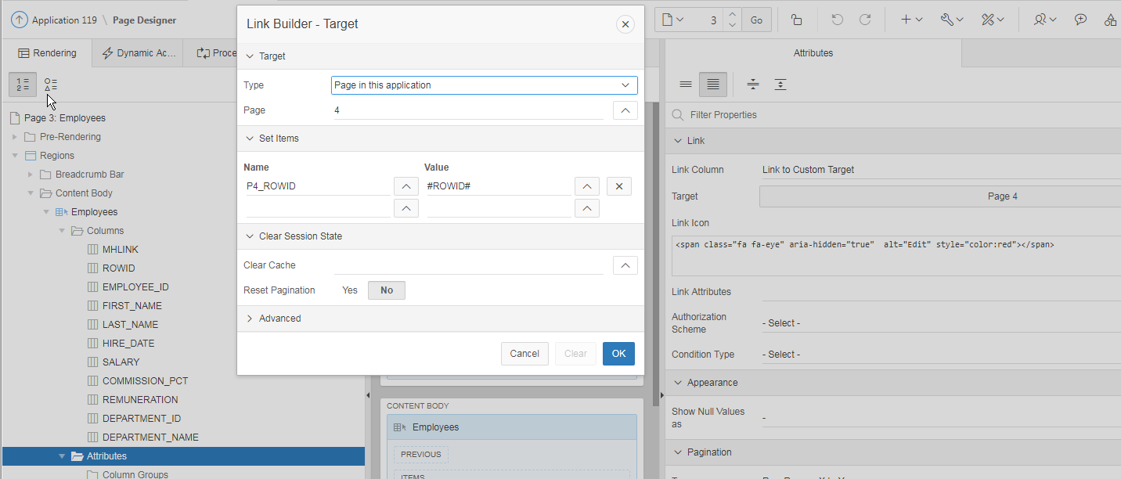
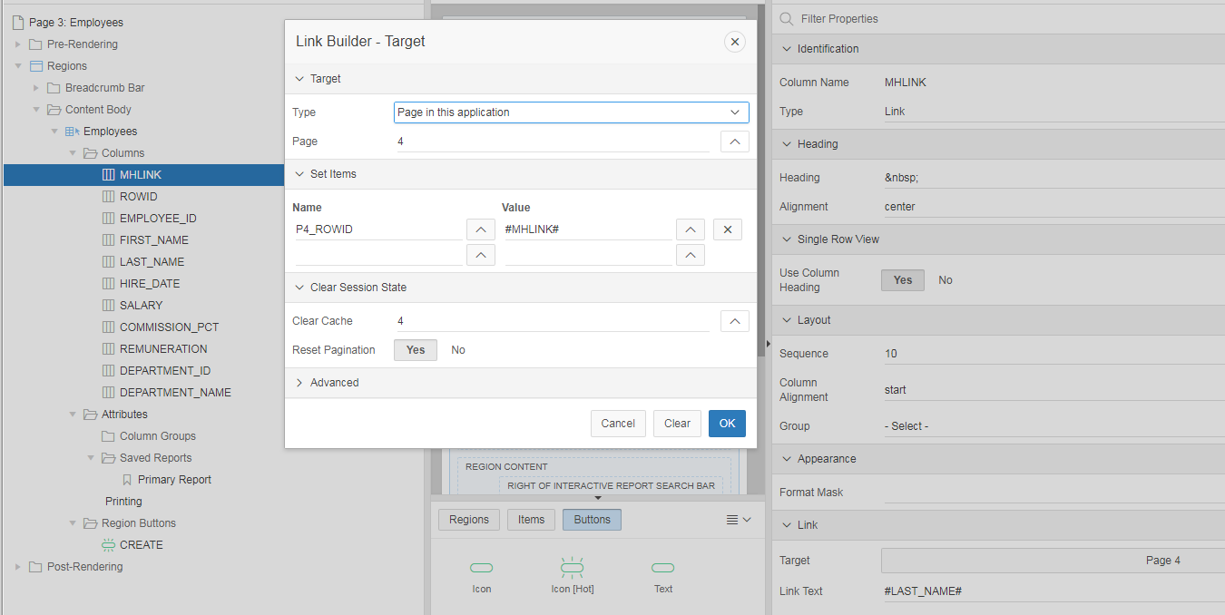
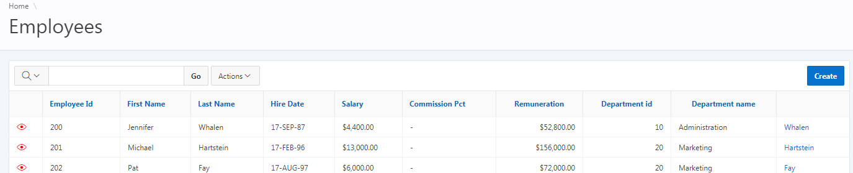
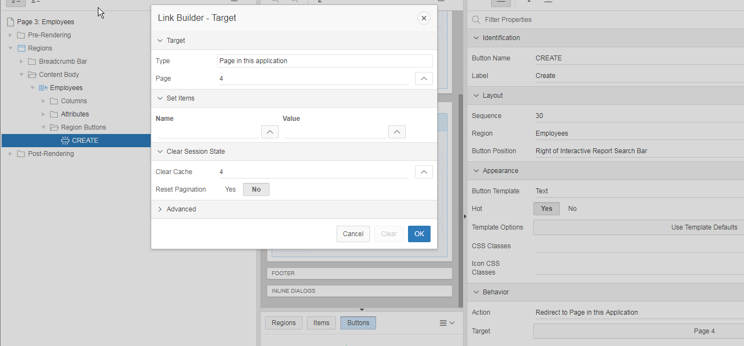

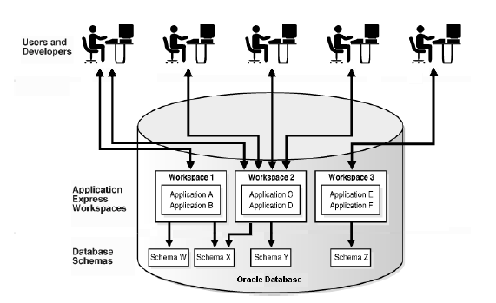

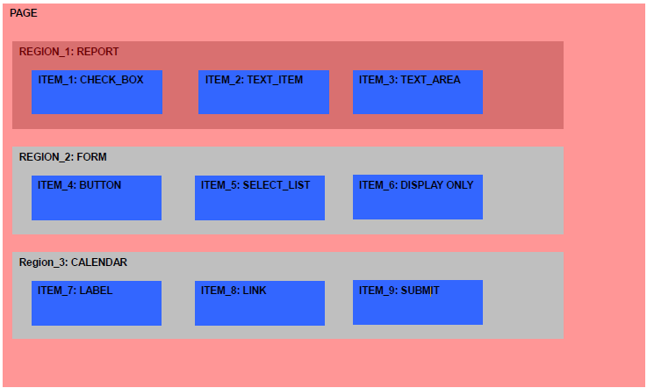

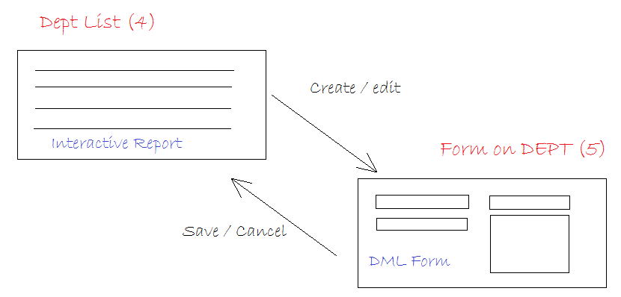

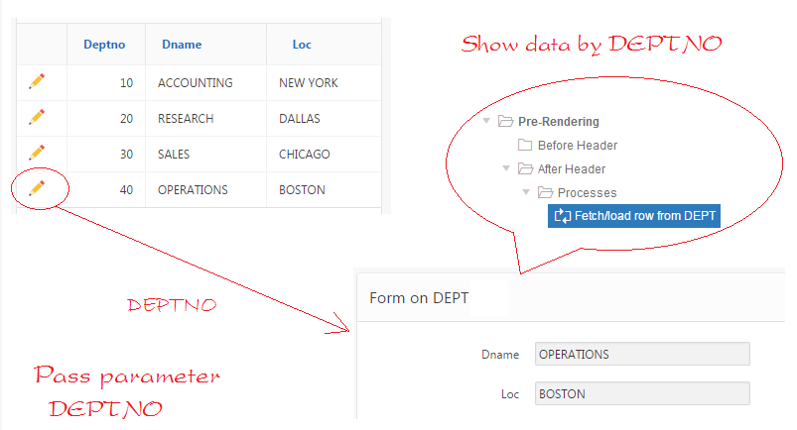

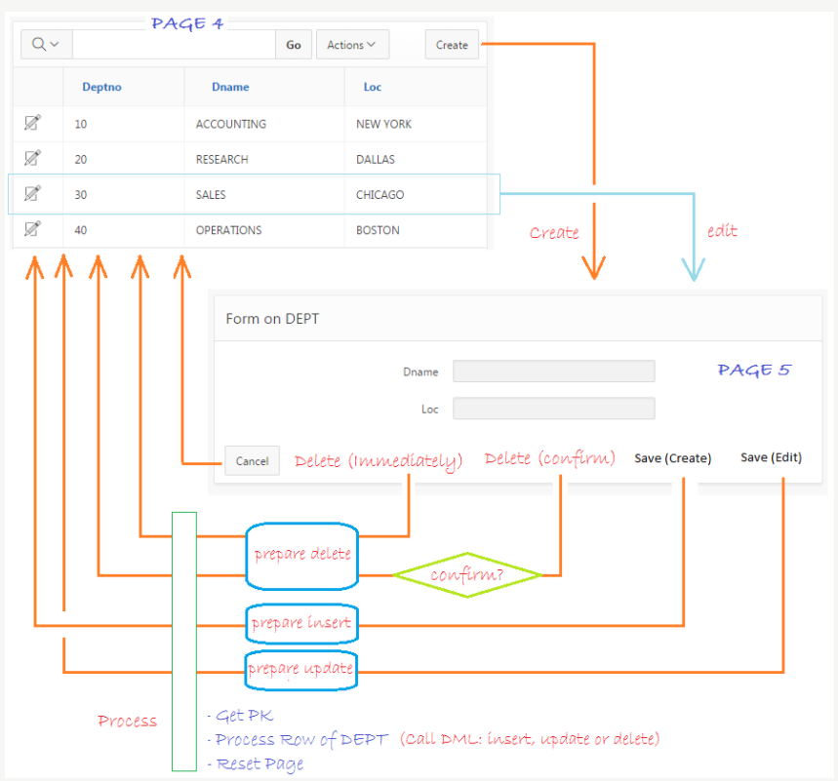

PL/SQL Expression
:G_PF_NUMMER is not null AND (:APP_USER = :P10150_BEHANDELAAR OR nvl(:P10150_IN_BEHANDELING,0) = 0) AND nvl(:P10150_AKKOORD_AANGEVRAAGD,0) = 0

:APP_USER <> :P10150_BEHANDELAAR AND :G_PF_NUMMER is not null AND :P10150_AKKOORD_AANGEVRAAGD = 0

SQL Query
select '<div class="fa '||
CASE WHEN LIJN_STATUS = 'Nieuw' THEN 'fa-plus" style="color:green; font-weight:900"'
WHEN LIJN_STATUS = 'Gewijzigd' THEN 'fa-refresh" style="color:orange; font-weight:900"'
WHEN LIJN_STATUS = 'Verwijderd' THEN 'fa-minus" style="color:red; font-weight:900"'
ELSE null
END||'"/>' STATUS,
CODE_CONTRACTANT,
KLANTNUMMER,
CORRECTIEDATUM,
KLANTNUMMER_GERECHTIGDE,
CODE_REGLEMENT,
DATUM_AANVANG_PENSIOENOVEREENK,
CODE_LIJN_TYPE,
DATUM_AANVANG_LIJN,
VORM,
SOORT,
DATUM_AANVANG,
DATUM_EINDE,
UITRUIL,
AANSPRAAK_BACKSERVICE,
GEKOZEN_PENSIOENDATUM,
GEKOZEN_EXPIRATIEDATUM,
TOELICHTING,
VERANTWOORDING,
CODE_KAPITAAL_VERDELING,
KLANTNUMMER_BEGUNSTIGDE,
KAPITAAL_BEREIKT_MUTATIE,
GRONDSLAG_PROLONGATIEPERIODE,
GRONDSLAG_TOEKOMST,
LIJN_STATUS,
AANGEMAAKT_OP,
AANGEMAAKT_DOOR
FROM CO_CM_CORRECTIES_TMP
WHERE code_contractant = :G_PF_NUMMER
AND CASE WHEN :APP_USER = :P10150_BEHANDELAAR AND LIJN_STATUS = 'Verwijderd' THEN 0
WHEN :APP_USER <> :P10150_BEHANDELAAR AND LIJN_STATUS = 'Ongewijzigd' THEN 0
ELSE 1
END = 1

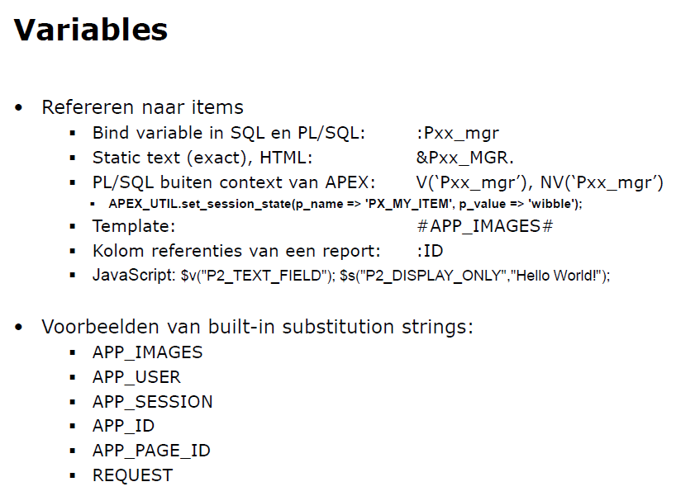

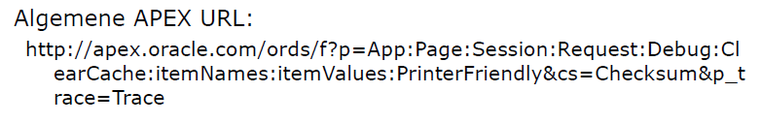

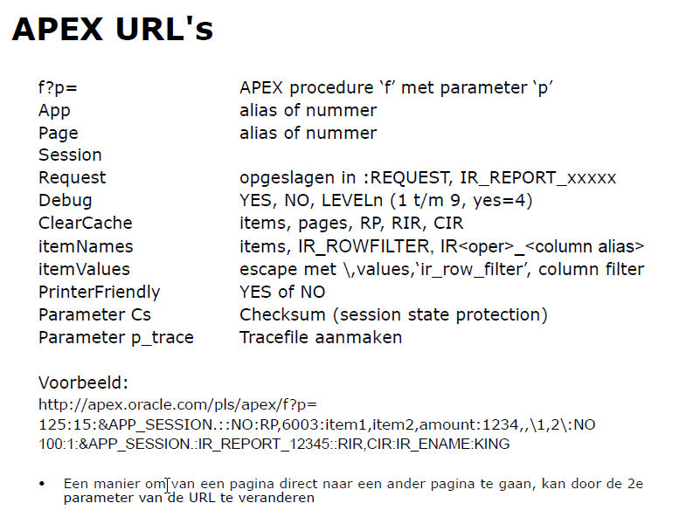

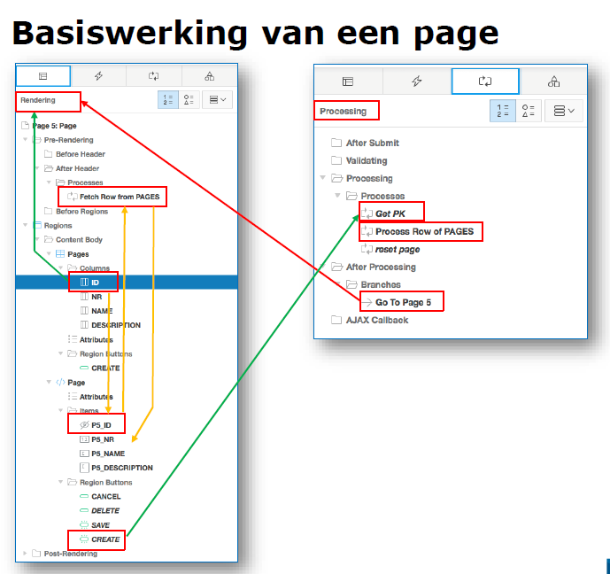

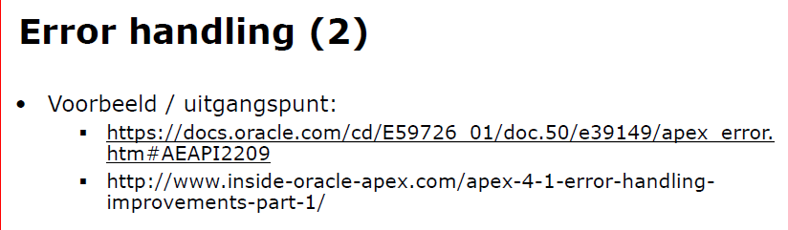

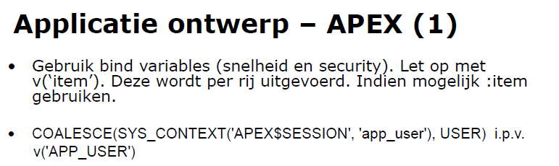

In de URL YES vervangen door LEVEL9 (voor uitgebreide debug).

De Inline Modal Region openen gaat met de volgende JavaScript functie: openModal('static_id_name');
Voor static_id_name moet de Static ID van de Region ingevuld worden.
Sluiten van de Inline Modal Region gaat met de JavaScript functie: closeModal('static_id_name');

Indien Javascript gebruiken dan altijd Static ID invullen (en gebruiken).

Form bevat processen (report niet).

PL/SQL Function Body: return sequence.nextval;

select ID,
UPPER(VOORLETTERS) VOORLETTERS,
VOORVOEGSELS,
INITCAP(NAAM) NAAM,
BSN,
GEBOORTEDATUM,
GESLACHT,
USER_ID,
WIJZ_DATUM
from WKS_PERSONEN

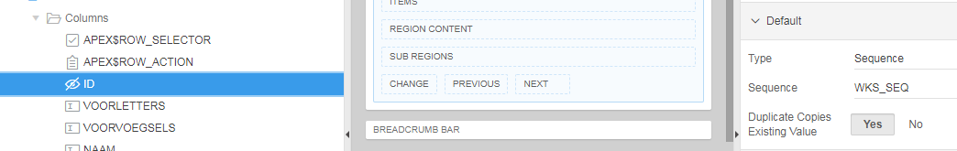

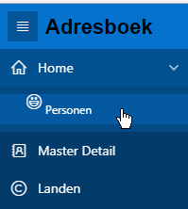
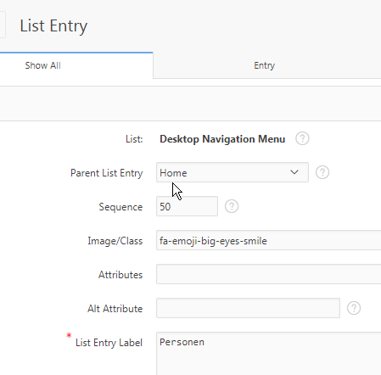

APEX Algemeen

SELECT * FROM apex_applications WHERE application_id = 260;

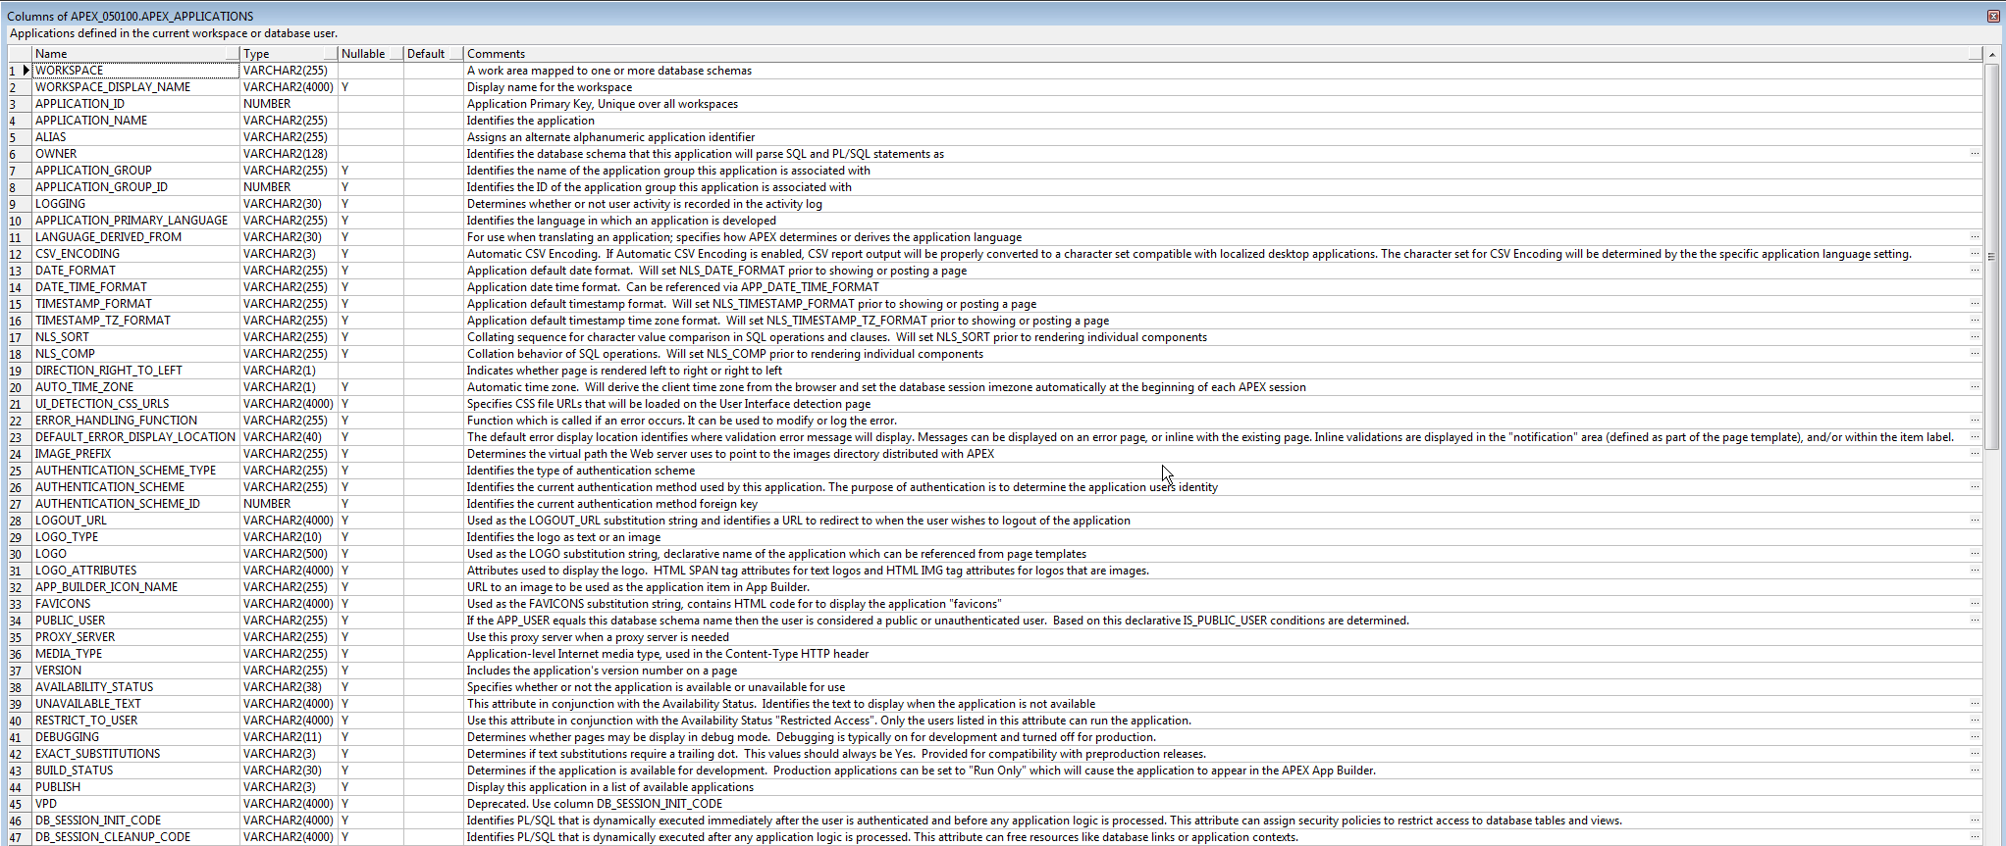
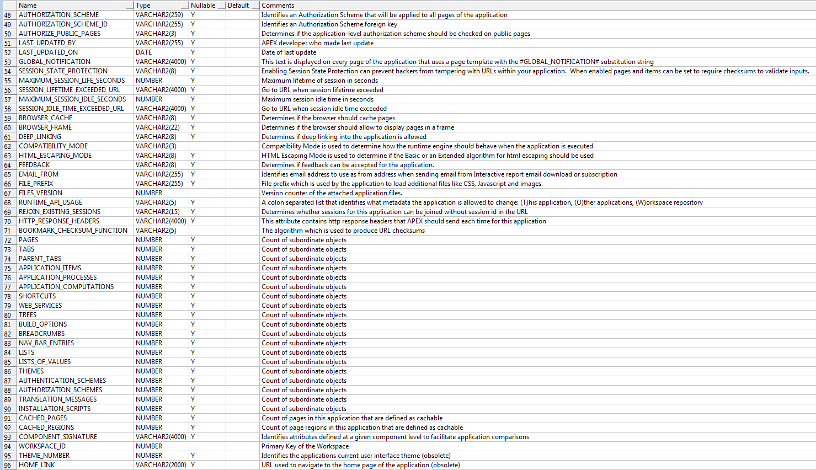

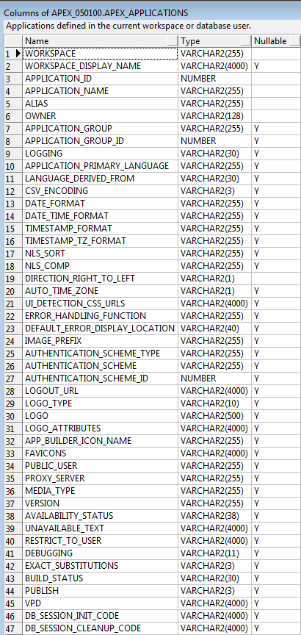
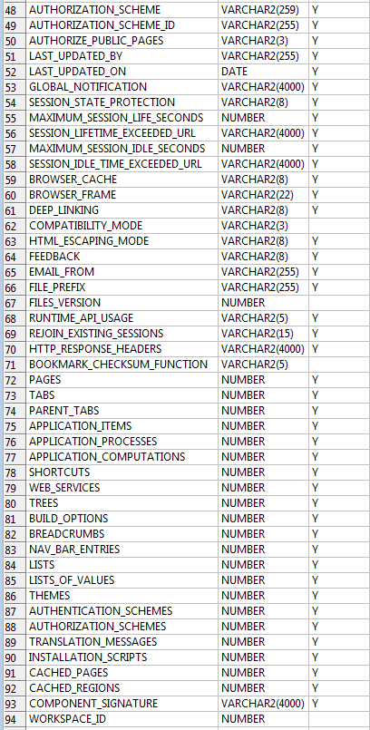
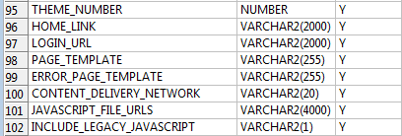

SELECT * FROM apex_workspace_activity_log WHERE application_id = 260;

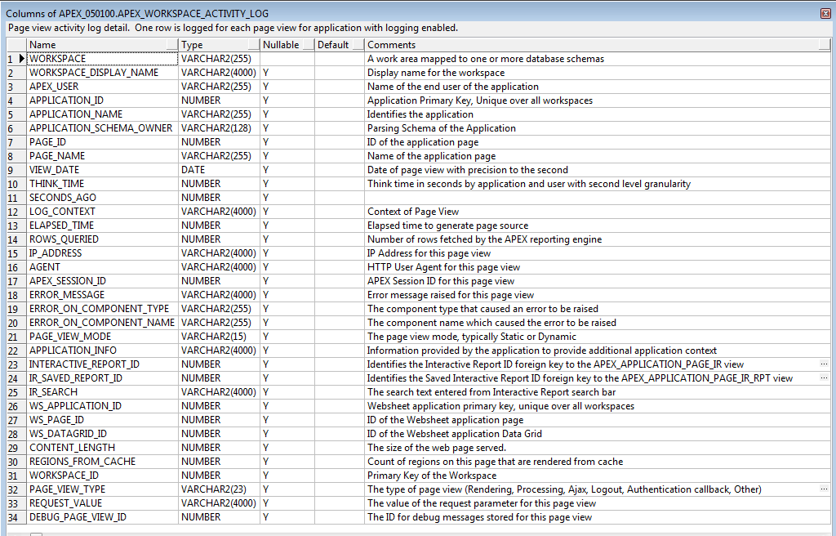

Variabele declareren: l_cgivar_name owa.vc_arr;

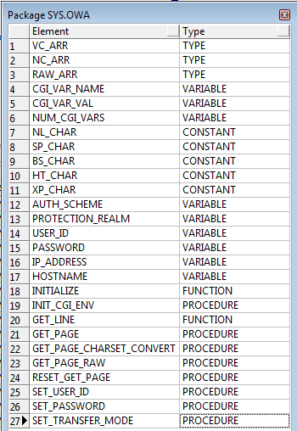

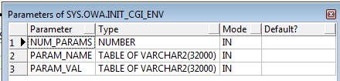

APEX_COLLECTION.ADD_MEMBER

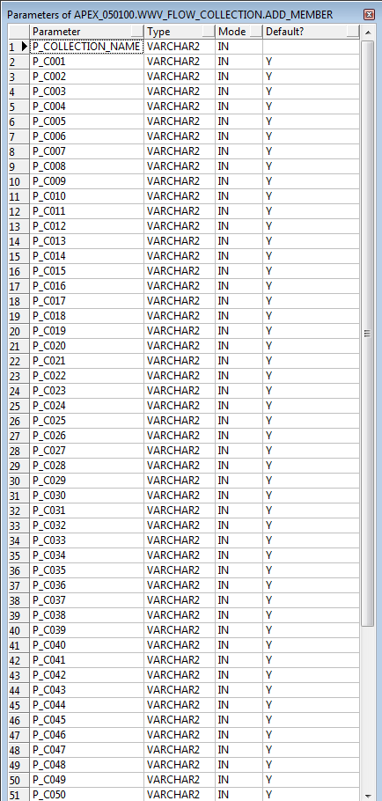
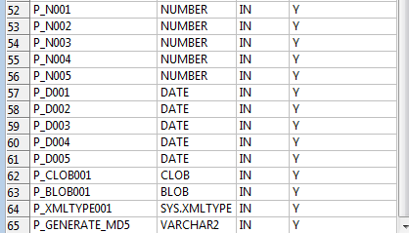

Variabele declareren:
v_data_array wwv_flow_global.vc_arr2;

Package APEX_COLLECTION

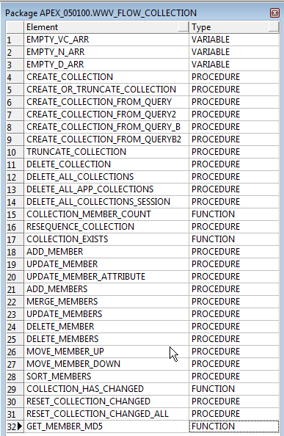

SELECT * FROM apex_application_temp_files;

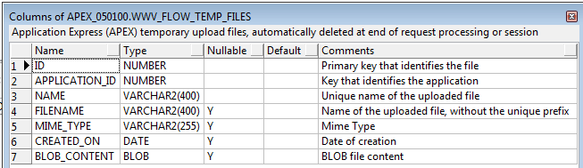

Package APEX_APPLICATION_GLOBAL

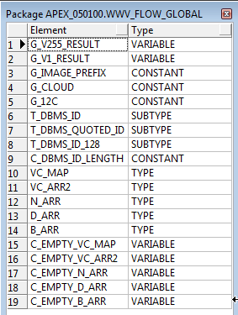

Template

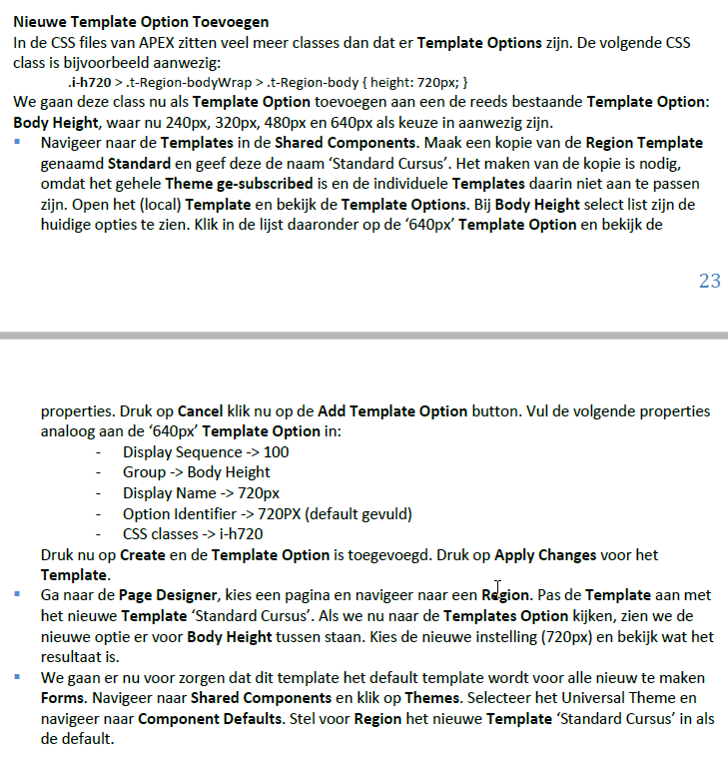

Authorization Scheme

PL/SQL Function Returning Boolean

BEGIN
RETURN pk_security.page_valid( p_use_id => :g_use_id
, p_pag_nr => :APP_PAGE_ID );
END;

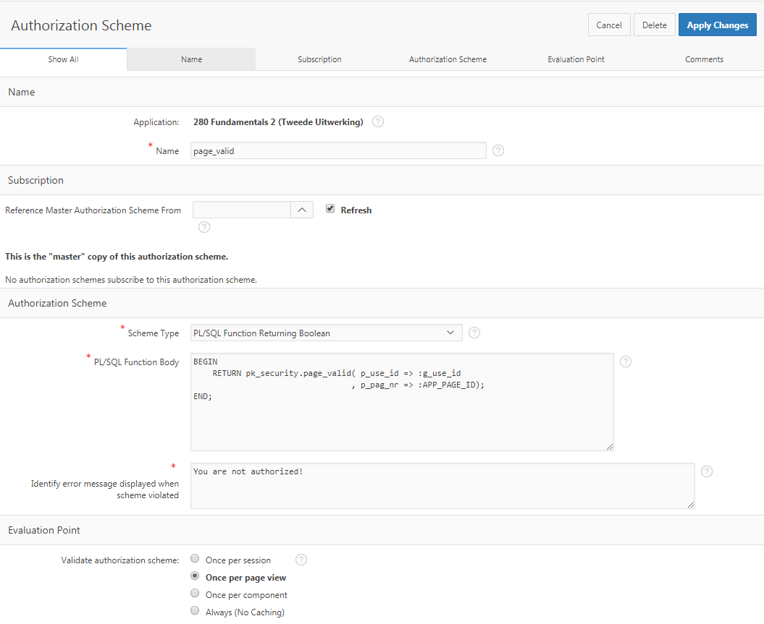

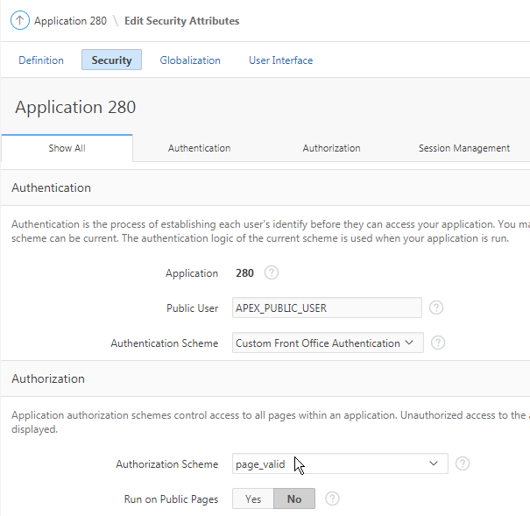

Application Item

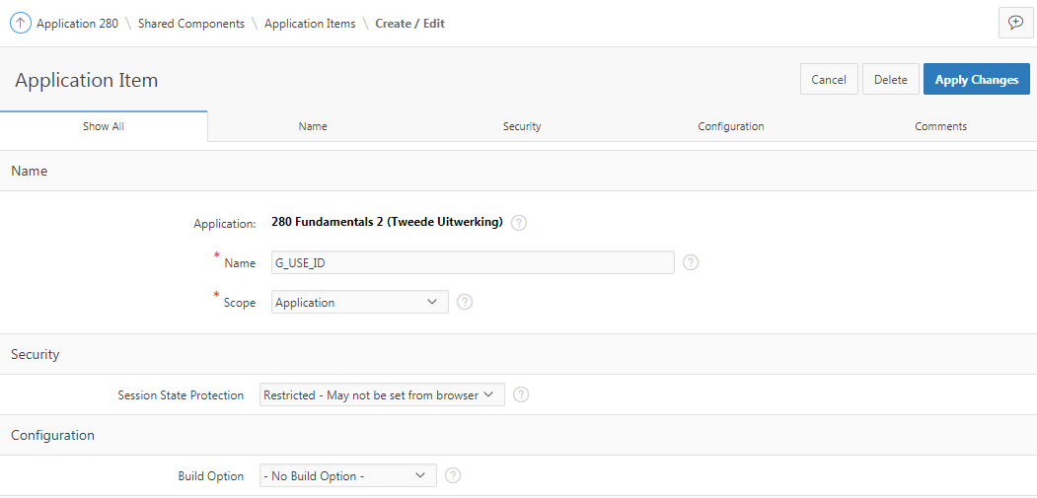

Authentication Scheme

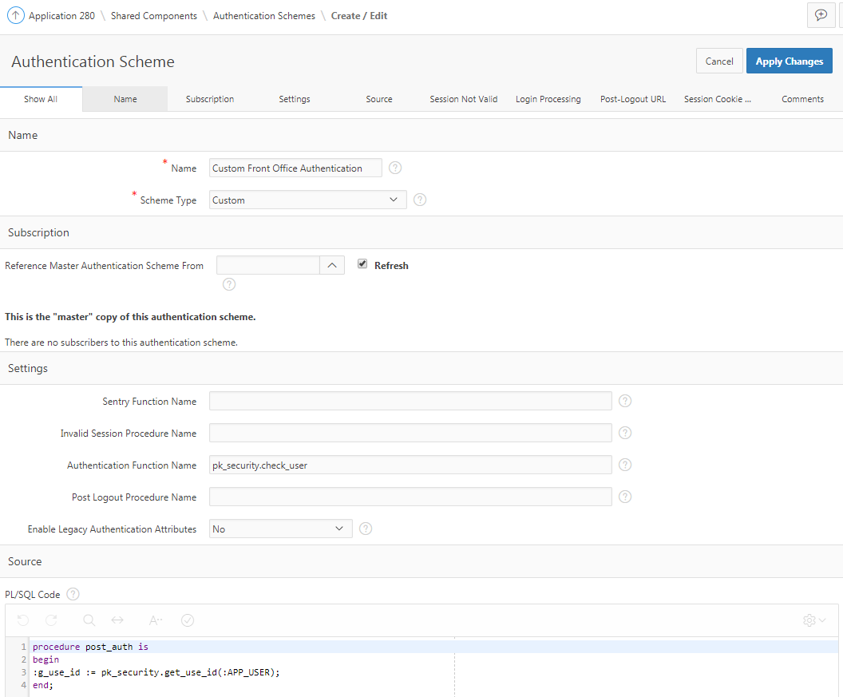

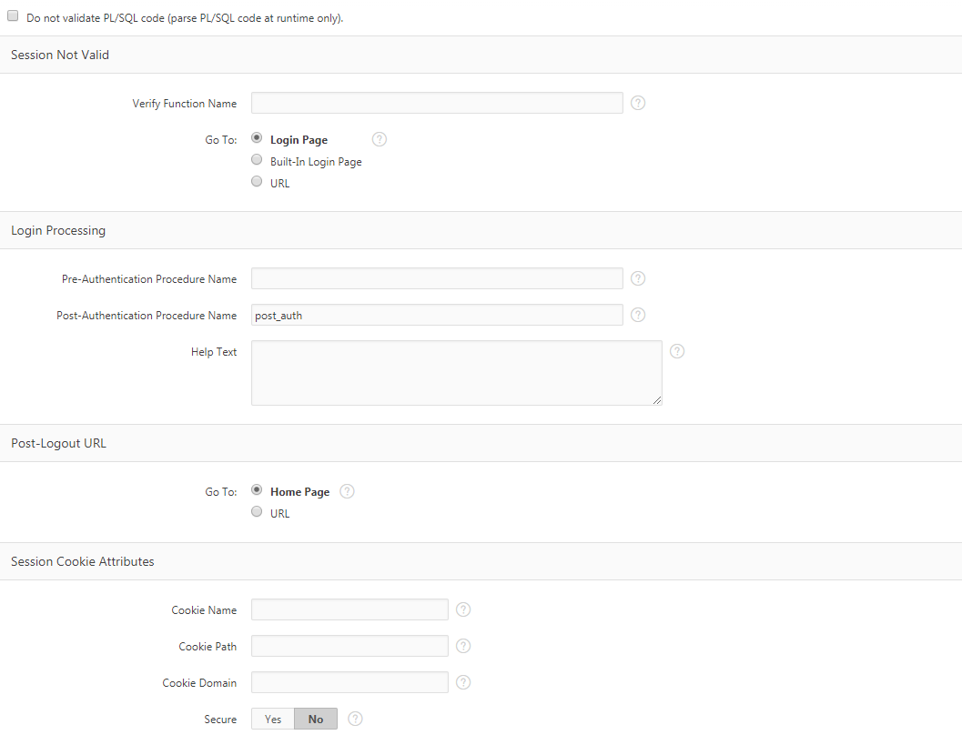

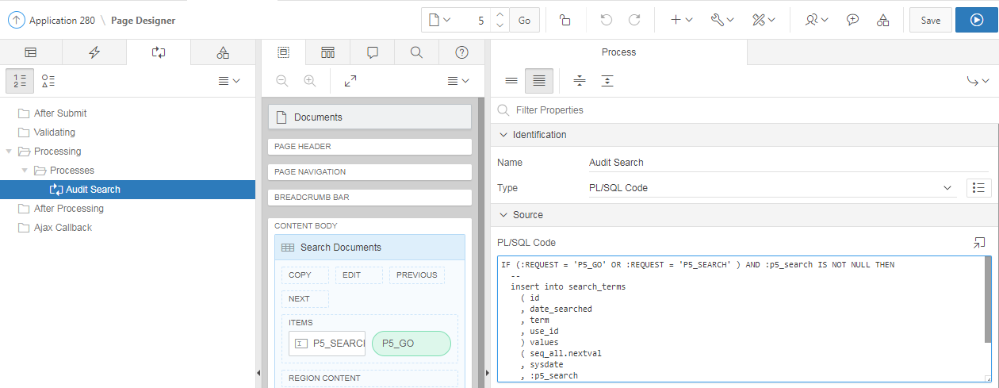

SELECT doc.id id
, dbms_lob.getlength(doc.DOCUMENT) DOCUMENT
, doc.description description
, doc.last_update_date last_update_date
, doc.filename filename
, doc. mimetype
, get_highlight_text('doc_index',doc.id,'%'||:P5_SEARCH||'%',40) text
FROM documents doc
WHERE (:P5_SEARCH IS NOT NULL
AND ( UPPER(doc.filename) LIKE '%'||UPPER(:P5_SEARCH)||'%'
OR
UPPER(doc.description) LIKE '%'||UPPER(:P5_SEARCH)||'%'
OR
CONTAINS(doc.document, '%'||:P5_SEARCH||'%', 1 ) > 0
)
)

Shared Components - Lists – Desktop Navigation Bar

Image/Class: fa-user
List Entry label: &APP_USER.
Target Type: - No Target -

List Entry label: Log Out
Target Type: URL
URL Target: &LOGOUT_URL.

List Entry label: Google
Target Type: URL
URL Target: http://www.google.nl

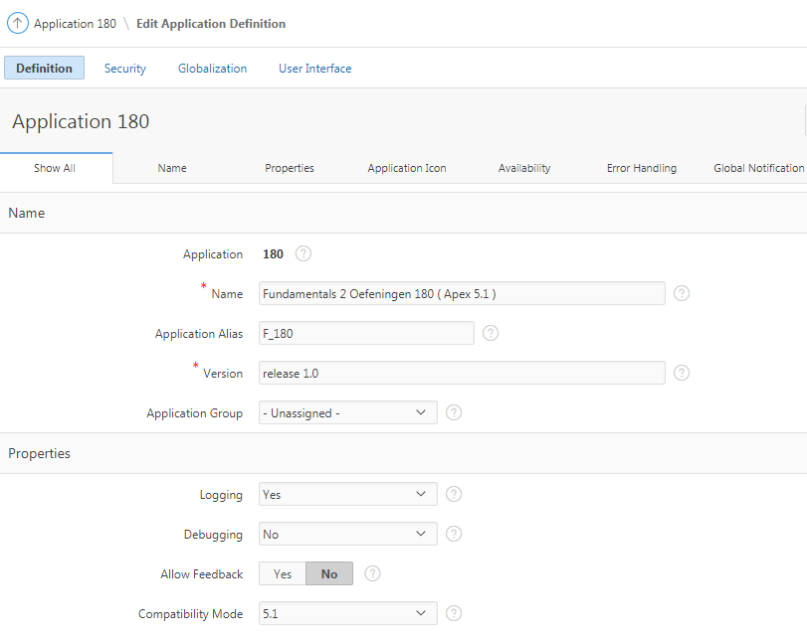

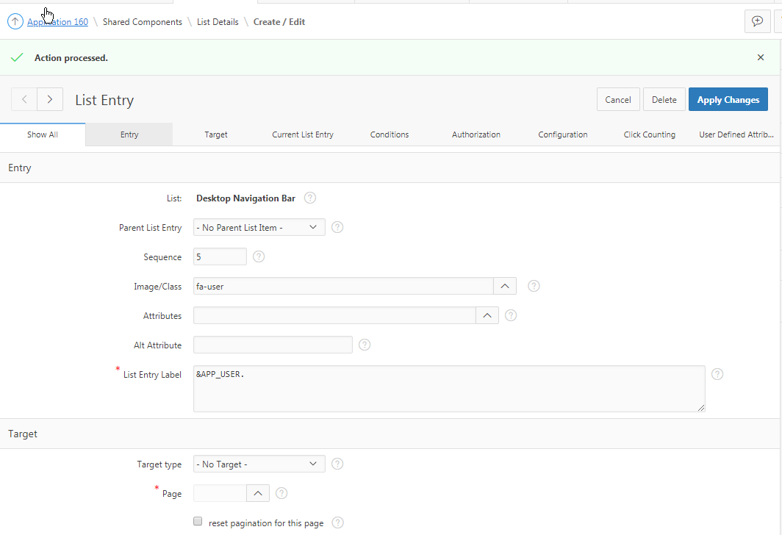

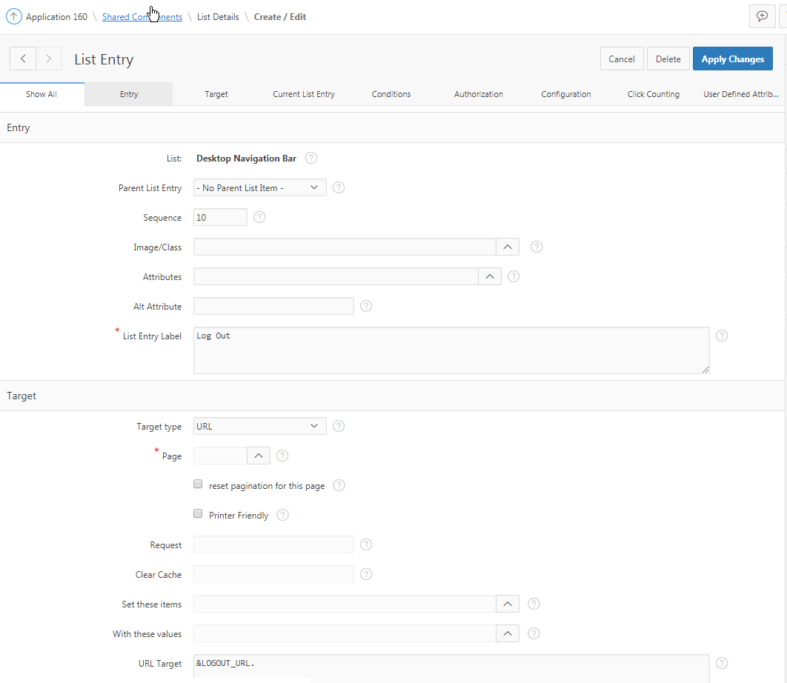

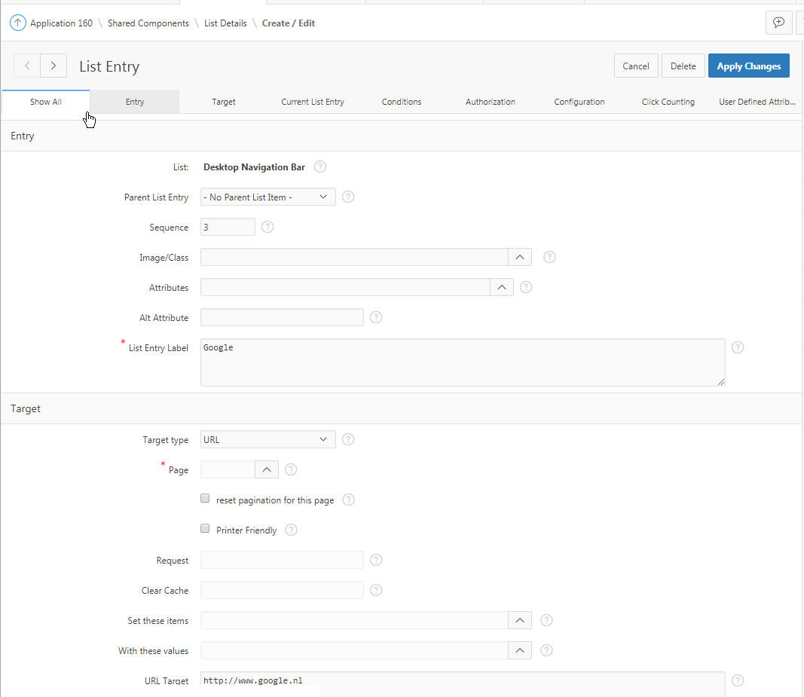

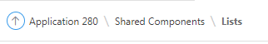

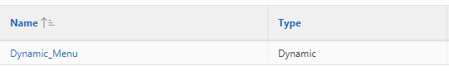

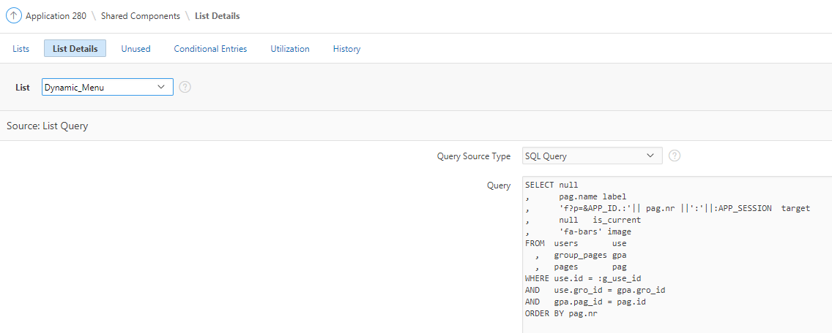

SELECT null
, pag.name label
, 'f?p=&APP_ID.:'|| pag.nr ||':'||:APP_SESSION target
, null is_current
, 'fa-bars' image
FROM users use
, group_pages gpa
, pages pag
WHERE use.id = :g_use_id
AND use.gro_id = gpa.gro_id
AND gpa.pag_id = pag.id
ORDER BY pag.nr

&APP_USER.
&LOGOUT_URL.

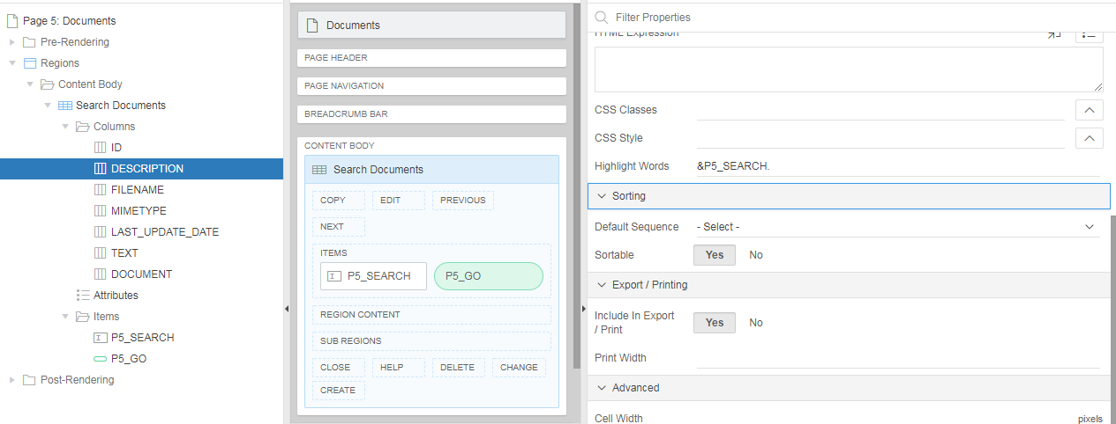

Bij "Description" en "Filename" bij "Hightlight Words" het volgende toevoegen: &P5_SEARCH.

-- Audit Search (Process)
-- PL/SQL Code
IF (:REQUEST = 'P5_GO' OR :REQUEST = 'P5_SEARCH' )
AND :p5_search IS NOT NULL
THEN
insert into search_terms
( id
, date_searched
, term
, use_id
) values
( seq_all.nextval
, sysdate
, :p5_search
, :g_use_id
);
END IF;

SELECT doc.id id
, dbms_lob.getlength(doc.DOCUMENT) DOCUMENT
, doc.description description
, doc.last_update_date last_update_date
, doc.filename filename
, doc. mimetype
, get_highlight_text('doc_index',doc.id,'%'||:P5_SEARCH||'%',40) text
FROM documents doc
WHERE (:P5_SEARCH IS NOT NULL
AND ( UPPER(doc.filename) LIKE '%'||UPPER(:P5_SEARCH)||'%'
OR
UPPER(doc.description) LIKE '%'||UPPER(:P5_SEARCH)||'%'
OR
CONTAINS(doc.document, '%'||:P5_SEARCH||'%', 1 ) > 0
)
)

Rendering

Dynamic Action

Processing

Pre-Rendering

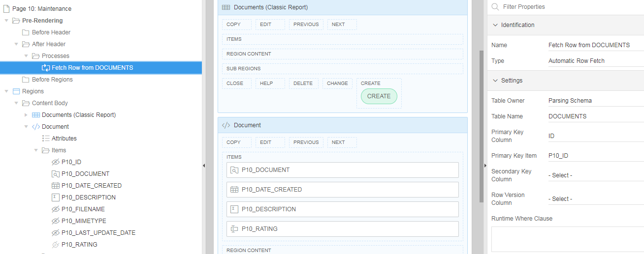

Processes

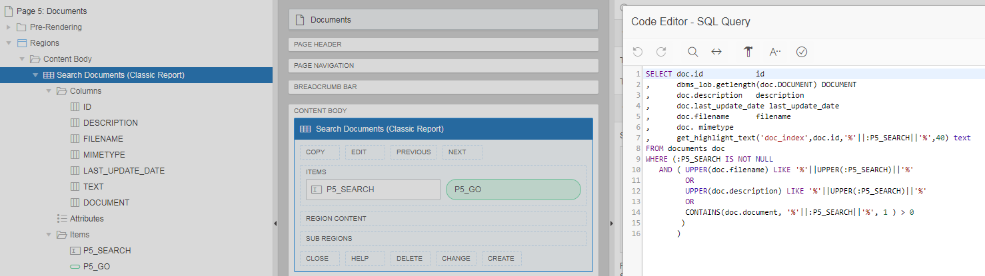

SELECT doc.id id
, dbms_lob.getlength(doc.DOCUMENT) DOCUMENT
, doc.description description
, doc.last_update_date last_update_date
, doc.filename filename
, doc. mimetype
, get_highlight_text('doc_index',doc.id,'%'||:P5_SEARCH||'%',40) text
FROM documents doc
WHERE (:P5_SEARCH IS NOT NULL
AND ( UPPER(doc.filename) LIKE '%'||UPPER(:P5_SEARCH)||'%'
OR
UPPER(doc.description) LIKE '%'||UPPER(:P5_SEARCH)||'%'
OR
CONTAINS(doc.document, '%'||:P5_SEARCH||'%', 1 ) > 0
)
)

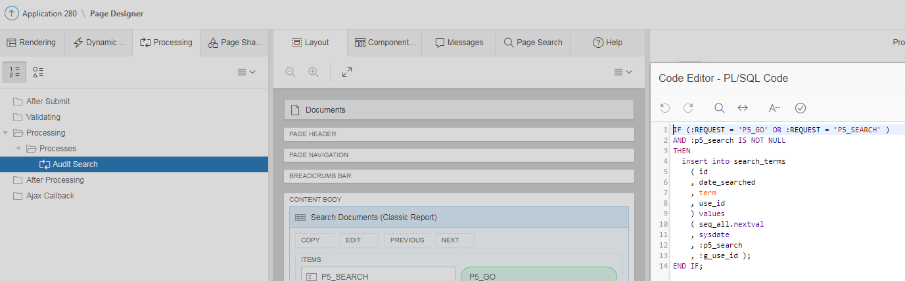

IF (:REQUEST = 'P5_GO' OR :REQUEST = 'P5_SEARCH' )
AND :p5_search IS NOT NULL
THEN
insert into search_terms
( id
, date_searched
, term
, use_id
) values
( seq_all.nextval
, sysdate
, :p5_search
, :g_use_id );
END IF;

THEMA’S

Algemeen

The LOV for a Text Field with Autocomplete item must contain only one column, which is used as lookup and display.

Create Page

Blank Page 39000, 29
Report
Interactive Report 39000, 2, 4, 19,20
Interactive Grid 39000, 6, 10
Classic Report 39000, 11, 14, 15, 19
Report with Form on Table
List View 39000, 8
Column Toggle Report 39000, 37
Reflow Report 39000, 16
Report on Web Service ?
Form
Report with Form on Table
Report with List View on Table
Editable Interactive Grid
Single Page Master Detail 39000, 35
Two Page Master Detail 39000, 36 + 38
Form on a Table
Form on a Procedure
Form on a SQL Query 39000, 44 ???
Form on Web Service ?
Report and Form on Web Service ?
Plug-ins
Chart (diverse mogelijkheden) 39000, 11, 20
Calendar 39000, 15
Tree
Wizard 39000, 22 + 23
Data Loading 39000, 24 + 25 + 26 + 27, 30 + 31 + 32 + 33

File Browse

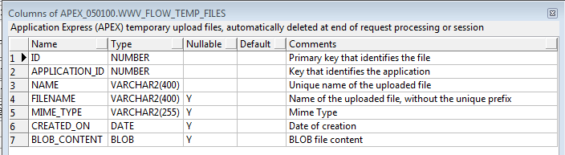

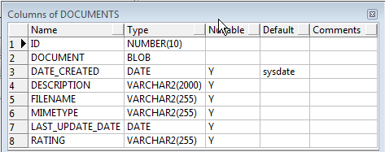

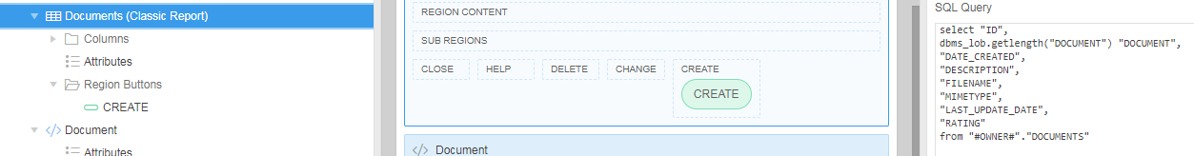

select "ID",
dbms_lob.getlength("DOCUMENT") "DOCUMENT",
"DATE_CREATED",
"DESCRIPTION",
"FILENAME",
"MIMETYPE",
"LAST_UPDATE_DATE",
"RATING"
from "#OWNER#"."DOCUMENTS"

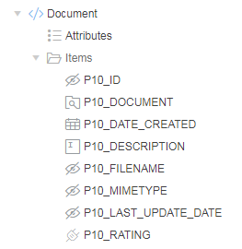

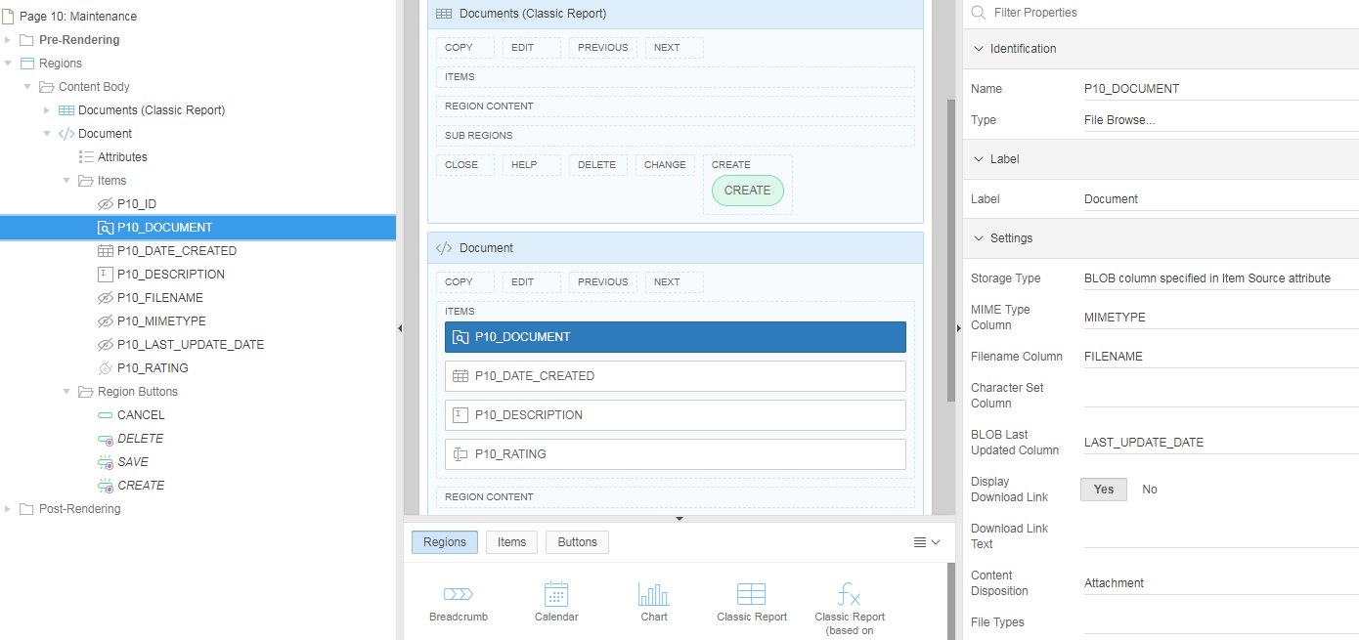

APEX_MAIL

DECLARE
arr APEX_APPLICATION_GLOBAL.vc_arr2;
l_id NUMBER;
l_filename apex_application_temp_files.filename%TYPE;
l_mime_type apex_application_temp_files.mime_type%TYPE;
l_blob_content apex_application_temp_files.blob_content%TYPE;
BEGIN
arr := apex_util.string_to_table( :P29_BIJLAGE );

l_id := APEX_MAIL.SEND( p_to => :P29_ADRES_AAN
, p_from => 'marc.houben@planet.nl'
, p_body => NULL
, p_body_html => :P29_TEKST
, p_subj => :P29_ONDERWERP || ' (Verstuurd vanuit APEX)'
, p_cc => :P29_ADRES_CC
, p_bcc => 'marc.houben@planet.nl'
, p_replyto => 'marc.houben@planet.nl' );

FOR i IN 1..arr.COUNT
LOOP
SELECT FILENAME, MIME_TYPE, BLOB_CONTENT
INTO l_filename, l_mime_type, l_blob_content
FROM apex_application_temp_files
WHERE name = arr(i);

APEX_MAIL.ADD_ATTACHMENT( p_mail_id => l_id
, p_attachment => l_blob_content
, p_filename => l_filename
, p_mime_type => l_mime_type );
END LOOP;
COMMIT;
END;

Application Groups

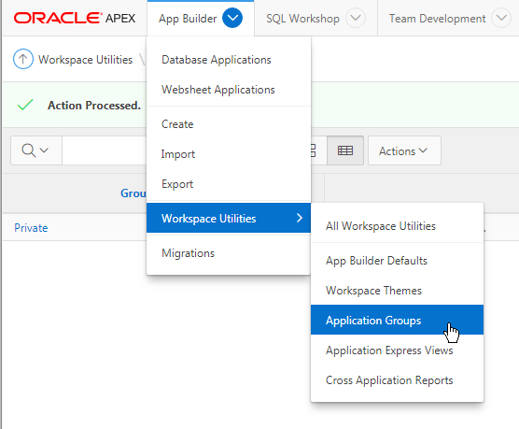

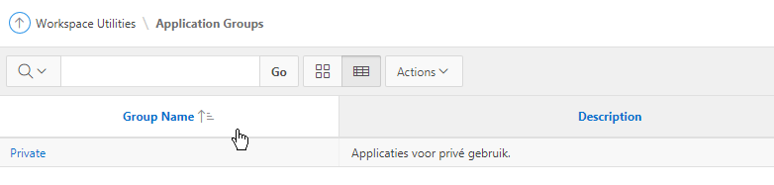

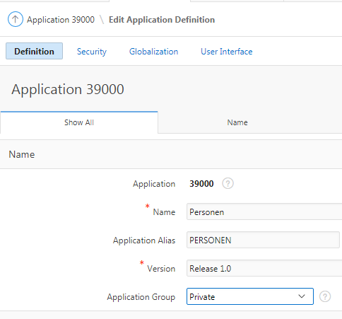

Shuttle

Rendering - Pre-rendering - Before Header – Processes

Name: Vul Shuttle
Type: PL/SQL Code

DECLARE
-- get the selectlist value as a list e.g. 1:2:4
l_selected APEX_APPLICATION_GLOBAL.VC_ARR2;

BEGIN

IF :p15_id IS NOT NULL THEN

SELECT mta_id
BULK COLLECT INTO l_selected
FROM group_tabs
WHERE gro_id = :p15_id ;

-- Assign the colon separated list to l_selected
:p15_shuttle := APEX_UTIL.TABLE_TO_STRING(l_selected);

END IF;

END;

Processing – After Submit – Processes

Name: Save Shuttle
Type: PL/SQL Code

DECLARE

-- insert the selectlist value (as a list e.g. 1:2:4) into the intersection table
l_selected APEX_APPLICATION_GLOBAL.VC_ARR2;

BEGIN

IF :p15_id IS NOT NULL THEN

-- convert the colon separated string of values into
-- a PL/SQL array
l_selected := APEX_UTIL.STRING_TO_TABLE(:p15_shuttle);

-- clean up the intersection table first
DELETE FROM group_tabs
WHERE gro_id = :p15_id;

-- Loop over array to insert lookup_ids and master_id
-- in to intersection table
FOR i IN 1..l_selected.count LOOP
INSERT INTO group_tabs
( id
, gro_id
, mta_id)
VALUES
(seq_all.nextval
, :p15_id
, l_selected(i) );

END LOOP;

END IF;

END;

Switch

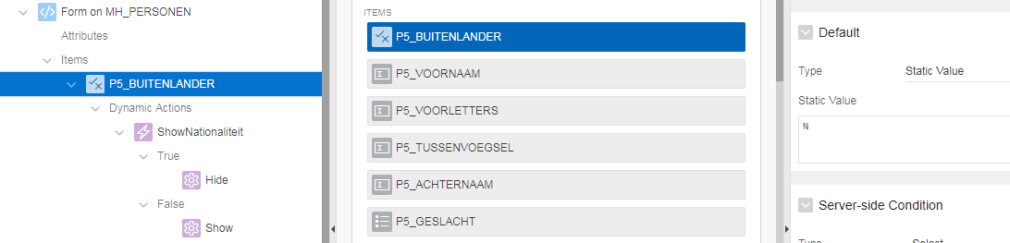

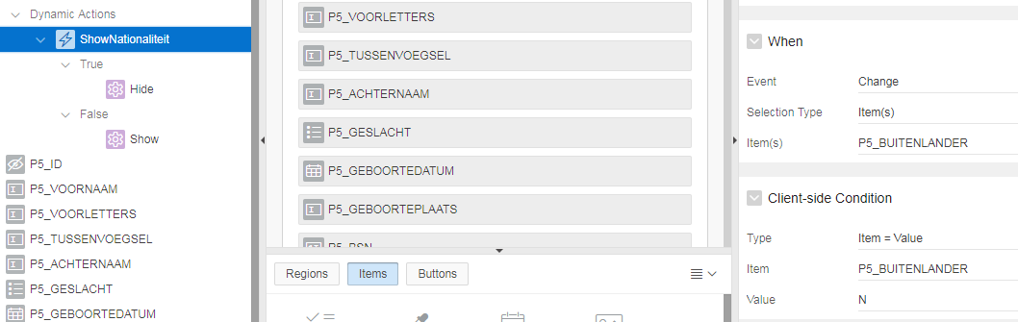

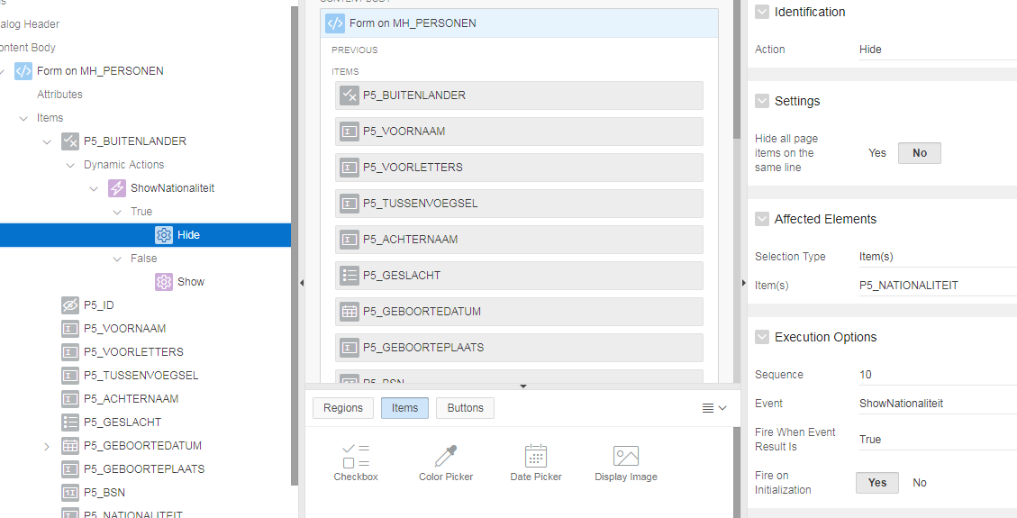

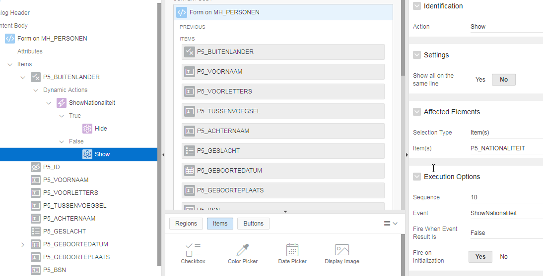

Validatie

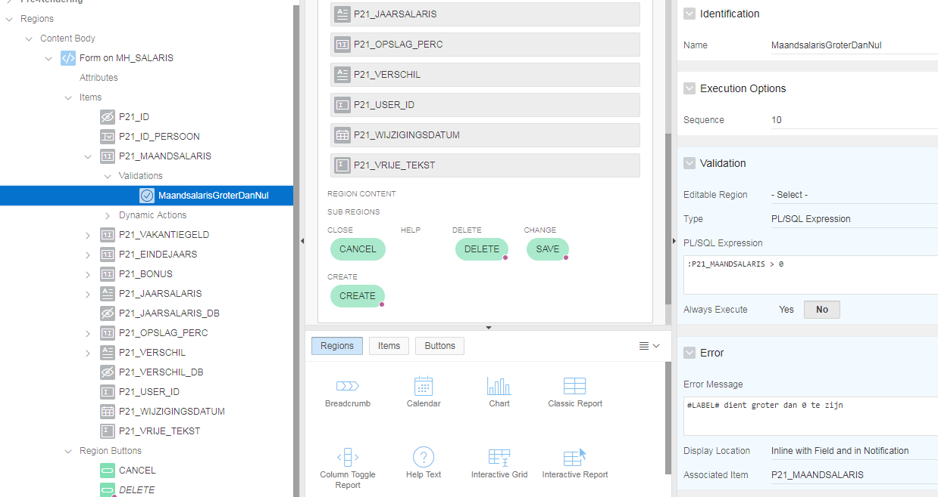

PL/SQL Expression:
:P21_MAANDSALARIS > 0
:P5_GEBOORTEDATUM < sysdate
regexp_like(:P7_POSTCODE, '^[0-9][0-9][0-9][0-9] [A-Z][A-Z]$')
regexp_like(:P9_TELEFOONNUMMER, '^\(?([+]31|0031|0)-?6(\s?|-)([0-9]\s{0,3}){8}$')
:P18_EINDDATUM > :P18_BEGINDATUM
:P18_BEGINDATUM > sysdate

Error Message:
#LABEL# dient groter dan 0 te zijn
#LABEL# mag niet in de toekomst liggen
Het formaat voor #LABEL# is NNNN XX (N=nummer, X=letter)
#LABEL# dient het juiste formaat te hebben
De einddatum mag niet voor de begindatum liggen
#LABEL# dient in de toekomst te liggen

DB en SC Items

Als je een waarde van een hidden page item wilt overschrijven door een dynamic Action, dan moet Value Protected de waarde No krijgen (want default staat deze bij een hidden op Yes).

Een page item dat Display Only is en van het type item, kun je wel een waarde toekennen, maar niet wegschrijven naar een tabel. Daarvoor moet je een hidden item aanmaken (_DB) die gekoppeld is aan een database kolom.

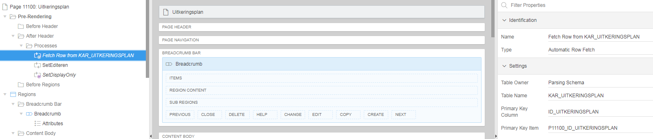

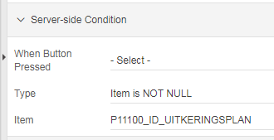

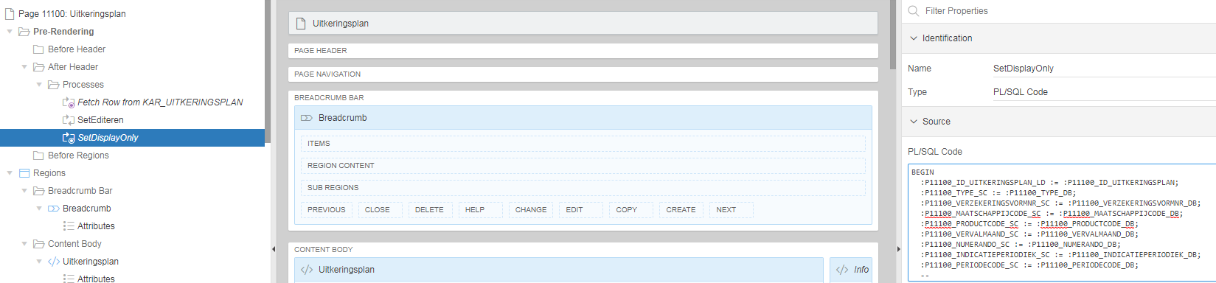

BEGIN
:P11100_ID_UITKERINGSPLAN_LD := :P11100_ID_UITKERINGSPLAN;
:P11100_TYPE_SC := :P11100_TYPE_DB;
:P11100_VERZEKERINGSVORMNR_SC := :P11100_VERZEKERINGSVORMNR_DB;
:P11100_MAATSCHAPPIJCODE_SC := :P11100_MAATSCHAPPIJCODE_DB;
:P11100_PRODUCTCODE_SC := :P11100_PRODUCTCODE_DB;
:P11100_VERVALMAAND_SC := :P11100_VERVALMAAND_DB;
:P11100_NUMERANDO_SC := :P11100_NUMERANDO_DB;
:P11100_INDICATIEPERIODIEK_SC := :P11100_INDICATIEPERIODIEK_DB;
:P11100_PERIODECODE_SC := :P11100_PERIODECODE_DB;
END;

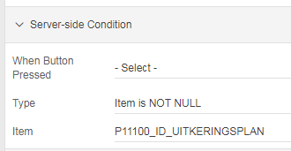

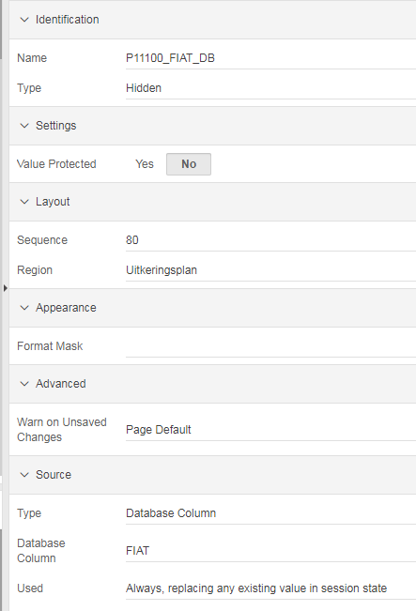

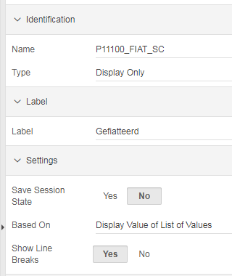

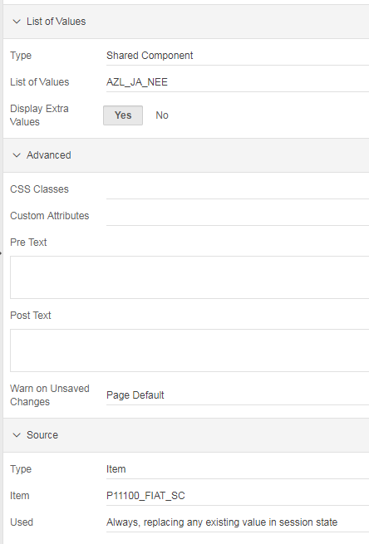

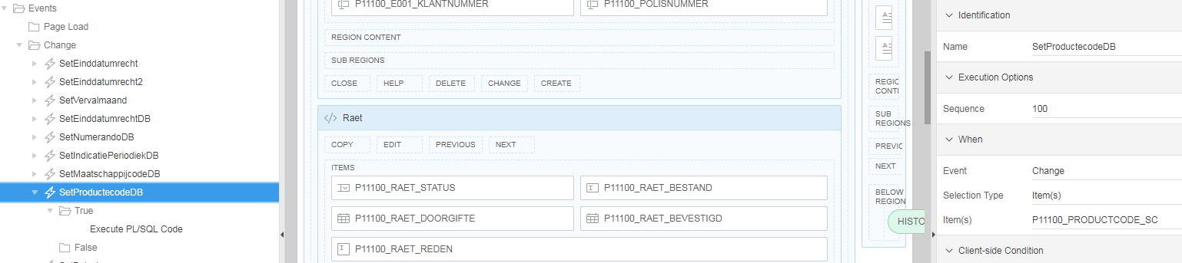

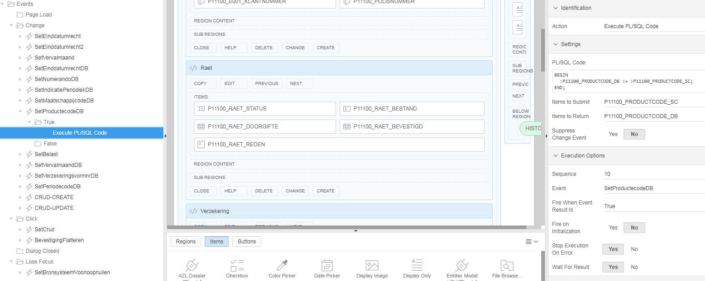

Buttons

CANCEL button:

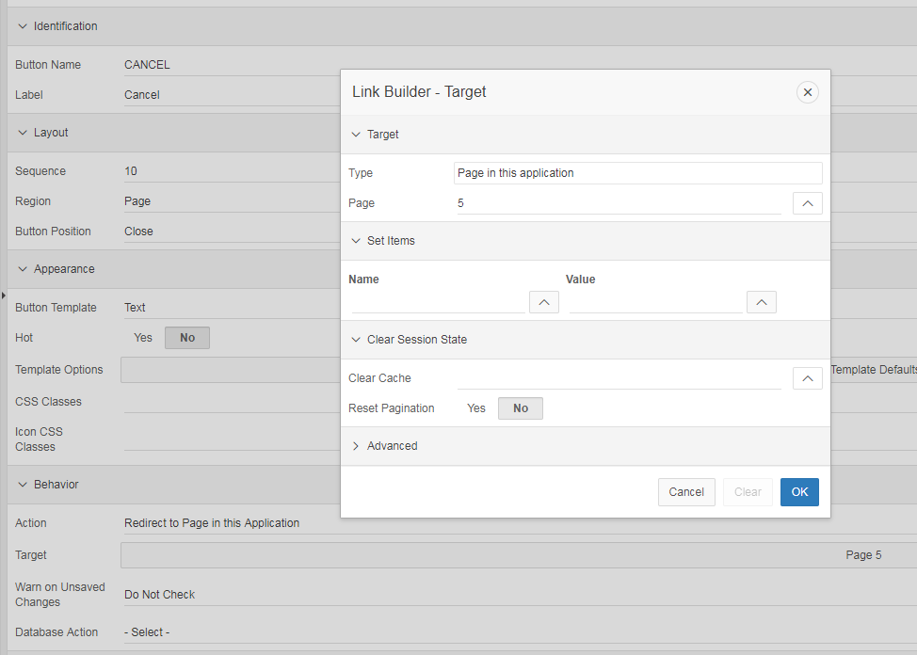

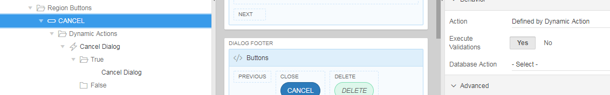

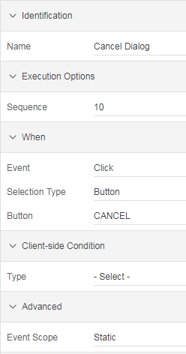

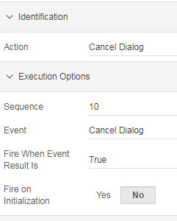

DELETE button:

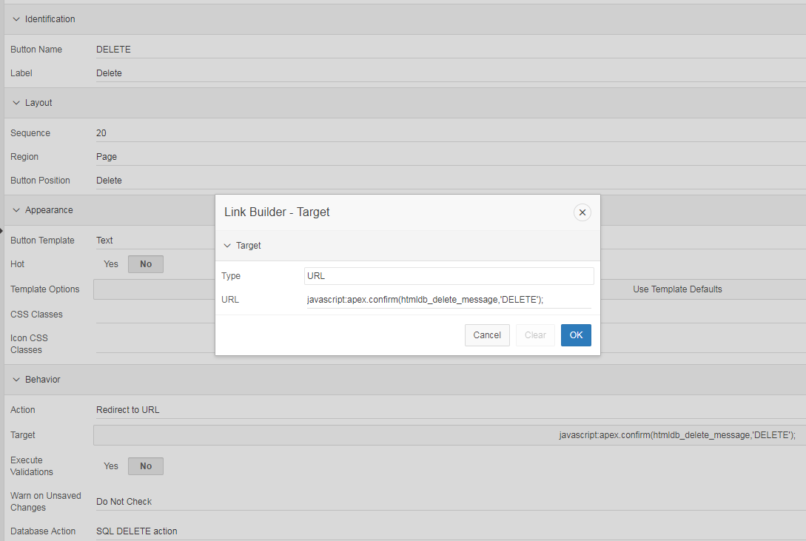

javascript:apex.confirm(htmldb_delete_message,'DELETE');

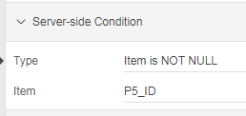

SAVE button:

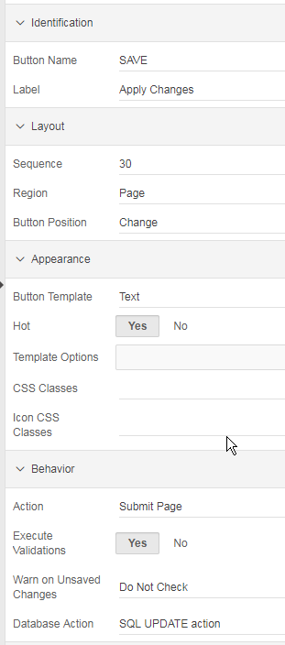

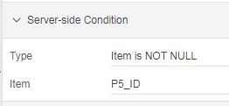

CREATE button:

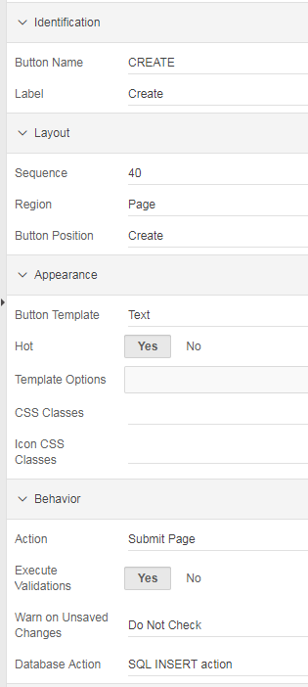

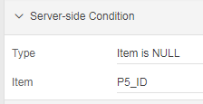

Bijbehorende processen:
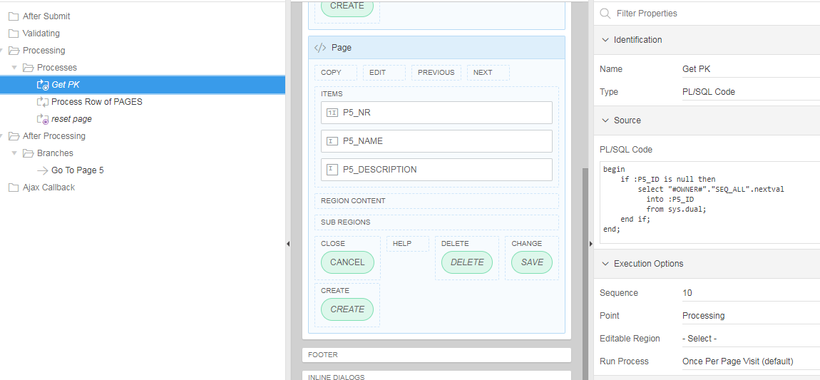
begin
if :P5_ID is null then
select "#OWNER#"."SEQ_ALL".nextval
into :P5_ID
from sys.dual;
end if;
end;

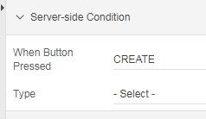

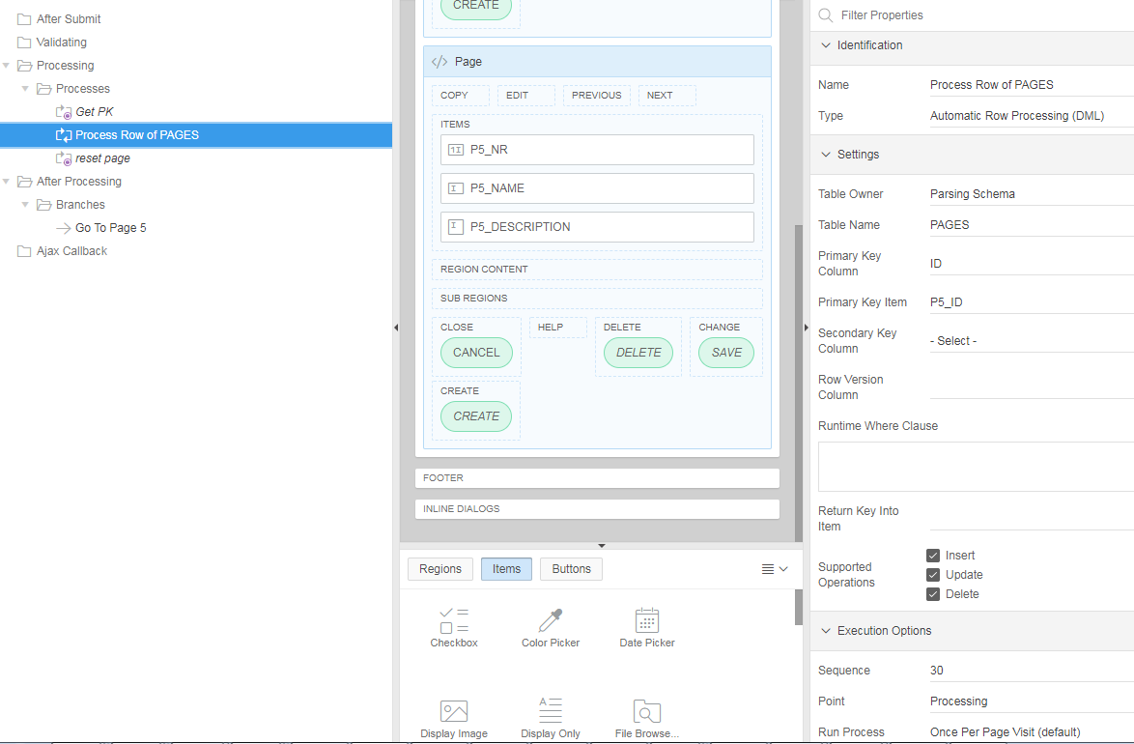

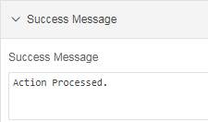

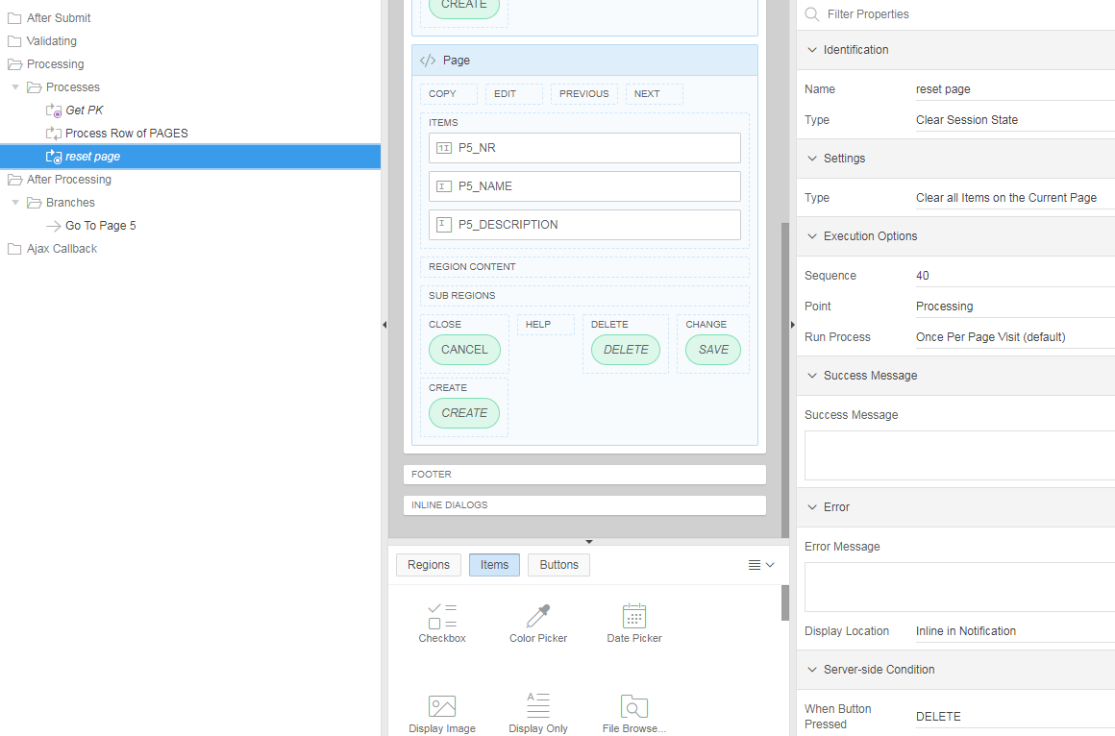

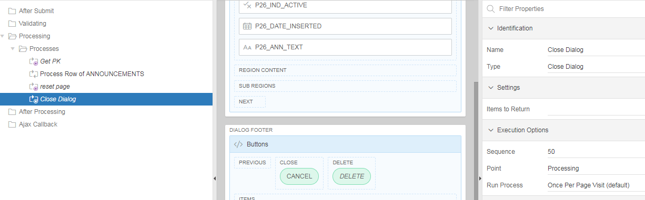

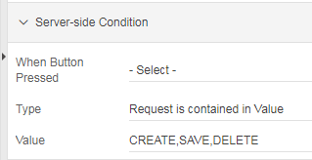

Branches : Go To Page …

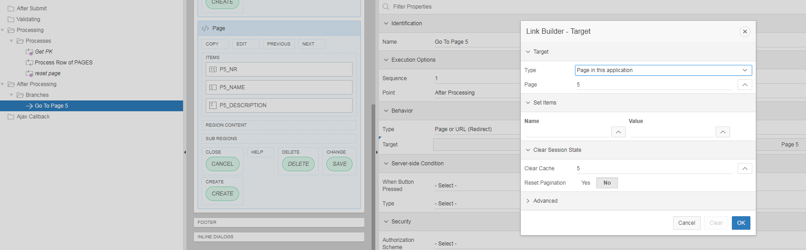

Get and Set Page Item values
To get page item values simply use $v(“<item_name>”):
x = $v("P2_TEXT_FIELD");
y = $v("P2_DISPLAY_ONLY");
To set the item values use:
$s("P2_TEXT_FIELD","Hello World!");
$s("P2_DISPLAY_ONLY","Hello World!");

Compute Dependencies

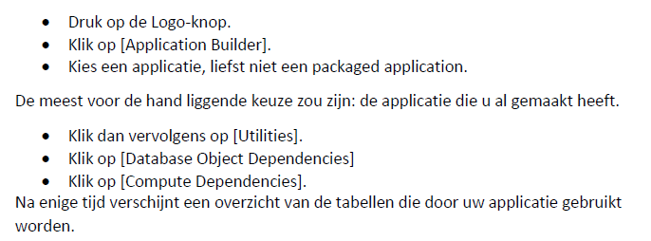

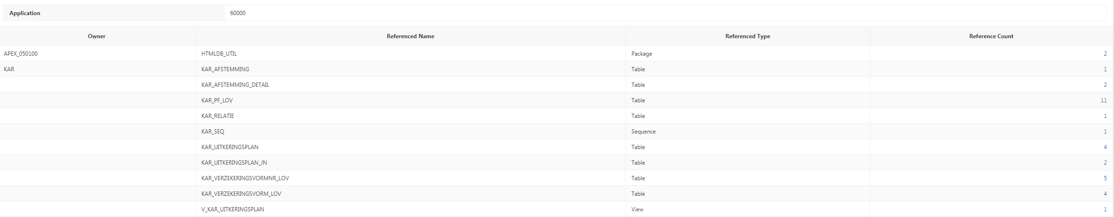

PL/SQL Dynamic Content

Identification:
Type: PL/SQL Dynamic Content

Source:
PL/SQL Code:

Voorbeeld:

DECLARE
CURSOR c_mh_personen
IS
SELECT voornaam
, achternaam
, nationaliteit
FROM mh_personen;
BEGIN
FOR a IN c_mh_personen
LOOP
IF a.nationaliteit = 'Nederland'
THEN
htp.p('<b>Persoon '||a.voornaam||' ('||a.achternaam||') is een goeroe.</b><br/>');
ELSE
htp.p('Persoon '||a.voornaam||' ('||a.achternaam||') is een sukkel.<br/>');
END IF;
END LOOP;
END;

Voorbeeld:

DECLARE

l_term_string VARCHAR2(1000);

CURSOR c_ste IS
SELECT '[''' || term || ''',' || COUNT(1) || ']' term
FROM search_terms
GROUP BY term
ORDER BY 1;

BEGIN

FOR r_ste IN c_ste LOOP
l_term_string := l_term_string || ',' || r_ste.term;
END LOOP;
l_term_string := substr(l_term_string,2);
htp.p('
<script type="text/javascript" src="https://www.gstatic.com/charts/loader.js"></script>
<script type="text/javascript">
google.charts.load(''current'', {''packages'':[''corechart'']});
google.charts.setOnLoadCallback(drawChart);
function drawChart() {
var data = new google.visualization.DataTable();

data.addColumn(''string'', ''Term'');
data.addColumn(''number'', ''nr'');
data.addRows([
');
htp.p(l_term_string);
htp.p(' ]);
var options = {''title'':''Search terms'',
''width'':400,
''height'':300};
var chart = new google.visualization.PieChart(document.getElementById(''chart_div''));
chart.draw(data, options);
}
</script>
<div id="chart_div"></div>
');

END;

Icons

Link Text: <span class="fa fa-list" style="color:green" value="#ID#"></span>

fa-ban
fa-undo-arrow
fa-check
fa-remove
fa-comment
fa-plus

http://astronautweb.co/snippet/font-awesome/

Tips & Tricks

U behoort te weten dat een Item of een Region altijd op een Region moet staan.

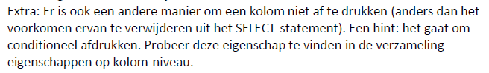

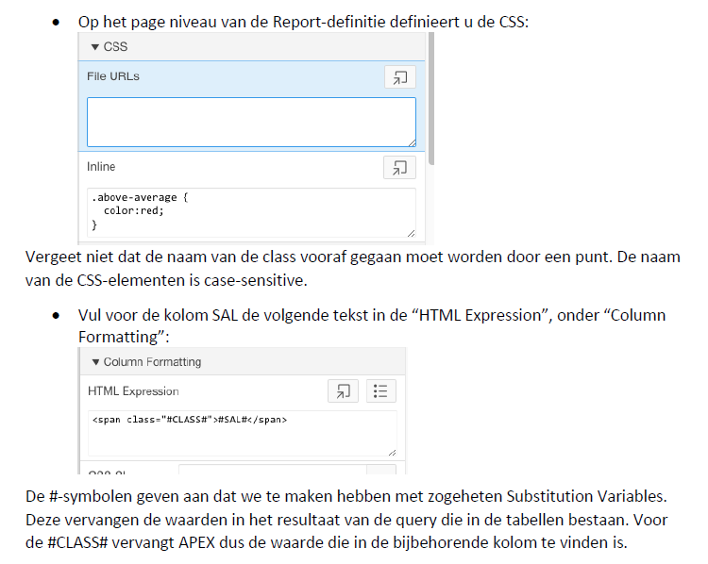

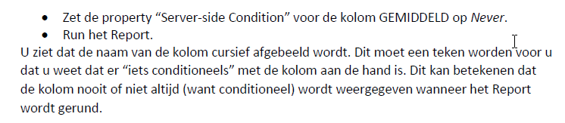

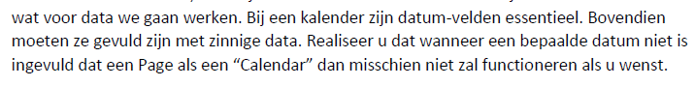

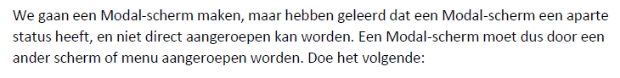

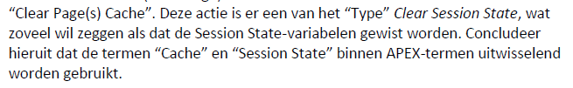

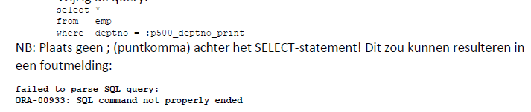

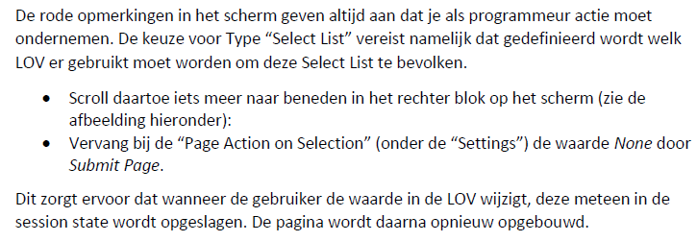

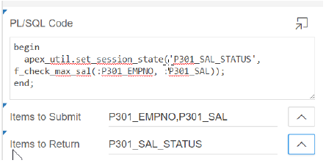

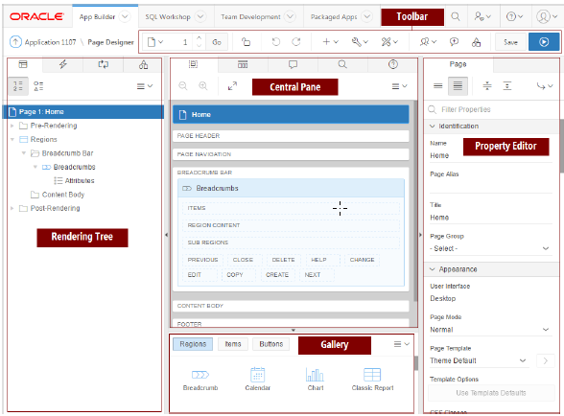

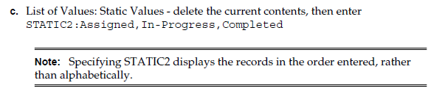

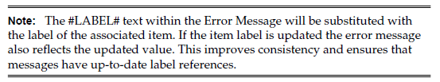

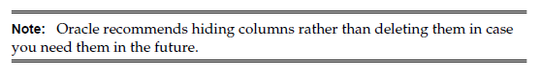

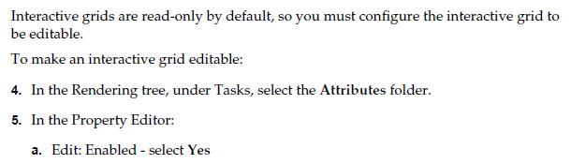

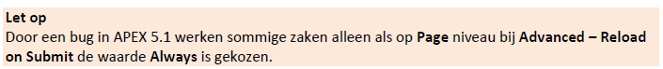

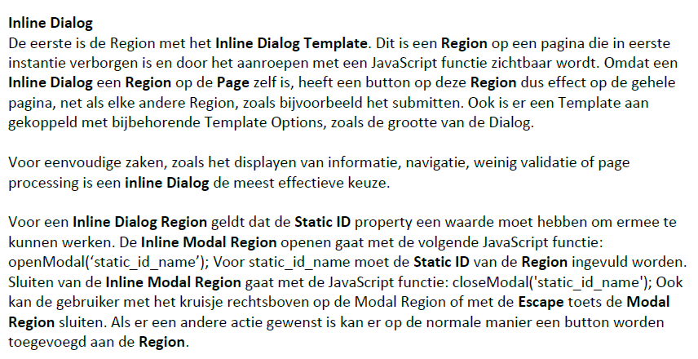

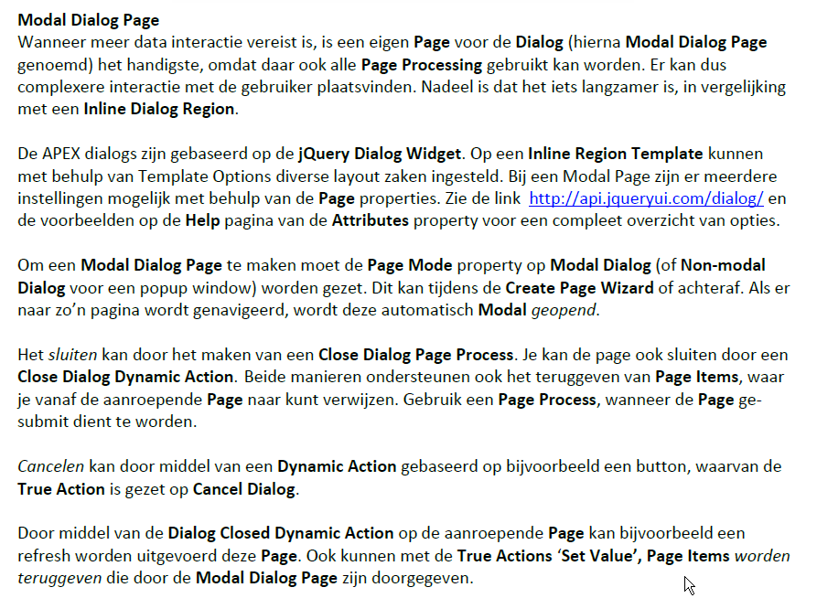

http://api.jqueryui.com/dialog/

https://docs.oracle.com/database/apex-5.1/HTMDB/managing-pages-in-a-database-application.htm

Om een kolom header in een rapport te laten wrappen kan eenvoudig ‘<br/>’ gebruikt worden.

Als eerste voegen we een item toe dat de waarde vasthoudt voor het geselecteerde id, waarop we een actie willen uitvoeren. Maak daartoe een item genaamd P11_ID. Dit mag een hidden item zijn, maar mag niet Protected zijn, omdat de waarde door het menu zal worden gewijzigd.

Rechtsklikken: 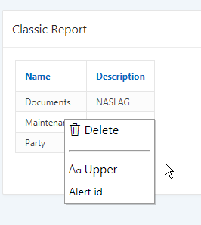

JavaScript
Function and Global Variable Declaration:

/*
* ContextMenu - jQuery plugin for right-click context menus
*
* Author: Chris Domigan
* Contributors: Dan G. Switzer, II
* Parts of this plugin are inspired by Joern Zaefferer's Tooltip plugin
*
* Dual licensed under the MIT and GPL licenses:
* http://www.opensource.org/licenses/mit-license.php
* http://www.gnu.org/licenses/gpl.html
*
* Version: r2
* Date: 16 July 2007
*
* For documentation visit http://www.trendskitchens.co.nz/jquery/contextmenu/
*
*/

(function($) {

var menu, shadow, trigger, content, hash, currentTarget;
var defaults = {
menuStyle: {
fontSize:'10px',
listStyle: 'none',
padding: '1px',
margin: '0px',
backgroundColor: '#fff',
border: '1px solid #999',
width: '120px'
},
itemStyle: {
margin: '0px',
color: '#000',
display: 'block',
cursor: 'default',
padding: '3px',
border: '1px solid #fff',
backgroundColor: 'transparent'
},
itemHoverStyle: {
border: '1px solid #0a246a',
backgroundColor: '#b6bdd2'
},
eventPosX: 'pageX',
eventPosY: 'pageY',
shadow : true,
onContextMenu: null,
onShowMenu: null
};

$.fn.contextMenu = function(id, options) {
if (!menu) { // Create singleton menu
menu = $('<div id="jqContextMenu"></div>')
.hide()
.css({position:'absolute', zIndex:'500'})
.appendTo('body')
.bind('click', function(e) {
e.stopPropagation();
});
}
if (!shadow) {
shadow = $('<div></div>')
.css({backgroundColor:'#000',position:'absolute',opacity:0.2,zIndex:499})
.appendTo('body')
.hide();
}
hash = hash || [];
hash.push({
id : id,
menuStyle: $.extend({}, defaults.menuStyle, options.menuStyle || {}),
itemStyle: $.extend({}, defaults.itemStyle, options.itemStyle || {}),
itemHoverStyle: $.extend({}, defaults.itemHoverStyle, options.itemHoverStyle || {}),
bindings: options.bindings || {},
shadow: options.shadow || options.shadow === false ? options.shadow : defaults.shadow,
onContextMenu: options.onContextMenu || defaults.onContextMenu,
onShowMenu: options.onShowMenu || defaults.onShowMenu,
eventPosX: options.eventPosX || defaults.eventPosX,
eventPosY: options.eventPosY || defaults.eventPosY
});

var index = hash.length - 1;
$(this).bind('contextmenu', function(e) {
// Check if onContextMenu() defined
var bShowContext = (!!hash[index].onContextMenu) ? hash[index].onContextMenu(e) : true;
if (bShowContext) display(index, this, e, options);
return false;
});
return this;
};

function display(index, trigger, e, options) {
var cur = hash[index];
content = $('#'+cur.id).find('ul:first').clone(true);
content.css(cur.menuStyle).find('li').css(cur.itemStyle).hover(
function() {
$(this).css(cur.itemHoverStyle);
},
function(){
$(this).css(cur.itemStyle);
}
).find('img').css({verticalAlign:'middle',paddingRight:'2px'});

// Send the content to the menu
menu.html(content);

// if there's an onShowMenu, run it now -- must run after content has been added
// if you try to alter the content variable before the menu.html(), IE6 has issues
// updating the content
if (!!cur.onShowMenu) menu = cur.onShowMenu(e, menu);

$.each(cur.bindings, function(id, func) {
$('#'+id, menu).bind('click', function(e) {
hide();
func(trigger, currentTarget);
});
});

menu.css({'left':e[cur.eventPosX],'top':e[cur.eventPosY]}).show();
if (cur.shadow) shadow.css({width:menu.width(),height:menu.height(),left:e.pageX+2,top:e.pageY+2}).show();
$(document).one('click', hide);
}

function hide() {
menu.hide();
shadow.hide();
}

// Apply defaults
$.contextMenu = {
defaults : function(userDefaults) {
$.each(userDefaults, function(i, val) {
if (typeof val == 'object' && defaults[i]) {
$.extend(defaults[i], val);
}
else defaults[i] = val;
});
}
};

})(jQuery);

$(function() {
$('div.contextMenu').hide();
});

Execute when Page Loads:

$('span.c_menu').closest('tr').children().contextMenu('myMenu1', {
bindings: {

'DEL': function(t) {
apex.submit( {request:'DEL'
,set:{'P11_ID':
$(t).closest('tr').find('span').attr('id') }
}
);
},

'UPPER': function(t) {
apex.submit( {request:'UPPER'
,set:{'P11_ID':
$(t).closest('tr').find('span').attr('id') }
}
);
},

'ALERT': function(t) {
alert('Id is:'+$(t).closest('tr').find('span').attr('id'));
}

}
});

Header and Footer
Header Text:

<div class="contextMenu" id="myMenu1">
<ul>
<li id="DEL"><span class="fa fa-trash-o"> Delete</span></li>
<li id=""><hr/></li>
<li id="UPPER"><span class="fa fa-change-case"> Upper</span></li>
<li id="ALERT">Alert id</li>
</ul>
</div>

CSS

Navigeer naar de Cascading Style Sheet – Inline en voeg onderstaande CSS toe:
table.a-IRR-table td {
padding-top:5px !important;
padding-bottom:5px !important;
white-space: nowrap !important;
}

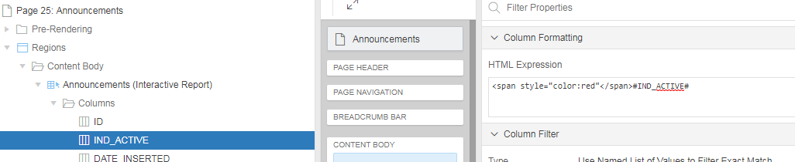

Column Formatting
HTML Expression: <span style="color:red"</span>#IND_ACTIVE#

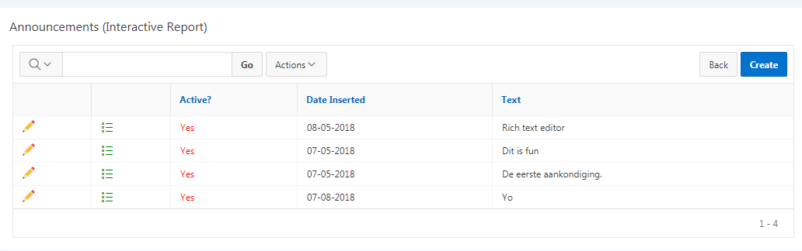

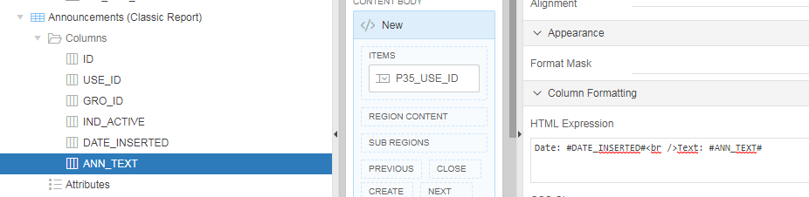

HTML Expression: Date: #DATE_INSERTED#<br />Text: #ANN_TEXT#

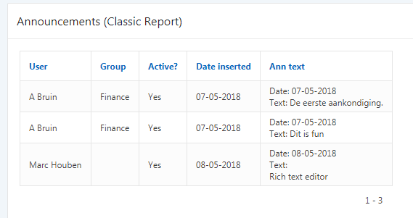

Query
select empno,ename,sal,
case when sal < 1000 then 'red'
when sal between 1000 and 2000 then 'purple'
when sal > 2000 then 'green'
end the_color
from emp
Report Attributes > Column Attributes for “SAL” > Column Formatting > HTML Expression
<span style="color:#THE_COLOR#;font-weight:bold;">#SAL#</span>

Query
select (level*20)-20 the_level,
empno,ename,mgr
from emp
connect by prior empno = mgr
start with mgr is null
Report Attributes > Column Attributes for “ENAME” > Column Formatting > HTML Expression
<span style="padding-left:#THE_LEVEL#px;">#ENAME#</span>
select empno,ename
, to_char(‘<span style="color:')
||
case when sal 2000 then ‘green’
end
||
to_char(‘;font-weight:bold;”>’)|| sal || to_char(”) as sal
from emp

- CASE WHEN COALESCE(bonus,0) > COALESCE(comm,0) THEN
- 'red'
- WHEN COALESCE(bonus,0) < COALESCE(comm,0) THEN
- 'green'
- WHEN COALESCE(bonus,0) = COALESCE(comm,0) THEN
- '#333333'
- END as fcolor
HTML Expression: <span style="color:#FCOLOR#;">#EMPNO#</span>

.syn-checkImg-J,.syn-checkImg-Y {
background-image:url("https://upload.wikimedia.org/wikipedia/commons/thumb/0/03/Green_check.svg/240px-Green_check.svg.png");
background-repeat: no-repeat;
background-origin: padding-box;
background-size: 20px 20px;
padding:0 20px;
}
.syn-checkImg-N {
background-image:url("https://upload.wikimedia.org/wikipedia/commons/thumb/a/a2/X_mark.svg/210px-X_mark.svg.png");
background-repeat: no-repeat;
background-origin: padding-box;
background-size: 20px 20px;
padding:0 20px;
}

CSS

.syn-check-J:before,.syn-check-Y:before {
content: "\f00c";
color: green;
}
.syn-check-N:before {
content: "\f00d";
color: #ff3a30; /* color: red; */
}
.syn-checkImg-J,.syn-checkImg-Y {
background-image:url("https://upload.wikimedia.org/wikipedia/commons/thumb/0/03/Green_check.svg/240px-Green_check.svg.png");
background-repeat: no-repeat;
background-origin: padding-box;
background-size: 20px 20px;
padding:0 20px;
}
.syn-checkImg-N {
background-image:url("https://upload.wikimedia.org/wikipedia/commons/thumb/a/a2/X_mark.svg/210px-X_mark.svg.png");
background-repeat: no-repeat;
background-size: 20px 20px;
width: 20px;
height: 20px;
}

HTML

<span class="fa syn-check-J"> </span><br/>
<span class="fa syn-check-N"> </span><br/>
<img src="https://upload.wikimedia.org/wikipedia/commons/f/fb/Yes_check.svg" height="25px" /><br/>
Span-empty: <span class="fa syn-checkImg-J"></span><br/>
Div-empty: <div class="syn-checkImg-Y"></div><br/>
Span-empty: <span class="fa syn-checkImg-N"></span><br/>
Div-empty: <div class="syn-checkImg-N"></div><br/>

Div <div class="syn-checkImg-Y">Text</div><br/>
Span <div class="syn-checkImg-Y">Text</div><br/>

select empno
,case mod (rownum, 2)
when 0 then 'male'
when 1 then 'female'
end gender
,ename
,job
from emp

<span class="t-Icon fa-#GENDER#"></span>

The names of the font awesome icons always start with "fa-", so this is prefixed to the content of the GENDER column. The result of a "female"-rows will be
<span class="t-Icon fa-female"></span>
For "male"-rows it will be
<span class="t-Icon fa-male"></span>

Row Highlight

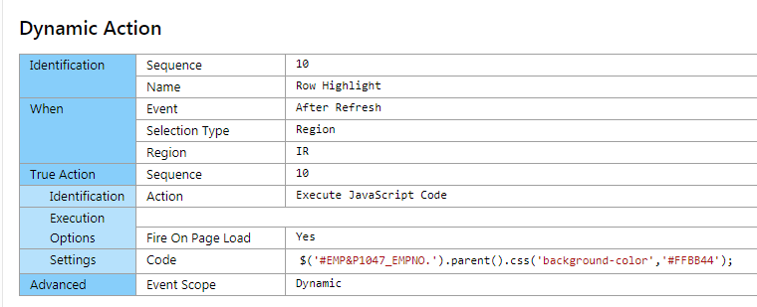

$('#EMP&P1047_EMPNO.').parent().css('background-color','#FFBB44');

CSS class: t-Report--rowHighlight

HTML

BEGIN
htp.htmlopen; -- generates <HTML>
htp.headopen; -- generates <HEAD>
htp.title('Hello'); -- generates <TITLE>Hello</TITLE>
htp.headclose; -- generates </HEAD>
htp.bodyopen; -- generates <BODY>
htp.header(1, 'Hello'); -- generates <H1>Hello</H1>
htp.bodyclose; -- generates </BODY>
htp.htmlclose; -- generates </HTML>
END;

htf.escape_sc:
Escape_sc is a function which replaces characters that have special meaning in HTML with their escape sequence.

converts occurrence of & to &amp
converts occurrence of “ to &quot
converts occurrence of < to &lt
converts occurrence of > to &gt

To prevent XSS (Cross Site Scripting) attacks, you must call SYS.HTF.ESCAPE_SC to prevent embedded javascript code from being executed when you inject the string into the HTML page.

sys.htf.escape_sc:
The SYS prefix is used to signify Oracle’s SYS schema. The HTP and HTF packages normally exist in the SYS schema and APEX relies on them.

Javascript

http://www.w3schools.com/js/js_json_syntax.asp

Action: Execute JavaScript Code
Code:
openModal('static_id_sociale_media');

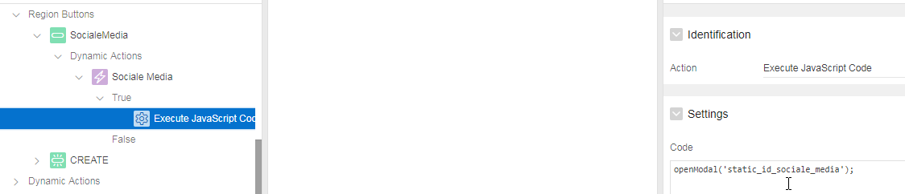

openModal('inline'); -- Bijv. om een “Classic Report” inline te openen als op button geklikt wordt

this.affectedElements.dialog('open');
this.affectedElements.dialog('close');

Button aanmaken
Behavior/Action: Redirect to URL (EMPDTLS = Static ID van region)
Target:
javascript:openModal('EMPDTLS');
javascript:closeModal('EMPDTLS');

Open Modal/Inline dialogue using Javascript in Oracle Apex 5.0
Follow the steps below
1. Assign the Static Id(Ex:staticRegion) to the Inline Region.
2. Create a report on that page(Ex: Report1)
3. Change one of the column type to link in that report (Ex: Report1) to open the inline dialogue on click on that column
4. Put below javascript code to open the region.
javascript:openModal('staticRegion');
5. To pass value to that region
javascript:$s(' P301_X_ORDER_ID','#ORDER_ID#');javascript:openModal('staticRegion');
P301_X_ORDER_ID will be created in the inline dialogue.

How to open inline modal dialog from simple java script code:
Step 1 : Create a inline modal dialog region.

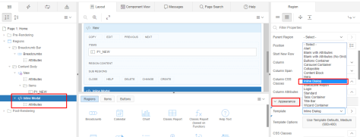Inline Modal Dialog Region
Also give static id for inline modal region ex: “sampledialog” as below snap
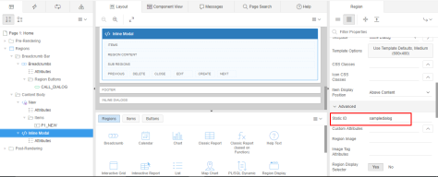
Step 2 : Create a button to call modal dialog.
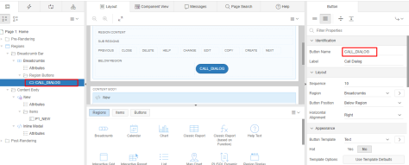
Step 3 : Call Inline Modal Dialog from button URL
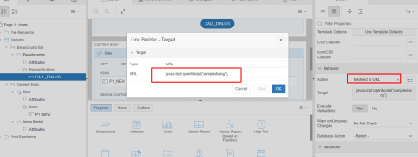
That’s it, you made it.. just click the button you can get to open the modal dialog.
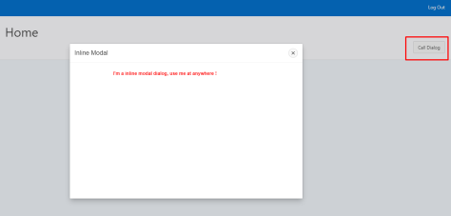

Create a Classic Report region that has a bind condition to the value returned from "text field A" set the template type to inline-dialog. Create a link in one of the columns that will return its value back to "text field B".
Dynamic Action_1
When: on-change
Selection Type: "text field A"
True Action: Execute PL/SQL Code
PLSQL Code: null; -- this is a known hack to set the value of a page item into session state
Items to Submit = "text field A"
Dynamic Action_2
When: Get Focus
Selection Type: Item = "text field B"
True action(1): Refresh
Selection Type: Region holding inline modal
True action(2): Execute Javascript Code
Code: openModal('place the static id of the inline modal region');
Inline modal will open you can click the link column created earlier and set the value for "text field B"

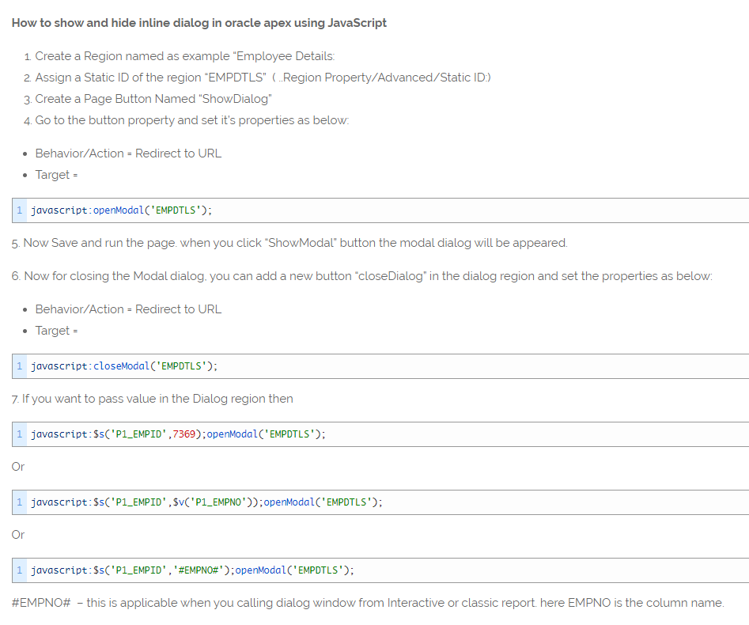

Execute when Page Loads:

var p_id = $v('P' + $v('pFlowStepId') + '_ID');
if (p_id) {
$('span[value=' + p_id +']').parents('tr').children('td').css('background-color','#FFFF99');
}

Target: P.._ID #ID#
Link Tekst: <span class="fa fa-list" value="#ID#"></span>

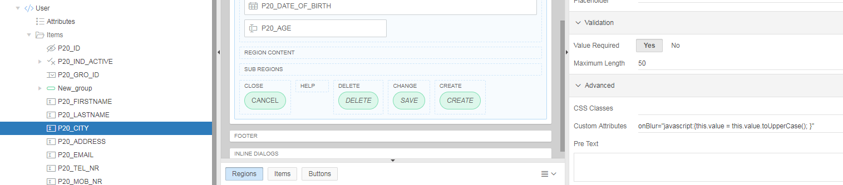

onBlur="javascript:{this.value = this.value.toUpperCase(); }"

AZL PROJECTEN

KAR (Straat-1)

:G_PF_NUMMER

Link Tekst : <span class="fa fa-list-alt" aria-hidden="true" style="color:black"></span>

When No Data Found : &NO_DATA.

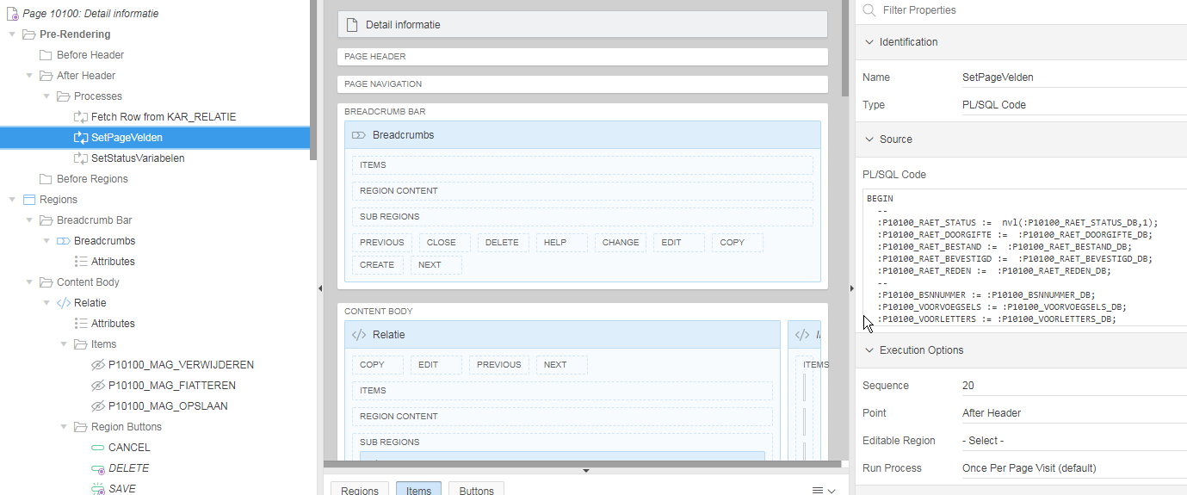

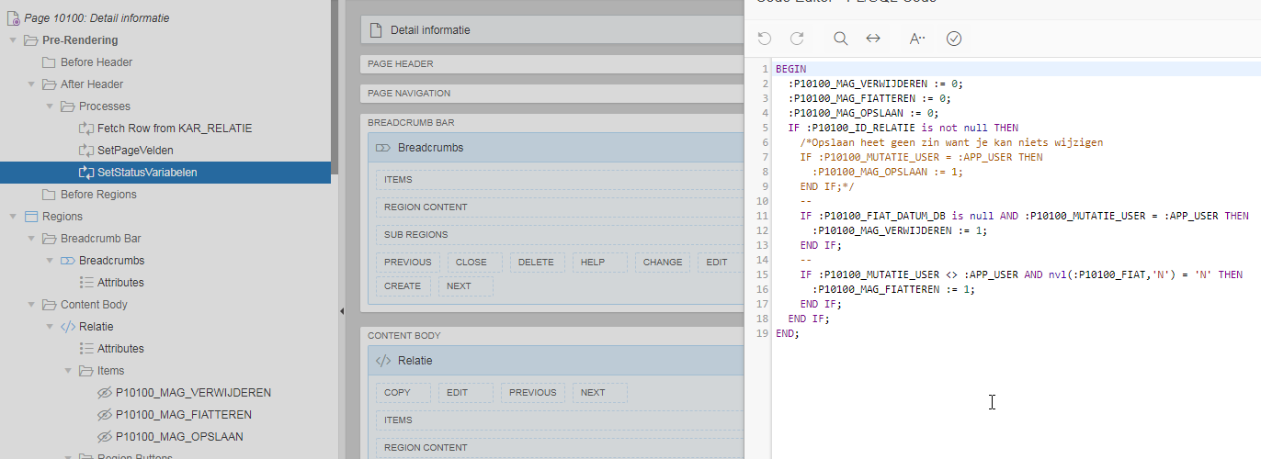

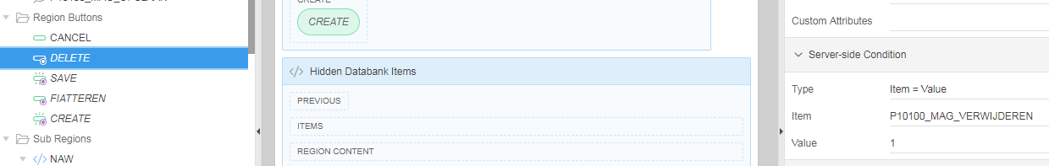

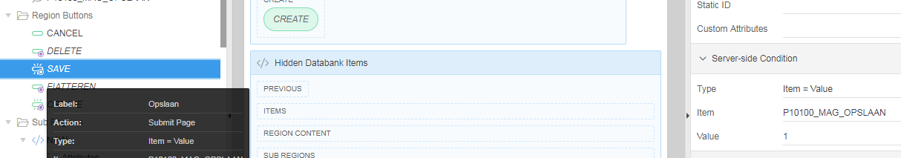

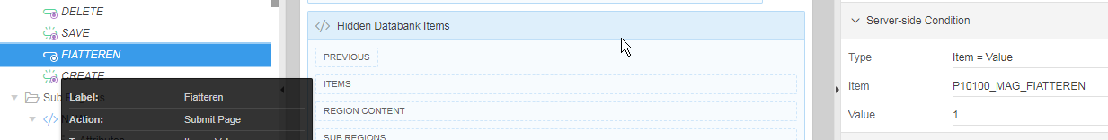

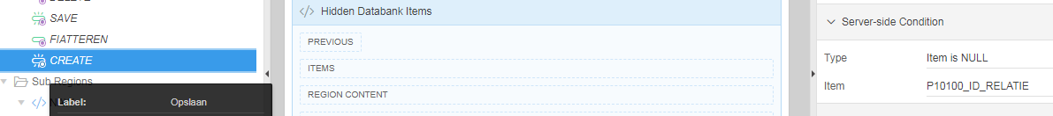

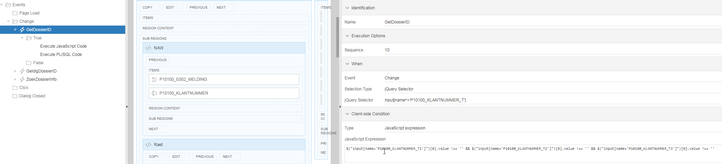

When
Event : Change
Selection Type : jQuery Selector
jQuery Selector : input[name^='P10100_KLANTNUMMER_T']

Client-side Condition
Type : JavaScript expression
JavaScript Expression :
$("input[name='P10100_KLANTNUMMER_T1']")[0].value !== '' && $("input[name='P10100_KLANTNUMMER_T2']")[0].value !== '' && $("input[name='P10100_KLANTNUMMER_T3']")[0].value !== ''

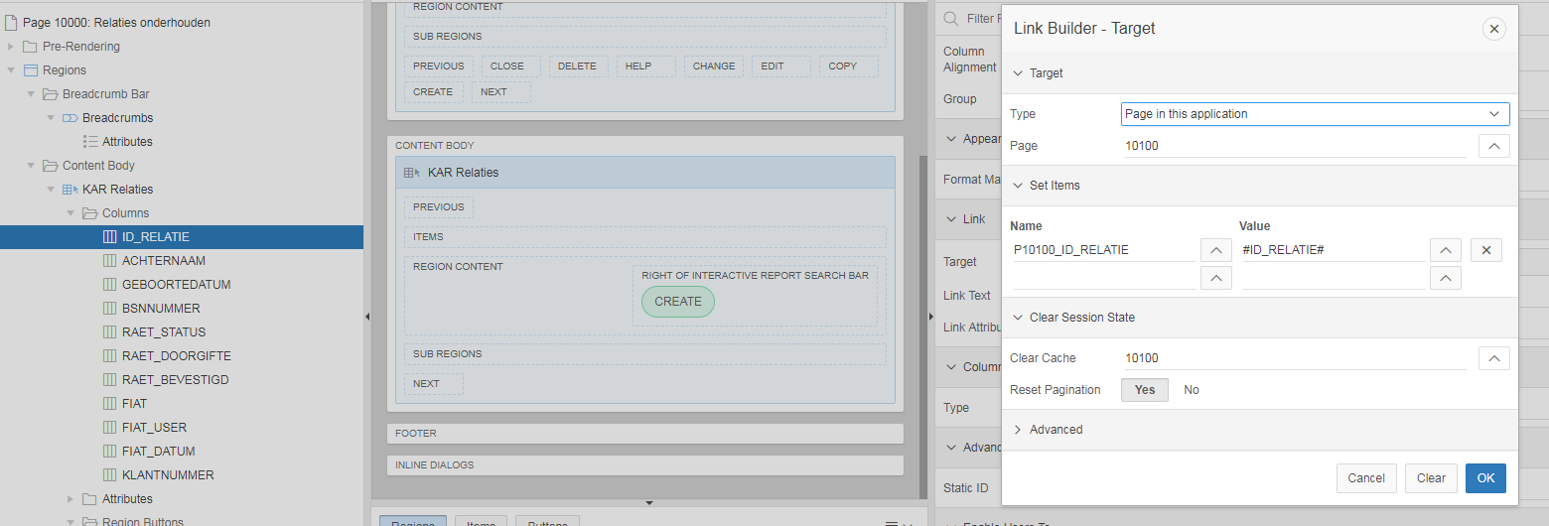

Execute JavaScript Code:
console.log($("input[name='P10100_KLANTNUMMER_T1']")[0].value);
console.log(this);

Execute PL/SQL Code:
DECLARE
CURSOR c_dossier
IS
SELECT e002.a9900
FROM personen_naw e002
WHERE lpad(e002.e000_a0001,3,'0')||'-'||lpad(e002.a0002,10,'0')||'-'||lpad(e002.a0003,2,'0') = :P10100_KLANTNUMMER;

BEGIN
OPEN c_dossier;
FETCH c_dossier INTO :P10100_E002_A9900;
IF c_dossier%notfound THEN
:P10100_E002_GELDIG := '0';
:P10100_E002_A9900 := '';
ELSE
:P10100_E002_GELDIG := '1';
END IF;
CLOSE c_dossier;
END;

<span class="fa fa-list-alt" aria-hidden="true" style="color:black"></span>

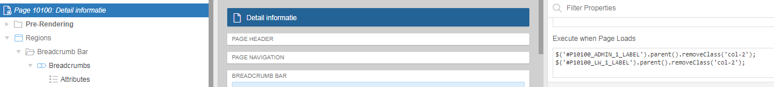

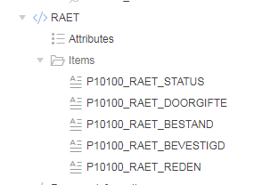

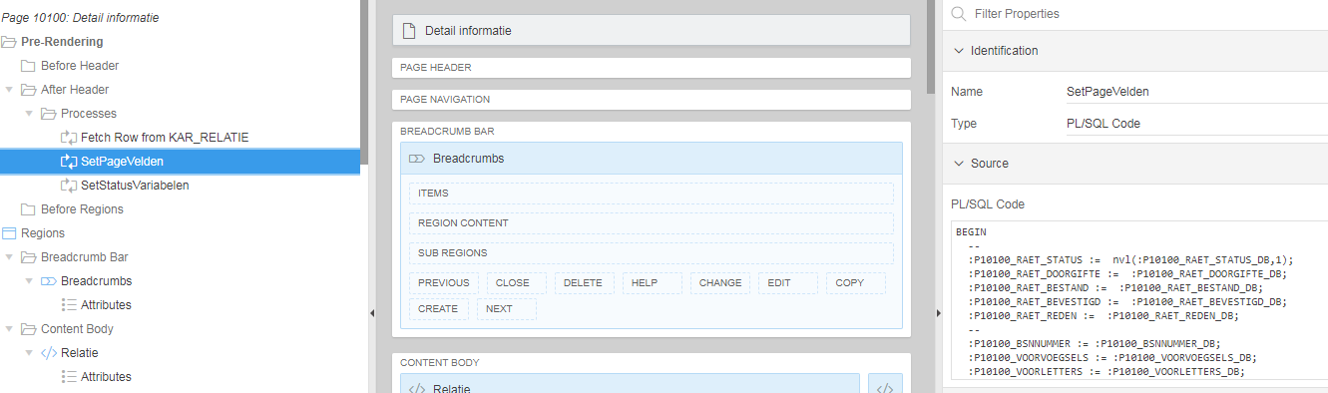

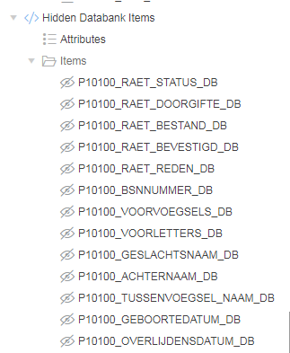

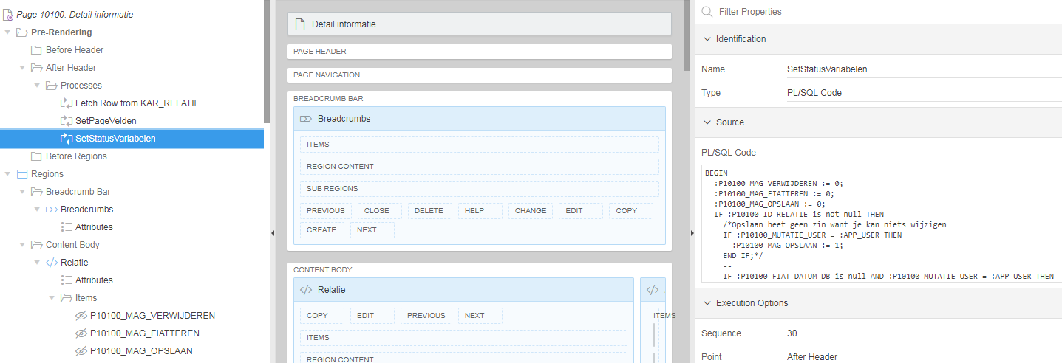

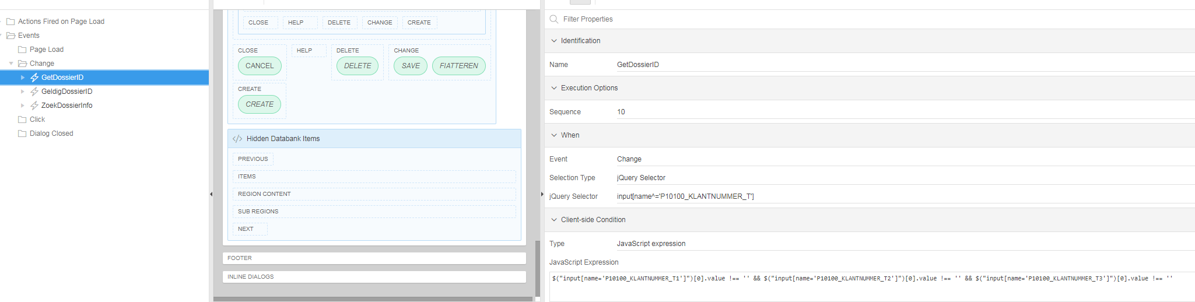

input[name^='P10100_KLANTNUMMER_T']

$("input[name='P10100_KLANTNUMMER_T1']")[0].value !== '' && $("input[name='P10100_KLANTNUMMER_T2']")[0].value !== '' && $("input[name='P10100_KLANTNUMMER_T3']")[0].value !== ''

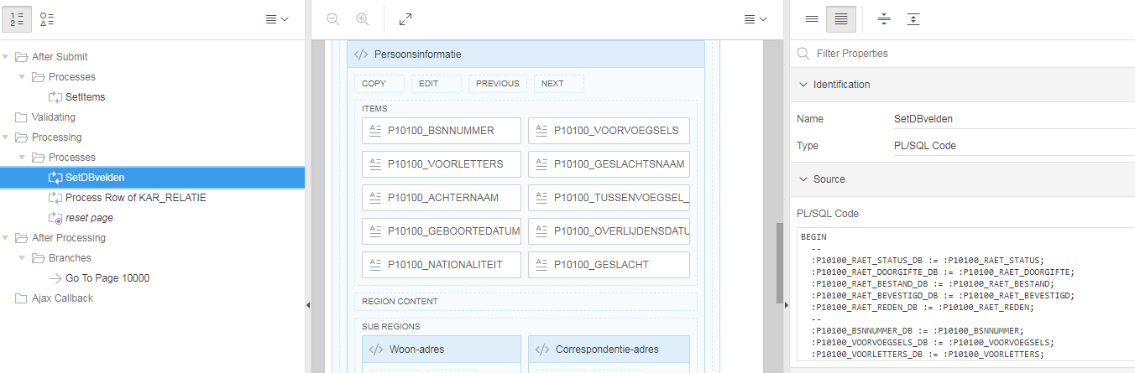

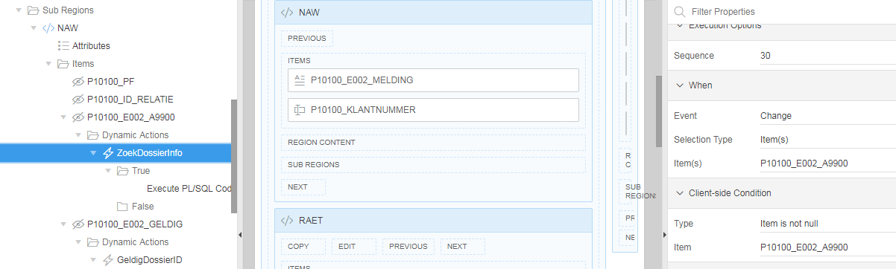

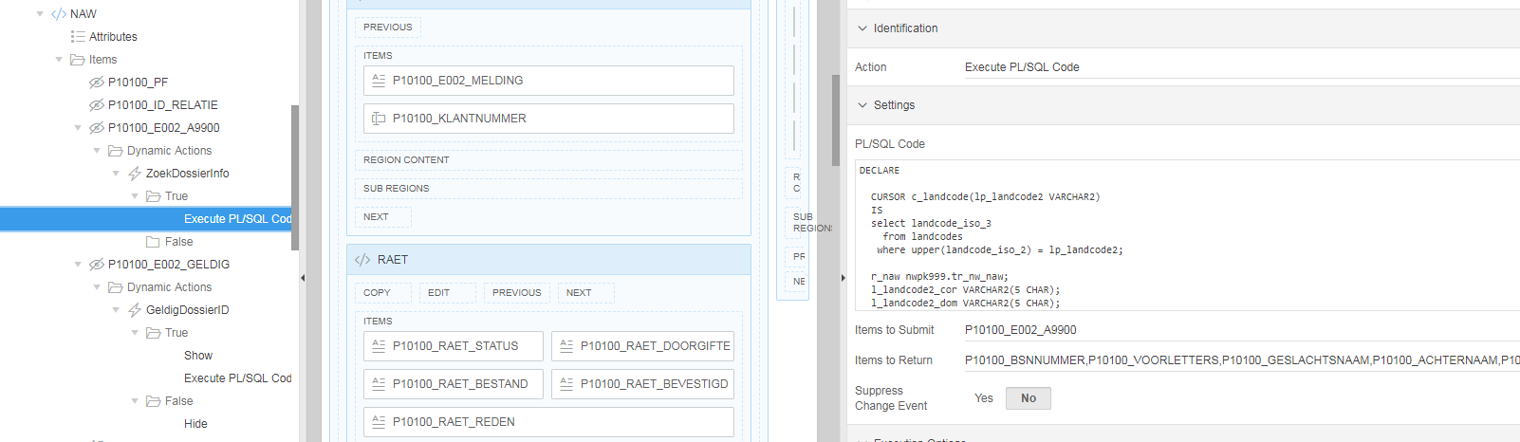

select ukp.ID_UITKERINGSPLAN
, ukp.ID_UITKERINGSPLAN detail
, ukp.ID_UITKERINGSPLAN historie
, ukp.e001_klantnummer dossier
, ukp.polisnummer polis
, ukp.FIAT FIATTEREN
, ukp.BRONSYSTEEM
, ukp.VERZEKERINGSVORM
, ukp.VERZEKERINGSVORMNR
, ukp.RAET_STATUS
, ukp.RAET_DOORGIFTE
, ukp.RAET_BESTAND
, ukp.RAET_BEVESTIGD
, ukp.RAET_REDEN
, ukp.TYPE
, ukp.BEGINDATUMRECHT
, ukp.EINDDATUMRECHT
, ukp.BEDRAG
, ukp.VALUTACODE
, ukp.VERVALDAG
, ukp.VERVALMAAND
, ukp.BETAALDAG
, ukp.PERIODECODE
, ukp.NUMERANDO
, ukp.BELAST
, ukp.VERZAMELONTVANGER
, ukp.INDICATIEPERIODIEK
, ukp.MAATSCHAPPIJCODE
, ukp.PRODUCTCODE
, ukp.AFWIJKENDE_VERVALMAAND
, ukp.AFWIJKENDE_PERIODECODE
, ukp.USER_ID
, ukp.WIJZ_DATUM
, ukp.MUTATIE_USER
, ukp.MUTATIE_DATUM
, ukp.FIAT
, ukp.FIAT_USER
, ukp.FIAT_DATUM
, CASE WHEN ukp.FIAT = 'N' THEN '<span class="fa fa-unlock fam-warning" aria-hidden="true" style="color:red;"></span>'
ELSE '<span class="fa fa-lock fam-check" aria-hidden="true" style="color:green; cursor:default;"></span>'
END FIAT_IMG
, CASE WHEN ukp.FIAT = 'N' THEN APEX_UTIL.PREPARE_URL(p_url => 'f?p=&APP_ID.:11100:&APP_SESSION.::NO::P11100_ID_UITKERINGSPLAN,P11100_FIATTEREN:'||ukp.ID_UITKERINGSPLAN||',1')
ELSE 'javascript:void(0)'
END FIAT_LINK
, CASE WHEN (select count(1) from kar_uitkeringsplan_jn where id_uitkeringsplan = ukp.ID_UITKERINGSPLAN) > 1 THEN '<span aria-hidden="true" class="fa fa-database fam-clock fam-is-success"></span>'
ELSE '<span aria-hidden="true" class="fa fa-database fam-clock fam-is-disabled"></span>'
END HIST_IMG
from V_KAR_UITKERINGSPLAN ukp
where to_number(ukp.bronsysteem) = :G_PF_NUMMER
order by to_number(ukp.bronsysteem)
, ukp.e001_klantnummer
, ukp.VERZEKERINGSVORM
, ukp.VERZEKERINGSVORMNR

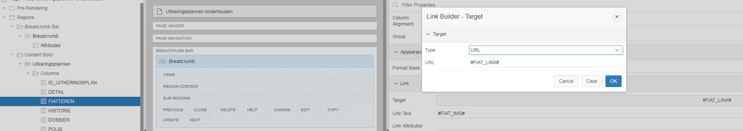

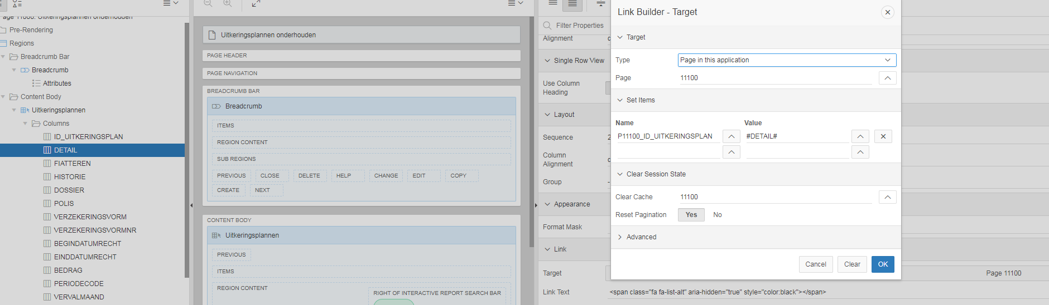

<span class="fa fa-list-alt" aria-hidden="true" style="color:black"></span>

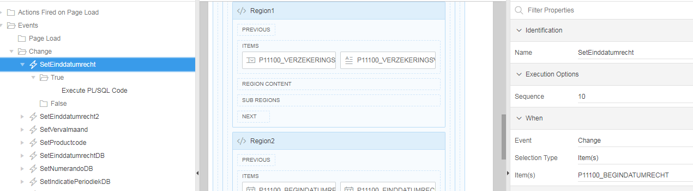

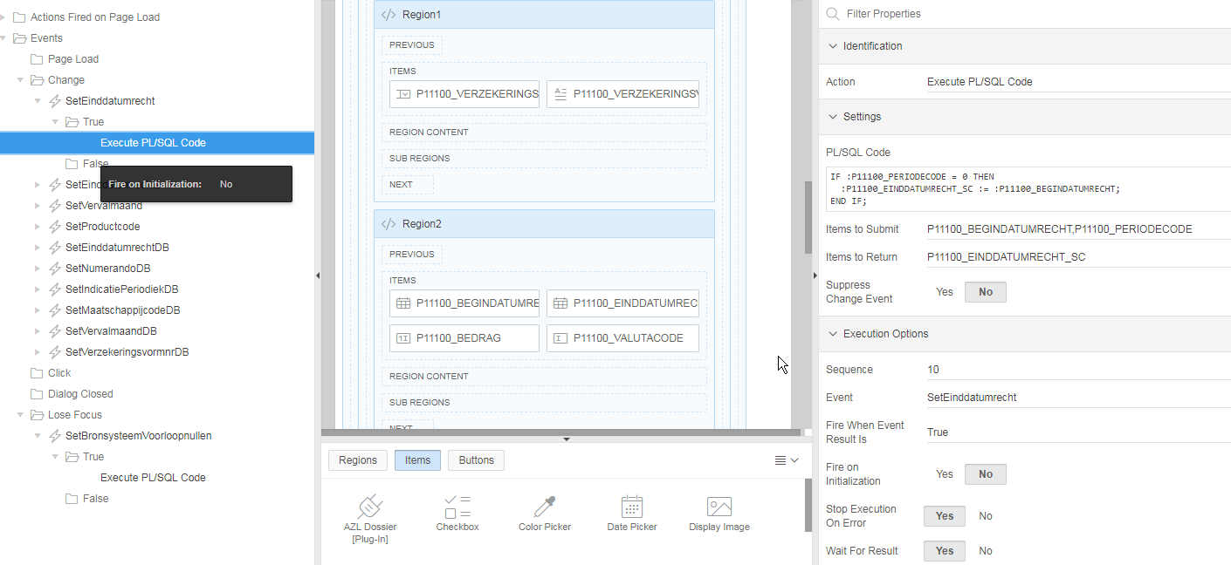

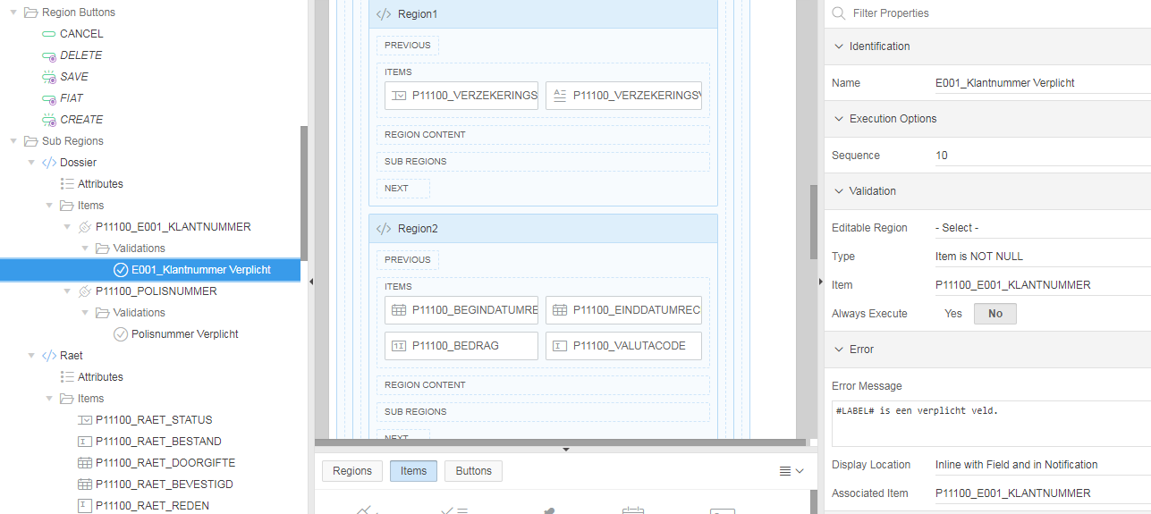

select ukp.ID_UITKERINGSPLAN
, CASE WHEN jn_operation = 'INS' THEN '<span class="fa fa-database-plus" aria-hidden="true" style="color:green"></span>'
WHEN jn_operation = 'UPD' THEN '<span class="fa fa-database-edit" aria-hidden="true" style="color:orange"></span>'
WHEN jn_operation = 'DEL' THEN '<span class="fa fa-database-x" aria-hidden="true" style="color:red"></span>'
ELSE ''
END actie
, ukp.e001_klantnummer dossier
, ukp.polisnummer polis
, ukp.VERZEKERINGSVORM
, ukp.VERZEKERINGSVORMNR
, ukp.BEGINDATUMRECHT
, ukp.EINDDATUMRECHT
, ukp.BEDRAG
, ukp.PERIODECODE
, ukp.VERVALMAAND
, ukp.BELAST
, ukp.MAATSCHAPPIJCODE
, ukp.PRODUCTCODE
, ukp.AFWIJKENDE_PERIODECODE
, ukp.AFWIJKENDE_VERVALMAAND
, ukp.USER_ID
, ukp.WIJZ_DATUM
, ukp.MUTATIE_USER
, ukp.MUTATIE_DATUM
, ukp.FIAT
, ukp.FIAT_USER
, ukp.FIAT_DATUM
, ukp.RAET_STATUS
, ukp.RAET_DOORGIFTE
, ukp.RAET_BESTAND
, ukp.RAET_BEVESTIGD
, ukp.RAET_REDEN
, ukp.TYPE
, ukp.VALUTACODE
, ukp.VERVALDAG
, ukp.BETAALDAG
, ukp.NUMERANDO
, ukp.VERZAMELONTVANGER
, ukp.INDICATIEPERIODIEK
from KAR_UITKERINGSPLAN_JN ukp
where to_number(ukp.bronsysteem) = :G_PF_NUMMER
and ukp.ID_UITKERINGSPLAN = :P11200_HISTORIE_ID
order by ukp.jn_datetime
, CASE WHEN ukp.jn_operation = 'INS' THEN 1
WHEN ukp.jn_operation = 'UPD' THEN 2
WHEN ukp.jn_operation = 'DEL' THEN 3
ELSE 9
END

DELETE button:

URL
javascript:apex.confirm(htmldb_delete_message,'DELETE');
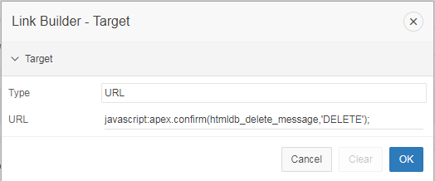

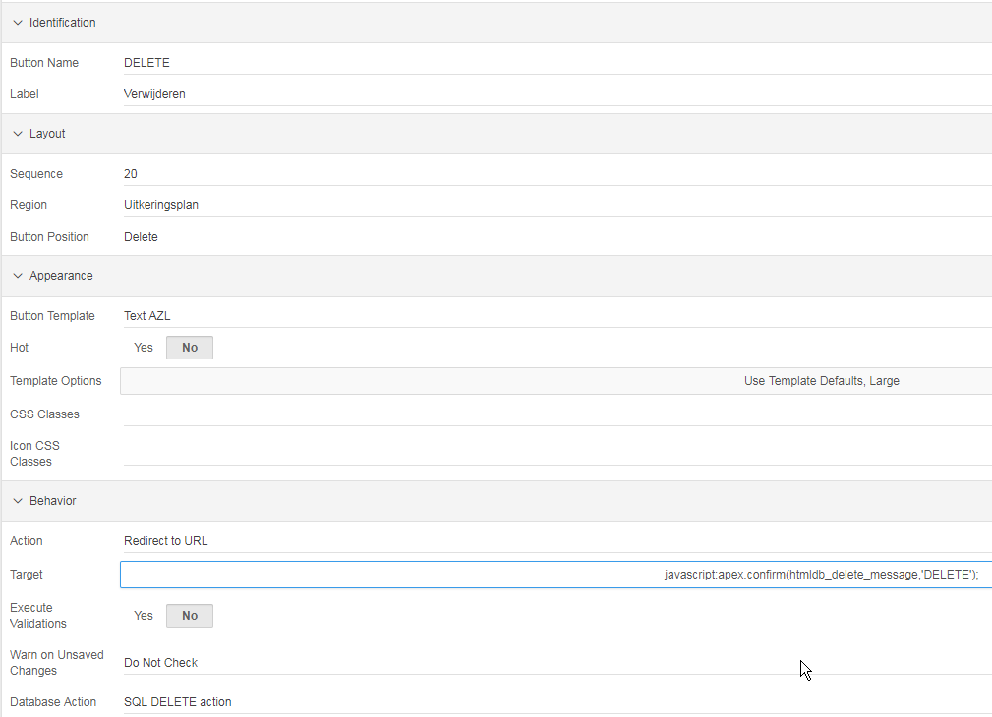

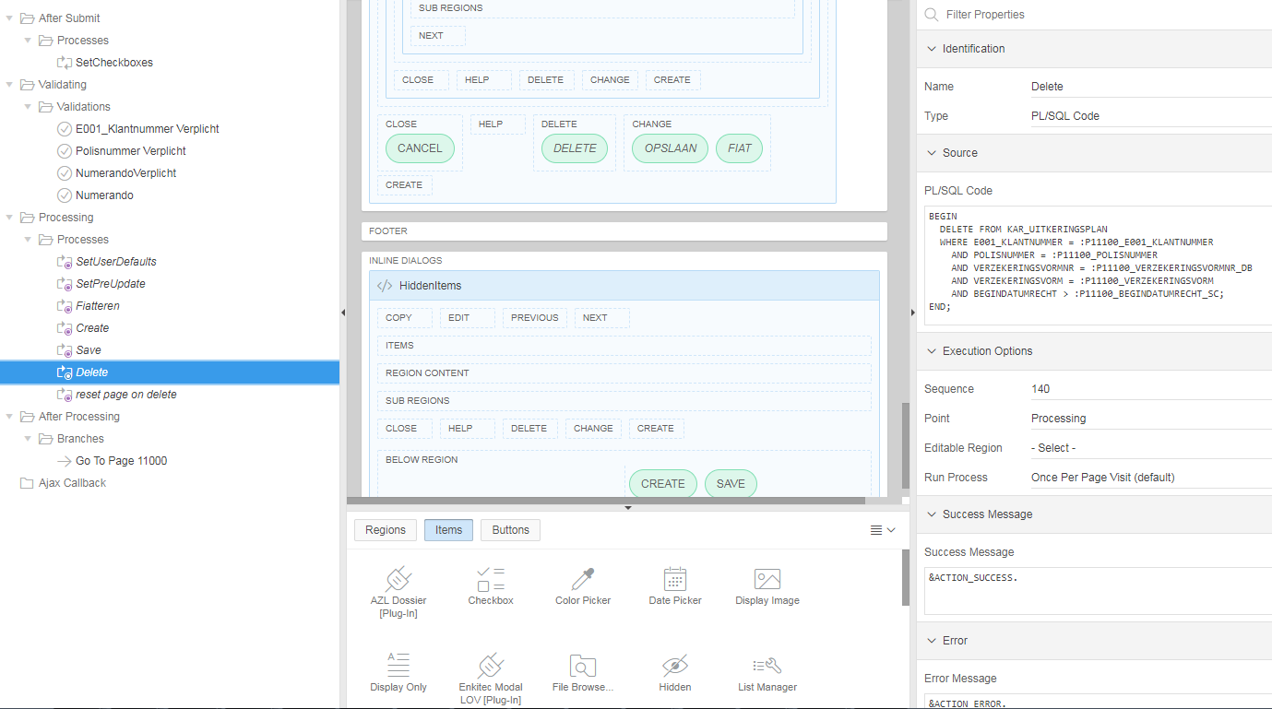

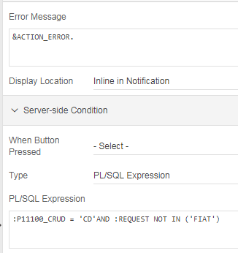

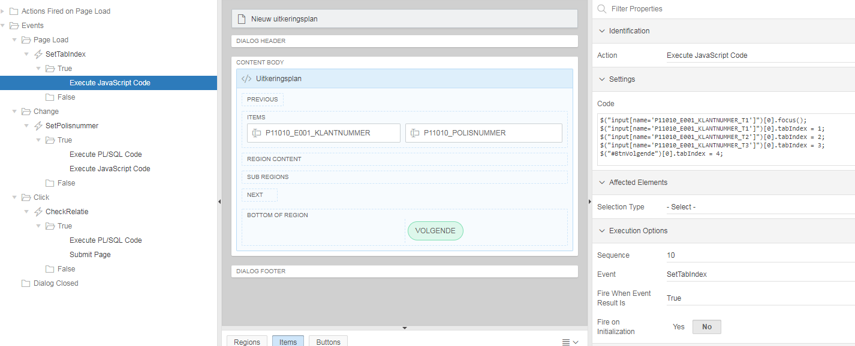

Execute JavaScript Code:
$("input[name='P11010_E001_KLANTNUMMER_T1']")[0].focus();
$("input[name='P11010_E001_KLANTNUMMER_T1']")[0].tabIndex = 1;
$("input[name='P11010_E001_KLANTNUMMER_T2']")[0].tabIndex = 2;
$("input[name='P11010_E001_KLANTNUMMER_T3']")[0].tabIndex = 3;
$("#BtnVolgende")[0].tabIndex = 4;

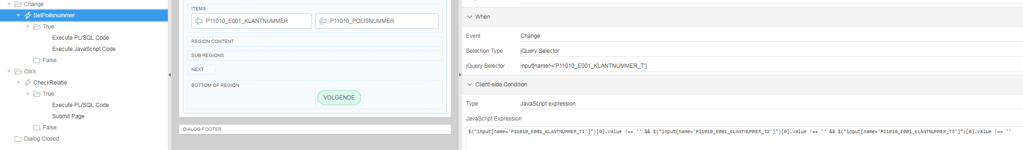

jQuery Selector : input[name^='P11010_E001_KLANTNUMMER_T']

JavaScript Expression :
$("input[name='P11010_E001_KLANTNUMMER_T1']")[0].value !== '' && $("input[name='P11010_E001_KLANTNUMMER_T2']")[0].value !== '' && $("input[name='P11010_E001_KLANTNUMMER_T3']")[0].value !== ''

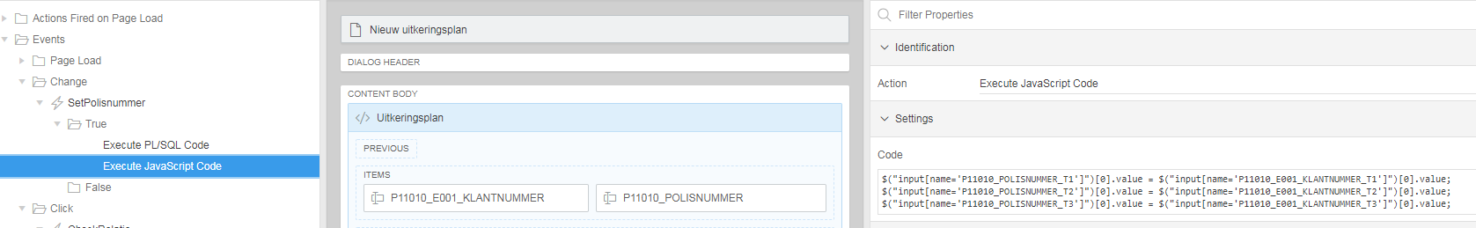

Execute JavaScript Code:
$("input[name='P11010_POLISNUMMER_T1']")[0].value = $("input[name='P11010_E001_KLANTNUMMER_T1']")[0].value;
$("input[name='P11010_POLISNUMMER_T2']")[0].value = $("input[name='P11010_E001_KLANTNUMMER_T2']")[0].value;
$("input[name='P11010_POLISNUMMER_T3']")[0].value = $("input[name='P11010_E001_KLANTNUMMER_T3']")[0].value;

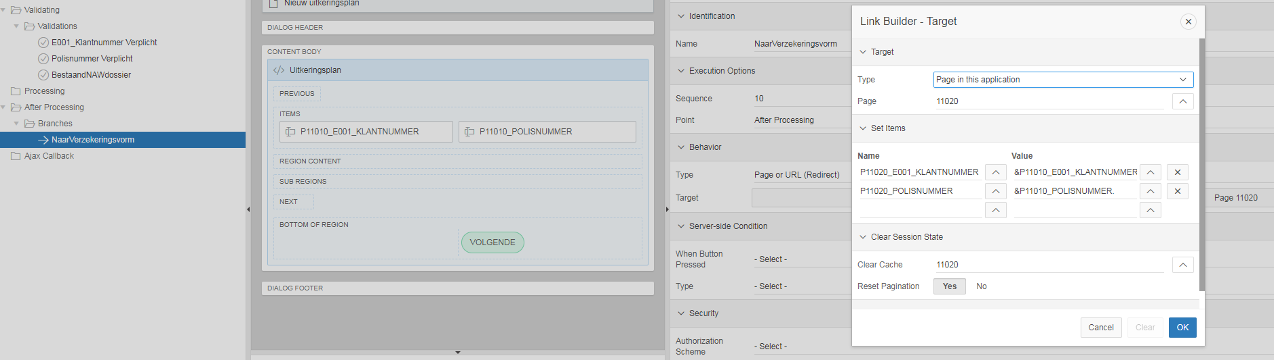

select ukp.ID_UITKERINGSPLAN
, CASE WHEN jn_operation = 'INS' THEN '<span class="fa fa-database-plus" aria-hidden="true" style="color:green"></span>'
WHEN jn_operation = 'UPD' THEN '<span class="fa fa-database-edit" aria-hidden="true" style="color:orange"></span>'
WHEN jn_operation = 'DEL' THEN '<span class="fa fa-database-x" aria-hidden="true" style="color:red"></span>'
ELSE ''
END actie
, ukp.e001_klantnummer dossier
, ukp.polisnummer polis
, ukp.VERZEKERINGSVORM
, ukp.VERZEKERINGSVORM CODE
, ukp.VERZEKERINGSVORMNR
, ukp.BEGINDATUMRECHT
, ukp.EINDDATUMRECHT
, ukp.BEDRAG
, ukp.PERIODECODE
, ukp.VERVALMAAND
, ukp.BELAST
, ukp.MAATSCHAPPIJCODE
, ukp.PRODUCTCODE
, ukp.USER_ID
, ukp.WIJZ_DATUM
, ukp.MUTATIE_USER
, ukp.MUTATIE_DATUM
, ukp.FIAT
, ukp.FIAT_USER
, ukp.FIAT_DATUM
, ukp.RAET_STATUS
, ukp.RAET_DOORGIFTE
, ukp.RAET_BESTAND
, ukp.RAET_BEVESTIGD
, ukp.RAET_REDEN
, ukp.TYPE
, ukp.VALUTACODE
, ukp.VERVALDAG
, ukp.BETAALDAG
, ukp.NUMERANDO
, ukp.VERZAMELONTVANGER
, ukp.INDICATIEPERIODIEK
from KAR_UITKERINGSPLAN_JN ukp
where to_number(ukp.bronsysteem) = :G_PF_NUMMER
and ukp.ID_UITKERINGSPLAN = :P11200_HISTORIE_ID
order by ukp.jn_datetime
, CASE WHEN ukp.jn_operation = 'INS' THEN 1
WHEN ukp.jn_operation = 'UPD' THEN 2
WHEN ukp.jn_operation = 'DEL' THEN 3
ELSE 9
END

select e011.ID_AFSTEMMING,
e011.ID_AFSTEMMING DETAILS,
e011.ID_AFSTEMMING AKKOORD,
CASE WHEN AKKOORD_BRUTO_1 = 'N' AND AKKOORD_BRUTO_2 = 'N' THEN '<span aria-hidden="true" class="fa fa-pie-chart-0"></span>'
WHEN AKKOORD_BRUTO_1 = 'J' AND AKKOORD_BRUTO_2 = 'N' THEN '<span aria-hidden="true" class="fa fa-pie-chart-50"></span>'
WHEN AKKOORD_BRUTO_1 = 'J' AND AKKOORD_BRUTO_2 = 'J' THEN '<span aria-hidden="true" class="fa fa-pie-chart-100"></span>'
END AKKOORD_LINK,
CASE WHEN AKKOORD_BRUTO_1 = 'N' AND AKKOORD_BRUTO_2 = 'N' THEN 'style="color:red"'
WHEN AKKOORD_BRUTO_1 = 'J' AND AKKOORD_BRUTO_2 = 'N' THEN 'style="color:orange"'
WHEN AKKOORD_BRUTO_1 = 'J' AND AKKOORD_BRUTO_2 = 'J' THEN 'style="color:green"'
END AKKOORD_STYLE,
e011.PF,
e011.PERIODE,
e011.PERIODE_VNR,
e011.AANTAL_RAET,
e011.AANTAL_COMPAS,
e011.AANTAL_AKKOORD,
e011.AKKOORD_BRUTO_1,
e011.USER_BRUTO_1,
e011.DATUM_BRUTO_1,
e011.AKKOORD_BRUTO_2,
e011.USER_BRUTO_2,
e011.DATUM_BRUTO_2,
e011.USER_ID,
e011.WIJZ_DATUM,
(select CASE WHEN count(1) > 0 THEN 'Ja' ELSE 'Nee' END aanwezig
from KAR_AFSTEMMING_DETAIL afk
where signaal IN ('05','06')
and afk.e011_periode = e011.periode
and afk.e011_pf = e011.pf
and afk.e011_periode_vnr = e011.periode_vnr) sig_0506_aanwezig
from KAR_AFSTEMMING e011
where e011.PF = :G_PF_NUMMER

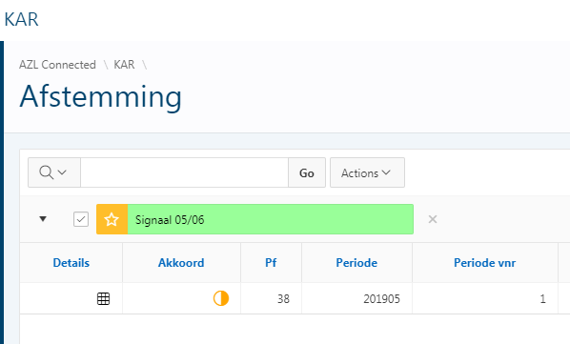

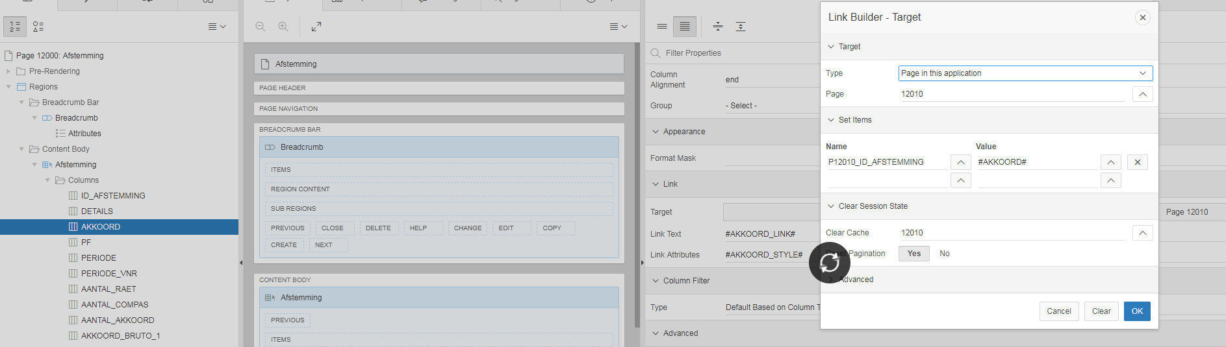

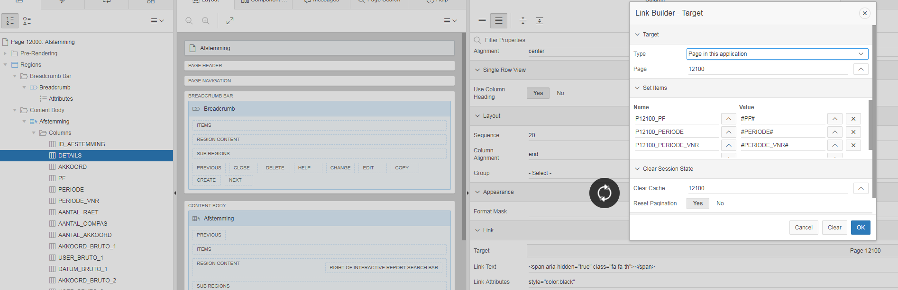

Link Text : <span aria-hidden="true" class="fa fa-th"></span>
Link Attributes : style="color:black"

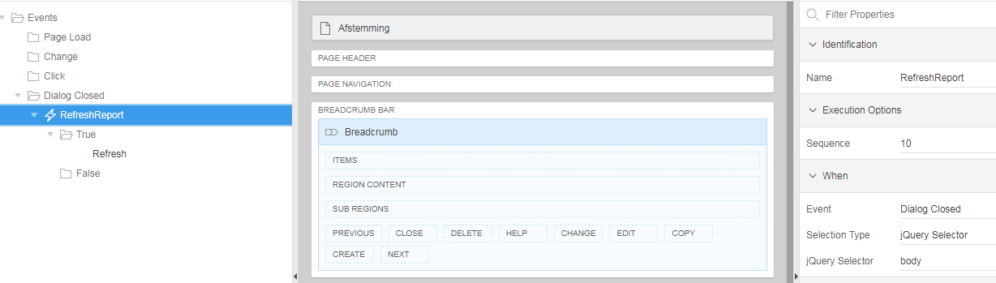

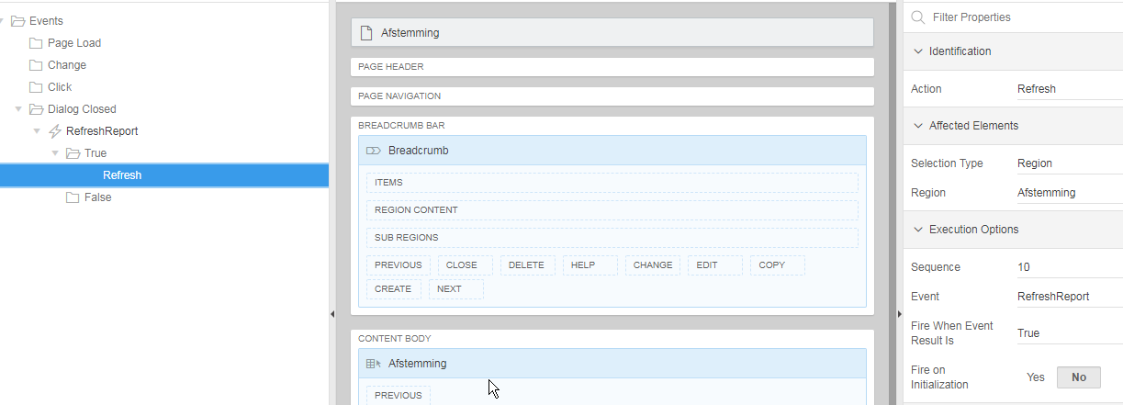

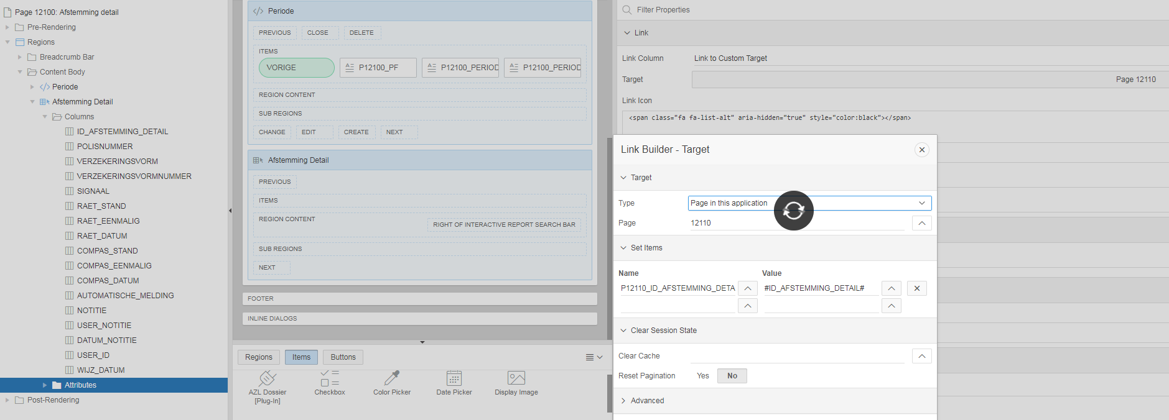

Link Icon : <span class="fa fa-list-alt" aria-hidden="true" style="color:black"></span>

Pagina 13000

SELECT kar_e008.id_pf_lov
, kar_e008.id_pf_lov detail
, kar_e008.fiat fiatteren
, kar_e008.pf
, kar_e008.raet_verzekeringsvorm
, vzv.omschrijving omschrijvingverzekeringsvorm
, kar_e008.raet_verzekeringsvormnr
, kar_e013.omschrijving omschrijvingverzekeringsvormnr
, kar_e008.omschrijving
, kar_e008.pf_stuur
, kar_e008.code_component
, kar_e008.user_id
, kar_e008.wijz_datum
, kar_e008.fiat
, kar_e008.fiat_user
, kar_e008.fiat_datum
, CASE WHEN kar_e008.FIAT = 'N' AND kar_e008.USER_ID <> :APP_USER THEN '<span class="fa fa-unlock fam-warning" aria-hidden="true" style="color:red;"></span>'
WHEN kar_e008.FIAT = 'N' AND kar_e008.USER_ID = :APP_USER THEN '<span class="fa fa-unlock fam-warning fam-is-disabled" aria-hidden="true" style="color:red; cursor:default;"></span>'
ELSE '<span class="fa fa-lock fam-check" aria-hidden="true" style="color:green; cursor:default;"></span>'
END FIAT_IMG
, CASE WHEN kar_e008.FIAT = 'N' AND kar_e008.USER_ID <> :APP_USER THEN APEX_UTIL.PREPARE_URL(p_url => 'f?p=&APP_ID.:13100:&APP_SESSION.::NO::P13100_ID_PF_LOV,P13100_FIATTEREN:'||kar_e008.ID_PF_LOV||',1')
ELSE 'javascript:void(0)'
END FIAT_LINK
FROM kar_pf_lov kar_e008
, kar_verzekeringsvormnr_lov kar_e013
, kar_verzekeringsvorm_lov vzv
WHERE kar_e008.pf = :G_PF_NUMMER
and kar_e013.raet_verzekeringsvormnr = kar_e008.raet_verzekeringsvormnr
and kar_e008.RAET_VERZEKERINGSVORM = vzv.RAET_VERZEKERINGSVORM
order by pf, RAET_VERZEKERINGSVORM, RAET_VERZEKERINGSVORMNR, pf_stuur, code_component

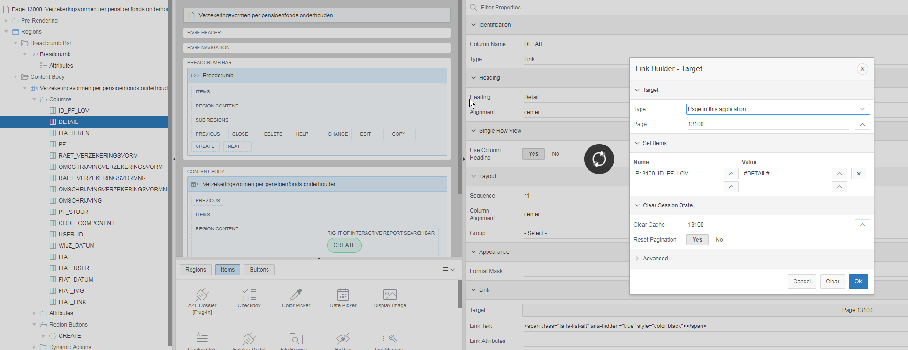

Link Tekst : <span class="fa fa-list-alt" aria-hidden="true" style="color:black"></span>

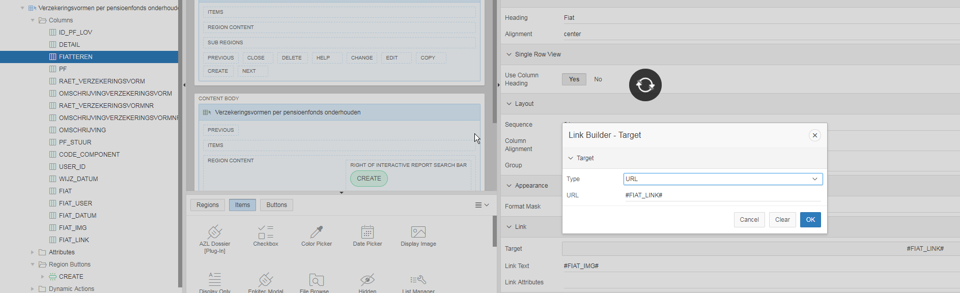

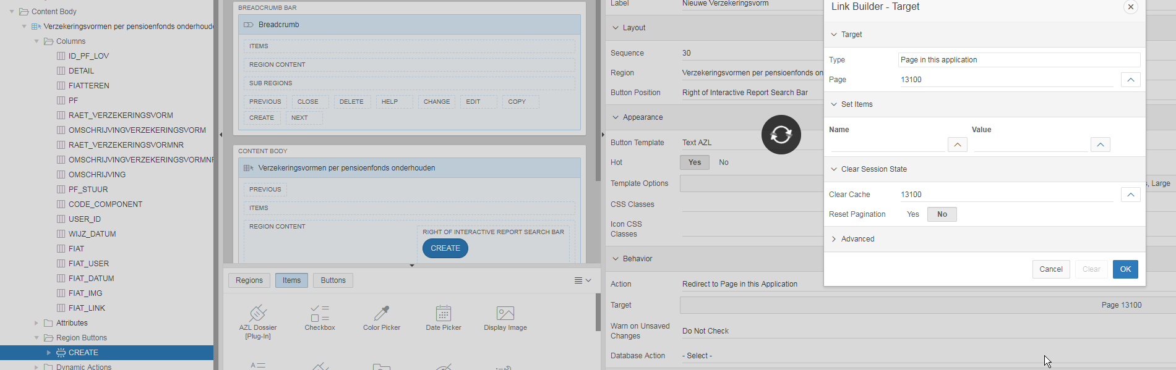

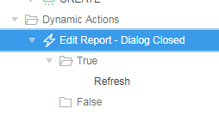

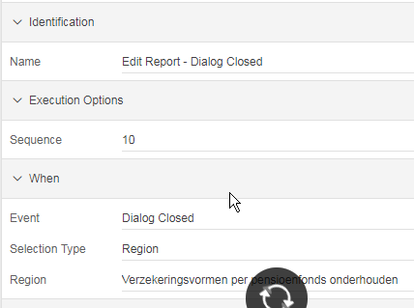

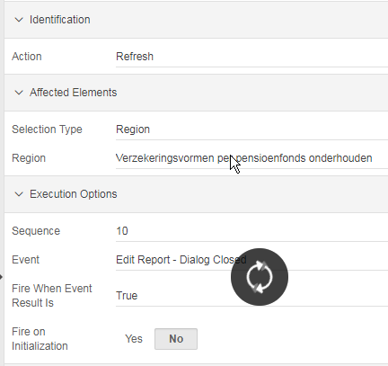

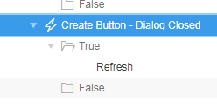

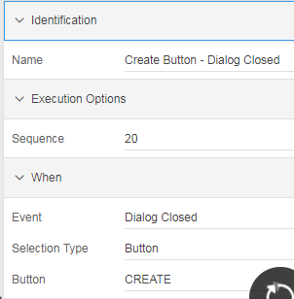

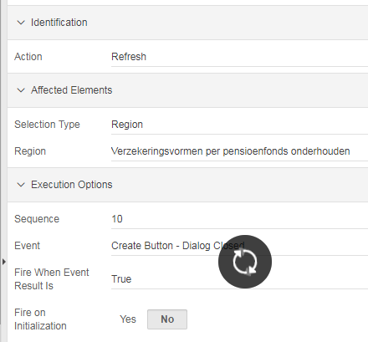

Pagina 13100

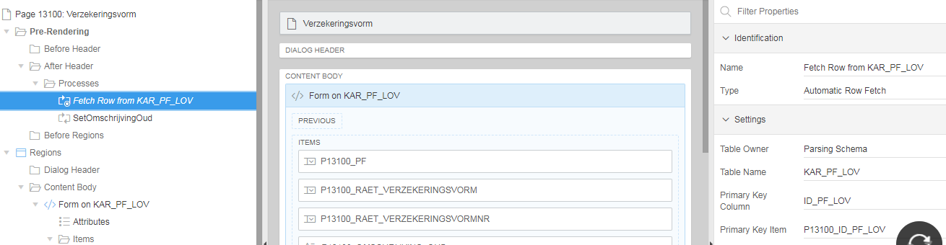

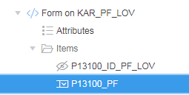

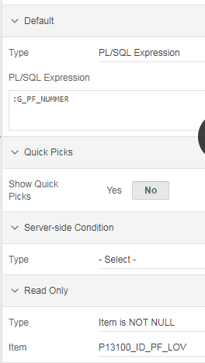

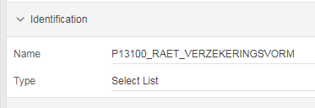

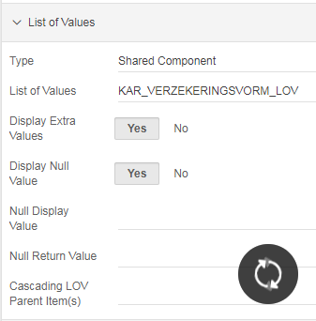
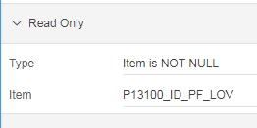

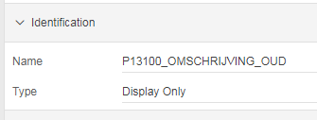

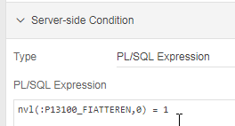

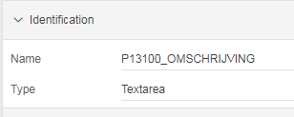

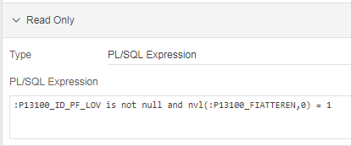

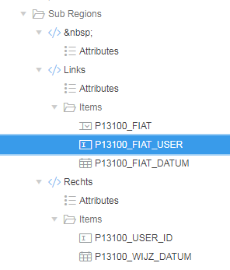

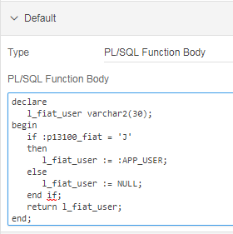

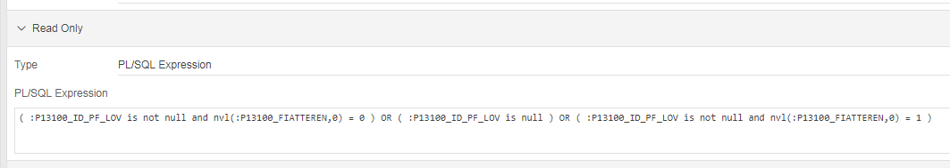

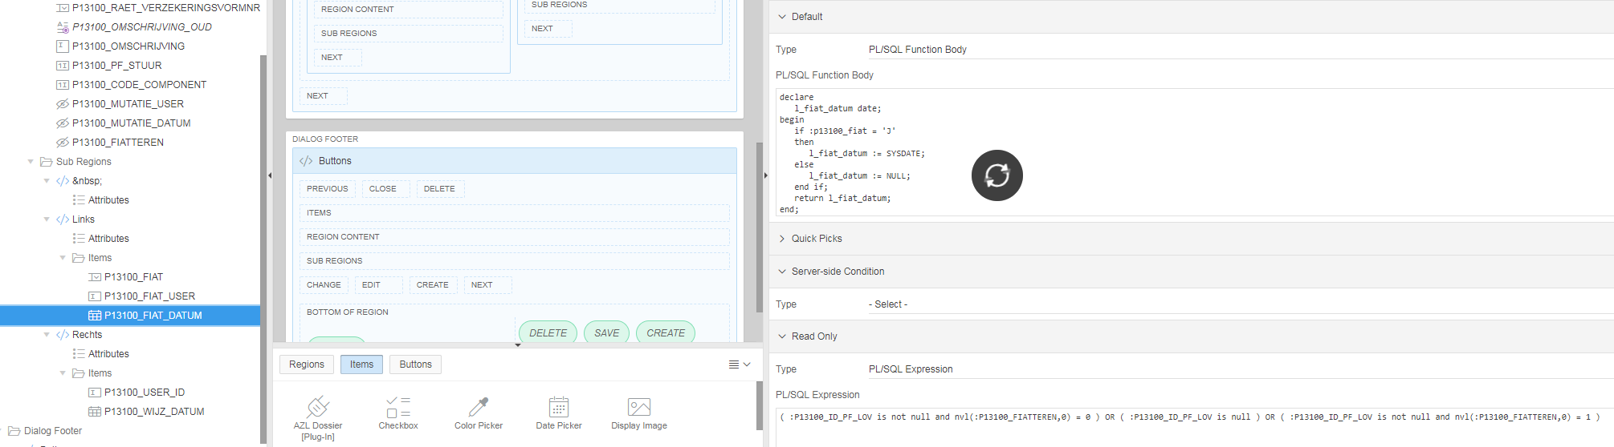

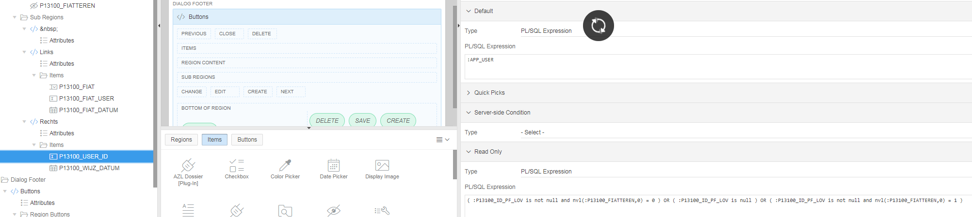

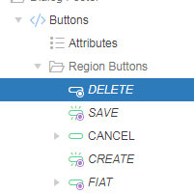

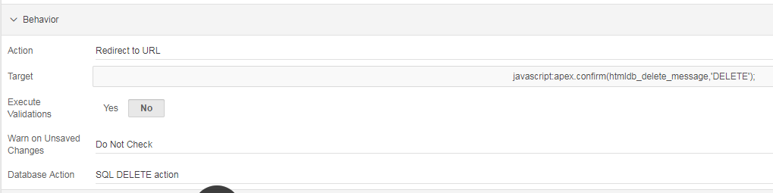

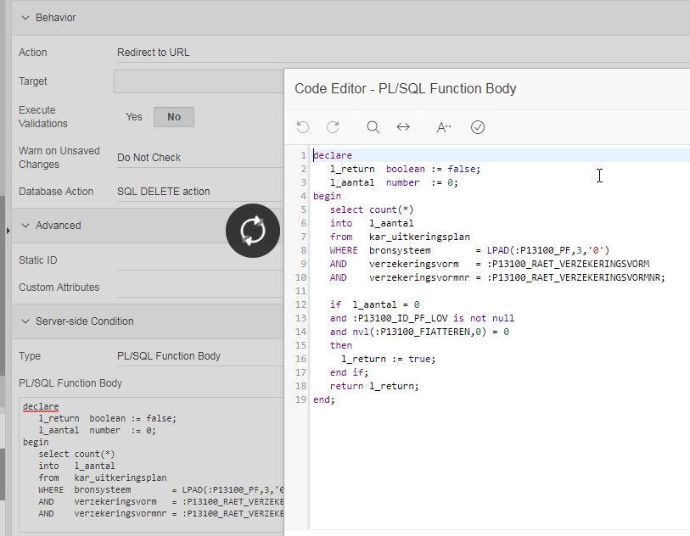

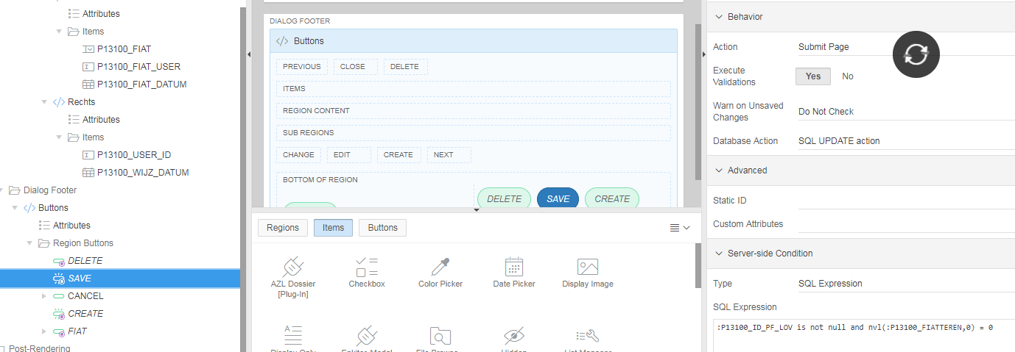

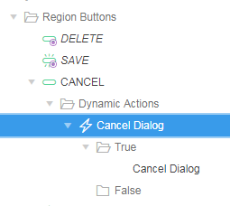

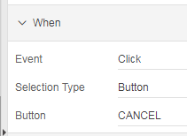

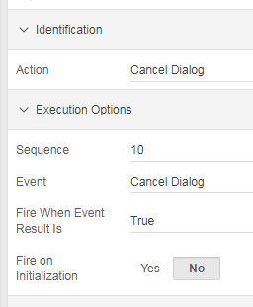

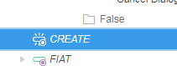

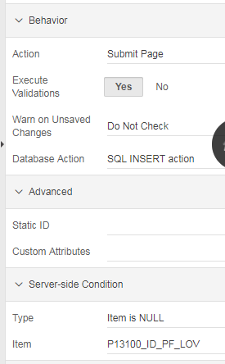

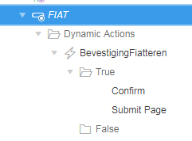

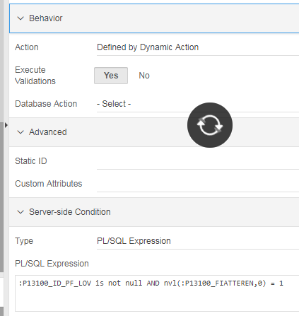

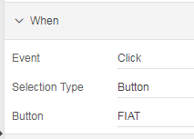

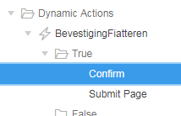

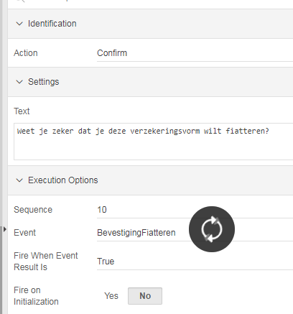

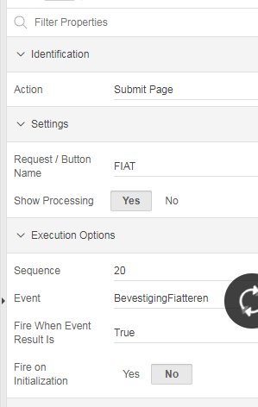

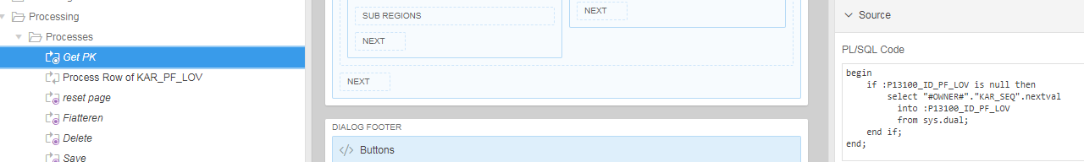

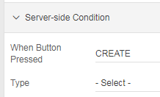

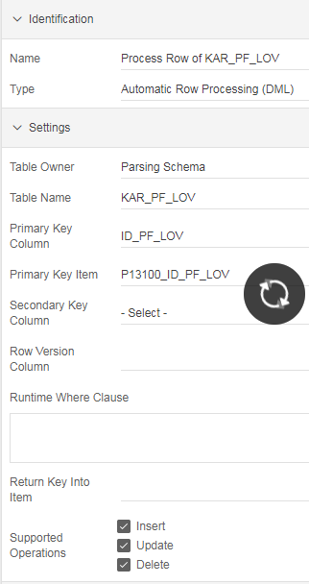

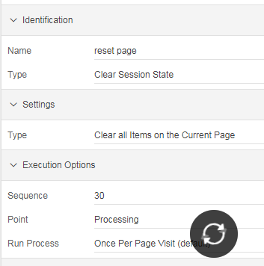

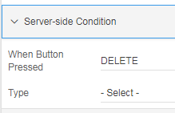

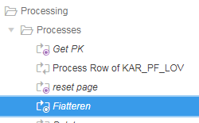

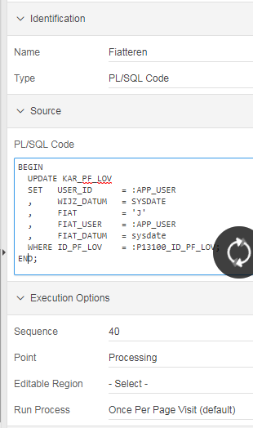

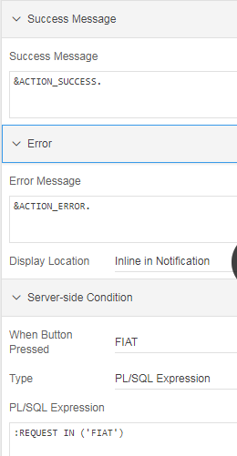

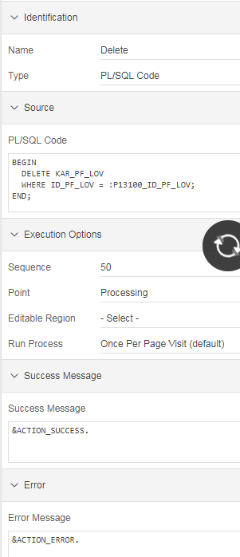

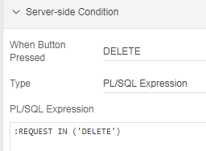

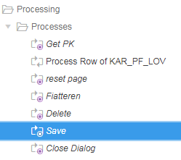

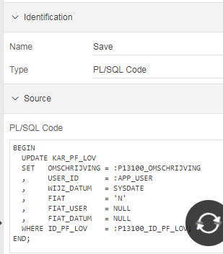

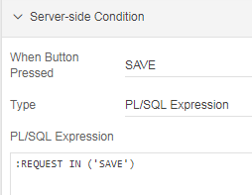

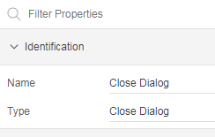

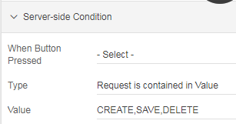

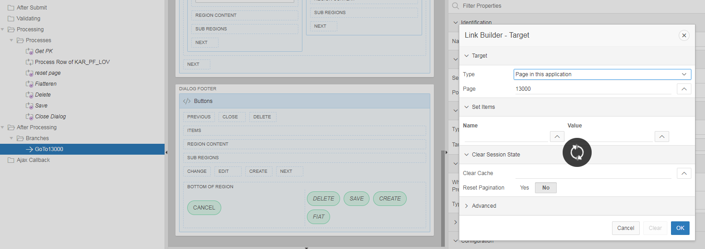

UPA (Straat-5)

ROWID_PREV en ROWID_NEXT

Pre-Rendering - After Header - Processes

Type: Form Pagination

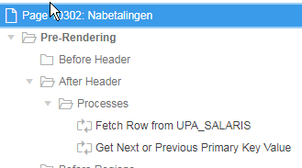

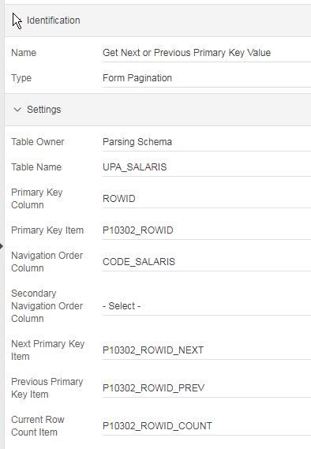

ROWID_NEXT, ROWID_PREV, ROWID_COUNT:
Settings : Value Protected : No
Source : Type : Null

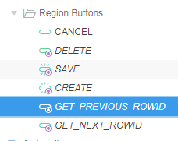

Behavior:
Action: Submit Page

Server-side Condition:
Type: Item is NOT NULL
Item: P10302_ROWID_PREV

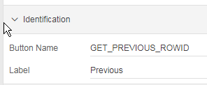

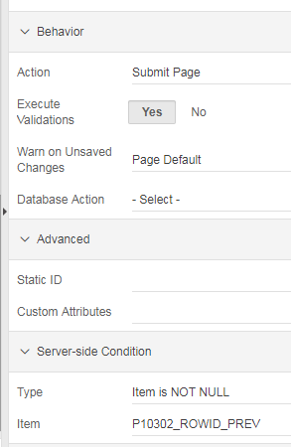

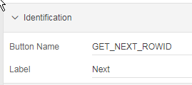

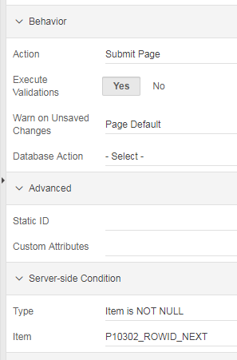

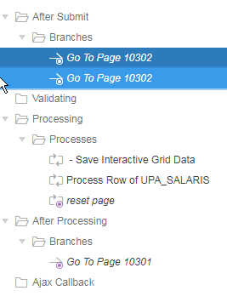

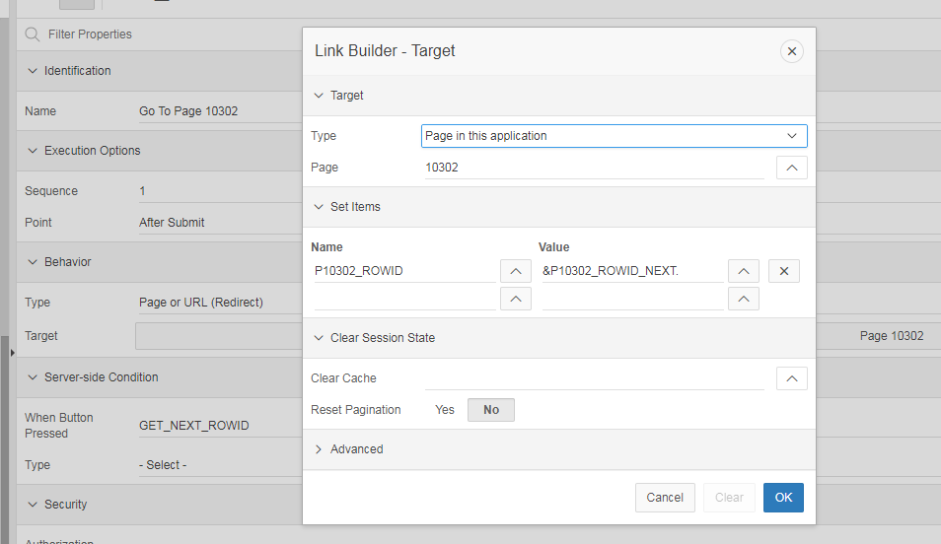

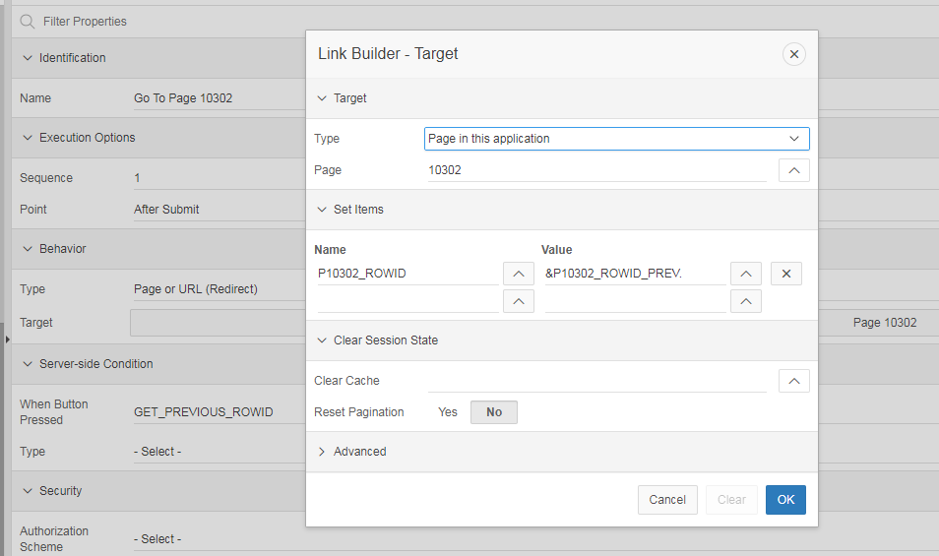

Zoek button

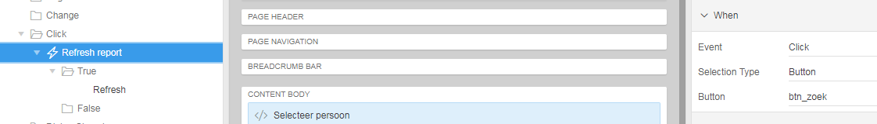

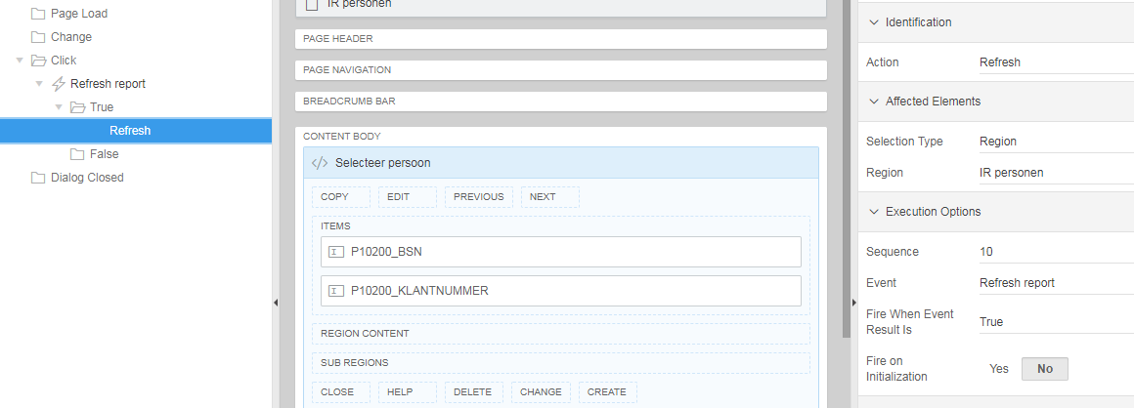

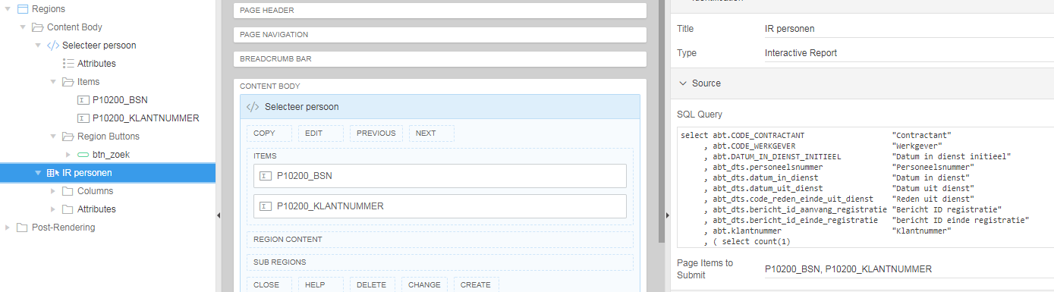

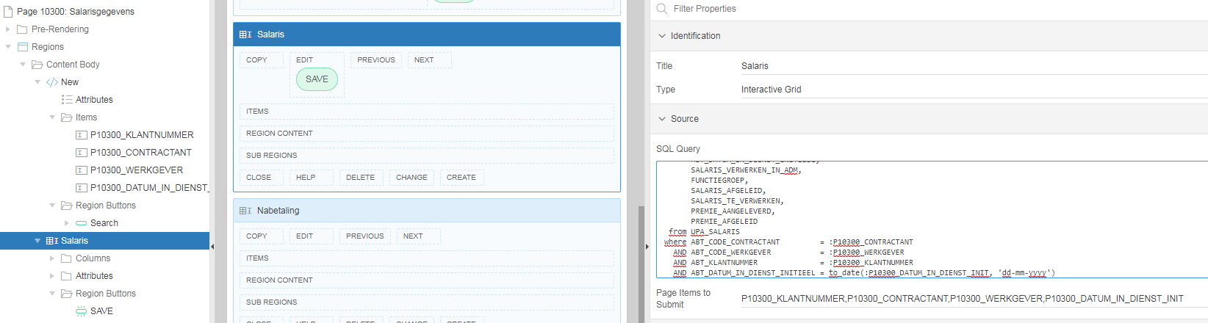

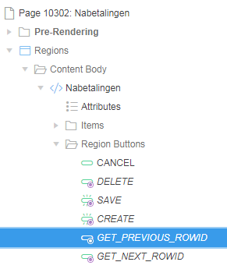

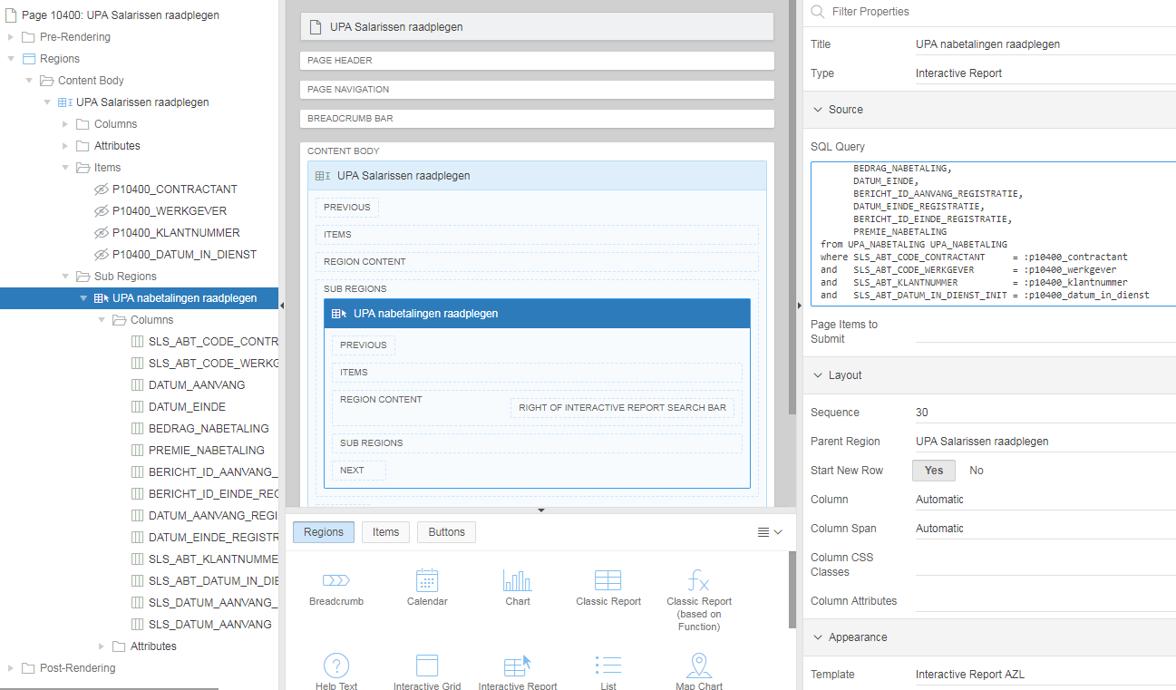

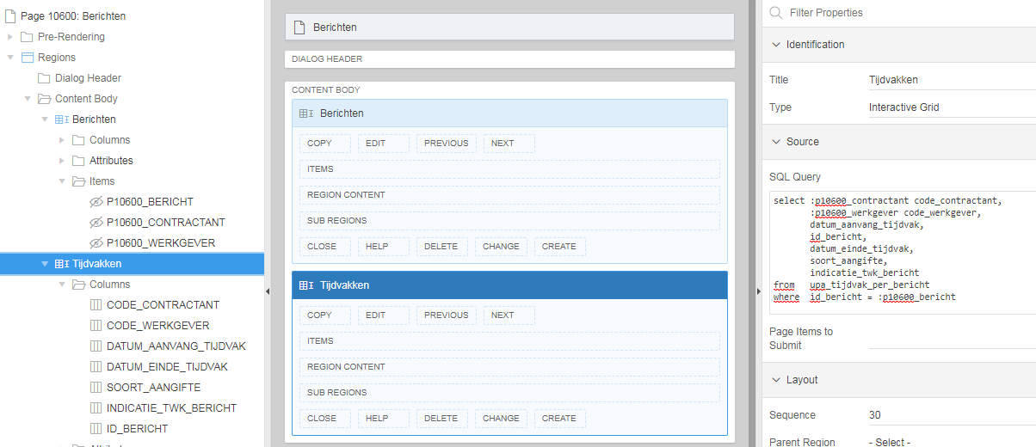

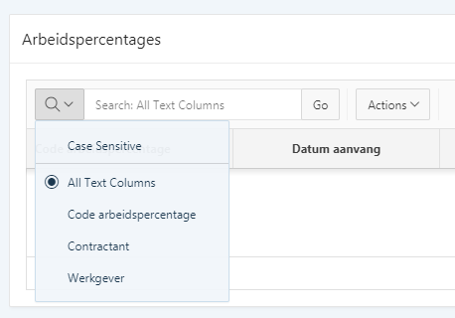

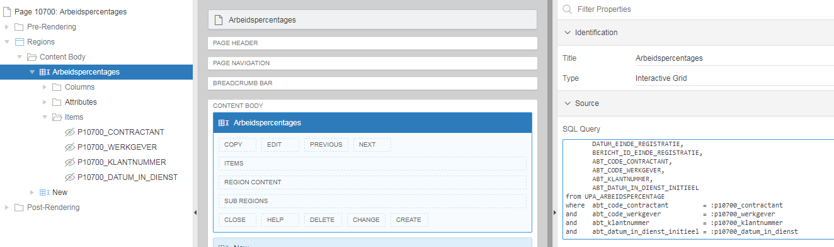

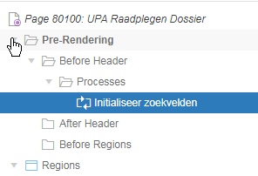

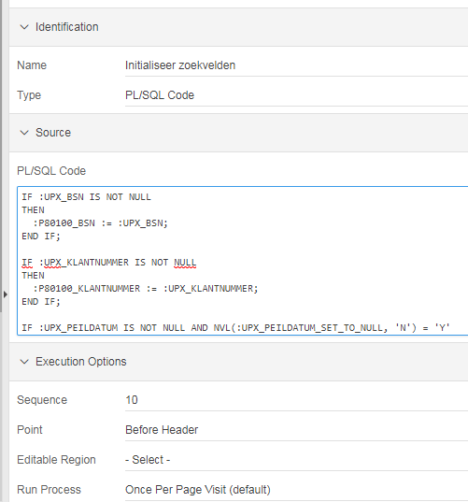

IF :UPX_BSN IS NOT NULL
THEN
:P80100_BSN := :UPX_BSN;
END IF;

IF :UPX_KLANTNUMMER IS NOT NULL
THEN
:P80100_KLANTNUMMER := :UPX_KLANTNUMMER;
END IF;

IF :UPX_PEILDATUM IS NOT NULL AND NVL(:UPX_PEILDATUM_SET_TO_NULL, 'N') = 'Y'
THEN
:P80100_PEILDATUM := :UPX_PEILDATUM;
END IF;

IF :UPX_PENSIOENFONDS IS NOT NULL
THEN
:P80100_CONTRACTANT := :UPX_PENSIOENFONDS;
END IF;

IF :UPX_WERKGEVER IS NOT NULL
THEN
:P80100_WERKGEVER := :UPX_WERKGEVER;
END IF;

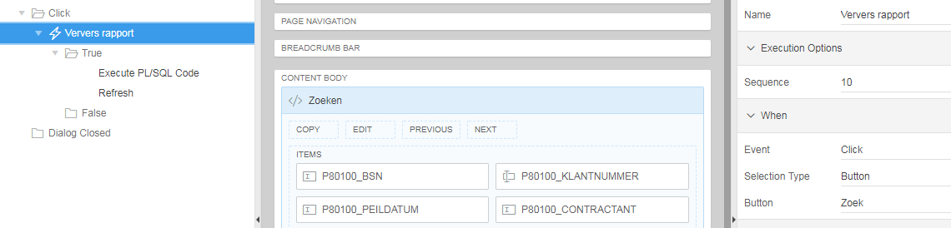

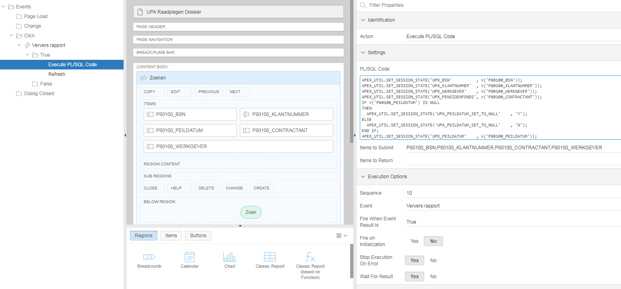

APEX_UTIL.SET_SESSION_STATE('UPX_BSN' , v('P80100_BSN'));
APEX_UTIL.SET_SESSION_STATE('UPX_KLANTNUMMER' , v('P80100_KLANTNUMMER'));
APEX_UTIL.SET_SESSION_STATE('UPX_WERKGEVER' , v('P80100_WERKGEVER'));
APEX_UTIL.SET_SESSION_STATE('UPX_PENSIOENFONDS', v('P80100_CONTRACTANT'));
IF v('P80100_PEILDATUM') IS NULL
THEN
APEX_UTIL.SET_SESSION_STATE('UPX_PEILDATUM_SET_TO_NULL' , 'Y');
ELSE
APEX_UTIL.SET_SESSION_STATE('UPX_PEILDATUM_SET_TO_NULL' , 'N');
END IF;
APEX_UTIL.SET_SESSION_STATE('UPX_PEILDATUM' , v('P80100_PEILDATUM'));
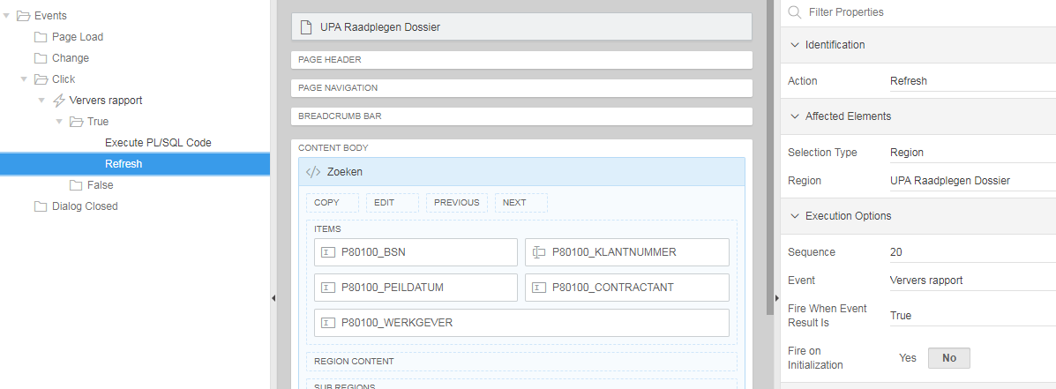

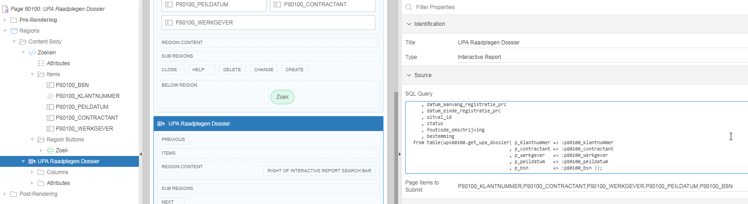

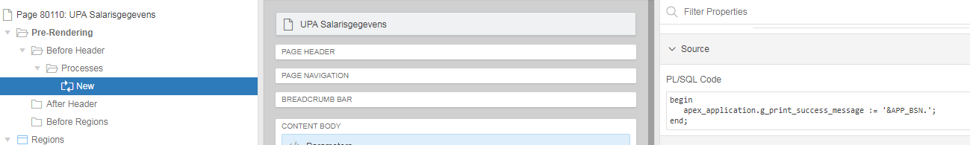

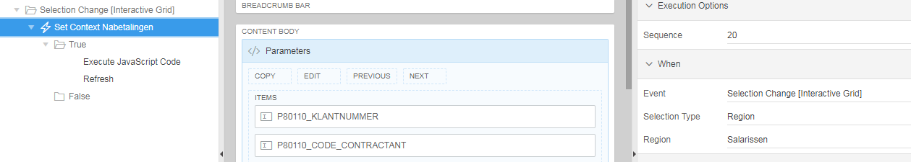

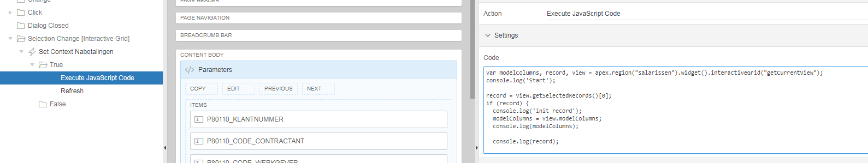

var modelColumns, record, view = apex.region("salarissen").widget().interactiveGrid("getCurrentView");
console.log('Start');

record = view.getSelectedRecords()[0];
if (record) {
console.log('init record');
modelColumns = view.modelColumns;
console.log(modelColumns);

console.log(record);

$s("P80110_CODE_SALARIS", record[modelColumns["CODE_SALARIS"]["index"]]);
$s("P80110_SLS_DATUM_AANVANG", record[modelColumns["DATUM_AANVANG"]["index"]]);
$s("P80110_SLS_DATUM_AANVANG_REG", record[modelColumns["DATUM_AANVANG_REGISTRATIE"]["index"]]);
$s("P80110_CODE_CONTRACTANT", record[modelColumns["ABT_CODE_CONTRACTANT"]["index"]]);
$s("P80110_CODE_WERKGEVER", record[modelColumns["ABT_CODE_WERKGEVER"]["index"]]);
$s("P80110_DATUM_IN_DIENST_INIT", record[modelColumns["ABT_DATUM_IN_DIENST_INITIEEL"]["index"]]);
$s("P80110_KLANTNUMMER", record[modelColumns["ABT_KLANTNUMMER"]["index"]]);
} else {
$s("P80110_CODE_SALARIS", null);
$s("P80110_SLS_DATUM_AANVANG", null);
$s("P80110_SLS_DATUM_AANVANG_REG", null);
$s("P80110_CODE_CONTRACTANT", null);
$s("P80110_CODE_WERKGEVER", null);
$s("P80110_DATUM_IN_DIENST_INIT", null);
$s("P80110_KLANTNUMMER", null);
}

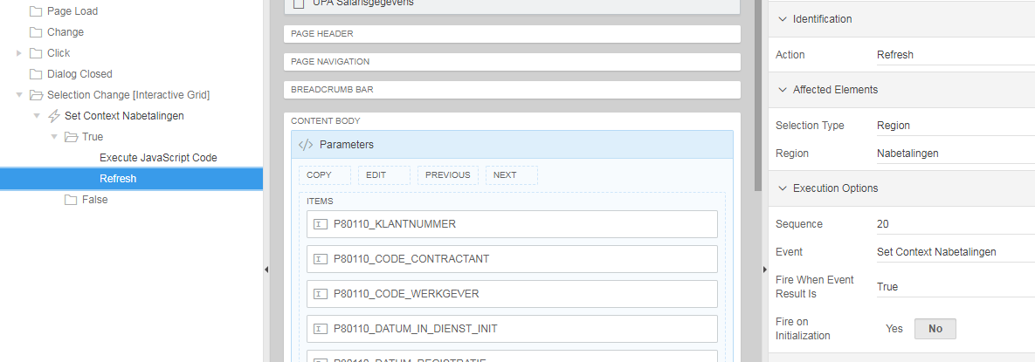

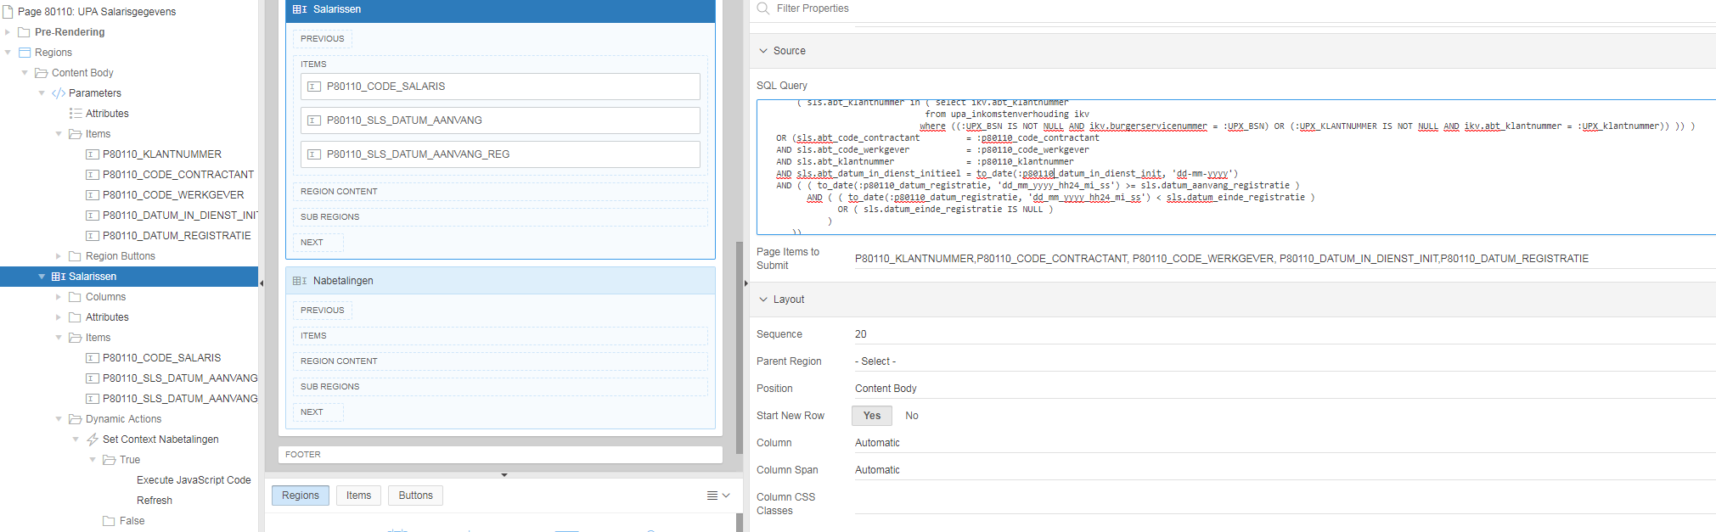

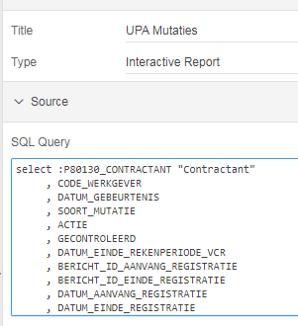
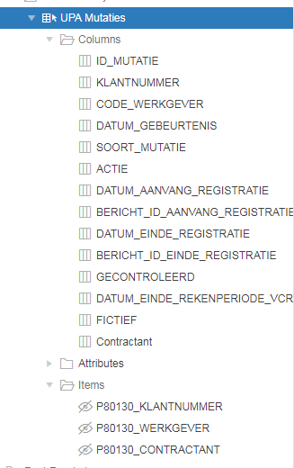

select :P80130_CONTRACTANT "Contractant"
, CODE_WERKGEVER
, DATUM_GEBEURTENIS
, SOORT_MUTATIE
, ACTIE
, GECONTROLEERD
, DATUM_EINDE_REKENPERIODE_VCR
, BERICHT_ID_AANVANG_REGISTRATIE
, BERICHT_ID_EINDE_REGISTRATIE
, DATUM_AANVANG_REGISTRATIE
, DATUM_EINDE_REGISTRATIE
, ID_MUTATIE
, KLANTNUMMER
, FICTIEF
from UPA_MUTATIES
where klantnummer = :P80130_KLANTNUMMER
and code_werkgever = NVL(:P80130_WERKGEVER, code_werkgever)

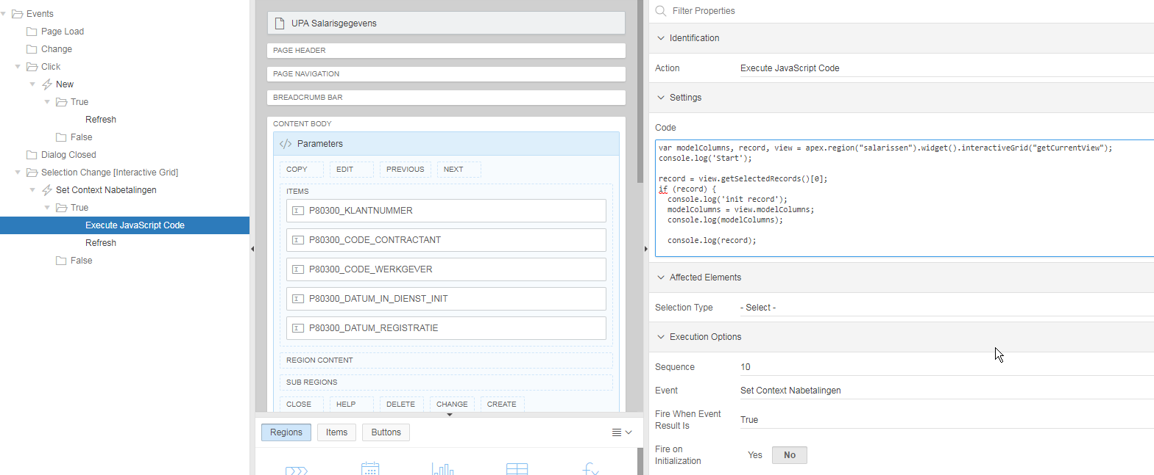

var modelColumns, record, view = apex.region("salarissen").widget().interactiveGrid("getCurrentView");
console.log('Start');

record = view.getSelectedRecords()[0];
if (record) {
console.log('init record');
modelColumns = view.modelColumns;
console.log(modelColumns);

console.log(record);

$s("P80300_CODE_SALARIS", record[modelColumns["CODE_SALARIS"]["index"]]);
$s("P80300_SLS_DATUM_AANVANG", record[modelColumns["DATUM_AANVANG"]["index"]]);
$s("P80300_SLS_DATUM_AANVANG_REG", record[modelColumns["DATUM_AANVANG_REGISTRATIE"]["index"]]);
$s("P80300_CODE_CONTRACTANT", record[modelColumns["ABT_CODE_CONTRACTANT"]["index"]]);
$s("P80300_CODE_WERKGEVER", record[modelColumns["ABT_CODE_WERKGEVER"]["index"]]);
$s("P80300_DATUM_IN_DIENST_INIT", record[modelColumns["ABT_DATUM_IN_DIENST_INITIEEL"]["index"]]);
$s("P80300_KLANTNUMMER", record[modelColumns["ABT_KLANTNUMMER"]["index"]]);
} else {
$s("P80300_CODE_SALARIS", null);
$s("P80300_SLS_DATUM_AANVANG", null);
$s("P80300_SLS_DATUM_AANVANG_REG", null);
$s("P80300_CODE_CONTRACTANT", null);
$s("P80300_CODE_WERKGEVER", null);
$s("P80300_DATUM_IN_DIENST_INIT", null);
$s("P80300_KLANTNUMMER", null);
}

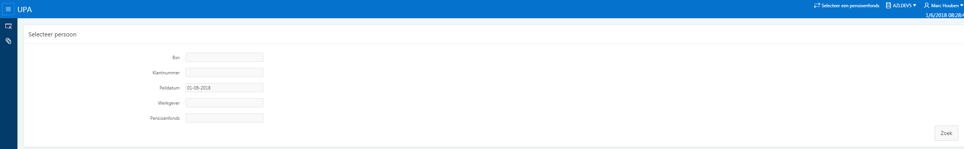

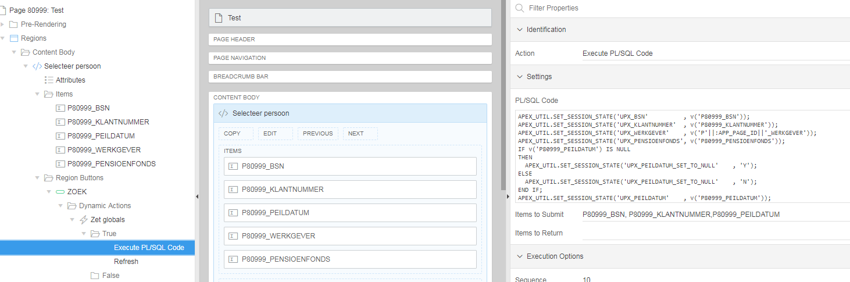

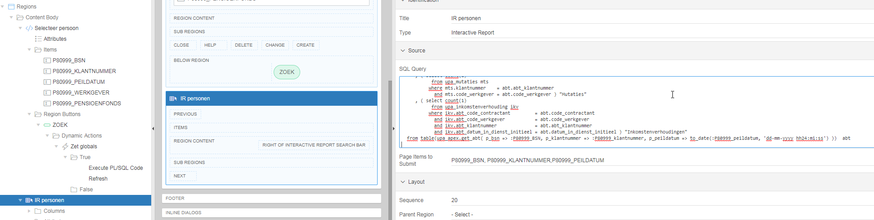

Workshop

Vragen 12-06-2018

Indien de foreign key relatie tussen tabellen niet via een ID loopt, maar via meerdere kolommen, hoe regel je dat dan binnen APEX?

Voorbeeld (applicatie 10110, pagina 4)

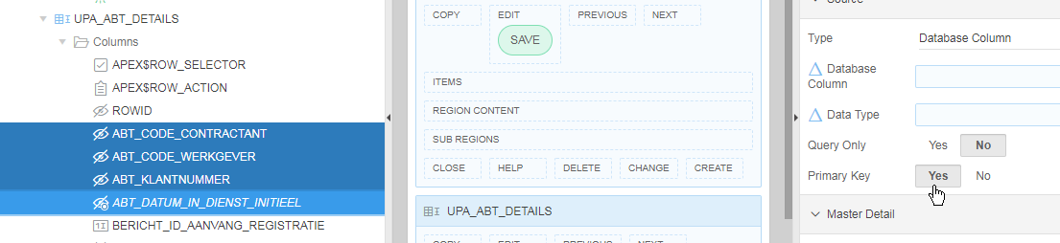

Hoe zorg je er voor dat je zelf debug informatie kunt genereren? Kan ik een PL/SQL blok toevoegen met daarin azldebug of trace.w? Op welke plek dient dat dat gedaan te worden?

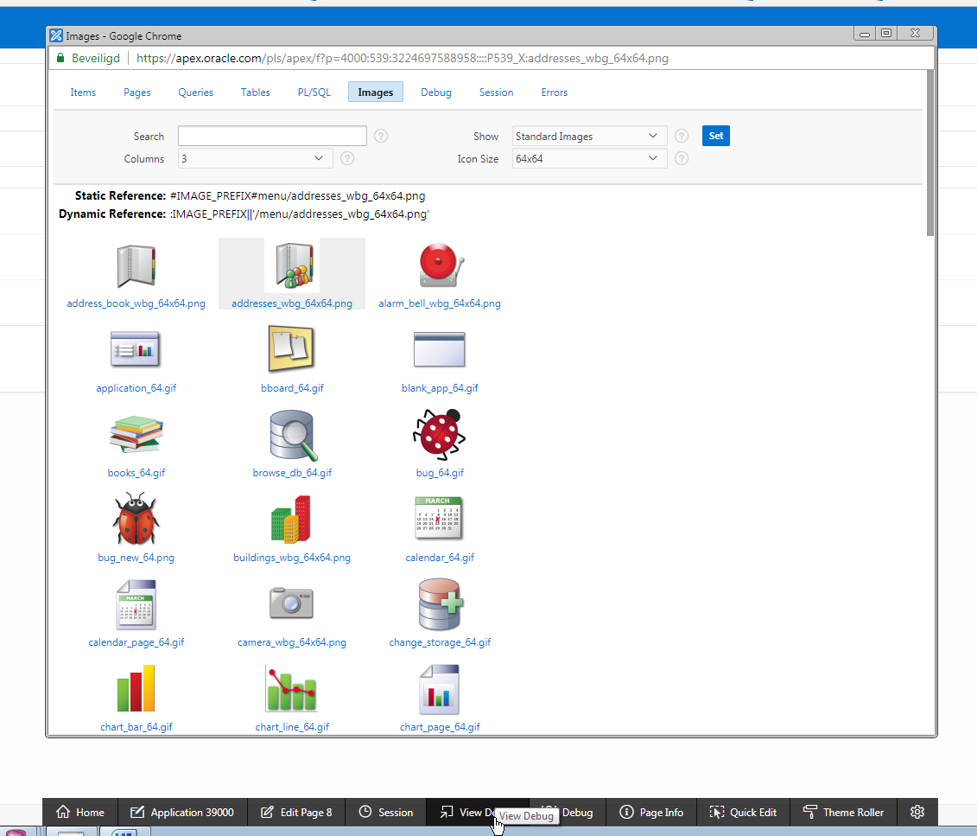

Chrome:
- Op F12 klikken
- Rechtsklikken op attribuut en dan Inspecteren

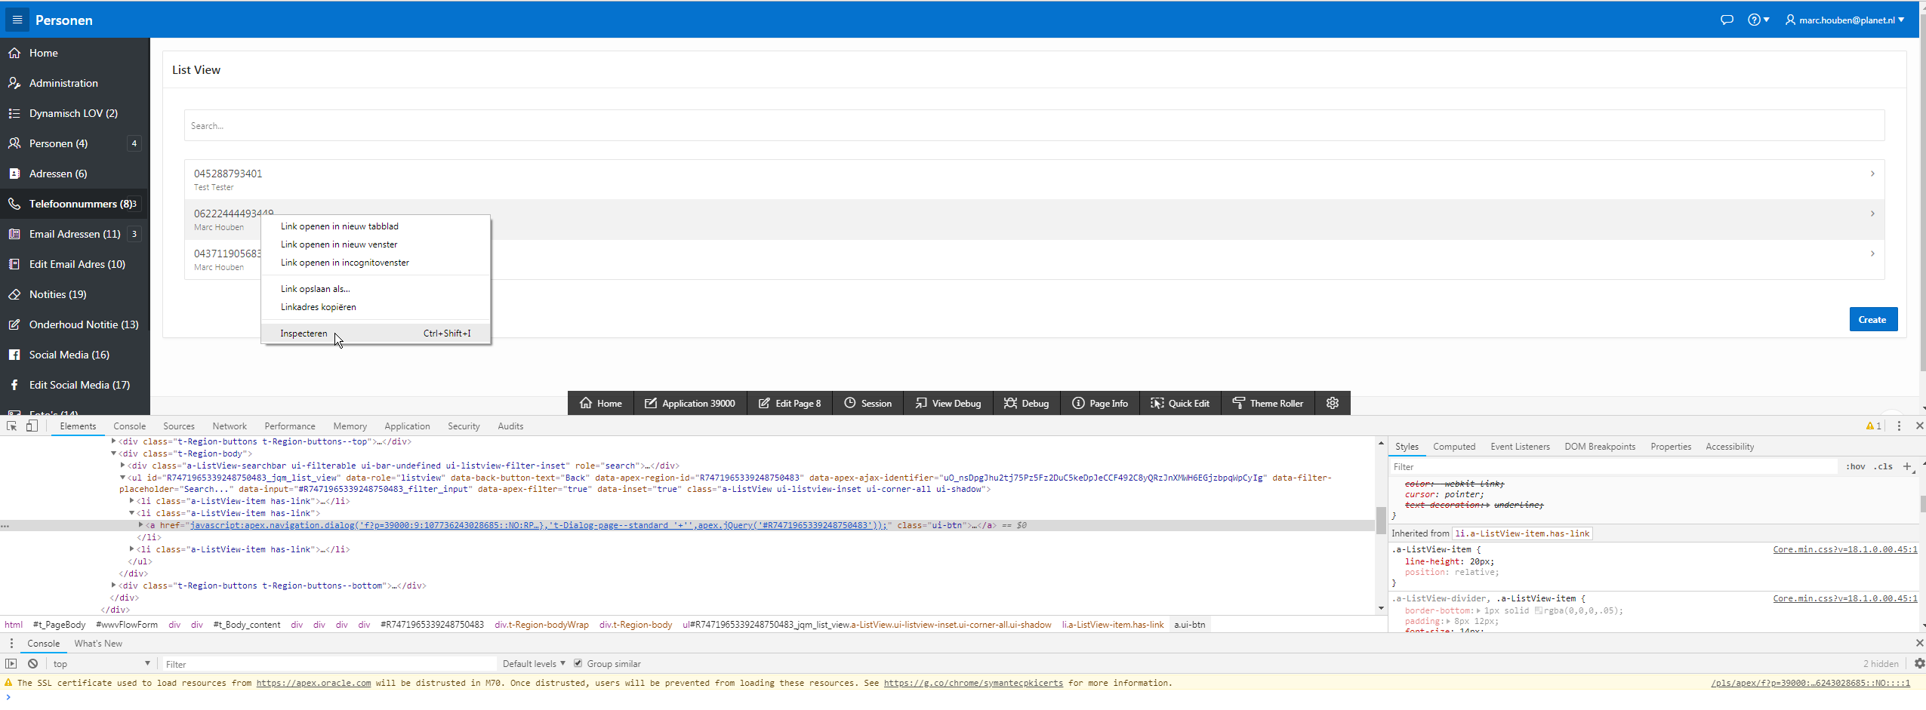

Apex collection aanmaken op volgende pagina report met inhoud van collection (zie coxpck90001). sp_create_apex_session is noodzakelijk voor PL/SQL developer

Javascript:
console.log( wat je wil tonen )
console.log(this)

Insert in log tabel

Hoe kun je parameters doorgeven vanuit een APEX applicatie aan een functie in een package en vervolgens het resultaat van de functie gebruiken in APEX?
Application 90001 : pagina 11000 :
Processing - Processes - Download :

Download

DECLARE
CURSOR c_code(lp_pf_nummer NUMBER)
IS
SELECT upper(A0008)
FROM pensioenfondsen
WHERE A0001 = lp_pf_nummer;

l_excel BLOB;
l_code pensioenfondsen.A0008%type;
BEGIN
OPEN c_code(:P11000_PF_NUMMER);
FETCH c_code INTO l_code;
CLOSE c_code;
--
l_excel := coxpck90001.download_et(:P11000_PF_NUMMER,:P11000_EXTRA_TABEL_DL);

-- Prepare Headers

owa_util.mime_header('application/vnd.openxmlformats-officedocument.spreadsheetml.sheet',FALSE);
htp.p('Content-Length: '||dbms_lob.getlength(l_excel));
htp.p( 'Content-Disposition: filename="'||l_code||'_extra_tabellen.xlsx' || '"' );
owa_util.http_header_close;
wpg_docload.download_file(l_excel);
apex_application.g_unrecoverable_error := true;

END;

Opladen

DECLARE
--
l_blob BLOB;

BEGIN

select blob_content
into l_blob
from APEX_APPLICATION_TEMP_FILES
where name = :P11000_SELECTEER;

DELETE from APEX_APPLICATION_TEMP_FILES WHERE name = :P11000_SELECTEER;

coxpck90001.upload_et(:P11000_PF_NUMMER_UP,l_blob);

END;

Verwijderen

BEGIN

coxpck90001.verwijder_et( :P11000_PF_NUMMER_DEL
, :P11000_EXTRA_TABEL
, :P11000_SLEUTEL1
, :P11000_SLEUTEL2
, :P11000_SLEUTEL3);

END;

Wanneer dient “Static ID” gevuld te worden?
Wordt gebruikt in Javascript

Oracle apex construct url

f?p=&APP_ID.

Applicatie beschikbaar stellen aan gebruiker?
Application Alias vullen bij Edit application properties (bijvoorbeeld AZL)
…..f?p=AZL

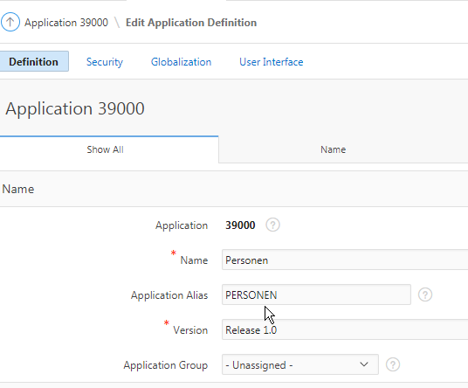

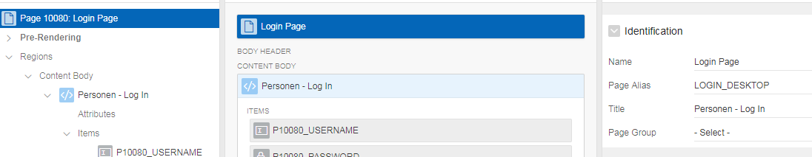

Vragen 26-06-2018

- In de tutorial wordt bij “Calendar” het volgende gebruikt bij “Drag and Drop PL/SQL Code”. Hoe kun je achterhalen dat het roodgekleurde beschikbaar is? Is er een overzicht van APEX variabelen die altijd tot je beschikking staan?

begin
update demo_tasks
set start_date = to_date(:APEX$NEW_START_DATE, 'YYYYMMDDHH24MISS')
, end_date = to_date(:APEX$NEW_END_DATE, 'YYYYMMDDHH24MISS')
where id = :APEX$PK_VALUE;
end;

https://docs.oracle.com/database/121/HTMDB/concept_sub.htm#HTMDB03024

#LABEL# is een verplicht veld

Google: Translating Messages

https://docs.oracle.com/cd/E59726_01/doc.50/e39147/global_messages.htm#HTMDB25939

Productie: lx10:8081/ords

http://translate-apex.com/apex/f?p=800:START::::::

- Waar wordt een “Proces” gebruikt? Als je bijvoorbeeld een “Dynamic Action” maakt, dan zie je deze terug bij het “Item”. In welke volgorde worden welke stappen afgewerkt? Wellicht kun je dit uitleggen aan de hand van de “Dialog Demo”?

- In het verlengde van de vorige vraag:
Pre-Rendering / Post-Rendering : Wat moet je op welke plek toevoegen (Before Header, After Header, Before Regions / After Regions, Before Footer, After Footer)?

Before Header
- branch naar andere pagina (je komt niet de pagina zelf, maar wordt doorgestuurd)
- computation om bijvoorbeeld bestandsnaam te bepalen

After header
- dit is de default voor processes

- Kun je voorbeelden laten zien van validaties? Voorbeelden: Salarisbedrag mag niet negatief zijn. Bij een planning dient de begindatum in de toekomst te liggen. Postcode bevat 4 cijfers en 2 letters.

Een validatie kun je bij een proces toevoegen (in PL/SQL).
Bij een dynamic action moet je de validatie via Javascript uitvoeren (dat kan namelijk niet in PL/SQL).

Bij “Associated Item” vul je in wanneer de validatie uitgevoerd moet worden.

- Wanneer gebruik je een branch (versus “Redirect to Page in this Application”)?

Een branch vangt een niet-redirect button op. Je drukt op een button, de bijbehorende validaties en processen worden uitgevoerd, en dan komt hij bij de branch die vertelt waar hij heen moet.

:REQUEST is afkomstig van je submit. De waarde is NAAM van de button (button name).

- Als je in “Shared Components” bij “Applications Items” een globale variabele definieert, hoe en waar kun je deze dan vullen met een waarde?

Bijvoorbeeld in “Application Computation”. Bij Authentication zet je een cookie. Bij andere applicatie definieer je wederom (global) het “Application Item” zonder de computation, maar dan is het toch gevuld vanwege de eerder gezette cookie.

- Voorbeeld van het gebruik van het item “Color Picker”?

Het item “Color Picker” wordt gebruikt om de hexadecimale waarde van de kleur op te slaan in een database veld. Deze waarde kan vervolgens op een andere plek gebruikt worden.

Vragen 24-07-2018

- Op welke punten wijkt de AZL template af van de default template?

Vragen 07-08-2018

Zelfstudie

Vragen

Hoe koppel je een zelfgemaakt CSS bestand aan een applicatie? En hoe gebruik je het vervolgens binnen je applicatie?
https://docs.oracle.com/html/E39147_04/ui_custom_css.htm
http://apexfusion.blogspot.com/2017/04/how-to-add-custom-css-files-to-apex.html
https://docs.oracle.com/cd/E11882_01/appdev.112/e11947/ui_custom_css.htm#HTMDB25734

Het volgende werkt NIET:
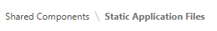
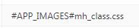

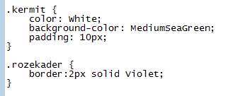

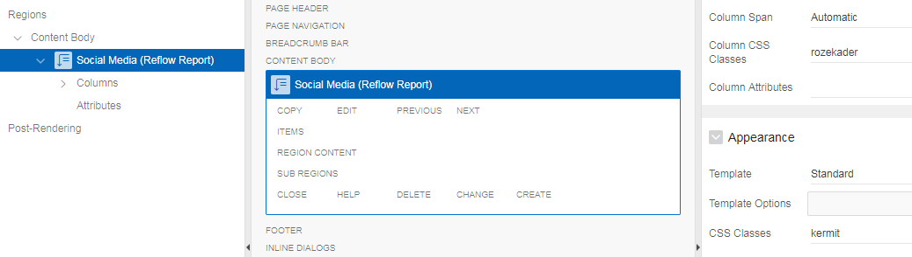

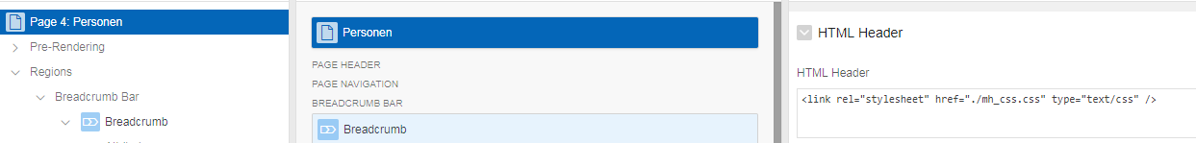

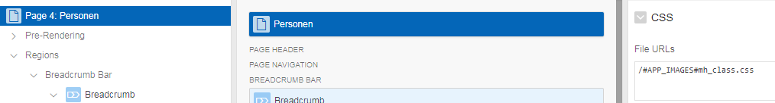

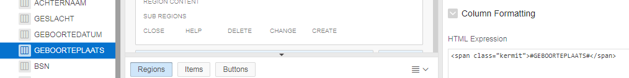

Het volgende werkt WEL:

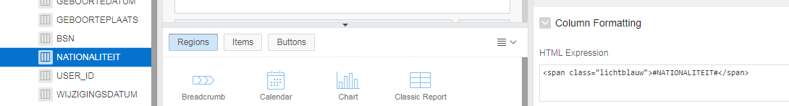

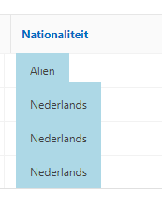

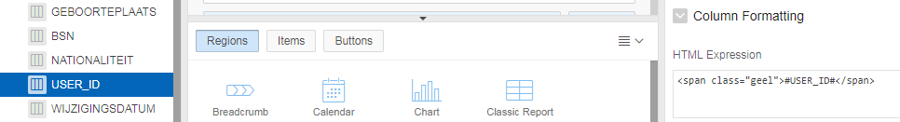

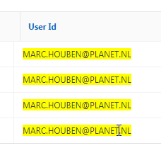

Wanneer kies je voor “Interactive Grid”, “Interactive Report” of “Classic Report”? Wat zijn de voor- en nadelen van elk? Afhankelijk van wie er wat mee wil doen.

Hoe kunnen we de “AZL Template” importeren in de LAB omgeving zodat deze bruikbaar wordt? Importeren van applicatie f99999 gaat goed, maar bij het runnen krijg je een foutmelding database link naar DEV1 toevoegen.

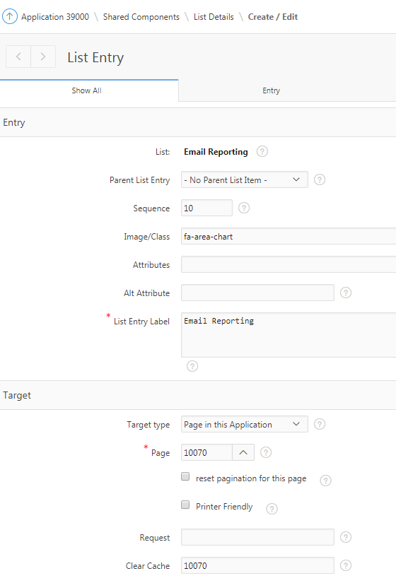
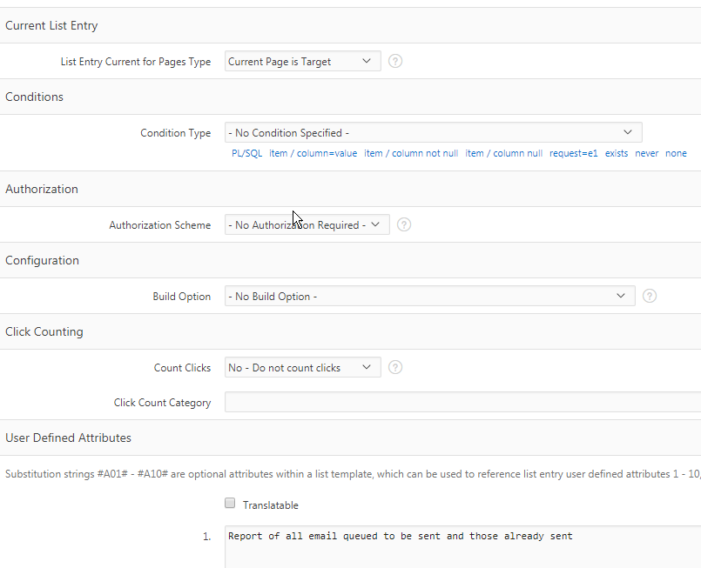

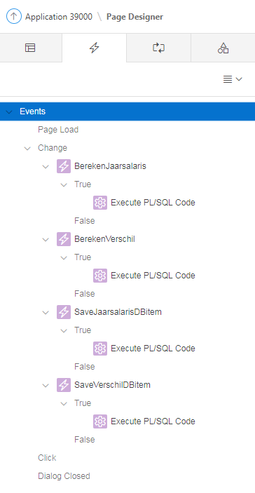

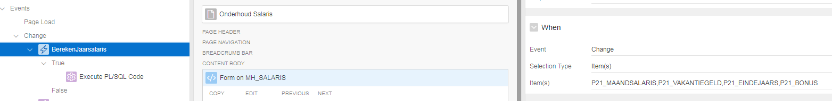

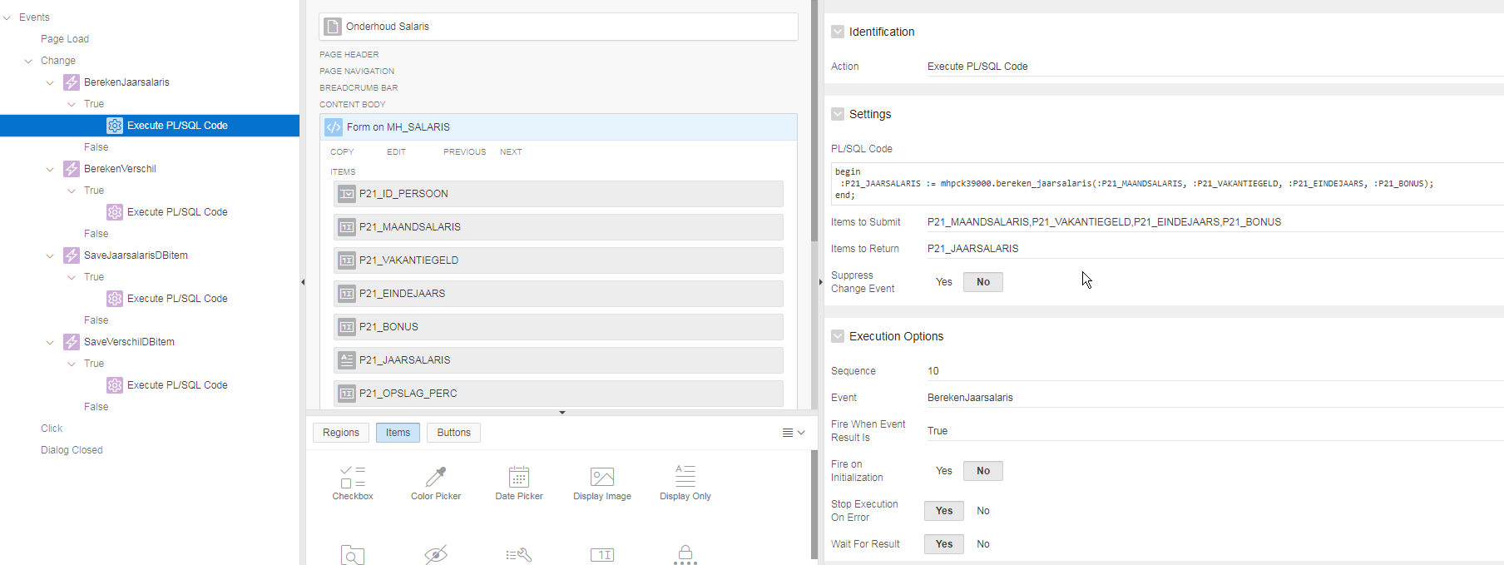

begin
:P21_JAARSALARIS := mhpck39000.bereken_jaarsalaris(:P21_MAANDSALARIS, :P21_VAKANTIEGELD, :P21_EINDEJAARS, :P21_BONUS);
end;

P21_MAANDSALARIS,P21_VAKANTIEGELD,P21_EINDEJAARS,P21_BONUS kunnen wijzigen en hebben invloed op het resultaat (= P21_JAARSALARIS).

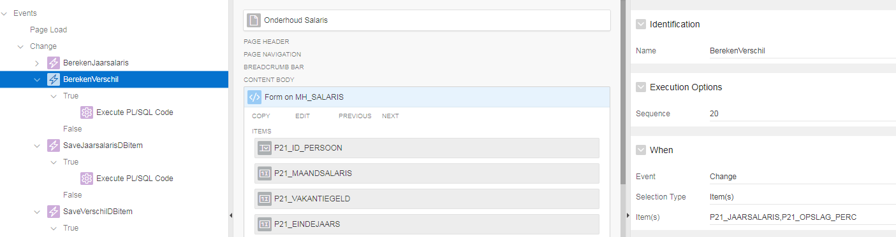

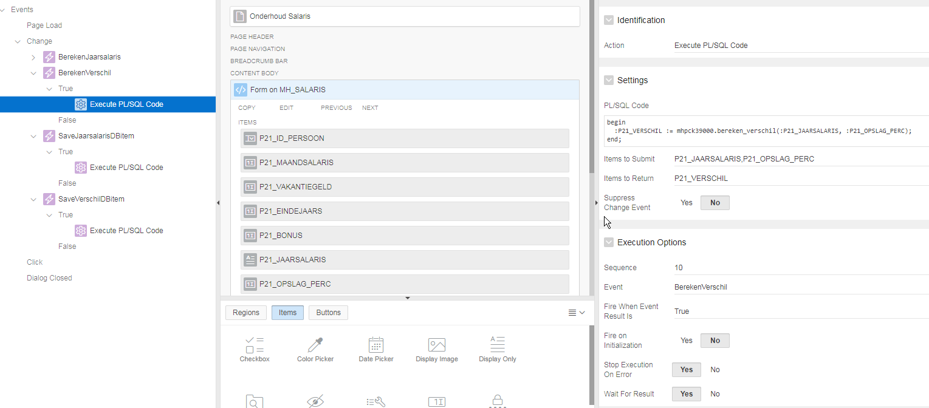

begin
:P21_VERSCHIL := mhpck39000.bereken_verschil(:P21_JAARSALARIS, :P21_OPSLAG_PERC);
end;

P21_JAARSALARIS,P21_OPSLAG_PERC kunnen wijzigen en hebben invloed op resultaat (=P21_VERSCHIL).

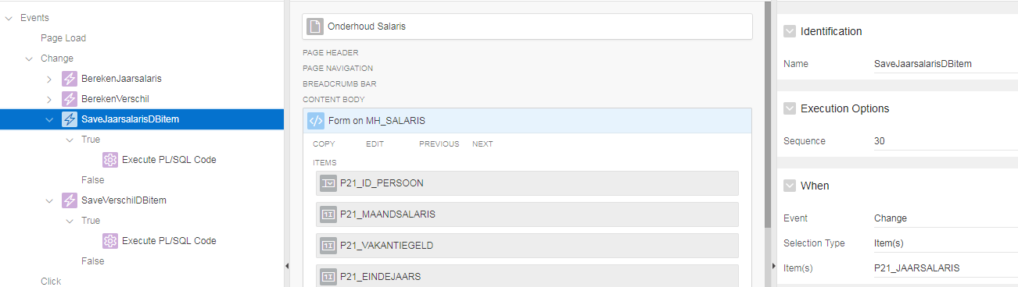

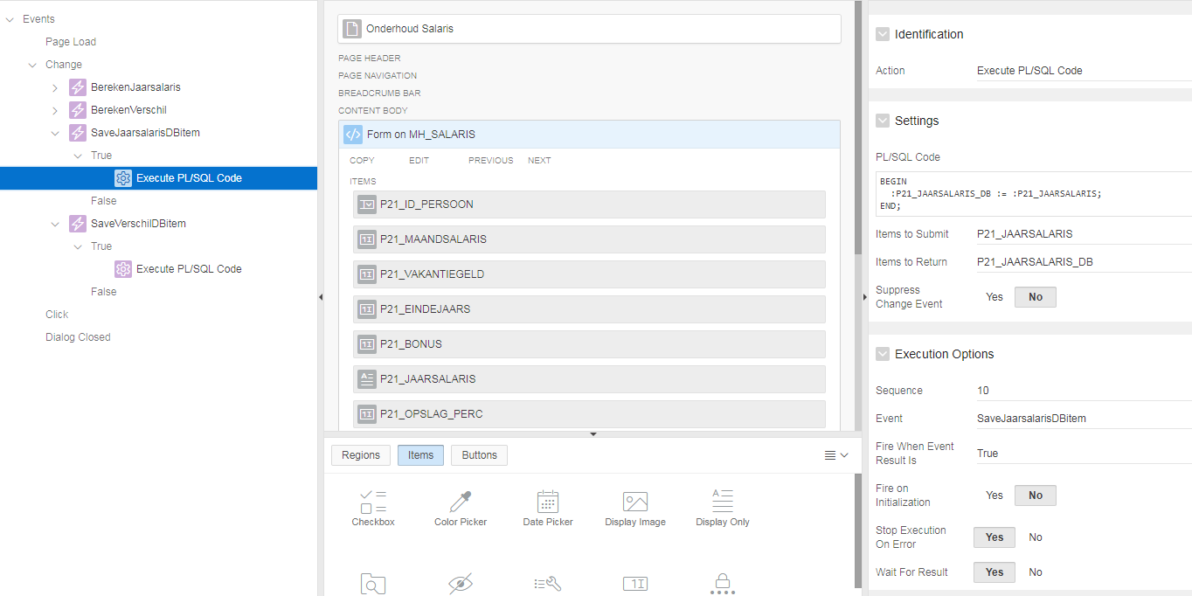

BEGIN
:P21_JAARSALARIS_DB := :P21_JAARSALARIS;
END;

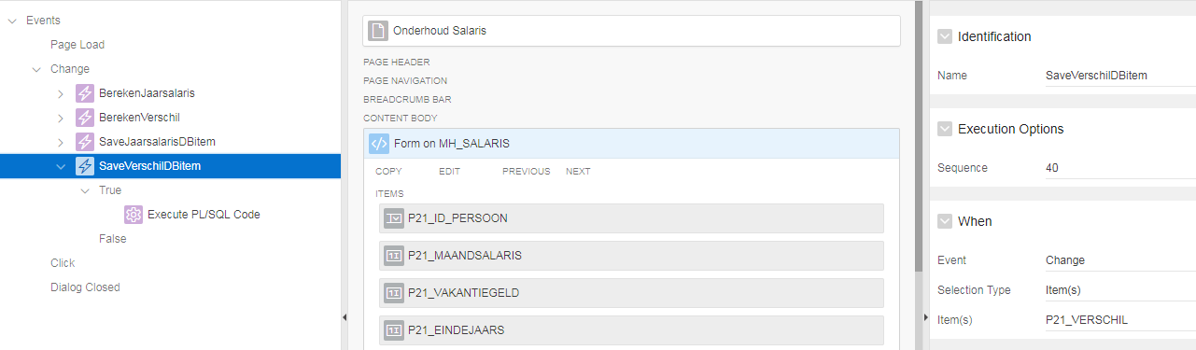

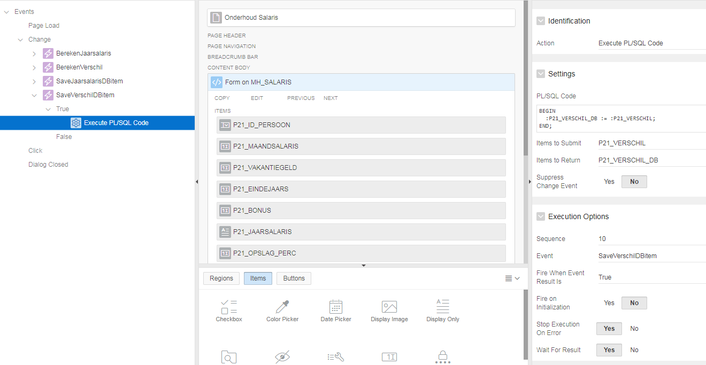

BEGIN
:P21_VERSCHIL_DB := :P21_VERSCHIL;
END;

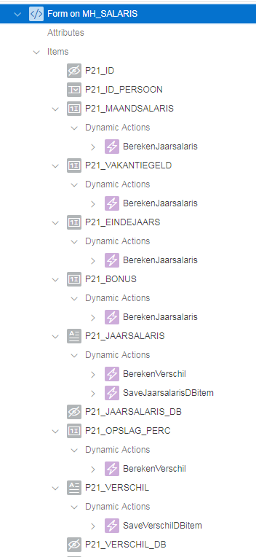

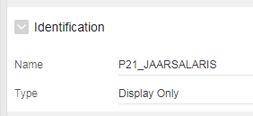

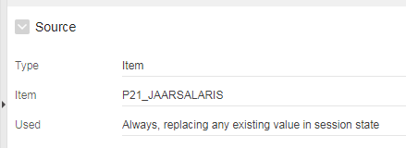

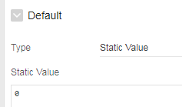

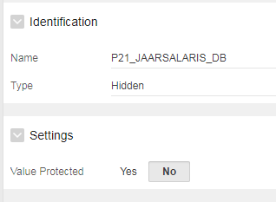

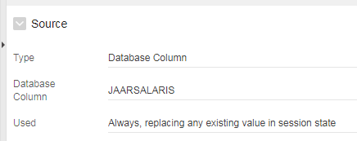

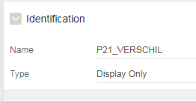

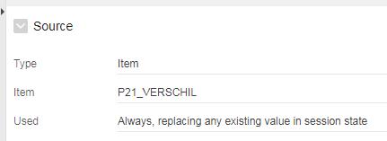

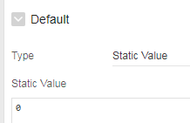

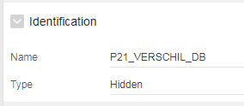

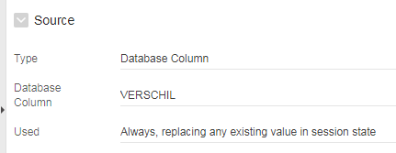

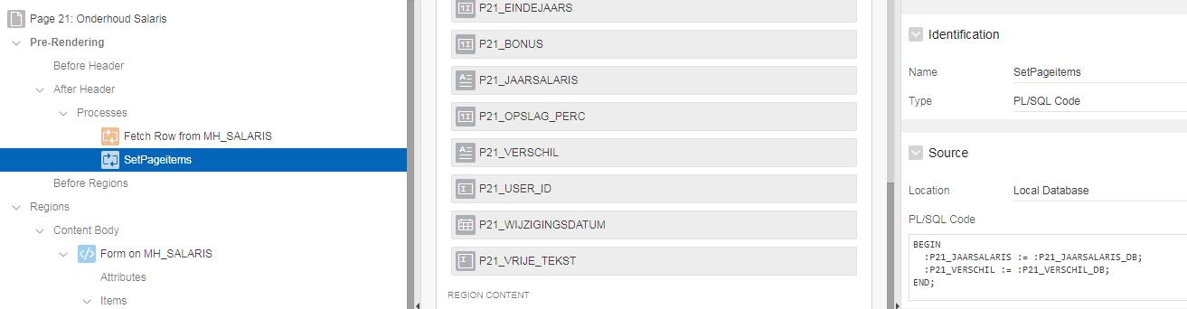

BEGIN
:P21_JAARSALARIS := :P21_JAARSALARIS_DB;
:P21_VERSCHIL := :P21_VERSCHIL_DB;
END;

- Bij Onderhoud Salaris begint het scherm met de vorige waarden. Er wordt geen nieuw record toegevoegd, maar het bestaande record wordt geupdate.
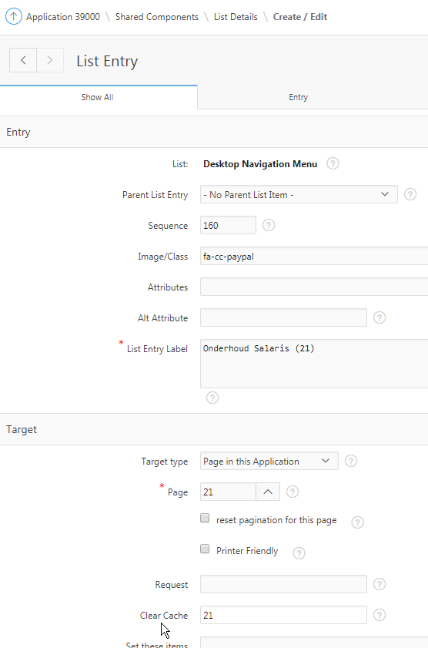

- Bij Edit Social Media begint het scherm met de vorige waarden (hetzelfde probleem als hiervoor).
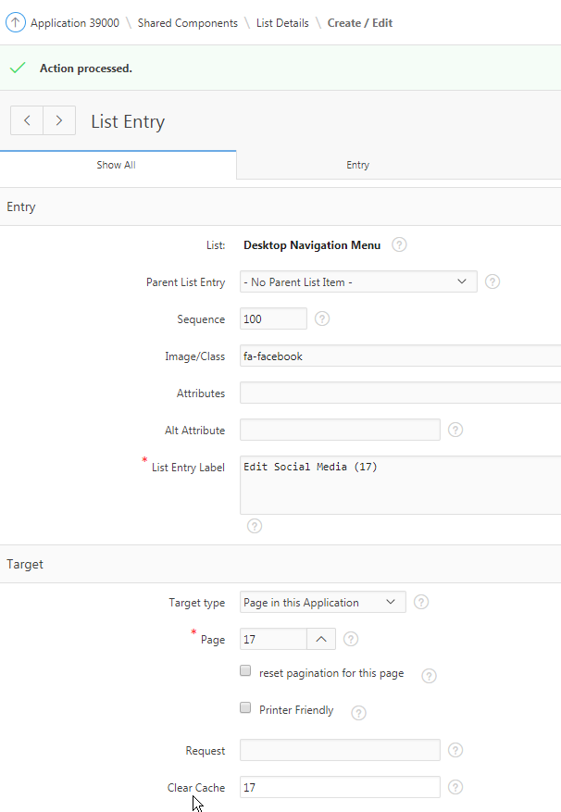

Logging toegevoegd aan mhpck39000. bereken_jaarsalaris : select clob001, TO_CHAR(wijzigingsdatum, 'DD-MM-YYYY HH24:MI:SS') wijzigingsdatum from mh_logging where application_id = 39000 and page_id = 21 order by wijzigingsdatum; Dynamic action wordt meerdere keren uitgevoerd (na elke wijziging van een item), zodoende meerdere records

DELETE

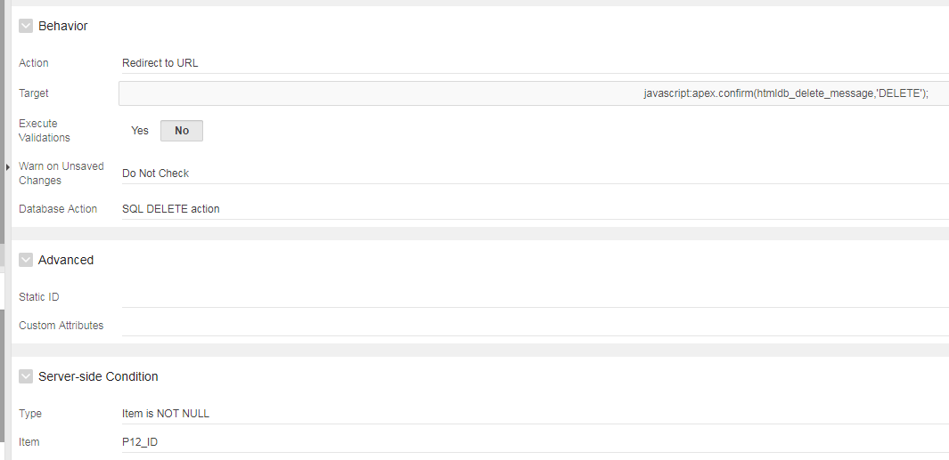

CANCEL

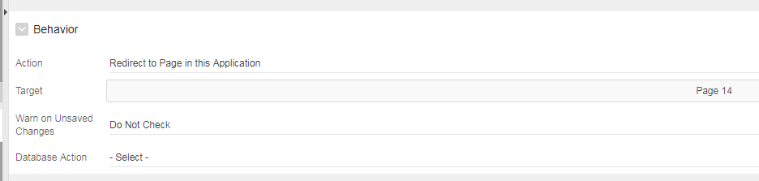

SAVE

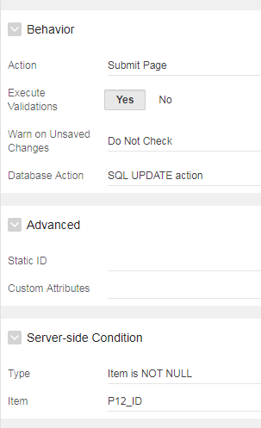

CREATE

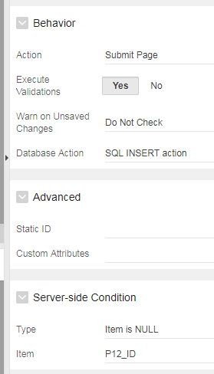

Processes

- GetPK

begin
if :P12_ID is null then
select "#OWNER#"."MH_SEQ".nextval
into :P12_ID
from sys.dual;
end if;
end;

When Button Pressed: CREATE

- Process Row

Automatic Row Processing (DML)

- Reset page

Type: Clear Session State
When Button Pressed: DELETE

- Edit Email Adres (10) (Interactive Grid) : wijziging opslaan geeft foutmelding ORA-20987: APEX - ORA-00904: "P10_ID": ongeldige ID Gegenereerde P10_ID moet ID zijn (bug?). Pxx_ alleen bij form.
- Persoon - Email (36. 38) : Bij CREATE van een nieuw persoon krijg je foutmelding “Kan geen NULL invoegen in ID” terwijl sequence van ID staat ingesteld op MH_SEQ. Moet via proces SequenceUitdelen

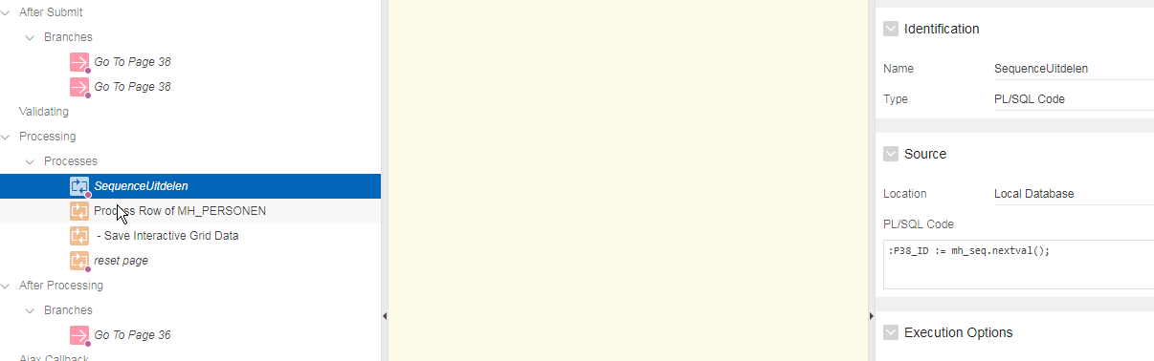

- Form on SQL Query (44) : Button CREATE niet zichtbaar. Items zijn gewijzigd in Type Database Column en processen zijn gedefinieerd. Zijn ze correct aangezien twee tabellen geraakt worden? Verder uitzoeken (clear cache vullen en zorgen dat sequence niet default de PK vult, want dat is de Server-side condition voor CREATE).
- Telefoonnummers (8) (List View) : Popup “Ik ben gloednieuw” komt niet alleen bij CREATE maar ook bij DELETE, terwijl Affected Elements op button CREATE staat ingesteld. Affected Elements is niet de juiste plek. Jan heeft een voorbeeld waarbij wordt teruggegeven waar je vandaan komt (bv button delete of button create).
- Cryptocurrency (28) : Op potlood klikken geeft report view (kunt niet update of delete uitvoeren).
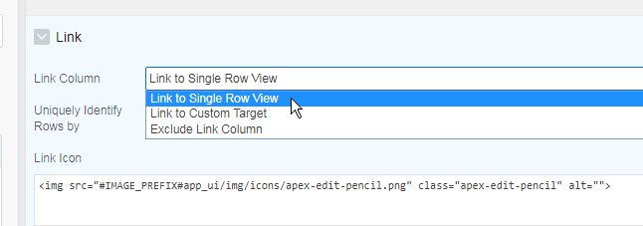
Je moet “Link to Custom Target” als je iets wilt wijzigen.
- Onderhoud Foto (12) : Als je op Apply Changes klikt, zou Foto’s (14) moeten openen. Of moet bij SAVE en CREATE de Action (onder Behavior) altijd “Submit Page” zijn? Bij SAVE en CREATE moet je ALTIJD “Submit Page” gebruiken, want anders worden de processen niet uitgevoerd. Als je, NADAT de processen klaar zijn, naar een pagina wilt gaan moet je een branch aanmaken.
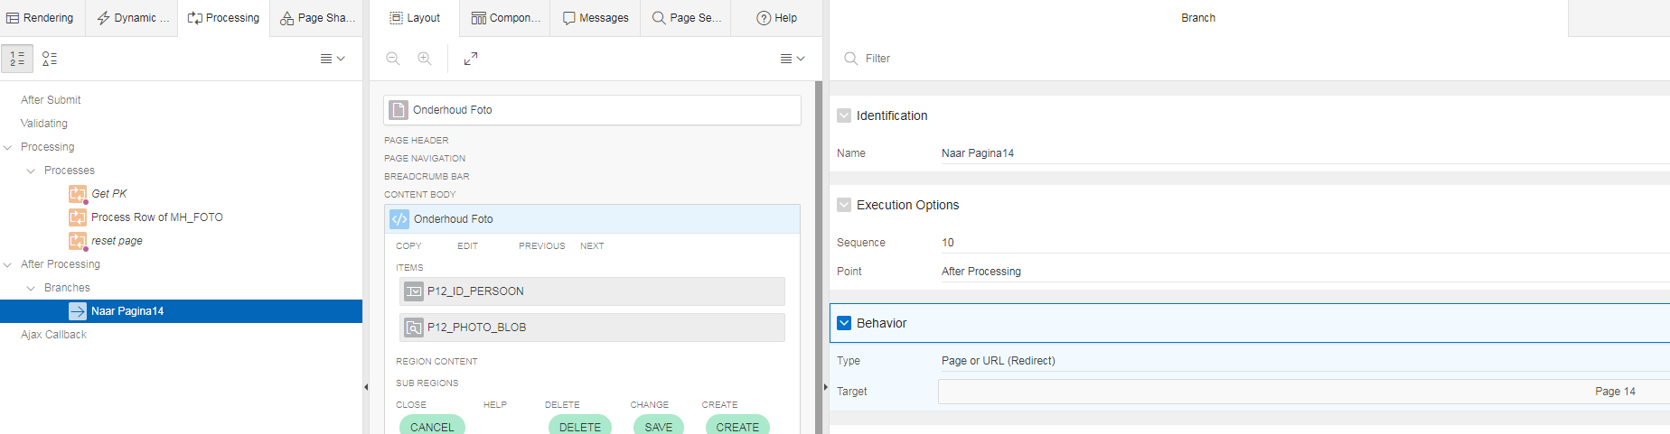
- Data Loading (24) : Lookup om ID_PERSOON te bepalen werkt niet. Bekijk “Sample Data Loading”. Probeer met verplichte kolommen om NULL te voorkomen.
- Data Validation (26) : Proces “Inhoud Collection Wegschrijven Naar Log Tabel” herkent :application_id en :page_id niet. ( NV('APP_ID') NV('APP_PAGE_ID') )
DECLARE
CURSOR c_collection
IS
select n001 as row_num,
wwv_flow_lang.system_message( 'DATA_LOAD.' || c049 ) as action,
c001, c002, c003,
c004, c005, c006,
c007, c008, c009,
c010, c011, c012,
c013, c014, c015,
c016, c017, c018,
c019, c020, c021,
c022, c023, c024,
c025, c026, c027,
c028, c029, c030,
c031, c032, c033,
c034, c035, c036,
c037, c038, c040,
c041, c042, c043,
c044, c045
from apex_collections
where collection_name = 'LOAD_CONTENT'
and c049 in ('INSERT','UPDATE', 'FAILED')
order by seq_id;

BEGIN
FOR i IN c_collection
LOOP
INSERT INTO MH_LOGGING( application_id
, page_id
, collection_name
, seq_id
, c001
, c002
, c003
, c004
, c005
, c006
, c007
, c008
, c009
, c010 )
VALUES ( :APP_ID -- Application ID
, :APP_PAGE_ID -- Page ID
, 'LOAD_CONTENT'
, i.row_num
, i.c001
, i.c002
, i.c003
, i.c004
, i.c005
, i.c006
, i.c007
, i.c008
, i.c009
, i.c010 );

COMMIT;
END LOOP;
END;

- Email Versturen (29) : Bij “Aan” kan ik email adres invullen. Als ik een select list gebruik kan ik kiezen uit de email adressen in MH_EMAIL_ADRESSEN. Als een adres niet in de LOV aanwezig is, wil ik handmatig een adres kunnen invullen (een tekst field combineren met een select list). Gebruik “Popup LOV” (Enterable en Allow Multi Selection = Yes).
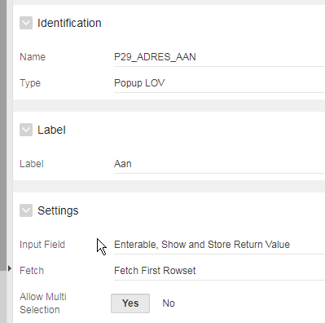

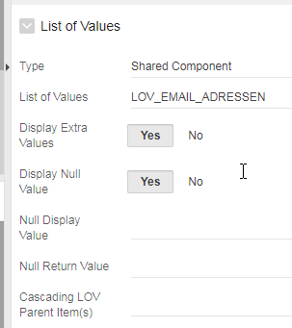

coxpck90001 : upload_ds

Openstaand
- Classic Report toevoegen aan Planningen (labels status) (zie Home bij Advanced Projects)
- Kleuren toevoegen aan Planningen (zie Calendar bij Advanced Projects)
https://www.talkapex.com/2017/02/custom-calendar-css-in-apex/
- Badges toevoegen (zie Application 260 - Fundamentals 2 (Eerste Uitwerking)
- 39000, pagina 5 : Switch Buitenlander, default Nee, indien Ja dan veld Nationaliteit tonen, anders niet tonen en default Nederlands opvoeren

Application Computation

G_AANTAL_PERSONEN

SELECT DECODE( count(1)
, 0, null
, '['||count(1)||']')
FROM mh_personen

Export
As of : Aantal minuten invullen. Dan wordt een export gemaakt van de applicatie van zoveel minuten geleden.

Problemen

- 39000, pagina 27 : Zoekterm invullen en dan <ENTER> drukken gaat goed. Klikken op ZOEK button levert geen resultaat. Indien niks ingevuld, dient alles getoond te worden. ZOEK button moet Submit Page uitvoeren (en niet een Dynamic Action)
- 39000, pagina 5 (Onderhoud Personen) : Dynamic Action op P5_BUITENLANDER : Execute PL/SQL Code werkt niet bij een CREATE. Return item invullen
- 39000, pagina 5 : P5_NATIONALITEIT : “Select List” en “Popup LOV” gaan goed. “Tekst Field with autocomplete” werkt niet met LOV_LANDEN Plugin gebruiken
- Applicatie 220, pagina 301 : Wat gebeurt hier en waarom?

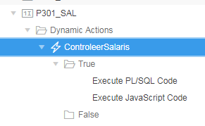
BEGIN
apex_util.set_session_state('P301_SAL_STATUS', f_check_max_sal(:P301_EMPNO, :P301_SAL));
END;

if ($v("P301_SAL_STATUS")) {
alert($v("P301_SAL_STATUS"));
}

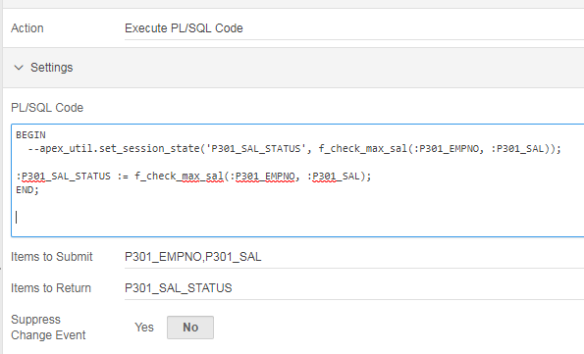

- 39000, pagina 26 : P26_ID is leeg als je pagina opent en toch wordt de Shuttle getoond, ondanks dynamic action Hide. Server-side Condition: Item is NOT NULL : P26_ID
- 39000, pagina 26 : Dynamic action dat je de onderste twee regions niet ziet, als je niets geselecteerd hebt in de bovenste region, werkt niet.

- Waar kun je instellen welke List gebruikt zal worden als menu aan de linkerkant?

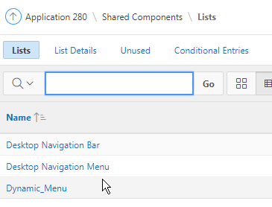

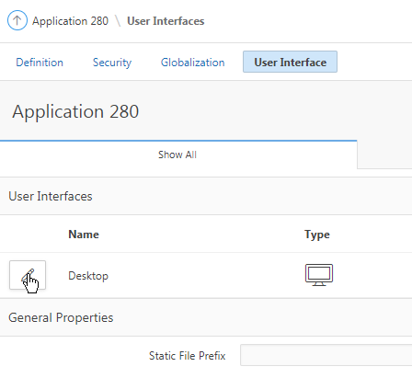
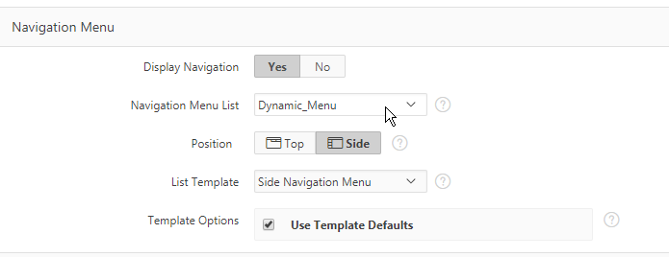

- Applicatie 280, pagina 10 : Bij draaien zie je niet de zwarte balk onderin. Javascript error

- 260, pagina 15 : P15_ID wordt gevuld met P16_ID (Idem Applicatie 260, pagina 20)
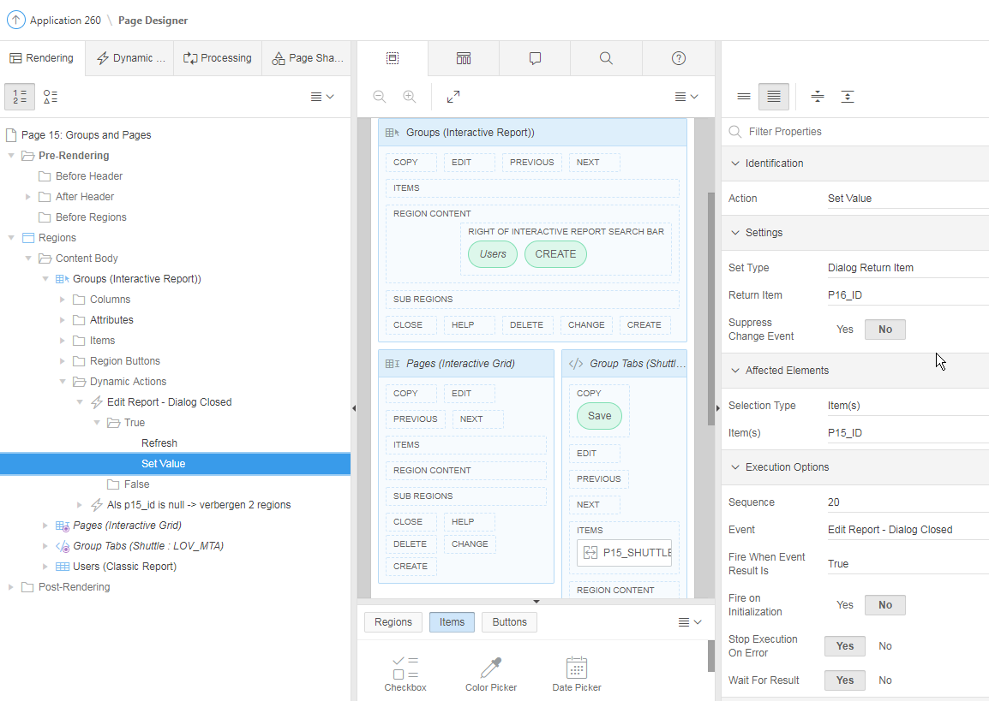

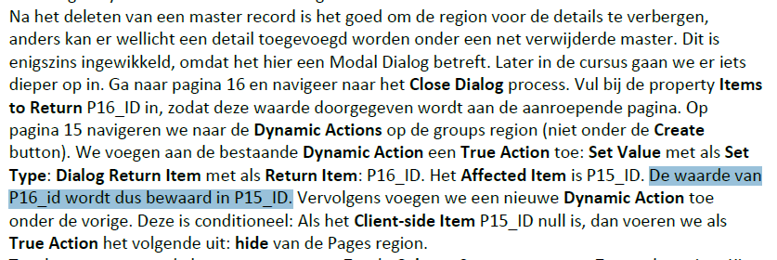

Applicatie 260, pagina 20 : “Affected Elements” is het doel (datgene wat je vult).
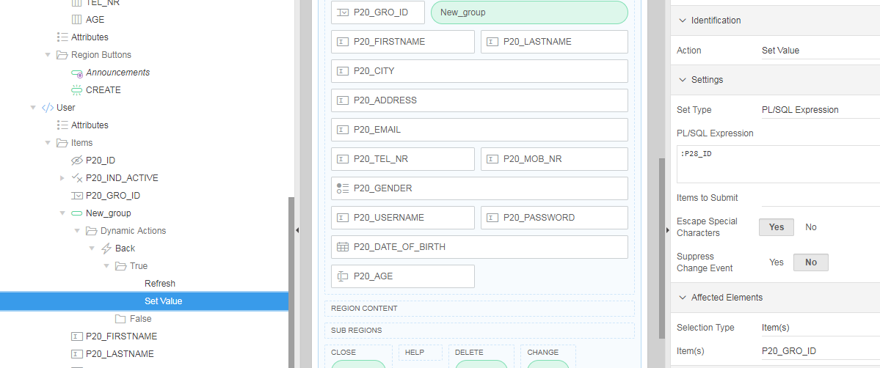

- Applicatie 260, pagina 20 : Wanneer/waarom voer je een Pre-Rendering After Header Fetch Row proces uit? Vanwege form (voor een report is dit nooit nodig)

